Message from the Headteacher
Dear Parents and Carers,
We have thought a lot about RESPECT this week in school. It has been anti-bullying week and through assemblies and activities in the classroom we have talked about what bullying is (repetitive, intentional hurting of another person or group) and how we can all use our Power For Good to safely speak up if we see bullying happening in person or online.
On Tuesday we marked Remembrance Day with a two minutes silence which was observed very respectfully. Classes 5 and 6 took part in the Royal British Legion live assembly where, through interviews with veterans, poems, art and music, they learned more about the service people have given to keep us safe.
Class 5 have enjoyed a visit to Magna this week to find out more about how the steel industry has impacted our local area while Class 2 have visited the Tropical Butterfly House where they have (bravely) handled mini-beasts and found out where they live and what they need to survive.
Have a lovely weekend, Miss Stothard


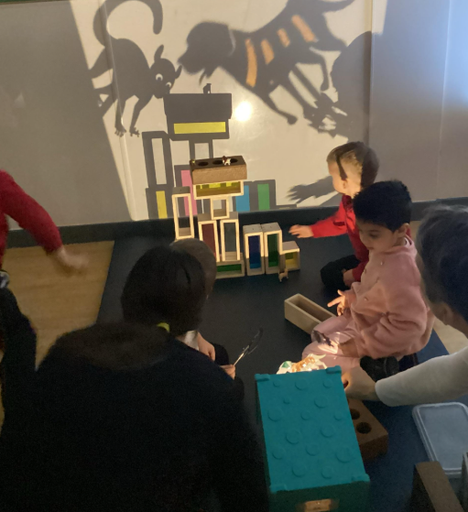
Small World Cinema
This week the foundation stage children have been lucky to take part in a small world cinema as part of Rotherham’s Children’s Capital of Culture project. They watched different short films and then loved trying lots of film making activities about light and shadows.
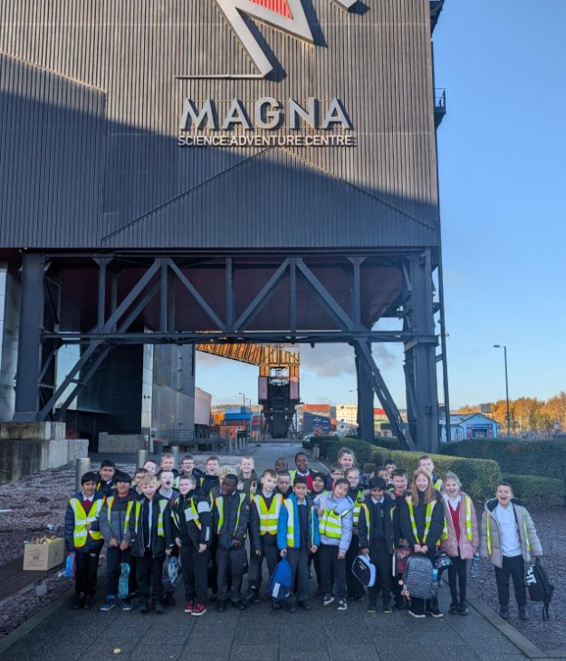
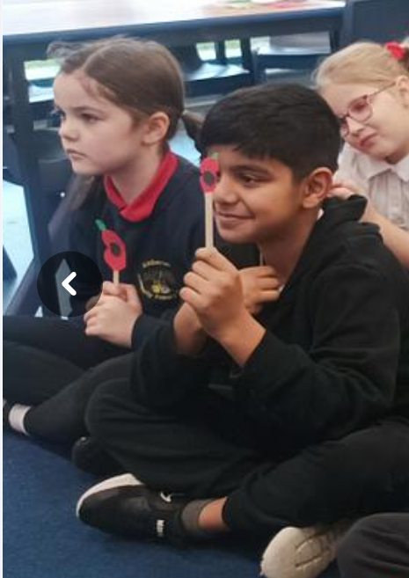
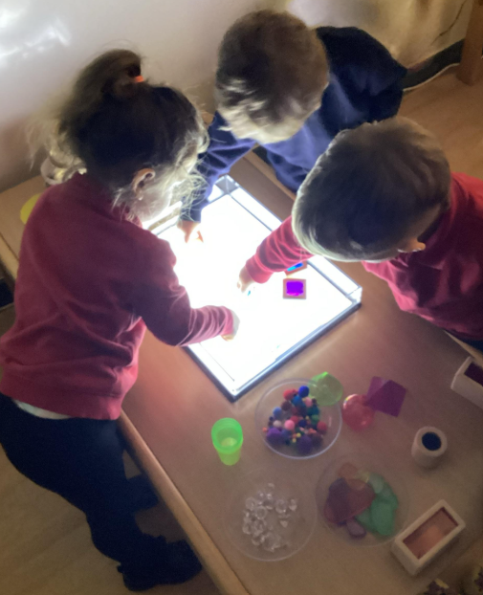
UPCOMING DATES
Tues. 18th Nov – Class 4 Visit to The Deep
Wed. 19th Nov 9am – Class 2 Family Learning Activity
Fri 21st Nov – Class 1 visit to Wentworth Farm
Wed 26th Nov – Artist in school to work with F2, Y1 + Y2
Fri 19th Dec – INSET day School closed for children

Attendance
Well done to our weekly attendance winners –
Class 5
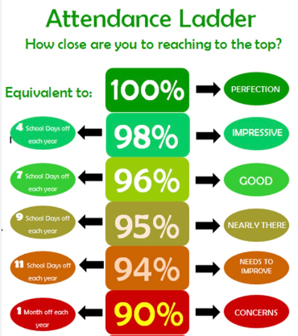
To report a child’s absence please contact the school office on 01709 740879

AT KIMBERWORTH WE LOVE TO READ!
We ask that children read at least 3 times each week. Please record this in reading diaries. Each week, the class with the highest percent of regular readers can choose a new book for their class.

