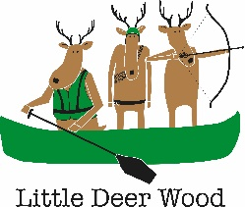
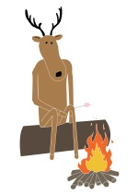
Little Deer Wood
Day Visit Kit List

Suggested kit list:
- Outdoor shoes e.g. old trainers (NO open-toed shoes or ballet shoes)
- Suitable clothing for woodland environment (Trousers, NO skirts)
- Waterproof coat and trousers (weather dependent)
- Sun hat, warm hat and gloves (weather dependent)
- Sunscreen (weather dependent)
- Medication clearly labelled with name and dosage
- Lunch and snacks
- Refillable water bottle
- Spare change of clothes, if canoeing.

