
Physical Education Policy
Rationale
At Barkisland C of E (VA) Primary School we recognise the importance PE plays in the curriculum and are committed to providing all children with opportunities to engage fully in Physical Education. The aim of our PE programme is to develop children's basic physical competencies, build confidence in their ability and build the foundations for a lifelong love of sport, physical activity and a healthy lifestyle. PE lessons encourage children to compete against themselves and others whilst being challenged to improve their physical, social, emotional and thinking skills. These skills are embedded in the heart of our planning. Our objectives in the teaching of PE align with the National Curriculum in that we aim to ensure all pupils:
- Develop competence to excel in a broad range of physical activities.
- Are physically active for sustained periods of time.
- Engage in competitive sports and activities.
- Lead healthy, active lives.
Responsibility for PE at Barkisland C of E (VA) Primary School

Mrs Nicoll (PE Coordinator) has responsibility for everything relating to PE, physical activity and the development, monitoring and review of the provision of PE and physical activity.

Mrs Nicoll will consult with the Head Teacher on PE matters and provision and the Head Teacher will oversee all things relating to PE at Barkisland Primary School.
Staff who teach or support in PE should be aware of the Policy and consider how they can support it and staff who provide PE and physical activity should ensure that safe and effective procedures are adopted in all physical activities at all times.

Curriculum Aims
• To develop skillful use of the body, the ability to remember, repeat and refine actions and to perform them with increasing control, co-ordination and fluency.
• To develop an increasing ability to select, link and apply skills, tactics and compositional ideas.
• To develop an understanding of the effects of exercise on the body, and an appreciation of the value of safe exercising.
• To develop the ability to work as a team player, taking the lead and learning to work collaboratively with others.
• To promote an understanding of safe practice, and develop a sense of responsibility towards their own and others’ safety and well-being.
Assessment
Our teachers assess the children’s work in PE, both by making informal judgements, as they observe them during lessons, and through assessing against the specific objectives set out in the National Curriculum and recorded using the Get Set 4 PE assessment software. We have clear expectations of what the pupils will know, understand and be able to do at the end of each Key Stage. Teachers are supported with resources to know how to prepare children for their next phase of education. These resources include the Get Set 4 PE progression of skills document, progression ladders and knowledge organisers.Swimming will be assessed by the swimming instructors at Sowerby Bridge Sports Centre.
Curriculum Coverage
Children will complete two hours of physical education per week; one indoor session and one outdoor session, weather permitting. However the outdoor topic will still be taught within the indoor environment. Below is the PE long term plan which shows each classes indoor and outdoor PE topics:
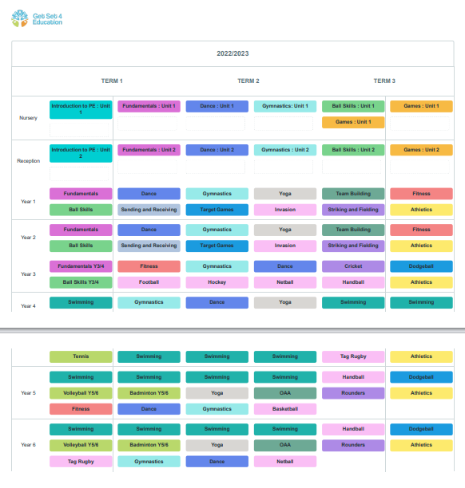

PE KIT
Indoor PE kit:
Light blue t-shirt
Navy blue or black shorts
Black pumps

Outdoor PE kit:
Light Blue t-shirt
Navy blue or black shorts
Navy blue or black tracksuit bottoms (winter)
Navy blue or black sweatshirt (winter)
Children come into school in their PE kit on their designated PE day which ensures all children participate in PE unless they are injured. For PE lessons, earrings must be removed. If children are unable to remove their own earrings, it is advisable on PE days that children don't come to school in their earrings until they are confident in taking them out themselves. Where earrings aren't able to be removed until the healing process is complete for example, they must be covered up with tape or plasters until the child is able to remove them. If you are considering having your child's ears pierced, please could you use the school holidays as an opportunity to do so. Long hair needs to be tied up.

Pupils who are unable to participate in a PE lesson are engaged purposefully with other roles such as observation, feedback, video recording, evaluation, coaching, umpiring and refereeing.
Extra – Curricular clubs
Extra – curricular clubs are organised and ran half termly. We aim to provide a wide range of clubs for all children utilising both out of school agencies and staff. All clubs are ran either before school, at lunchtime or after school for 45 to 60 minutes. Only clubs ran by outside agencies are chargeable and this is paid on a half termly basis.
A club letter is sent out to parents at the end of the previous half term giving details of clubs on offer. Clubs requiring payment are then paid for in full via school money which immediately gains the child a place within the club, a slip does not have to be returned. Any clubs not requiring payment are signed up to via the attached slip which has to be returned to school. Clubs are then offered on a first come first served basis.
Cross curricular
Active maths
All classes (KS1 and KS2) will participate in an active maths lesson every two weeks, ideas can be accessed through the ‘Maths of the Day scheme’ where children have practical lessons surrounding different areas of maths.
Daily mile
Each class have a designated slot for the daily mile. This is where the children run/jog/walk for 15 minutes each day on our all-weather running track.
Sports Day
We organise an annual Sports Day event at the end of the summer term. Our sports day is inclusive for all children and focuses on traditional races. Parents and carers are actively involved to attend and support their children. We have a wide range of sporting activities on the day to encourage participation and success for all children.

Involving parents and carers
We recognise the important part parents and carers play in encouraging children to participate in physical activity. Information about PE, physical activities and sporting competitions organised by the school and opportunities after school, are shared with parents/carers by means of specific PE letters from the PE Coordinator and through the school newsletter.
Monitoring and evaluation of physical activity
The PE Coordinator is responsible for the overall monitoring of the quality of PE and physical activity provision.
We monitor PE in the curriculum through subject reviews and self-evaluation in order to provide an accurate perspective on how it is being delivered and how it can be further improved.

Physical Education is monitored and evaluated through:
- Lesson observations
- Monitoring of lesson planning
- Monitoring of equipment
- Pupils Assessment data
- Feedback from staff
- Children questionnaires
- Pupil records of participation, focusing on different groups
- Feedback from pupils/school council about PE and general physical activity
- Pupil attendance and achievement in sporting competitions
- Attendance at after school sports clubs

Reviewed August 2024 A Nicoll

