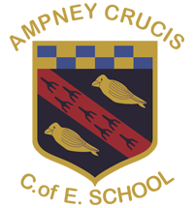
Ampney Crucis C of E Primary School
School Lane, Ampney Crucis
Cirencester, Glos. GL7 5SD
Tel. & Fax No: (01285) 851440
E-mail: admin@ampneycrucis.gloucs.sch.uk
Website: ampneycrucis.gloucs.sch.uk
Head teacher: Mrs Tana Wood

A Voluntary Aided School

“Together we live, learn and flourish.”
2.9.25

Dear Parents and Carers,

Welcome to Maple Class! We are so thrilled that you have chosen our school to begin your child’s learning journey and can’t wait to get started!

In Maple Class, we aim to provide an environment where each child is valued and treated as an individual. We embrace individual interests and abilities and tailor our curriculum to them to enable everyone to reach their potential. We want to create a fun learning environment where everyone respects each other and can work together within the boundaries that we think are important. Communication is really key to us, and we will encourage communication and language in everything that we do with the children to enable each child to grow. We also value communication with our parents, so please do talk to us about everything from achievements your child has made at home such as swimming a width unaided, to things they are finding tricky, whether that be academic, emotional or social challenges. All experiences impact on children and so it’s vital that we always know of any changes that may affect them in school.

School begins each day at 8.45am. We will meet the children on the playground in front of school, they can then say goodbye to you and line up before being led into class via the side gate. This also gives you the opportunity to ask us any questions before the day starts.

At the end of the school day, the children will meet you once again at the side gate. Please can we ask whoever is collecting your child, to come forward towards the gate, so that it is easy for us to see you and to ensure your child reaches you safely. As you can appreciate, there will be lots of parents and carers collecting children, which can be quite overwhelming for the youngest children to negotiate if you are near the back. Please do not stand on the road or behind the wall.

PE will be on a Wednesday and Friday, please can the children wear their PE kits and trainers to school on these days. We will also have Forest School on Thursday afternoons for which the children will need their own named wellies which will be kept in school. We provide a wet weather suit for each child, but they may need some extra layers to keep warm as the colder weather approaches. You may also want to send in a coat that you don’t mind getting muddy as coats don’t always fit under the wet weather suits!

Our priority this term is to settle the children into school life and to really get to know them. We will focus on the question ‘I wonder what makes us special?’ and through this we will be finding out about each child’s family, pets, interests whilst also looking at families across the world. To help the children talk about their families and pets, and for the other children to make links, it would be brilliant if the children could have a photo of their family as part of a class display.

*Please could everyone bring in a small photo of their family for a display – thank you!

Each day, your child will be in our class with our class teacher Mrs Hopkins (Monday, Tuesday and Wednesday) or Mrs Duffey (Thursday and Friday) and our wonderful TA, Mrs Cordell. Mrs Hopkins and Mrs Duffey will have time out of the classroom on a Wednesday afternoon, and during this time, the class will be led by Mrs Cordell and another Teacher Assistant from the school.

Our initial phonics teaching will focus on Level 1 which incorporates environmental sounds, body percussion and oral segmentation and blending of words. Once we move onto Level 2, the children will bring home our daily sound to learn and then to build their own simple words. The children will also start to bring books home to read, initially these will just have pictures to develop their skills of storytelling and understanding the structure of a story. These will then progress onto books with words to match the phonics taught along with a book of choice which will contain words that will be more challenging. As well as group reading each week with a teacher, we also aim for each child to read 1-1 with Mrs Cordell. The children’s reading book will be changed once a week when they read with Mrs Cordell. Our homework expectation is that the children practice their sounds each day as well as read their book. In addition children can select a library book from the library trolly each week to bring home and share with you. Please ensure these are returned each week so as a new book can be chosen. Unfortunately if any books are lost or not returned we will ask for them to be replaced to charge a fee so as we can replace them.

We would like to invite you into school for a Phonics & Reading meeting on Thursday 11th September at 2pm where we will discuss our phonics program in further detail and be able to answer any questions you may have.

A few housekeeping things and reminders:

- Please ensure all clothing is named
- The children need to bring fresh water (not juice or squash) to school each day in a named water bottle.
- Please ensure your child is always dressed appropriately for the weather as we use the outdoor classroom daily, this includes sunhats, raincoats, winter hats etc.

I hope this information covers many of the questions you may have but please do ask if not!

Many thanks,
Mrs Hopkins, Mrs Duffey & Mrs Cordell

Maple Class Autumn 1 2025

I wonder what makes us special?

Personal, Social, Emotional Development  *select and use activities and resources with help  *show confidence in new social situations  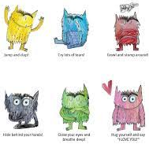  * talk about how we are feeling  * take turns and share   | Communication & Language  *be attentive and listen to a story together  *take part in small group discussions  *learn new vocabulary  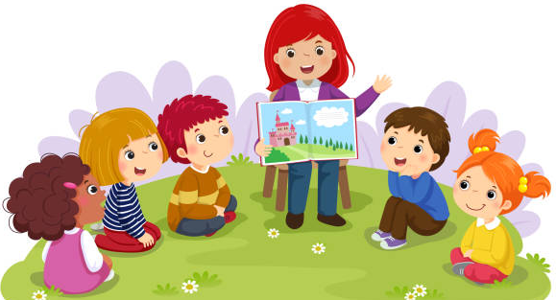  *story telling |  | Physical Development  *PE – working on Gross Moter Skills  *negotiate space & obstacles safely  *hold a pencil effectively in preparation for fluent writing  *practice forming letters in own name  *develop cutting skills – grip and control    *Squiggle while you wriggle
Reading & Writing  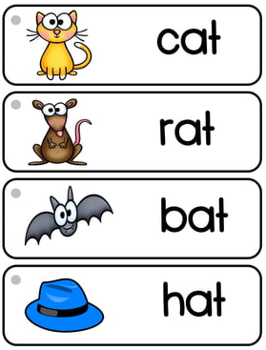  * recognise print as meaning  *handle books correctly  *track text left to right  *rhyming  *ascribe meanings to marks made  *join in with repetitive stories  *show understanding of stories  *begin to learn phase 2 sounds  *orally segment & blend CVC words |  | Maths  *Oral Counting  *Counting to 5,6,7  *Develop spatial awareness – position & shape  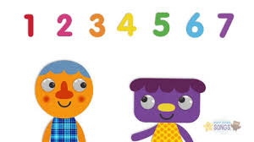
Understanding the World  *talk about our families, favourite places, pets and families around the world  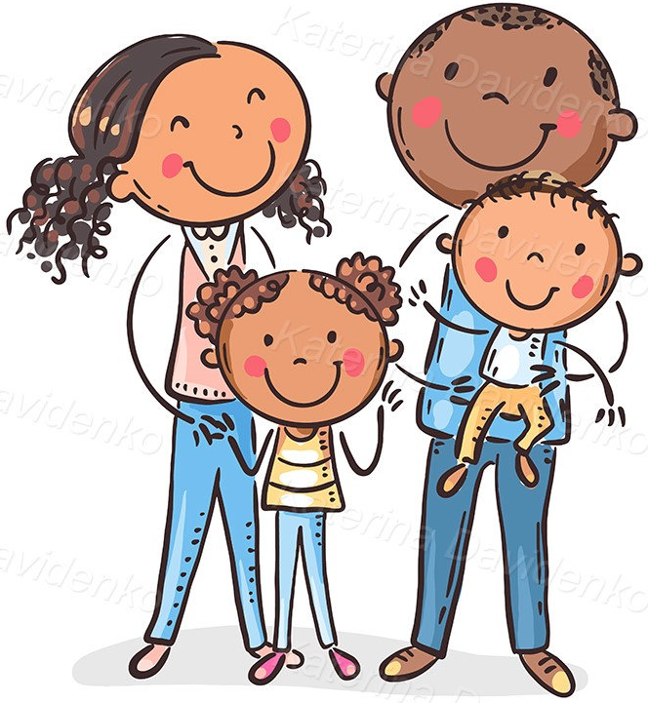  *place grandparents, parents and themselves on a simple timeline  *seasons – signs of autumn  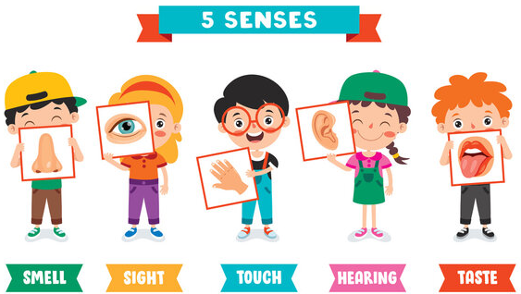  *identifying parts of the body & senses |  | Expressive Arts and Design  *sing nursery rhymes and songs  *take part in role play, creating story lines and dialogue  *Drawing: (pencil, charcoal, inks, chalk, pastels, ICT software)  *Begin to use a variety of drawing tools    *Use drawings to tell a story  *Investigate different lines  *Explore different textures  *Encourage accurate drawings of people  *Focus artist – Jackson Pollock

Homework:
- Daily practise of sounds and words
- Reading stories at home together, discussing what has happened and why and what might happen next
- Counting up to 7 objects and recognising the corresponding numerals
- Identifying numbers up to 7 shown in different ways such as on fingers, a dice, 5 sticks lined up, stones in a circle etc so that the children can quickly recognise the number of objects without counting

How you can help at home
We greatly encourage and appreciate your involvement in your child’s learning and you are always welcome to ask questions or seek advice on how you can support your child’s learning at home. Here are a few ideas.

Personal Social & Emotional Development
Give your child lots of opportunities to make decisions, give opinions and discuss their feelings e.g. what fruit shall we buy? How does that story make you feel? What did you like best?
Encourage their attempts at independence and don’t worry when they don’t always get things right e.g. dressing themselves, doing up fastenings, tidying up.
Show them how to resolve conflicts peacefully. For example, if they are upset because they don’t want to do something, offer them some simple choices with the same outcome e.g. would you like this or that story before you go to bed?
Value and praise their efforts, especially when trying something new.
Take them to parks and places where they can spend time with other children.
Play simple turn taking games.
Talk to them about healthy food choices and why they are important.

Communication and language
Make time for conversations with your child daily.
Share and talk about stories and information in books.
Play with them, commenting on what you are doing.
Echo back what they say with new words added.
Be aware of too much background noise e.g. tv, radio etc.
Sing nursery rhymes.
Physical Development
Provide opportunities, such as visits to the park, to encourage your child to be physically active. Encourage and show them how to move in different ways, e.g. hopping, jumping, skipping.
Sing action songs and rhymes and encourage them to dance along to music.
Encourage mark making in lots of different ways e.g. using paints, pens, chalks on a pavement, sticks in mud etc.
Allow children time to develop their fine motor skills through activities such as rolling and squeezing playdough, pegging things onto washing line or string, threading or sewing.
Play puzzle and threading activities to help develop hand-eye coordination.
Show your child how to hold a pencil correctly between thumb and forefinger.
Help your child to form letters correctly.
Help them to practise learning to write their name, with a capital letter at the beginning and lower case letters after.

Literacy
Share stories and books daily with your child. Talk to them about what they have heard, drawing attention to the pictures and print.
Visit the library to encourage and develop your child’s interest and excitement in books and stories.
Talk to them about the world around them and enjoy rhymes, poems and songs together.
Support your child’s developing reading and writing skills by engaging with the resources and activities sent home from school. These will include story books to listen to and talk about, letters to practise sounding and, when ready, simple regular and irregular words to practise reading. When appropriate, simple books for your child to read will also be sent home for them to share.

Mathematics
Count everything with your child, from ducks on the pond to stairs up to bed.
Sing counting songs and rhymes to help teach your child about numbers and order, as well as rhythm and rhyme e.g., ‘Five Little Monkeys’, ‘Ten in the Bed’.
Play counting-based games such as dominoes, ludo, snakes and ladders or number snap.
Play ‘spot the number’–focus on the numerals 0 to 9, and challenge your child to find them everywhere–on front doors, clocks, car registrations, birthday cards and more.
Involve your child in everyday activities such as shopping and cooking to help them understand mathematical concepts such as weight, capacity, sharing and measuring.

Understanding the World
Draw your child’s attention to the world around them. Talk to them and encourage them to talk to you about things that they see, smell, hear and feel and the changes they notice throughout the year.
Encourage their natural curiosity and support their ability to ask and answer questions by exploring changing materials such as freezing water or helping with simple cooking activities.
Read and talk about information books based on their interests.
Look at photos of family members and themselves when they were younger. Talk about the past from your own and their own personal experiences. Talk about what different people do at home, at school and in the wider community. Ask questions such as, ‘what would you like to do when you grow up?’

Expressive Arts and Design
Encourage them to draw, make pictures and models of what they are interested in, see or experience.
Encourage them to build and create props for play using everyday junk materials e.g., turning an empty cardboard box into a castle for a toy.
Keep a ‘busy box’ with things like string, tape, wrapping paper scraps, lolly sticks, stickers and straws that your child can use to make whatever they want. Ask them to talk about their creations.
Use drama to act out things from daily life. It could be doctors, mothers, fathers, shopkeepers, firefighters – whatever your child likes. At story time, encourage your child to act out roles from a story with movements or sounds.
Put on some favourite music to get them moving. Encourage them to march, roll, stamp, hop, slide and twirl. Point out sounds with steady beats, like a ticking clock or a dripping tap. Encourage your child to clap, tap, march or bang to the beat.
Help them develop a sense of rhythm with songs, and rhymes like ‘Incy wincy spider’, ‘Heads and shoulders’ or ‘Five little monkeys’.

