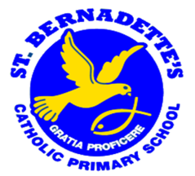

A Guide to Phonics at St. Bernadette’s
ST BERNADETTE’S CATHOLIC PRIMARY SCHOOL
A S P I R E



At St. Bernadette’s, we use the DFE validated Phonics scheme, ‘Supersonic Phonic Friends’. The scheme starts in FS1 and continues into Key stage 1, focussing on the higher levels of Phonics and spelling rules.

What is Synthetic Phonics?
Synthetic phonics is a method of teaching reading which first teaches the letter sounds and then builds up to blending these sounds together to achieve full pronunciation of whole words.
Through phonics, children are taught how to:
- recognize the sounds that each individual letter represents
- identify the sounds made by different letter combinations, such as ‘sh’ or ‘oo’; and
- blend these sounds together from left to right to form a word.
Children can then apply this knowledge to ‘decode’ new words they hear or see. This is the crucial first step in learning to read.

What children are taught:
- learning letter sounds (as distinct from the letter names) – For example, mmm not em, sss not es, fff not ef. The letter names can be taught later but should not be taught in the early stages
- learning the 40+ sounds and their corresponding letters/letter groups
- The English Alphabet Code ‘Key’: 40+ phonemes with their common ‘sound pattern’ representations.
Watch the video to find out more.

Why is phonics important?
Once children can decode words using phonics, they are able to learn wider reading skills and develop a passion for reading. Studies indicate that phonics instruction is most effective when it follows a structured approach, beginning with simple sounds and gradually progressing to more complex ones. Phonics is a powerful tool for teaching word recognition, and nearly all children who receive high-quality phonics instruction acquire the skills necessary to decode unfamiliar words. This enables them to read any type of text fluently and with confidence, fostering a love for reading. Moreover, children who are taught phonics tend to read more accurately than those who learn through other methods. This is particularly true for children who face challenges in learning to read, including those with dyslexia.

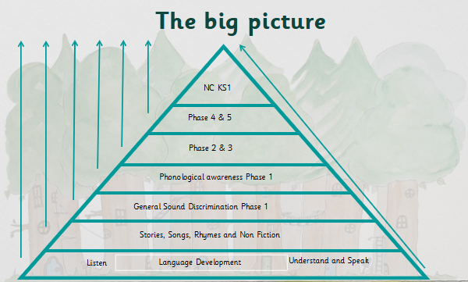

Common Terminology
Some common terminology used includes:
Tricky words
Tricky words are used across all of the phonics phases. Tricky words are words that cannot be sounded out easily or with the knowledge the children have learnt in phonics. Nonsense Nan words are used across all of the phonics phases after The Basics 2 and are included in the year 1 phonics screening test.
Some examples of tricky words:
I | to | to | go | into
he | she | me | be | we

Nonsense Nan Words
Nonsense words are words that are made up of sounds the children have already learnt. These words are not real and the children have to use their phonics knowledge to decode the words.
Examples of Nonsense Nan words:
tish | shig
sheb | shab

Segmenting
All the sounds we can hear in a word
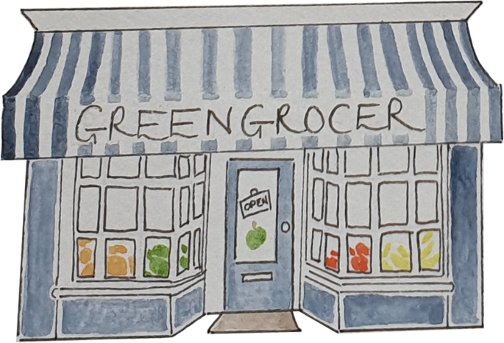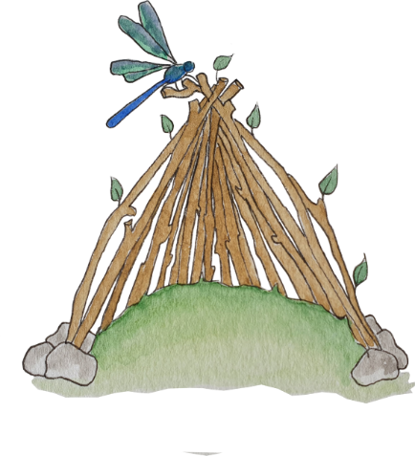
sh-o-p d-e-n

Blending
Joining one or more sounds together to create a word

Phoneme
The sounds we can hear in a word
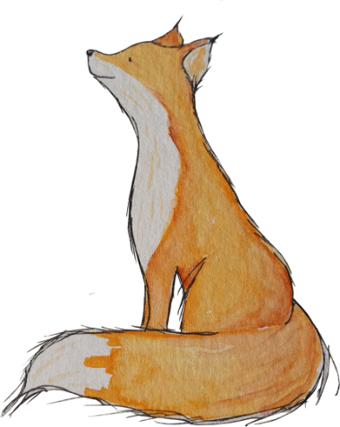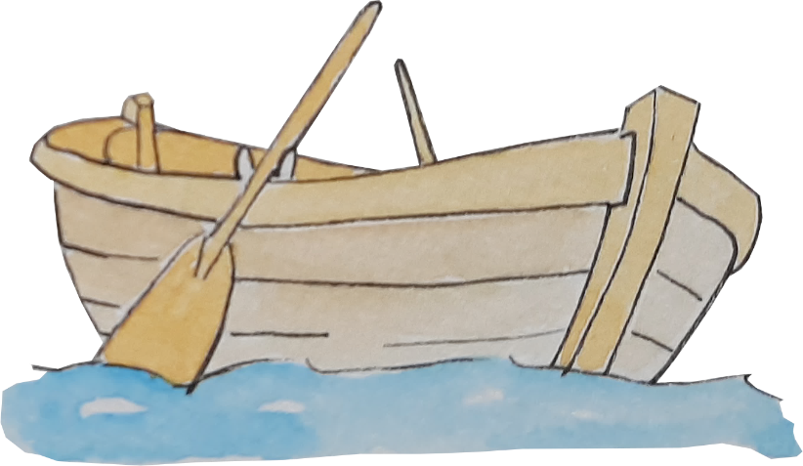
f-o-x b-oa-t

Grapheme
The spelling/ letters we can see
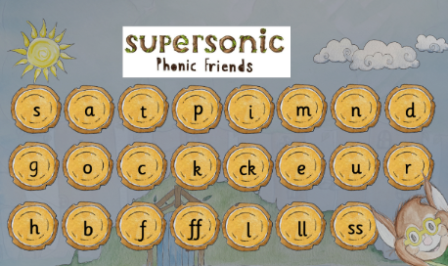

Rhythming
The sounds at the end of a word are the same. For example:
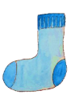
sock clock knock
“It is in green so it can be seen”

Alliteration
The sounds at the beginning of a word are the same. For example:
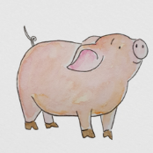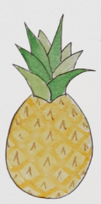
pig pineapple panda

Phonics Across the Stages
Phonics in Acorns
In Acorns, phonics is incorporated into attention autism time using a sensory approach. This takes place 3 times a week and is followed up by daily one to one work. The children are taught one sound a week with a range of activities around this sound. Phonics starts when the children are ready for this learning.
Phonics in Nursery
In Nursery, we offer a mix of child-led and adult-led activities designed to meet the curriculum expectations for 'Communication and Language' and 'Literacy.' The activities allow the children to practise and develop their skills to support early reading and listening. In the ‘Firm Foundations’ there are 7 key aspects which are taught through a multisensory approach. The 7 aspects are revisited throughout the year,
These aspects are:
- Aspect 1: General sound discrimination – environmental sounds
- Aspect 2: General sound discrimination – instrumental sounds
- Aspect 3: General sound discrimination – body percussion
- Aspect 4: Rhythm and rhyme
- Aspect 5- Alliteration
- Aspect 6: Voice sounds
- Aspect 7: Oral blending and segmenting
In addition to this, an environment which supports communication and language and reading is fostered. This helps to support and nurture phonological awareness and the children’s interests in sounds before formal phonics lessons are introduced. For example:
- Sharing high-quality stories
- Learning a variety of nursery rhymes and action rhymes
- Spotting and suggesting rhymes
- Counting and clapping syllables
- Engaging in activities that support focused listening and attention
- Fostering an environment of rich, high-quality language
- Recognising words with the same initial sound such as ‘money’ and ‘mother’
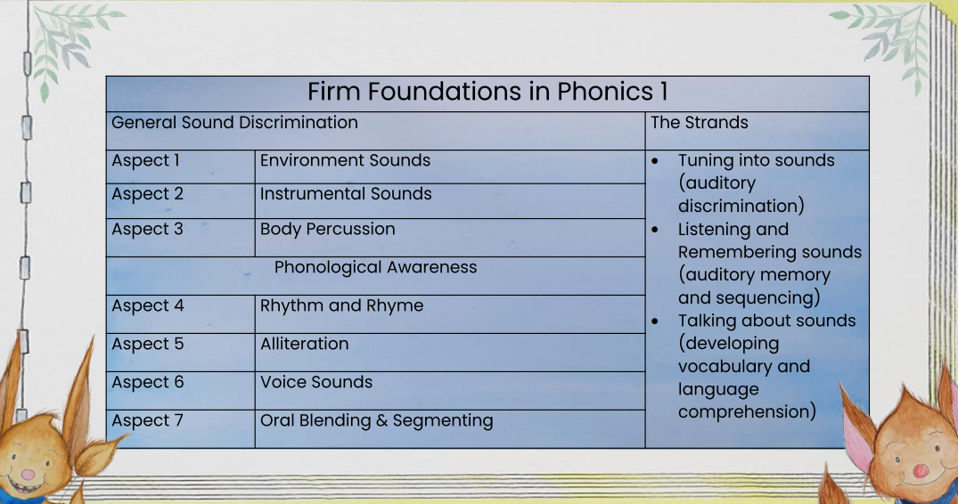
Phonics in Reception

The Basics 2
Listen, Recognise, Build, Read and Write
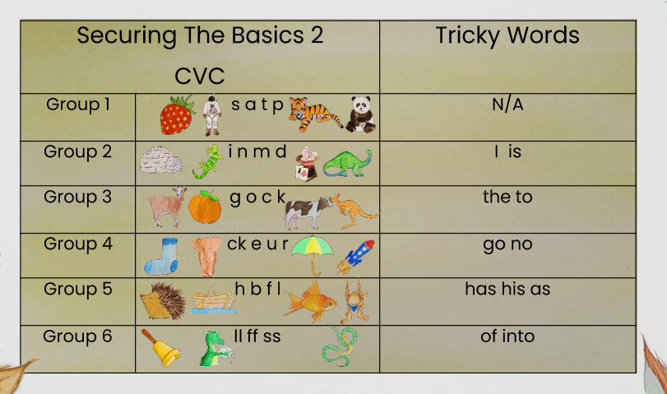
The Basics 3
Recognise, Build and Write
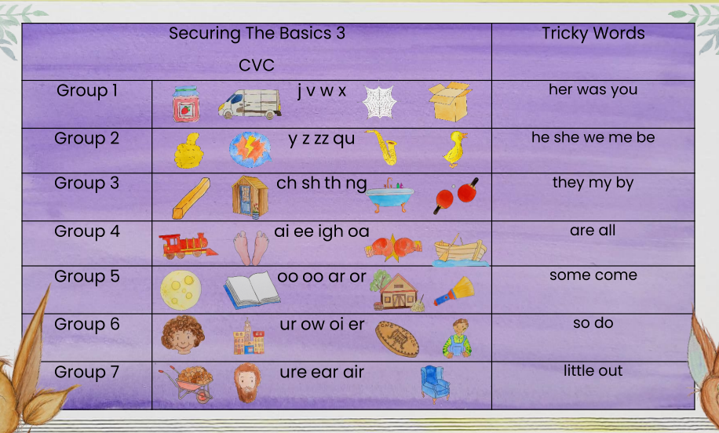

Phonics in Year 1

The Basics 4
Recognise, Build, Read and Write
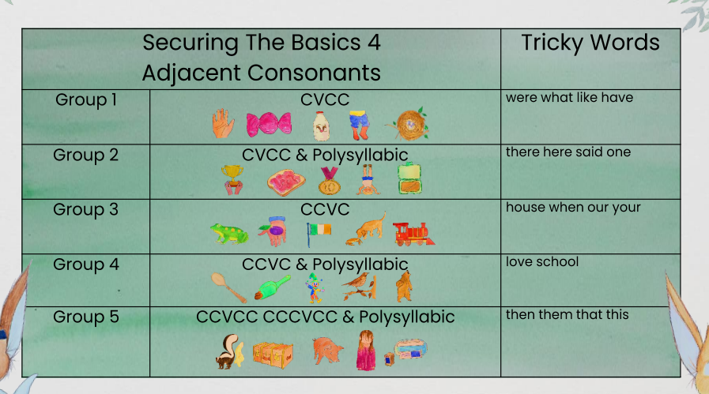
The Higher Levels of Phonics 5 c & b- Adjacent Consonants & The Higher Levels
Recognise, Build, Read and Write
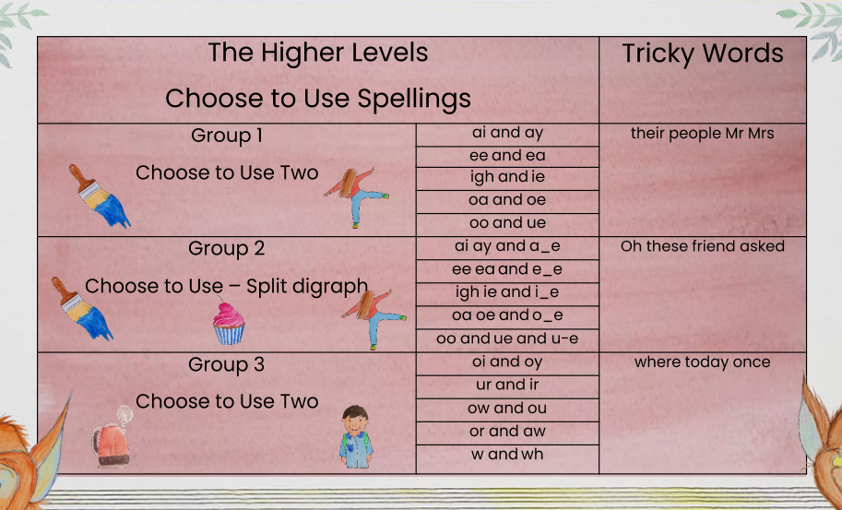
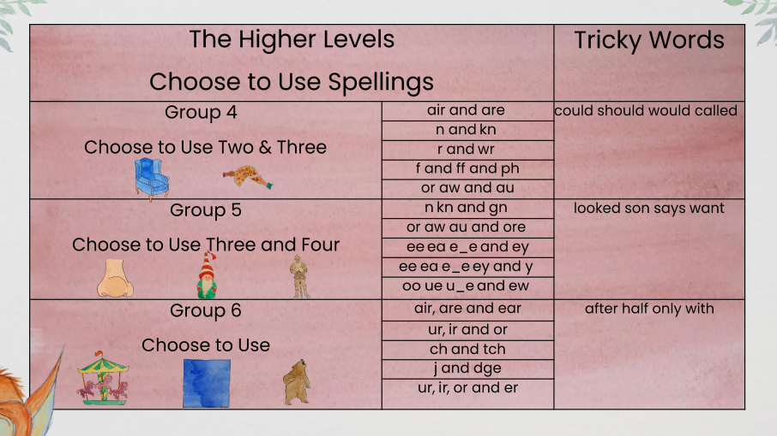
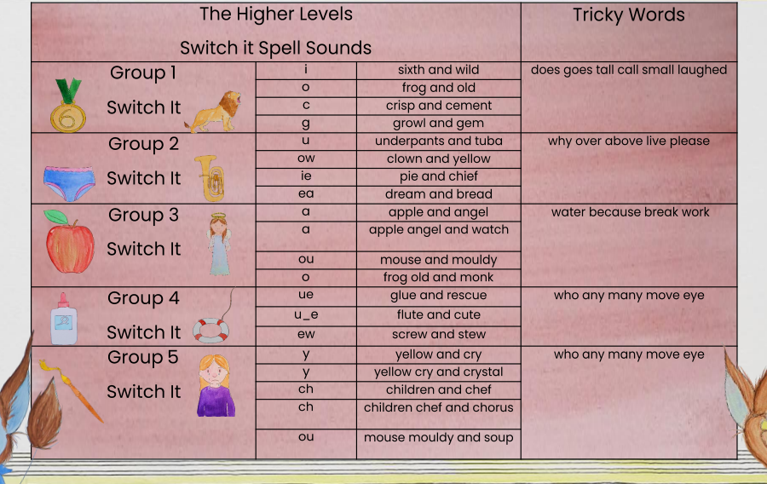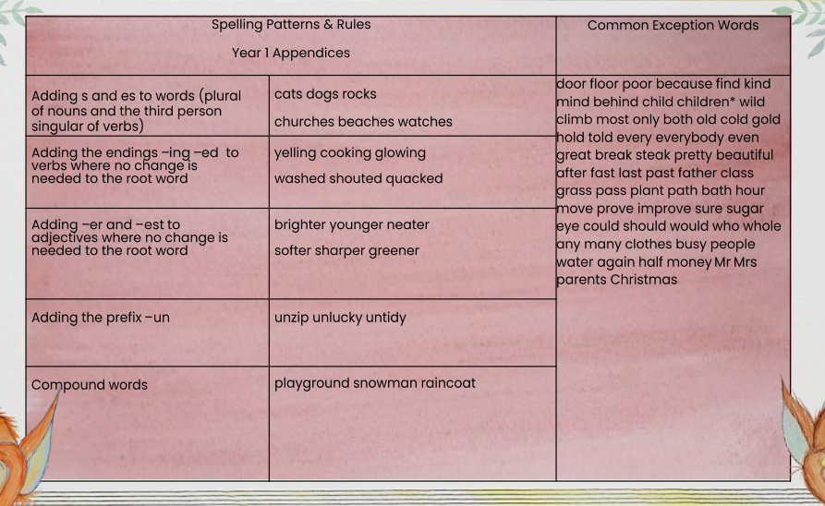

Phonics in Year 2
Spelling Rules & Appendices
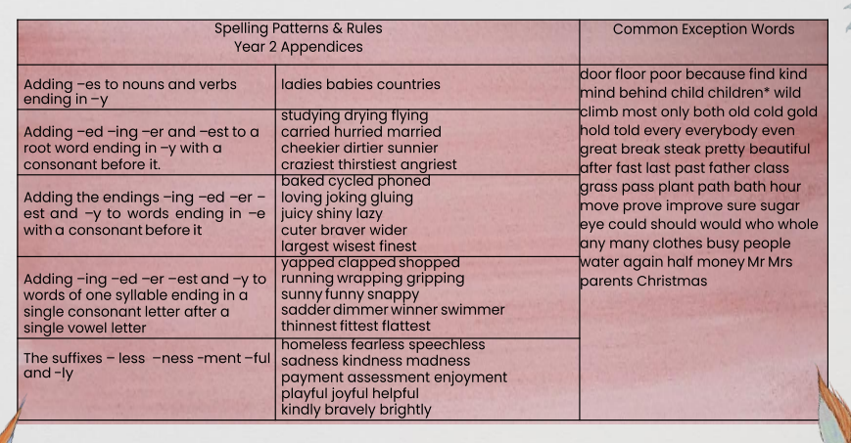
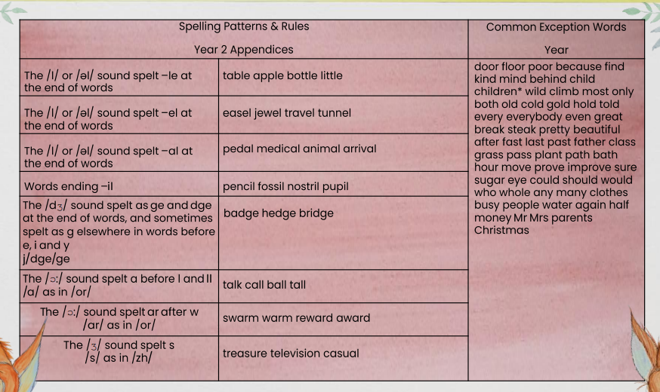
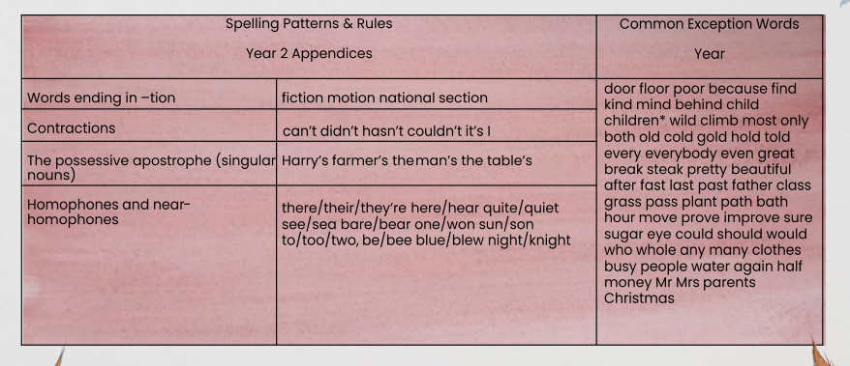

The SSPF characters:
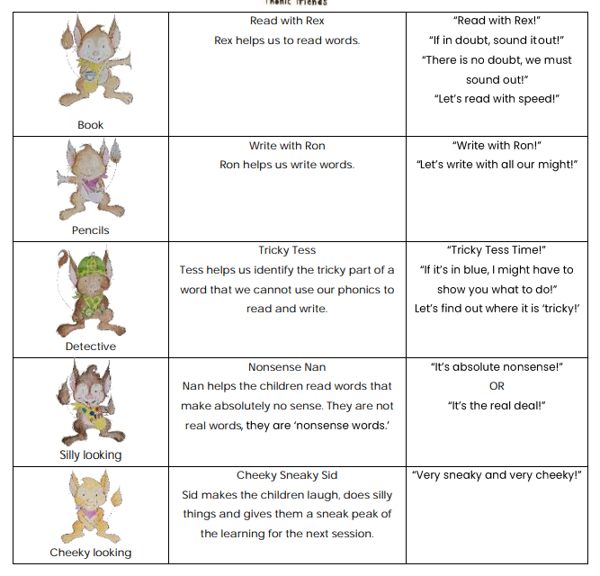
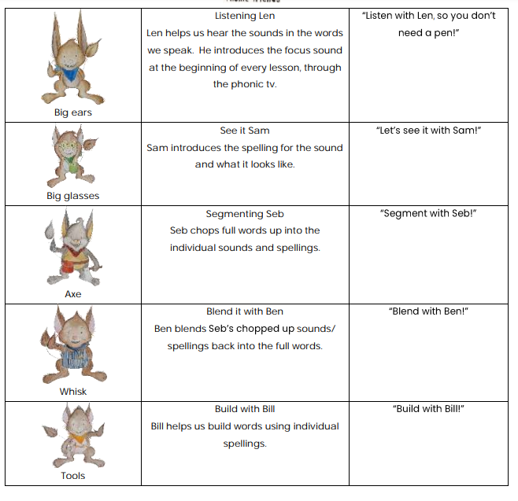

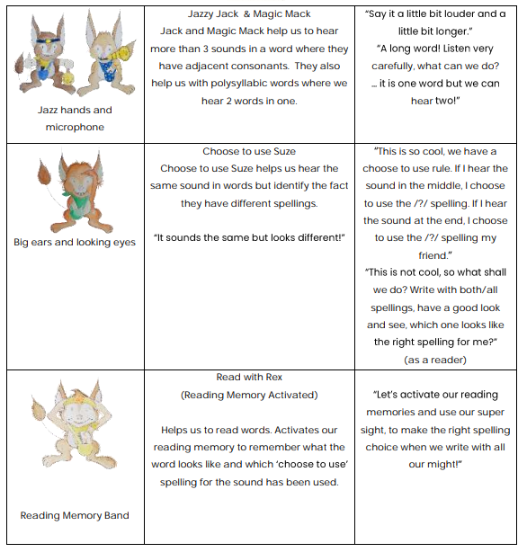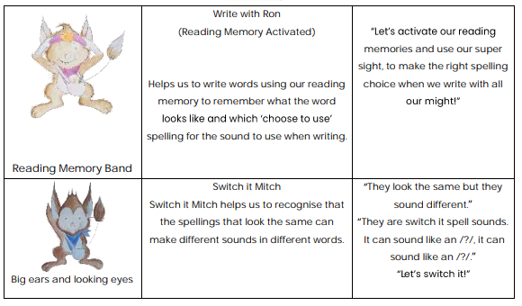

Reading Books

Children receive reading books matched to their current level in phonics. All phonetically decodable books are ordered in sets linked to our Phonics scheme.
Nursery
In nursery, it is vital to read and explore stories. This helps to improve their phonic knowledge. Story time is a great time for parents to talk to their child about skills the children have been learning in school. For example, an adult may point out the alliteration in a story title or sentence.

After Christmas, the children will receive a phonics book. This will be wordless. This is the perfect time to talk to your child about the illustrations and potential storyline of the book. There is a guide at the front of the reading records to support you with reading at home.

Reception and Up
The children will have a decodable reading book sent home with them every week. This starts from Reception. All of the books will be matched to the children’s phonic ability and help the children to practise the phonemes and graphemes they have previously learnt in school.

Phonics Screening - Year 1
By the end of Year 1, most children should be able to decode simple words, making it the ideal time to assess whether they have acquired this skill. The phonics screening check is a quick and straightforward way to evaluate your child’s phonics knowledge. It helps schools determine whether students are making the expected progress. The check is administered by teachers during a designated week in June each year, and parents receive their child's results by the end of the summer term. Designed to be a low-pressure assessment, it is tailored to be suitable for young children. During the check, children read a list of 40 words to a familiar teacher in a comfortable setting, with teachers recording whether each word is read correctly.

