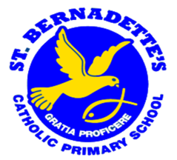

OUR ART and DESIGN CURRICULUM
ST BERNADETTE’S CATHOLIC PRIMARY SCHOOL
A S P I R E

Aspiration Self-Belief Perseverance Independence Respect Enjoyment

“Every child is an artist.” Pablo Picasso
Our Aspirations
We aim to provide a high-quality Art and Design curriculum that will inspire and stimulate in pupils creativity and imagination. Our curriculum provides visual, tactile and sensory experiences, and a special way of understanding and responding to the world. It enables our children to communicate what they see, feel and think, through the use of colour, texture, form, pattern and different materials and processes. Children have the opportunity to become involved in shaping their environments through art and design activities. They learn to make informed judgements, and aesthetic and practical decisions. They explore ideas and meanings through the work of artists and designers. Through learning about the roles and functions of art, they can explore the impact it has had on contemporary life and on different periods and cultures. The appreciation and enjoyment of the visual arts enrich all our lives.

National Curriculum
EYFS
Children in EYFS are introduced to artists over a two year cycle. They are also able to freely express themselves using a range of provision that they use independently both indoors and outdoors. Children in the Early Years are working towards achieving the Early Learning Goal at the end of the Foundation Stage.
We teach art in the Foundation Stage as an integral part of our topic work covered during the year. We relate the art side of the children’s work to the objectives set out in the ‘Expressive Arts and Design’ section of the Development Matters in the Early Years document. Our progression document maps out the experiences children have over a two year cycle.
The Foundation Stage Curriculum at St. Bernadette’s is driven through a key narrative each half-term. This is called the Narrative Immersion Curriculum.
Topics are taught in a two-year cycle and a range of artists and styles are covered in topics throughout the year. For example, Joanne Wishart’s seaside paintings during our work on The Singing Mermaid by Julia Donaldson.
In addition to the above, teachers follow children’s interests and suggestions when working with the children in the continuous provision.

Key stage 1
Pupils should be taught:
To use a range of materials creatively to design and make products to use drawing, painting and sculpture to develop and share their ideas, experiences and imagination.
To develop a wide range of art and design techniques in using colour, pattern, texture, line, shape, form and space about the work of a range of artists, craft makers and designers, describing the differences and similarities between different practices and disciplines, and making links to their own work.
At St Bernadette’s we do this through children experiencing 3 artists or artistic styles over each year group. Initially, they work in their sketchbooks to become familiar with the vocabulary associated with the skills they are practising.
Key stage 2
Pupils should be taught:
We build on learning in KS1 by developing their techniques, including their control and their use of materials, with creativity, experimentation and an increasing awareness of different kinds of art, craft and design. They create sketch books to record their observations and use them to review and revisit ideas.
They improve their mastery of art and design techniques, including drawing, painting and sculpture with a range of materials [for example, pencil, charcoal, paint, clay] about great artists, architects and designers in history. Children build on prior knowledge from KS1 to further develop their skills and vocabulary.

Our Curriculum
We want the children to develop as critical and creative thinkers and enrich, extend and consolidate learning in a variety of contexts. Through systematic and progressive planning, we intend to encourage the children to express, explore and celebrate ideas, feelings, attitudes and values. We aim to foster originality and creativity using Art as a means of communication. Innovation and sensitivity to personal feelings and attitudes will permeate the school environment.
Throughout the curriculum children will be given opportunities:
- To develop knowledge, understanding and skills.
- To learn about materials and techniques used by artists
- To learn about the world of art, craft and design
- To recognise achievement of artists, designers and craftspeople, from many different times and cultures.
We aim to raise the standards of the pupils’ abilities in specific art and craft skills such as:
- Cutting
- Joining
- Drawing
- Evaluating
- Use of sketchbooks within KS2 and KS1
We aim to increase the opportunities for the children to experience:
- Art from different cultures
- Visits to art galleries, exhibitions and installations
- Using different materials and techniques
- Art within our community

Our Curriculum
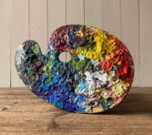
Our curriculum is organised to ensure each year-group studies three artists and engages each year in three projects based on drawing, painting, sculpture, and incorporating other media. Take a look at our Long Term Overview, which shows when we teach the focus artist, links to other curriculum areas being studied at the same time and the end point to be achieved.
Long term planning:
Art Curriculum Overview
 | Drawing | Painting | Sculpture
EYFS  Cycle A | Artist: Laura McKendry  Curriculum Link: Literacy-Drawing and illustration for Naughty Bus/Pumpkin Soup  End Point-To create an illustration showing movement  Term: Autumn | Artist: Joanne Wishart  Curriculum Link: K&U-Geography  End point: To create a painting of a seaside town  Term:Summer | Ugo Rondinone  Curriculum Link: Physical-Fine Motor  End Point: To create a stack of painted ‘rocks’ inspired by Ugo’s work  Term: Spring
EYFS  Cycle B | Artist: Roy Litchenstein  Curriculum Link: Literacy (Phonics) and Understanding the World  End point: To create a simple drawing inspired by the ‘POP’ cover of Newsweek.  Term: Autumn | Artist: Alma Thomas  Curriculum Link: Maths-Numerical patterns  End point: To create a painting using dots  inspired by Alma Thomas  Term:Summer | Kurtz William  Curriculum link: K&U Animals  End point: To create a large collaborative animal out of papier mache  Spring
Year 1 | Artist: L.S Lowry  Curriculum Link: History and Geography.  End point: To create a collage of a local mill in the style of Lowry.  Term: Autumn | Artist: Kandinsky  Curriculum Link: Maths  End point: To explore colour and create a painting inspired by ‘Squares with Concentric Circles’  Term: Spring | Artist: Angela Haseltine Pozzi: Washed Ashore.  Curriculum Link: Literacy and Geography  End point: To create a sculpture using recycled plastics.  Term: Summer
Year 2 | Artist: Lyn Li  Curriculum Link: English, History and Geography.  End point: To create an oil pastel drawing inspired by the artist Lyn Li.  Term: Autumn | Artist: Vincent Van Gogh  Curriculum Link: Geography  End point: To create a watercolour picture inspired by ‘The Sea at Les Saintes-Maries-de-la-Mer’.  Term: Summer | Artist: James DeRosso  Curriculum Link: English  End point: To create a ceramic monster inspired by James DeRosso.  Term: Spring
Year 3 | Artist: Paul Cezanne  Curriculum Link: Science  End point: To create a still life drawing inspired by ‘Apples and Oranges’.  Term: Autumn | Artist: Hokusai Traditional Japanese Painting  Curriculum Link: Geography and History  End point: To create a painting using a japanese technique/style.  Term: Spring | Artist: Susan Williams  Curriculum Link: English and Science  End point: To create a sculpture or installation that is site-responsive.  Term: Summer
Year 4 | Artist: Andy Goldsworthy  Curriculum Link: Geography and Maths.  End point: To create a piece of land art and a sketch inspired by Andy Goldsworthy.  Term: Summer | Artist: Antoni Gaudi  Curriculum Link: English, History and Geography  End point: To create a painting inspired by Antoni Gaudi and Roman mosaics.  Term: Spring | Artist: Grayson Perry  Curriculum Link: English, History and Geography.  End point: To sculpt a greek vase inspired by Grayson Perry.  Term: Autumn
Year 5 | Artist: Anglo Saxon and Viking warrior sketches.  Curriculum Link: History  End point: To create an accurate sketch using a variety of sketching techniques.  Term: Autumn | Artist: Andy Warhol  Curriculum Link: History, Geography and English.  End point: Create a pop art inspired print.  Term: Spring | Artist: Alfie Bradley  Curriculum Link: Science, Geography and English.  End point: Create a sculpture inspired by the Knife Angel by Alfie Bradley  Term: Summer
Year 6 | Artist: Graffiti Art - Banksy, Keith Haring, Shepard Fairy.  Curriculum Link: Geography and PSHE.  End point: To create a piece of graffiti art.  Term: Autumn | Artist: Kara Walker  Curriculum Link: English, History and Geography.  End point: To create a sculpture/installation inspired by the works of Kara Walker.  Term: Spring | Artist: Georgia O’Keeffe  Curriculum Link: Geography  End point: To create a painting of a natural form inspired by Georgia O’Keeffe  Term: Summer

The long term plan is translated into a detailed medium term planning.

Sample of Medium term planning:
Year Group: 5 Term: Autumn Topic: Drawing - Anglo Saxon and Viking warrior sketches

Learning objectives | Generating ideas  - To engage in open ended research and exploration in the process of initiating and developing their own personal ideas.  - To confidently use sketchbooks for a variety of purposes including: recording observations; developing ideas; testing materials; planning and recording information.  Making  - To confidently investigate and exploit the potential of new and unfamiliar materials and media.  - To use their acquired technical expertise to produce work that effectively reflects their ideas and intentions.  Evaluating  - To regularly analyse and reflect on their progress taking account of what they hoped to achieve.  Knowledge and understanding  - To research and discuss the ideas and approaches of Viking art, identify its key characteristics, features and take account of the particular cultural context and intentions.  - To know how to describe the processes they are using and how they hope to achieve high quality outcomes.
Key Knowledge |  | Key Vocabulary
- The Anglo-Saxons were great craft workers.  - They made intricate jewellery and illuminated manuscripts.  - Anglos Saxon arts survive mostly in illuminated manuscripts, architecture, ivory carvings, jewellery and metal work.  - Viking art is called Norse art.  - Vikings decorated and added carvings to just about everything.  - Things that could not be carved were colourfully decorated with embroidery and patches.  - Their art was ornate, with complicated patterns.  - Drawings of Anglo Saxon and Viking warriors are not from the time. They have been created by artists using their knowledge of history. |  | - Colours; Patterns; Images; Styles; Knots; Interweaving; Proportion; Shading; Hatching; Cross-hatching; Stippling; Value; Line; Form; Contrast; Tonal Range; Gestural line; High Key; Low Key; Texture; Pattern; Composition; Perspective; Full range.

 | Lesson 1 – Discovering Viking Art
Learning objective | To engage in open ended research and exploration in the process of initiating and developing their own personal ideas.  To research and discuss the ideas and approaches of Viking art, identify its key characteristics, features and take account of the particular cultural context and intentions.
Possible activities  Slides  Picture Cards 1A/1B/1C  Worksheet 1A or sketchbooks  Challenge Card (FSD? activity only)  Access to the internet (FSD? activity only) | - What do you already know about the Vikings? Children to think, pair, share their ideas, then go through the brief information on the slides about who the Vikings were and where they came from.  - Explain that over the next few lessons we will be exploring Viking art.  - What kind of artwork do you think the Vikings created?  - What materials do you think they worked with? Discuss ideas as a class.  - Show children the examples of Viking art on the slides. What can we learn about Viking art from each image? Discuss each one, encouraging children to describe what images, patterns, colours and styles have been used. Go through the information on the slides about the six main styles of Viking art. Which of these styles do you like the best? Why? Invite children to share their responses.  - Provide children with Picture Cards 1A/1B/1C (differentiated). Children to look through the cards and discuss what they can see. They are then challenged to sketch sections from some of the different works of art either in their sketchbooks.  - Provide children with a copy of the Challenge Card in pairs. Children are asked to find examples of each of the kinds of Viking art listed online. They are then to copy and paste each of the examples they find onto a Power point document or similar, describing each work of art in as much detail as they can.  - Once children have finished their documents, give them some time to share what they found with the rest of the class.
 | Lesson 2 – Sketching Viking Knots
Learning objective | To confidently use sketchbooks for a variety of purposes including: recording observations; developing ideas; testing materials; planning and recording information.  To regularly analyse and reflect on their progress taking account of what they hoped to achieve.
Possible activities  Slides  Instruction Card 2A/2B/2C  Worksheet 2A or sketchbooks  Challenge Card (FSD? activity only) | - Show children the three Viking works of art on the slides. What do these three works have in common? What is different about them? Children to share their responses. Explain that one of the main features of Viking art is knots.  - Go through the information on the slides explaining how this was also a feature of Celtic art and how the two styles are very closely linked. Go through the step-by-step process, children to do each step in their sketchbooks as you go through the tutorials.  - Provide children with Instruction Cards 2A/2B/2C. Give them some time to practise the four basic Viking knots, as well as how to extend these into borders. This can be done in sketchbooks.  - Once children have had some time to practise their knots, provide children with the Challenge Card which shows how to draw freehand patterns that weave in and out of themselves.  - Children are shown how to use pencil to map out their designs, create ‘bridges’ that go over other strands of the patterns, and how to finalise their patterns in pen. Give children some time to practise this in their sketchbooks before creating a final piece.  - Invite children to share their finished patterns and evaluate their designs.  - What did you find most challenging about creating these patterns?  - What did you have to do to improve your work?  - How could you take what you have learnt and apply it in a different way?
 | Lesson 3 – Creating Viking Animal Artwork
Learning objective | To confidently use sketchbooks for a variety of purposes including: recording observations; developing ideas; testing materials; planning and recording information.  To confidently investigate and exploit the potential of new and unfamiliar materials and media.
Possible activities  Slides  Snake Head Instruction Sheet  Horse Head Instruction Sheet  Dragon Head Instruction Sheet  Example Sheet  Template Sheets (FSD? activity only)  Picture Cards (FSD? activity only) | - What kinds of animals were popular in Viking art? Invite children to share their responses. Show children examples on the slide.  - What animal is being shown?  - What style is being used?  - How has the artist created effects?  - What patterns and colours can you see?  - Tell children that today they will be learning how to draw some basic animal heads in the style of Viking art using pencil. This will be done in sketchbooks.  - Go through the step-by-step process on the slides for drawing a snake head with the children doing each step, then show how they can incorporate the knots they learnt how to draw in the last lesson to draw a Viking animal knot. Challenge children to try this for themselves.  - Provide children with the Snake/Horse/Dragon Head Instruction Sheet. Children to use the steps to draw a dragon head, then draw a freehand animal, drawing on the learning they did in the previous lesson. Children can use the Example Sheet for ideas.  - Provide children with one of the Template Sheets (which has an incomplete Viking knot) to use as the basis for their artwork. Using the Picture Cards as a reference, they then add a head, tail and any other features to complete their Viking animal. After this should be stuck in their sketchbooks.  - Show children the Viking animal on the slides. Can you draw this? You have five minutes!  - After five minutes, invite children to share what they have drawn and discuss their ideas and responses to the challenge.  - Where did you start? Why?  - What did you do to make sure you worked quickly?  - How could you improve on what you have done?
 | Lesson 4 – Developing pencil sketching skills
Learning objective | To confidently use sketchbooks for a variety of purposes including: recording observations; developing ideas; testing materials; planning and recording information.  To confidently investigate and exploit the potential of new and unfamiliar materials and media.
Possible activities  Slides  Practice Sheet  Picture Card 4A/4B/4C/4D/4E/4F  Worksheet 4A/4B (FSD? activity only) | - What images come into your head when you think of the word ‘Viking’? Children to think, pair, share your ideas.  - Go through the suggestions on the slides for images commonly associated with Vikings, then explain that today we will be focusing on accurately sketching a Viking dragon head.  - Where might you have found a dragon head if you were living in the times of the Vikings?  - Go through the images on the slides showing the prows of Viking longboats. Show children a picture of a dragon head.  - If you were to sketch this, what would be the first thing you would need to do?  - How could you make sure to draw it as accurately as possible?  - Next go through slides about proportion and revisit shading techniques from Y4. (See image bank >>>>>)  - Children practise each technique in sketchbooks as you go through them.  - Experiment creating different strokes and lines.  - Using the edge, tip or side of the media.  - Practice blending and shading - use different amounts of pressure or use fingers to smudge and blend.  - Provide children with worksheet 4A which has a photo of a dragon’s head and several blank outlines so that the children can practise different shading techniques.  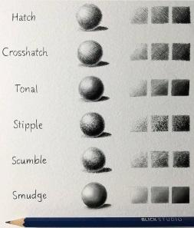  - Once they have had time to practise, provide children with the picture cards. Children will now sketch and shade a dragon head on a blank sheet of A4 paper.  - They can then cut it out, mount it on coloured paper or create their own background for it.  - Extension challenge: Show children the dragon head on the slides. Can you sketch this dragon head (including any shading or details) without your pencil leaving the page?  - Give children some time to do this, starting again each time they lift their pencil off the page! After a time, ask children to share their work with the rest of the class and discuss:  - How has not being able to lift your pencil off the page changed the way you sketch?  - What effect does it give the sketch?  - Do you like the outcome? Why or why not?
 | Lesson 5 – Developing pen sketching skills
Learning objective | To confidently investigate and exploit the potential of new and unfamiliar materials and media.  To know how to describe the processes they are using and how they hope to achieve high quality outcomes.
Possible activities  Slides  Grid Template 5A/5B  Picture Sheet 5A/5B/5C  Instruction Sheet 5A/5B (FSD? activity only) | - Revisit techniques for sketching and shading from previous lesson - What tips did you learn?  - Today children will use black pen to produce a picture of a Viking Warrior.  - Explore pen shading techniques in their sketchbooks the same way they did with pencil. (See website for techniques and vocabulary: https://thevisualartacademy.com/freedrawinglessons/pen-and-ink-techniques-and-practice/)  - Show children the picture of a Viking warrior on the slides.  - If we were to draw a picture of this Viking warrior, how could we make sure it is accurate?  - How could we get it as life-like as possible?  - Go through the example and tips on the slides for how to copy a Viking warrior portrait accurately.  - Children to use Grid Template 5A/5B/5C to draw a Viking warrior, using the process shown on the slides.  - They should apply some of the pen shading techniques to their sketches.  - Invite children to share their Viking portraits and encourage them to evaluate each other’s work using artistic vocabulary.  - What do you think of each other’s work?  - Can you describe two positive things you like about the portrait? Can you suggest an area for improvement?  - How did using pen compare to using pencil?
 | Lesson 6 – Creating and evaluating a final piece
CLearning objective | To use their acquired technical expertise to produce work that effectively reflects their ideas and intentions.  To regularly analyse and reflect on their progress taking account of what they hoped to achieve.
Possible activities | - Today the students will use the knowledge and skills they have gained from the previous lessons to produce a final drawing of either a Viking portrait or an animal on an A4 piece of card. They are not allowed to use a template.  - The children can choose which medium they would like to use to produce their drawing (either pen or pencil) and they should apply the techniques they have practiced throughout the project.  - Early finishers can begin mounting their images to backing card to be displayed.  - Finally take a picture of the finished drawing and stick the photo into their sketchbook.  - Children will evaluate their drawing in sketchbook:  - What did they enjoy about the process? (Look back through the sketchbook.)  - What did they find difficult?  - How/why did they select particular mediums?  - Did their sketch go to plan? Why/why not?  - Would you change anything about your drawing?

Skills Coverage
A wide range of skills are taught over each year group. Children will experiment with these in their sketchbooks. This is where children can take risks, try out new techniques and ideas and plan for their final piece of work.
Children will also evaluate their own and others' work, in a safe and supportive manner.
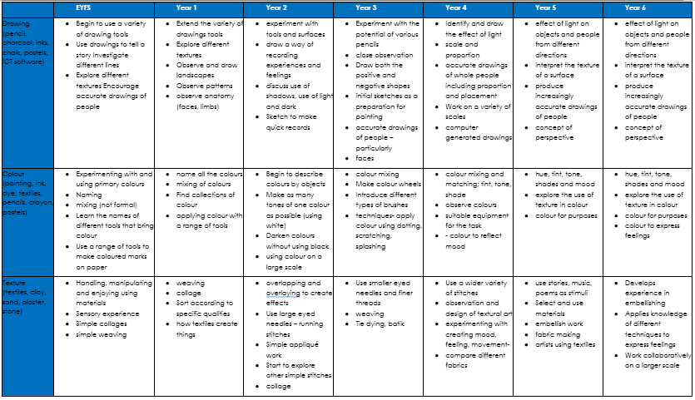
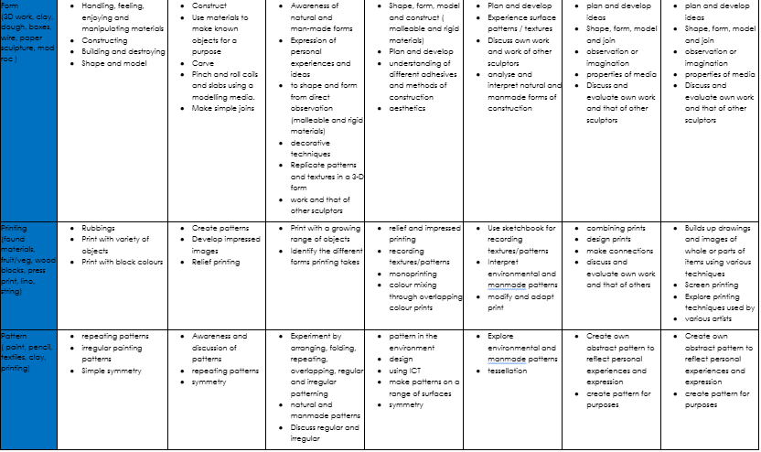

Inclusion
Our Art and Design curriculum has been planned to ensure that learning is accessible and inclusive for all learners. Our intent is sequenced to show a progression of knowledge and skills and clear end points to be assessed. We assess the barriers to learning for each individual and adapt the environment, equipment and teaching strategies to meet the needs of all children. The children are supported to access a wide range of processes, such as drawing, painting, sculpture, printmaking, collage, textile and digital art.

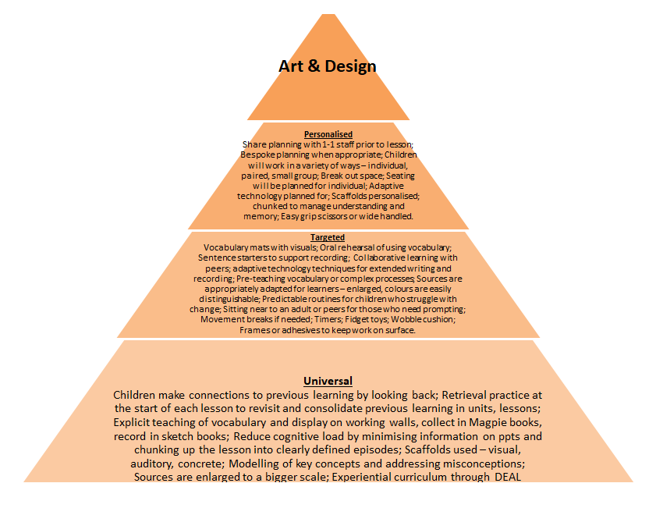

Assessment
- Children are invited to self assess and appraise their own work. They are given feedback in sketch books by teachers.
- Work is assessed not based on outcome, but on whether the child has understood the aims, skills and objectives of the project and has been able to use the vocabulary taught with the project.
- Assessments are based on skills and application of skills. Teachers complete assessments termly using ‘Below, Emerging, Met or Exceeding’ on Insight. Teachers make best fit judgements.
- Teachers will not write in sketch books. Post-its can be used to provide positive feedback


KS1 Assessment Proforma:
How did you find this project?

Tell me one thing that you have learned:

Are you pleased with your final piece? What would you change next time?

KS2 Assessment Proforma:
How did you find this project?

Tell me three things that you have learned:

Are you pleased with your final piece? What would you change next time?

Some examples of finished pieces of art at our school
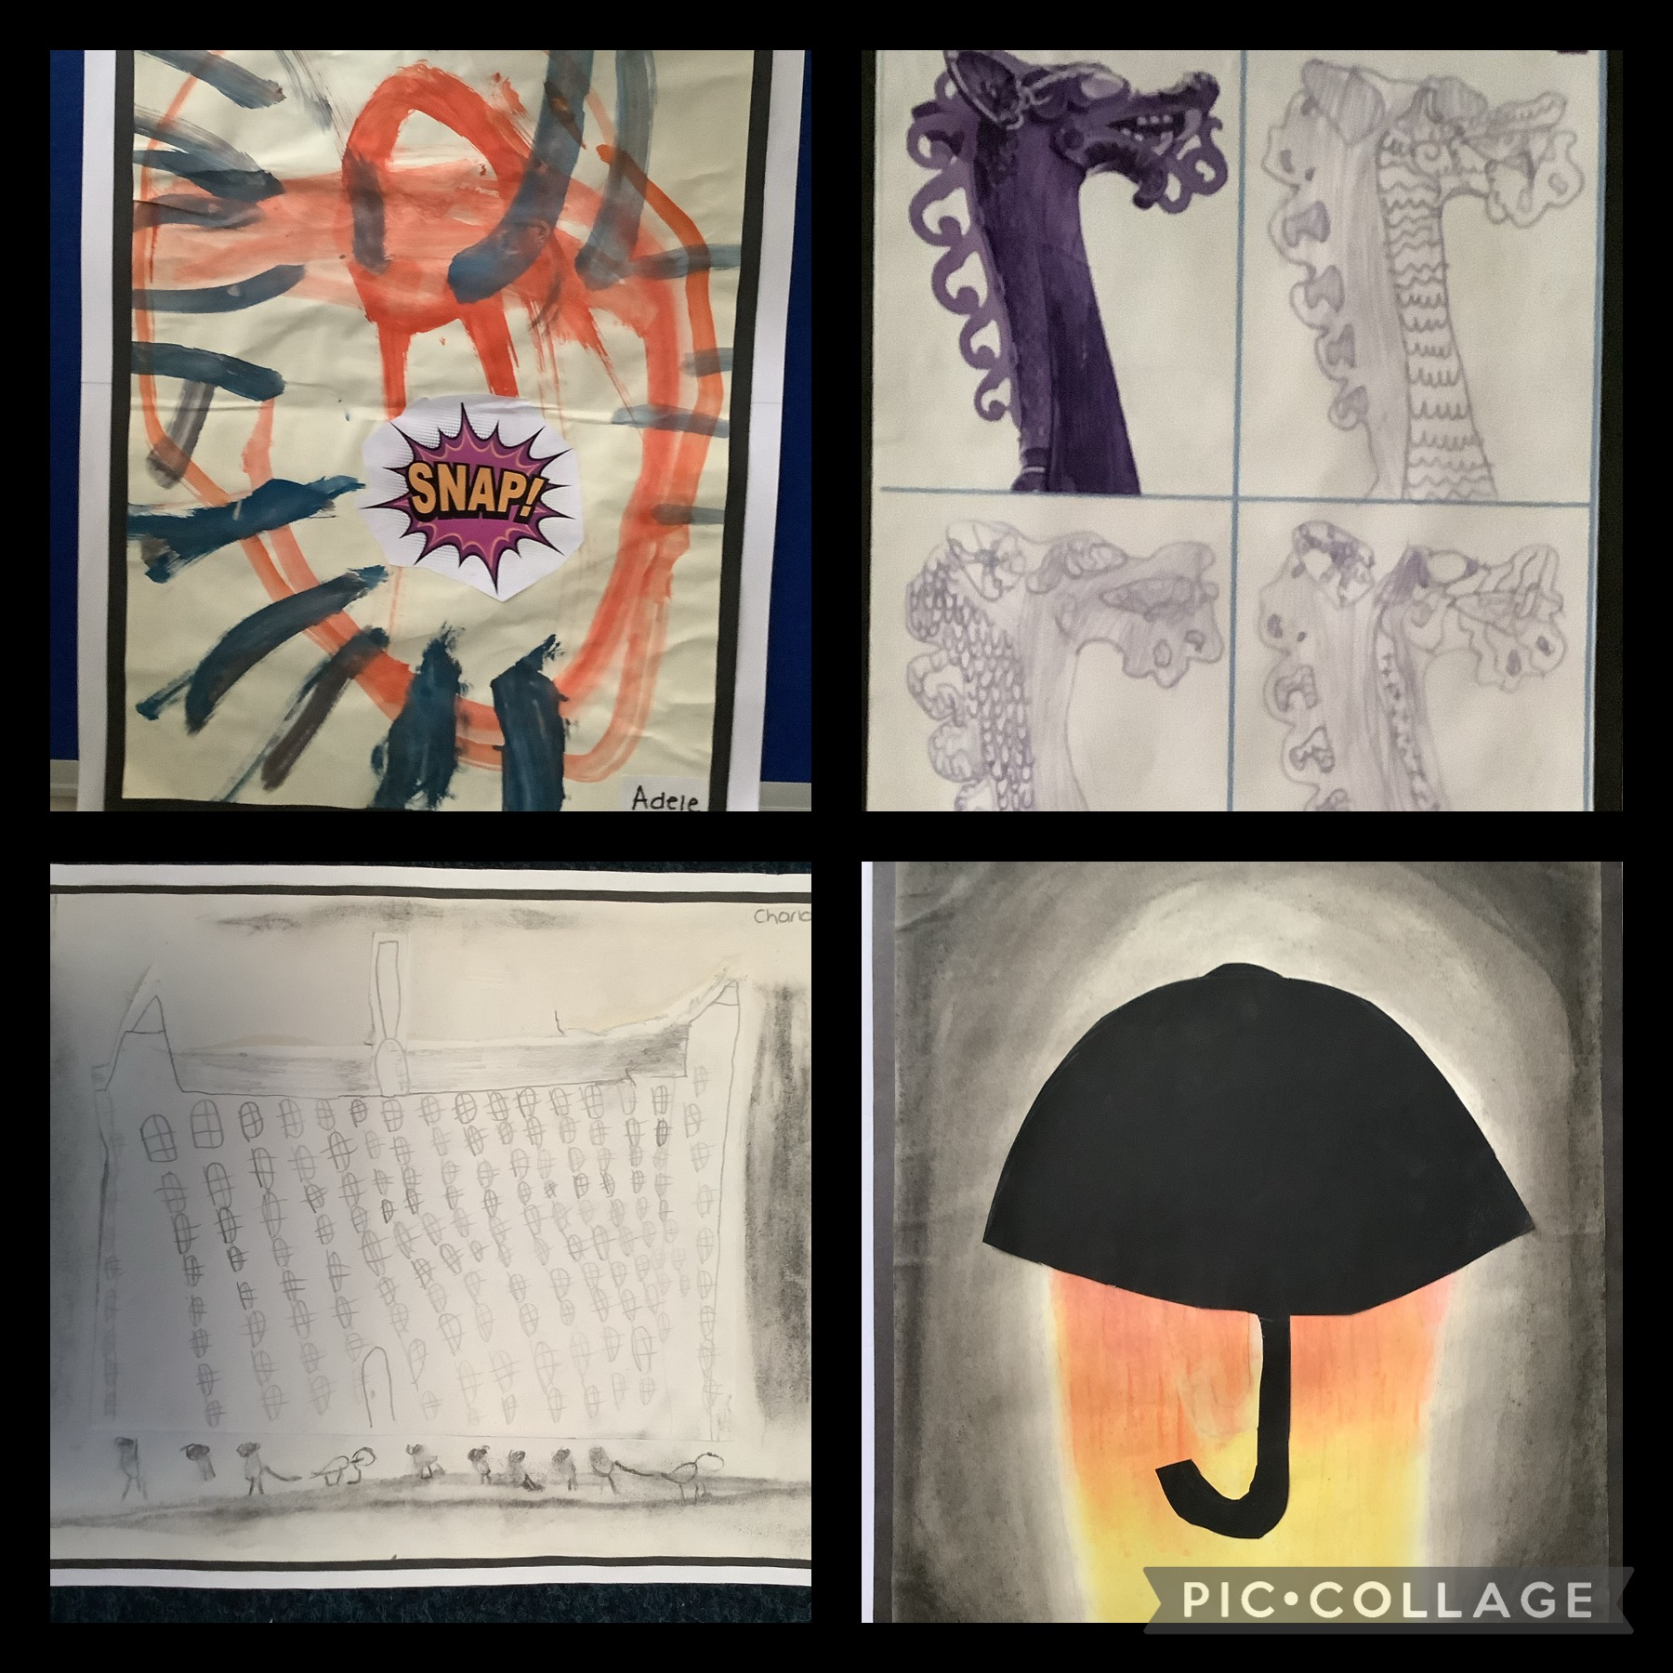
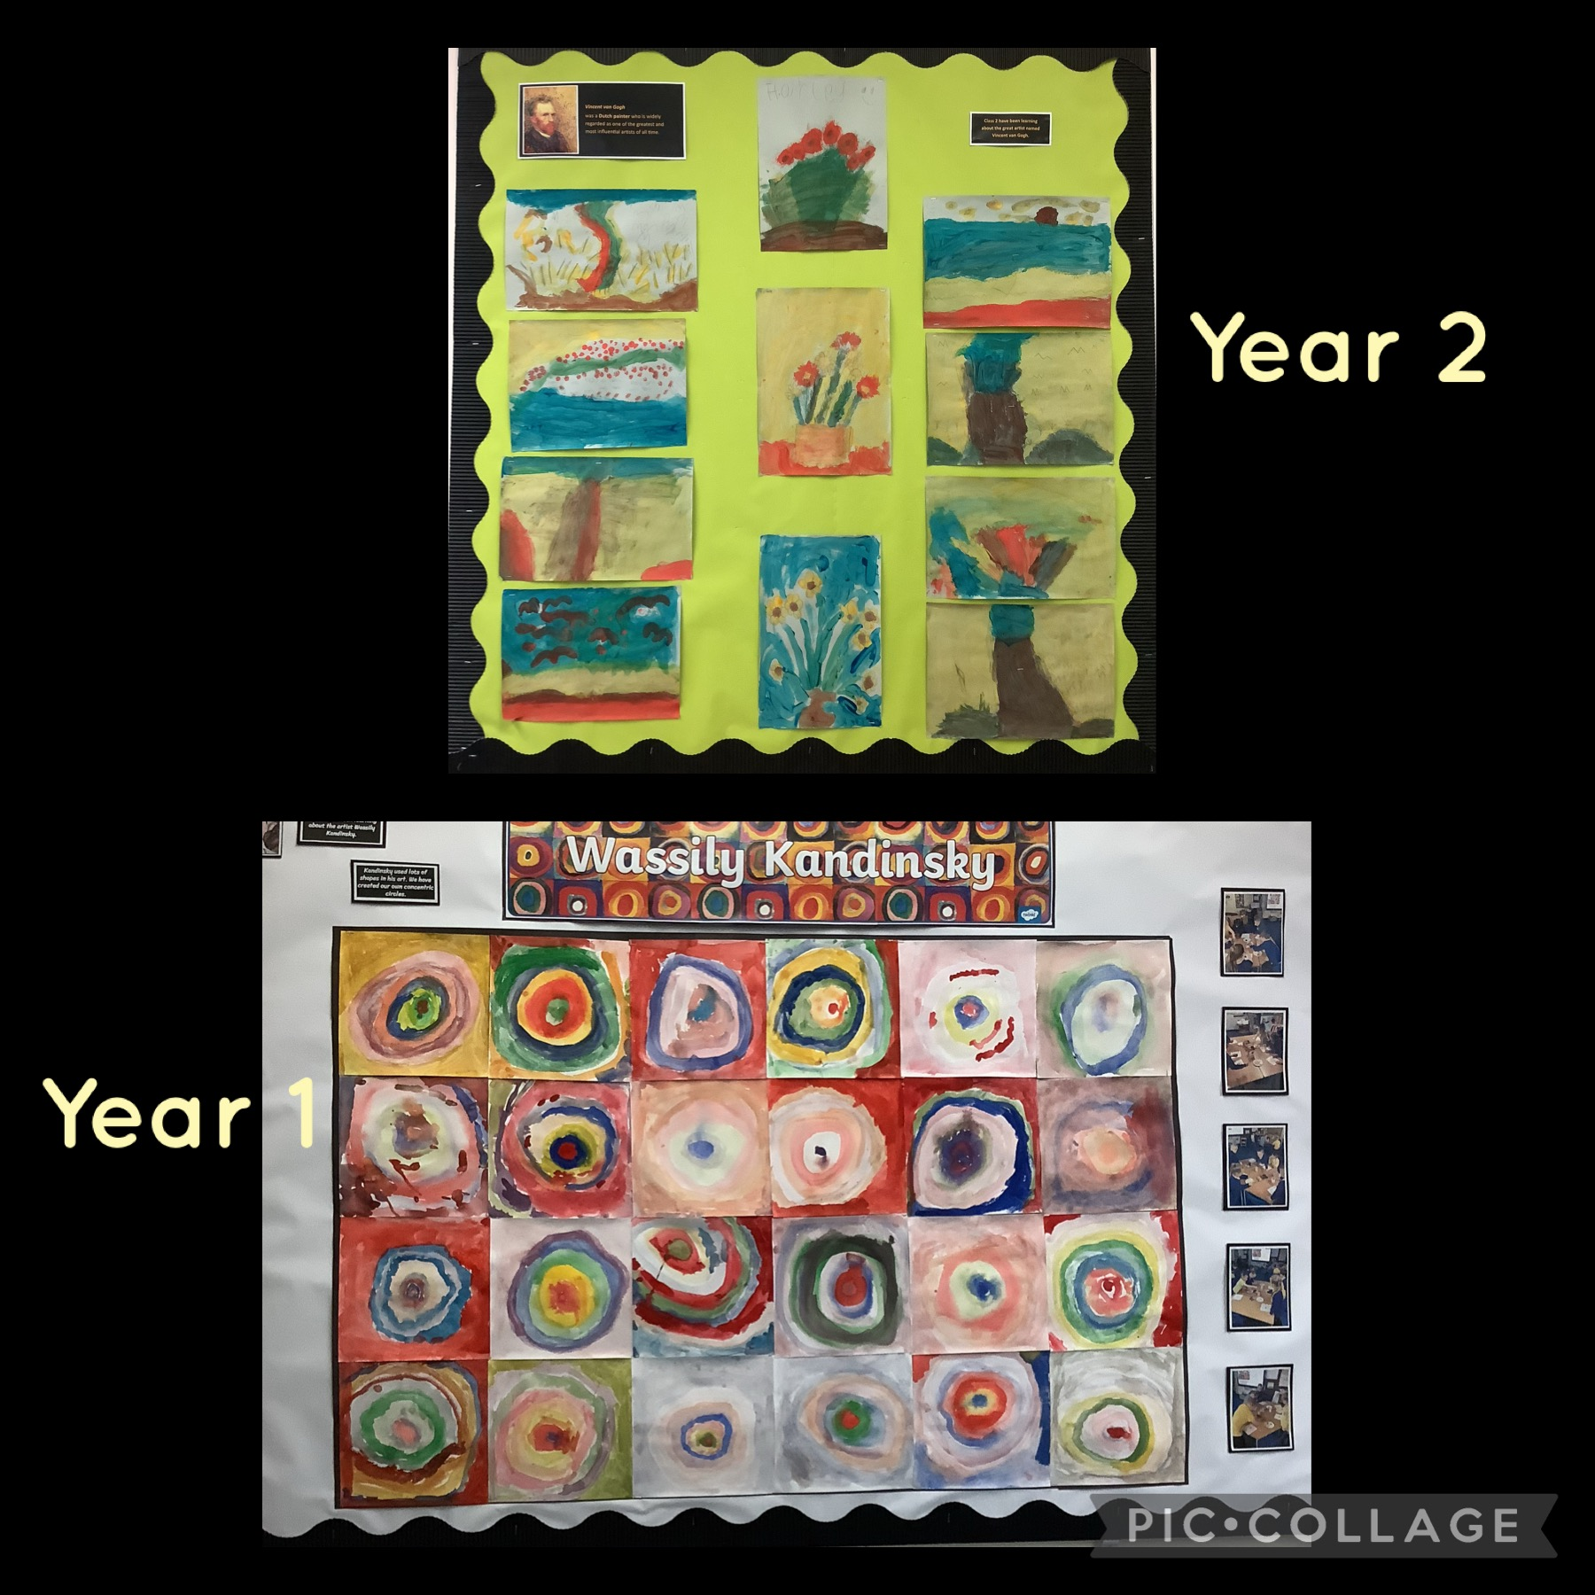

What children say about art and design at St Bernadette's
“When I first started doing art I didn't feel like I was doing really well but then when I made my final Mount Fuji painting I was very impressed."Y3 pupil.

"I look back through my book then and I look back through it now and I think I improved.” Y5 pupil.

“We are learning the things the artists do.” Y2 pupil.

