Read With Me
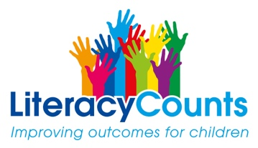
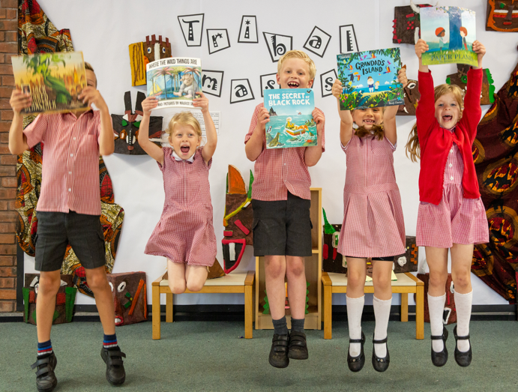
FREE: Live Webinar Thursday 11th February 2021
Literacy Counts in Partnership with Cheshire East
Supporting Parents and Carers in Supporting Reading

This first session aims to help you:
- develop a love of reading with your child
- listen and respond to your child as a reader
- support positive interactions around books
- encourage conversations about books

This free webinar includes practical ‘take away’ activities and solutions for reading to and with your primary school child.
Read with Me
Date: Thursday 11th February 2021
Time: 3-4pm
7-8pm (repeated session)
Location: Zoom

3pm-4pm
https://zoom.us/j/91478883218?pwd=V3VVQVdPdG5wVTNyT3d3SmhieW5vQT09
Meeting ID: 914 7888 3218
Passcode: 777418

7pm-8 pm (Repeated)
https://zoom.us/j/97442367663?pwd=Tk16Q0IrQk5sSVN0YUN2MEdpVmVLdz09
Meeting ID: 974 4236 7663 Passcode: 489265

