
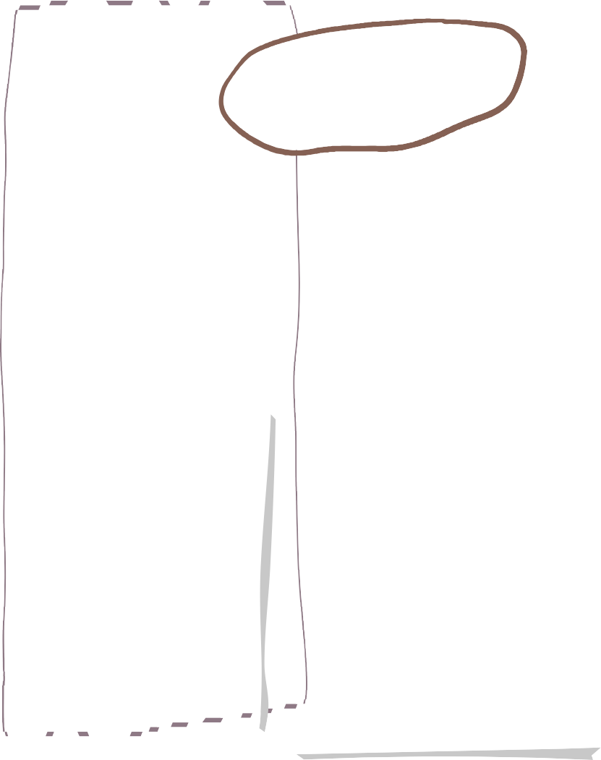





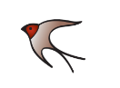

Spring 2 2026 in Year 4
Maths
Reading

English
This term we will be using the book Wisp
The children will be learning to:
Expand noun phrases by the addition of modifying adjectives, nouns and prepositional phrases
Choose nouns or pronouns appropriately for clarity and cohesion and to avoid repetition
Use inverted commas and other punctuation to punctuate direct speech
Use commas after fronted adverbials

Our whole class reading book is The Borrowers

We are reading…

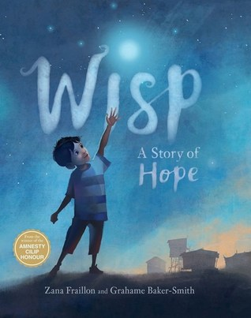
We will be following the White Rose Maths programme of study and beginning the autumn term learning about Length and Perimeter, and Fractions

Maths homework will link to the current learning objectives.
Children will read daily in school.
They will be assessed using a new system called Accelerated Reader.
This gives the children a ‘band’ so that they can choose appropriate books for their level.
Children are assessed regularly on the system and then can move to a higher band when they are ready.
Children will all also have access to the Whole Class Reading book – this term it The Borrowers

Our PE days will be…

Monday and Thursday

Other information

Homework

- Set on Friday and due in the following Wednesday.
- Using Atom Prime
- Reading comprehension or grammar, and maths.

Add your text here

