New Brighton Primary School
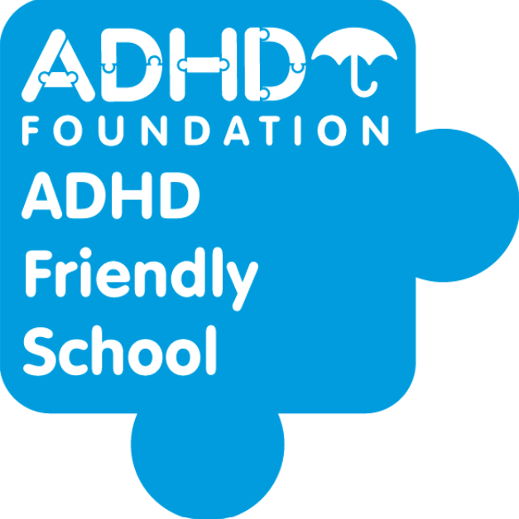
SEND Information Report for Families 2026

New Brighton Primary School is a highly inclusive school which focuses on the well-being and progress of every child. We have very high expectations of all our children, including those with Special Educational Needs or a Disability (SEND). All children have equal access to a broad and balanced curriculum.

To ensure all of our children achieve their potential we engage a range of strategies to provide challenges at an appropriate level, and provide support to help them overcome any barriers to learning.
Children with SEND are supported within their own class but sometimes may be supported for short periods with a specialist adult, individually or in a small group as part of an intervention.

1. Special Educational Needs that are provided for at New Brighton. | New Brighton provides support for pupils across the four areas of need as laid out in the SEN Code of Practice 2015:  www.gov.uk/government/publications/send-code-of-practice-0-to-25  - Communication and interaction  - Cognition and learning  - Social, emotional and mental health difficulties  - Sensory and/or physical needs
2.Information about the school’s policies for identification and assessment of pupils with SEND. | Pupils are identified as having SEND, and their difficulties assessed, through:  - Problems with their academic achievement  - Social, emotional or behavioural difficulties preventing them from fully accessing the curriculum  - Teacher/parental referral to the SENDCo (who will then decide the next steps needed)  - Information from previous settings  - Those children showing greater difficulty may be assessed by  Outside agencies including the Special Educational Needs Assessment and Advisory Team (SENAAT).
3a.Evaluating the effectiveness of provision made for pupils with SEND. | Senior Leaders, Class Teachers and the SENDCo closely monitor the progress of children receiving additional support each term.  For those children with significant barriers to their learning their class teacher will write a One Page Profile or an Individual Learning Plan. Any specialist advice that has been given is included in this plan.  For children with an EHCP, their learning plan will be linked directly to their EHCP targets.  Learning Plans are used to track the progress each child makes on their individual targets. Monitoring of additional support is completed by the Class Teachers, Senior Leaders and SENDCo in order to inform the type and scope of interventions that take place.  The effectiveness of SEND provision is evaluated through pupil outcomes, attendance, participation, engagement, progress towards individual targets and feedback from pupils and families. Provision is reviewed regularly to ensure it has a measurable impact and remains the most effective use of resources.  Provision and outcomes are developed through a co-produced approach involving pupils, parents, class teachers, the SENDCo and, where appropriate, external professionals.

3b. Arrangements for assessing and reviewing pupils’ progress towards outcomes, including opportunities available to work with parents and pupils as part of this assessment and review. | Arrangements include:  - Graduated approach – Assess, Plan, Do, Review  Teachers remain responsible and accountable for the progress and development of all pupils in their class, including where pupils access interventions or additional support.  www.sendlowirral.co.uk/wirral-graduated-approach  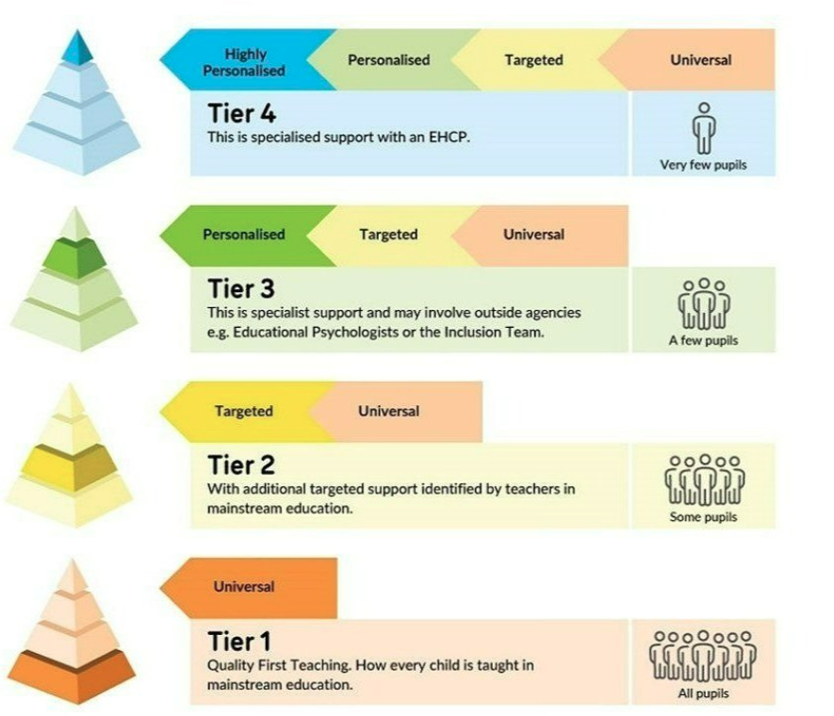  - Data Tracking for pupil progress  - Learning Plans using Provision Map    - EHCP reviews  - Intervention Tracking

3c. The school’s approach to teaching pupils with SEND. | New Brighton will ensure:  - A calm, welcoming environment supported through the Therapeutic School Approach and My Happy Mind  - An inclusive approach to all areas of school life  - Balanced and broad curriculum with flexibility to meet every child’s needs  - Effective adaptations to lessons along with reasonable adjustments  - Peer tutoring and collaborative learning  - Alternative methods of responding or recording work  - Specialist resources for those children with sensory or mobility impairments where appropriate  - Extra-curricular activities are barrier free and do not exclude any pupils  - Lesson resources in formats other than print provided  - Adapted printed materials for children with Literacy learning difficulties  - Extra adult support in classrooms where appropriate and  possible  The school fulfils its duties under the Equality Act 2010 by making reasonable adjustments and ensuring disabled pupils are not placed at a substantial disadvantage.
3d. How adaptations are made to the curriculum and the learning environment of pupils with SEND. | The curriculum/learning environment may be adapted by:  - Quality First Teaching with reasonable adjustments  - Groupings that target specific levels of progress  - Flexible groupings  - Adapted resources  - Diverse teaching methods and AFL styles  - Appropriate choice of texts and topics to suit the learner  - Access arrangements for standardised testing  - Additional adult support where possible  - Individual Learning Plans with specific targets  - Specialist equipment such as writing slopes, posture cushions, pencil grips, easy to use scissors, specialist seating etc.  - Sensory spaces are created to suit diverse needs. (including sensory bay, whole school sensory circuit and sensory club)  - Support from the learning mentor where needed  - SEND specific Teaching Assistant providing a range of SEND specific intervention opportunities.  - The school’s Accessibility Plan is available on the school website and outlines how we improve access to the curriculum, physical environment and information for pupils with disabilities.

3e. Additional support for learning that is available to pupils with SEND. | The following support is available:  - TA support within the class  - Intervention groups  - 1:1 individual support on specific targets where appropriate and possible  - EHCP/ EYIPFA funded children (1:1 support as identified)  - Hearing/Vision support  - Speech and Language Therapy  - MHST  - SEMH intervention  - Meet and greet  - Family Support Worker  - Pastoral Team  Resourced Provisions:  Nurture Hub (8 EYFS children) Agreed at panel  SALT Hub (10 EY/KS1 children) Agreed at panel  MLD Hub 2SA (10 children with MLD diagnosis and EHCP)  MLD Hub 2LL (10 children with MLD diagnosis and EHCP)

3f. How the school enables children with SEND to engage in all school activities along with children who do not have SEND. | Pupils are included and engaged through:  - Truly inclusive approach to all areas of school life  - Flexible grouping and seating  - Collaborative learning  - Adapted activities where appropriate  - Alternative methods of recording where appropriate  - Specialist resources such as ICT where appropriate for sensory difficulties  - Adapted printed materials  - School trips are available to all, including residential trips  - 1:1 support arranged if required for an out of school visit
3g. Support that is available for improving the social, emotional and mental health of pupil with SEND. | Pupils are well supported by:  - Calming classroom environments  - ‘Communication Friendly’ approach to learning environments.  - An anti-bullying policy that is supported by all staff  - School council participation  - PSHE curriculum prioritised and embedded  - Sensory spaces available to all children throughout school  - Experienced, Non- Teaching SENDCo  - Non- Teaching Pastoral Team made up of Safeguarding and Pastoral Lead, 1 Learning Mentor, Attendance Lead and Family Support Worker.  - Access to MHST
4. In relation to Mainstream Schools and maintained nursery schools, the name and contact details of the SEND coordinator, name and contact details of SEND governor. | SENDCo and AHT: Mrs. Kate Elsender  SENDCo Governor: Mr. Owen Fields  k.elsender@newbrighton.wirral.sch.uk  0151 639 3869  School Website: www.newbrightonprimary.co.uk

5. Information about the expertise and training of staff in relation to children and young people with SEND, including how specialist expertise will be secured. | New Brighton has:  - An experienced, non-teaching SENDCo who holds the National Award for SEN Coordination (NASENCO).  - An experienced Safeguarding Lead.  - A Pastoral Team who deliver a range of programs to support children with social, emotional and mental health difficulties.  - A Family Support Worker to support families.  - A SEND specific Level 3 trained Teaching Assistant.  Staff are trained in:  - Autism  - Speech and Language  - Trauma Informed practice  - Team Teach /Positive Handling  - Dyslexia Friendly approaches
6. Information about how equipment and facilities to support children and young people with SEND will be secured. | The SEND budget is allocated each financial year.  The money is used to provide additional support or resources dependent on the individual’s needs.  Resources may include deployment of staff or equipment in response to pupils’ specific needs.  A child who has been awarded an Education and Health Care Plan has their allocated money spent to meet their specific and individual outcomes.  A child who has been awarded Tier 3 funding or EYIPFA has their allocated money spent to meet their specific and individual outcomes.

7. The arrangements for consulting parents of children with SEND about, and involving such parents in, the education of their child. | Support available to parents:  - Open communication with school staff through email and Dojo  - Meetings with the SENDCo and class teacher  - MHST support  - Family Support Worker  - Workshops / coffee mornings are offered throughout the school year  - Reports from outside agencies are shared with parents and may contain suggestions of programs that can be used at home.
8. The arrangements for consulting young people with SEND about and involving them in their education. | Pupils at New Brighton are consulted when a Learning Plan is being written.  Their strengths and aspirations are also taken into account when writing a One Page Profile.  Pupils are also consulted when applications are made for an EHC Assessment following the Local Authority guidelines.  Person-centred planning is considered throughout.
9. Arrangements made by the governing body relating to the treatment of complaints from parents of pupils.  Please visit this page with SEND concerning the provision made at the school. | If parents have concerns regarding SEND provision they should initially contact the class teacher or SENDCo.  Parents who remain dissatisfied may contact the Governing Body and ultimately pursue concerns through the Local Authority disagreement resolution service, mediation arrangements or SEND Tribunal where appropriate.

10. How the governing body involves other bodies, including health and social services bodies, local authority support services and voluntary organisations, in meeting the needs of pupils with SEND and in supporting their families. | Where necessary, the following outside agencies are consulted for specialised expertise:  - Child protection advisors  - Educational Psychologists  - MHST (Mental Health Support Team)  - EWO (Educational Welfare Officers)  - Social Care  - SALT (Speech & Language Therapy)  - OT (Occupational Therapy)  - Paediatricians  - ASC (Autism Social Communication Team)  - Hearing/Vision Support (Wirral Sensory Service)  - Family Support Workers  - SENAAT (Special Educational Needs Assessment Advice Team)  - Orrets Meadow Outreach  - Wirral Inclusion Team
11. The contact details of support services for the parents of pupils with SEND, including those arrangements made in accordance with section 32. | WIRED - Head Office Wirral Unit 7, Wirral Business Park, Arrowe Brooke Road, Upton, Wirral, CH49 1SX.  Email: contact@wired.me.uk Website: www.wired.me.uk Tel: 0151 522 7990 Fax: 0151 670 1600

12. The school’s arrangements for supporting pupils with SEND in a transfer between phases of education or in preparations for adulthood and independent living. | Transition strategies:  - Discussions between previous or receiving schools/settings prior to the pupil joining/leaving  - Transition days spent with their new class teacher  - Additional visits arranged for pupils who need extra time in their  new school or new year group which is in a different part of the school  - Our SENDCo is available to meet with parents of children joining the school  - Our SENDCo will liaise with other SEND staff from secondary schools to pass on information regarding SEND pupils  - Secondary staff visit school to meet the children and speak to class teachers  - Where a pupil may have specialised needs, a separate meeting is  arranged for the SENDCo to meet with the secondary SEND staff, parents and pupil  - Foundation Stage staff visit private nursery settings to gather all  relevant information. Private nursery staff are also invited to school to support pupils during transition  - Foundation Stage Lead/ SENDCo will visit the settings of any  children starting at New Brighton with additional needs to ensure that the appropriate provision is in place  - Foundation Stage Lead will hold open evenings to allow teachers to meet prospective parents
13. Admission and accessibility arrangements for disabled pupils. | New Brighton Primary School welcomes applications for all pupils, including those with disabilities. Disabled pupils are admitted through the same admission arrangements as other pupils and are not treated less favorably because of their disability.  The school makes reasonable adjustments to ensure that disabled pupils can access education, facilities and activities alongside their peers. Further information about how we improve access to the curriculum, physical environment and information is set out in our Accessibility Plan, available on the school website.
14. Information on where the local authority’s Local Offer is published. | The local offer is available on the following link: https://www.sendlowirral.co.uk

