Reception Class West Street Community School: Long Term Plan – 2025-2026
This is an overview of the expected learning to be taught in Reception during the academic year 2025/26.

 | Autumn 1 3rd Sep - 24th Oct  Marvellous Me | Autumn 2  3rd Nov – 19th Dec  Celebrations and Festivals | Spring 1  5th Jan – 13th Feb  Traditional Tales | Spring 2  23rd Feb – 27th Mar  Dinosaurs | Summer 1  13th Apr – 22nd May  Mini beasts and growing | Summer 2  1st Jun – 16th July  Time to Travel/Space
Core Text  A bank of familiar text/ traditional  tales will be shared  daily at story time.  This will enable them to orally re-  tell popular text and stories  independently. | Colour Monster (goes to school)  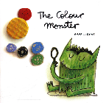  Once they were Giants  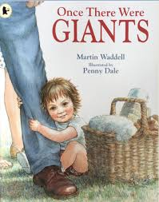 | Stickman  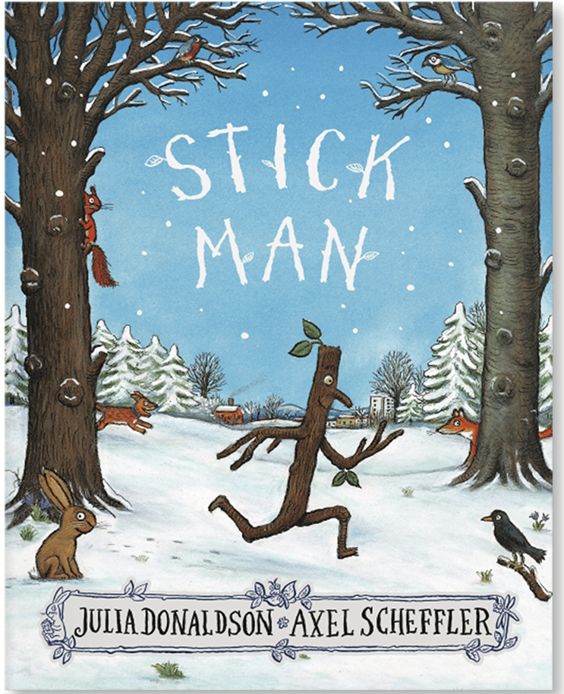  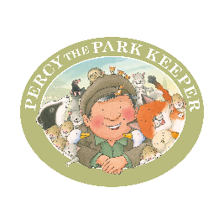  Percy the Park Keeper  The Christmas Story  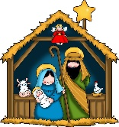 | The Ugly Duckling  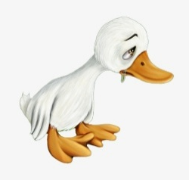  Gingerbread Man  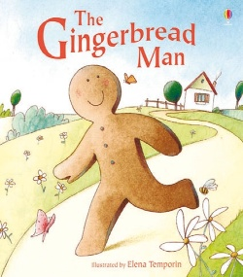 | Harry and the Bucket full of Dinosaurs  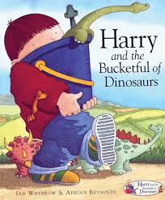  Mad about Dinosaurs  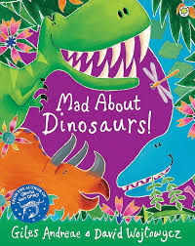 | Jack and the Beanstalk  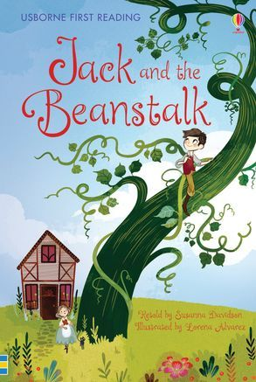  What the Ladybird Heard  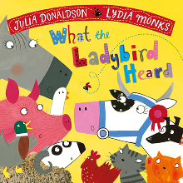 | Aliens Love Underpants  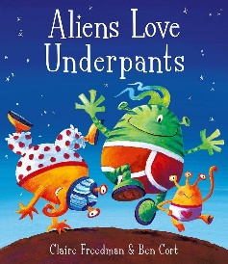  The Lighthouse Keepers Lunch  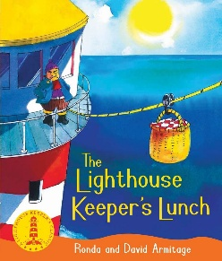
Supplementary texts and themes | Non-fiction books about starting school  The Big Book of Families  Goodbye Summer, Hello Autumn  Autumn (Non-fiction)  Halloween | Bonfire night  Diwali  Remembrance Day  Children in Need  The Best  Diwali | Winter  Chinese New Year  Valentine’s Day  Goodbye Winter, Hello Spring | Easter  Spring  Mother’s Day (15th March) | Non-fiction text life cycles  A Tiny Seed  Goodbye Spring, Hello Summer | Farm Trip  Father’s Day (21st June)
Nursery rhymes/songs/poems | Old MacDonald  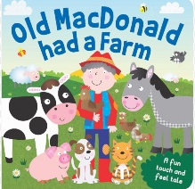  I’m a Little Teapot  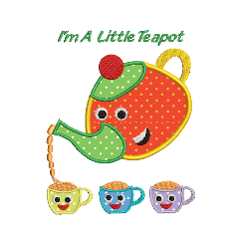 |   I Hear Thunder  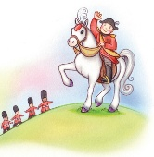  Grand Old Duke of York  Christmas Songs | The Wheels on the Bus  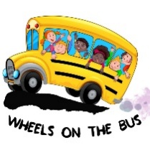    Hickory Dickory Dock | 5 Little Ducks  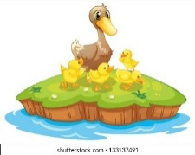  Humpty Dumpty  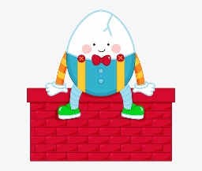 | 5 Little Speckled Frogs  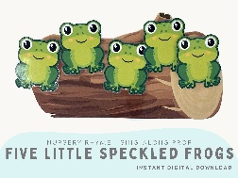  There’s a Worm at the Bottom of the Garden  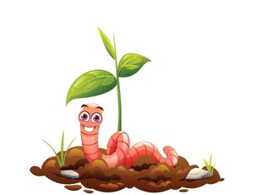 | 5 Little Men in a Flying Saucer  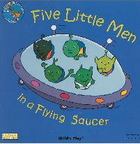  When I was One…  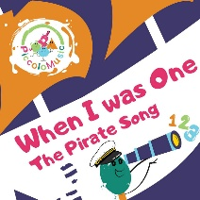
Communication and Language
The development of children’s spoken language underpins all seven areas of learning and development. The number and quality of the conversations they have with adults and peers throughout the day in a language rich environment is crucial. Our curriculum is designed and built up on stories which means children are emerged in high quality text providing them with extensive opportunities to use and embed new words in a range of contexts. Through conversations, story-telling and role play, children share ideas and with support and modelling from practitioners are able to elaborate and become more comfortable with using a rich range of vocabulary and language structures.
Personal, Social and Emotional Development
PSED is not specifically planned for in a sequence across the year, however PSED Principles underpin daily classroom practice which ensures all aspects of developing PSED are covered. Children’s PSED is crucial for children to lead happy and healthy lives, and is fundamental to their cognitive development. Underpinning their personal development are the important attachments that shape their social world. Strong, warm and supportive relationships with adults enable children to learn how to understand their own feelings and those of others. Children are supported to manage emotions, develop a positive sense of self, set themselves simple goals, have the confidence in their own abilities, to persist and wait for what they want and direct attention as necessary. Through adult modelling and guidance, they will learn how to look after their bodies, including healthy eating, and manage their personal needs independently. Through supported interaction with other children, they learn to make good friendships, co-operate and resolve conflicts peaceably. These attributes will provide a secure platform from which children can achieve at school and in later life.

Physical Development
Physical activity is vital to children’s all-round development, enabling them to pursue happy, healthy and active lives. Providing activities both indoors and out, adults support children to develop core strength, stability, balance, spatial awareness, co-ordination and agility. Gross motor skills provide the foundations for developing healthy bodies and social and emotional well-being. Fine motor control and precision helps with hand-eye coordination, which is linked to early literacy. Repeated and varied opportunities to explore and play with small world activities, puzzles, arts and crafts and the practice of using small tools, with support from adults, allow children to develop proficiency, control and confidence.
Mathematical Development
Developing a strong grounding in number is essential so that all children develop the necessary building blocks to excel mathematically. Children should be able to count confidently, develop a deep understanding of the numbers to 10, the relationships between them and the patterns within those numbers. By providing frequent and varied opportunities to build and apply this understanding – such as using manipulatives, including small pebbles and tens frames for organising counting- children will develop a secure base of knowledge and vocabulary from which mastery of mathematics is built. In addition, it is important that the curriculum includes rich opportunities for children to develop their spatial reasoning skills across all areas of mathematics including shape, space and measures. It is important that children develop positive attitudes and interests in mathematics, look for patterns and relationships, spot connections, ‘have a go,’ talk to adults and peers about what they notice and not to be afraid to make mistakes.
‘ | Subitising-Perceptually subitise within 3.  Identify sub-groups in larger arrangements.  Create their own patterns for numbers within 4.  Practise using their fingers to represent quantities which they can subitise.  Experience subitising in a range of contexts, including temporal patterns made by sounds.  Cardinality, ordinality and counting-Relate the counting sequence to cardinality, seeing that the last number spoken gives the number in the entire set.  Have a range of opportunities to develop their knowledge of the counting sequence, including through rhyme and song.  Have a range of opportunities to develop 1:1 correspondence including by coordinating movement and counting.  Explore a range of strategies which support accurate counting.  Composition-see that all numbers can be made of 1s.  Compose their own collections within 4.  Comparison-  Understand that sets can be compared according to a range of attributes, including by their numerosity.  Use the language of comparison, including ‘more than’ and ‘fewer than’.  Compare sets ‘just by looking’.  Geometry-  Circle, triangle square and rectangle.  Extend and create ABAB patterns. | Subitising-Continue from first half-term.  Subitise within 5, perceptually and conceptually, depending on the arrangements.  Cardinality, ordinality and counting-Relate the counting sequence to cardinality, seeing that the last number spoken gives the number in the entire set.  Have a range of opportunities to develop their knowledge of the counting sequence including through rhyme and song.  Have a wide range of opportunities to develop 1:1 correspondence, including by coordinating movement and counting.  Have opportunities to develop an understanding that anything can be counted, including actions and sounds.  Explore a range of strategies which support accurate counting.  Composition-  Explore the concept of ‘wholes’ and ‘parts’ by looking at a range of objects that are composed of parts, some of which can be taken apart and some of which cannot.  Explore the composition of numbers within 5.  Comparison-  Compare sets using a range of strategies, including ‘just by looking’ , by subitising and by matching.  Compare sets by matching, seeing that when every object in the set can be matched to one on the other set, they contain the same number and are equal amounts.  Measurement-  Prepositional language.  Time-timeline. | Subitising-Increase confidence in subitising by continuing to explore patterns within 5, including structured and random arrangements.  Explore a range of patterns made by some numbers greater than 5, including structured patterns in which 5 is a clear part.  Experience patterns which show a small group and ‘1 more’.  Continue to match arrangements to finger patterns.  Cardinality, ordinality and counting-Continue to develop verbal counting to 20 and beyond.  Continue to develop object counting skills, using a range of strategies to develop accurate counting.  Continue to link counting to cardinality, including using their fingers to represent quantities between 5 and 10.  Order numbers, linking cardinal and ordinal representations of numbers.  Composition-  Continue to explore the composition of 5 and practice recalling ‘missing’ or ‘hidden’ parts for 5.  Explore the composition of 6, linking this to familiar patterns, including symmetrical patterns.  Begin to see that numbers within 10 can be composed of ‘5 and a bit’.  Comparison-  Continue to compare sets using the language of comparison, and play games which involve comparing sets.  Continue to compare sets by matching, identifying when sets are equal.  Explore ways of making unequal sets.  Geometry-  Extend and create ABC, ABB, AAB pattern. | Subitising-  Explore symmetrical patterns, in which each side is a familiar pattern, linking this to ‘doubles’.  Cardinality, ordinality and counting-  Continue to consolidate their understanding of cardinality, working with larger numbers within 10.  Become more familiar with the counting pattern beyond 20.  Composition-  Explore the composition of odd and even numbers, looking at the ‘shape’ of these numbers. Begin to link even numbers to doubles.  Begin to explore the composition of numbers within 10.  Comparison-  Compare numbers, reasoning about which is more, using both an understanding of the ‘howmanyness’ of a number, and its position in the number system.  Measurement-  Compare length weight and capacity. | Subitising-  Continue to practise increasingly familiar subitising arrangements, including those which expose ‘1 more’ or ‘doubles’ patterns.  Use subitising skills to enable them to identify when patterns show the same number but in a different arrangement, or where the patterns are similar but have a different number.  Subitise structured and unstructured patterns, including those which show numbers within 10, in relation to 5 and 10.  Be encouraged to identify when it is appropriate to count and when groups can be subitised.  Cardinality, ordinality and counting-  Continue to develop verbal counting to 20 and beyond, including counting from different starting numbers.  Continue to develop confidence and accuracy in both verbal and object counting.  Composition-  Explore the composition of 10.  Comparison-  Order sets of objects, linking this to their understanding of the ordinal number system. | In this half-term, the children will consolidate their understanding of concepts previously taught through working in a variety of contexts and with different numbers.  Geometry-  Exploring patterns select, rotate and manipulate shapes in order to develop spatial reasoning skills.
Literacy
It is crucial for children to develop a life-long love of reading. Through high quality discussion about the world around them and the books they read with adult’s children develop language comprehension. Skilled word reading involves the decoding of unfamiliar words and the speedy reading of familiar words. Writing involves spelling, handwriting and articulating ideas orally before writing them down. The children are taught to read and write in focused groups and through daily phonic sessions of Supersonic Friends.
Understanding the World
Understanding the World involves guiding children to make sense of their physical world and their community. The frequency and range of children’s personal experiences increases their knowledge and sense of the world around them – from visiting parks, libraries and museums to meeting important members of society such as police officers, nurses and firefighters. In addition, listening to a broad selection of stories, non-fiction, rhymes and poems will foster their understanding of our culturally, socially, technologically and ecologically diverse world. As well as building important knowledge, this extends their familiarity with words that support understanding across domains enriching and widening children’s vocabulary.
Understanding the World  Our RE Curriculum enables children to develop a positive sense of themselves and others and learn how to form positive and respectful relationships. They will begin to understand and value the differences of individuals and groups within their own community.  Children will have the opportunity to develop their emerging cultural awareness.  Children will have the opportunity to work scientifically throughout the year. | Observe and record daily weather.  Discuss the changes in the season.  Talk about the lives of people around them identifying own family. Naming who they can see in photos and what relation they are.  Discuss key events in own family.  Introduce children to key members in school.  Describe key features of school and home.  Know the purpose of everyday technology at home.  Introduce visual timetable.  Discuss and celebrate different cultures and festivals-Diwali. | Observe and record daily weather.  Discuss changes in season.  Talk about events and situations from the past-Guy Fawkes-Christmas.  Talk about different buildings and their purpose.  Recognise and talk about different symbols on a local map.  Past events -Remembrance Sunday  Recognise some key features on a local map.  Complete a simple program on iPad e.g. number blocks  Baking/food preparation.  Discuss and celebrate different cultures and festivals-Christmas. | Observe and record daily weather.  Talk about animal habitat/ environment. How is it different?  Discuss changes in season.  Discuss and celebrate different cultures and festivals-Chinese New Year.  Explore the natural world-ice.  Recognise that some environments are different to the one in which they live.  Explore the features and wildlife of the Antarctic.  Talk about a timeline of events using some appropriate vocabulary.  Basic programming skills using beebots.  Basic programming skills on iPad e.g. number blocks.  Baking/food preparation. | Observe and record daily weather.  Discuss changes in season.  Explore the world around us and see how it changes when we enter Spring.  Discuss and celebrate different cultures and festivals-Easter.  Talk about light, dark and shadows.  Take digital photographs.  Baking/food preparation. | Observe and record daily weather.  Explore change in living things-caterpillars, frogs, insects and plants and record findings.  Explore the world around us and see how it changes when we enter Summer.  Minibeast hunt- create a “Bug Hotel.”  Discuss immediate environment using knowledge from observations, discussions and maps.  Record and play back sounds using microphones and talking tin lids.  Talk about the lives of people around them and their role in this society.  Talk about the timeline of a bean/life cycle using appropriate vocabulary.  Discuss and celebrate different cultures and festivals-Ramadan and Eid.  Baking/food preparation. | Use the appropriate vocabulary to describe the weather.  Discuss the changes in season.  Talk about recycling and how it can take care of our world.  Investigate what rubbish can do to our environment and animals. Explore oceans and what lives in them.  Describe some key features of the seaside.  Talk about some key symbols on a map.  Name some key features from the countries that I have visited or have seen in books.  Introduce children to a range of transport and where they can be found.  Look at the difference between transport in this country and one other country and make simple comparisons.  Compare own environment and contrasting environments through books and conversation.  Materials: Floating and sinking. Boat building.  Talk about forces they feel eg water pushing boat up to float.  Discuss change in weather-seasons.  Make references to the natural world, weather and our habits.
Expressive Arts and Design.  EAD is not planned in sequence across the year, however there are opportunities within topics for skills to be developed, both independently and adult led. Children will have opportunities to deepen and transfer their skills throughout the year. Children will be encouraged to explore materials/ resources finding out what they are/ what they can do and decide how to use them. | Painting and colour.  Apply colour with a range of tools.  To begin to take control of tools for different purposes.  Drawing.  Use a range of drawing tools.  Develop their own creative ideas in their drawings and talk about these ideas.  Texture and form.  Use (safely) materials/tools for painting, collage, sculpture, etc  Use simple language created through discussion of feel, size, look, smell etc | Painting and colour.  Kandinsky  Experiment with colour mixing.  Drawing.  Use drawings to tell a story.  Develop their own creative ideas in their drawings and talk about these ideas.  Texture and form.  Use (safely) materials/tools for painting, collage, sculpture, etc  Make rubbings showing a range of textures.  Pattern and printing.  Explore printing as an introduction to ‘pattern’ using a repetitive image and make own patterns using different media and materials.  Produce simple pictures by printing objects. | Painting and colour.  To continue to allow for experimenting with mixing of colours.  Drawing.  Investigate different lines.  Create accurate drawings of people.  Texture and form.  Use (safely) materials/tools for painting, collage, sculpture, etc  Shape and model from observation and imagination.  Pattern and printing.  Explore irregular pattern through first hand experiences then make irregular painting patterns based on real life-i.e., printing the skin of a tiger/zebra or tree bark.  Create a simple repeating pattern and recognise pattern in the environment. | Painting and colour.  Develop colour mixing techniques to enable them to match the colours they see and want to represent.  Drawing.  To begin to explore a variety of media.  Draw from imagination.  Texture and form.  Use (safely) materials/tools for painting, collage, sculpture, etc  Plan, construct and build simple objects.  Discuss problems and how they might be solved as they arise.  Pattern and printing.  Imprint onto a range of textures-newspaper, coloured paper, plain paper into clay and dough etc. | Painting and colour.  Work from imagination and observation.  Develop colour mixing techniques to be able to match the colours they see and want to represent.  Drawing.  Explore different textures.  To work from imagination and observation.  To begin to explore scale.  Texture and form.  Use (safely) materials/tools for painting, collage, sculpture, etc  Pattern and printing.  Encourage independent creation of simple symmetry-folding painted butterflies etc. | Painting and colour.  Work from imagination and observation.  Drawing.  Develop their own creative ideas in their drawings and talk about these ideas.  Texture and form.  Selects, sorts, tears and glues items down.  Begins to create collages for a purpose using paper, pasta, beans and larger tactile things.  Observe and discuss what happens to the materials.  Make rubbings showing a range of textures.

