NURSERY Class: Long Term Plan – 2025-2026
This is an overview of the expected learning to be taught in Nursery during the academic year 2025/26.

 | Autumn 1  3rd Sep - 24th Oct  All About Me | Autumn 2  3rd Nov – 19th Dec  Celebrations | Spring 1  5th Jan – 13th Feb  Once Upon a Time | Spring 2  23rd Feb – 27th Mar  On the Farm | Summer 1  13th Apr – 22nd May  In the Garden | Summer 2  1st Jun – 16th July  Under the Sea
Core/ Key Texts  A bank of familiar text/ traditional  tales will be shared  daily at story time.  This will enable them to orally re-  tell popular text and stories  independently. | Owl Babies  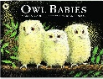  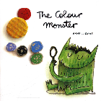  The Colour Monster  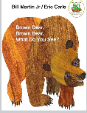  Brown bear, Brown bear | We’re Going on a Bear Hunt  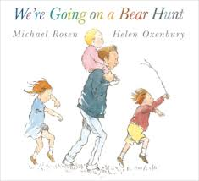  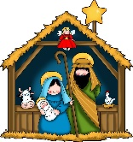  The Christmas Story | 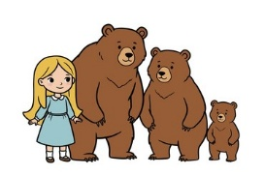  Goldilocks and the 3 bears  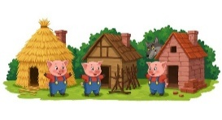  The 3 little Pigs | 3 Billy goats Gruff  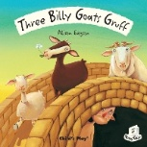  Farmyard Hulabaloo  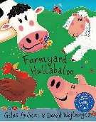 | The Very Hungry Caterpillar  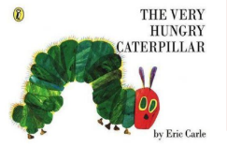  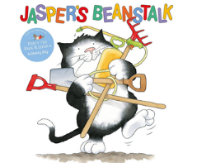  Jaspers Beanstalk | Rainbow Fish  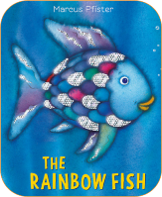  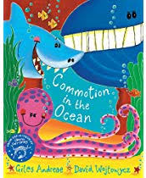  Commotion in the Ocean
Supplementary  Texts  Themes and events | Non-fiction books about starting nursery  Stories about families  Tidy Titch  Autumn  Halloween | Skeleton Story  Dear Santa  Bonfire night  Diwali  Remembrance Day  Children in Need | Where’s My Teddy?  Little Red Riding Hood  Winter  Chinese New Year  Valentine’s Day | Rosie’s Walk  Dear Zoo  Easter  Spring  World Book Day  Mother’s Day (15th March)  Red Nose Day (20th March) | Sam Plants a Sunflower  Life Cycles – Non-fiction | Mrs Pirate  Non-fiction books about starting school  Farm Trip  Father’s Day (21st June)  Graduation
Nursery Rhymes/songs | Finger Family (Tommy thumb)  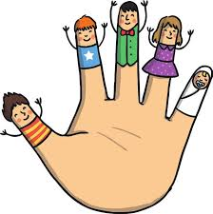  Head, shoulders, knees and toes  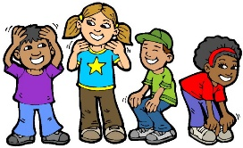 | 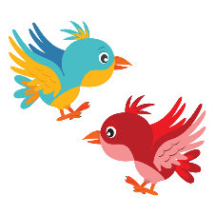  2 Little dicky birds  Twinkle Twinkle    Christmas Songs | Wind the Bobbin up  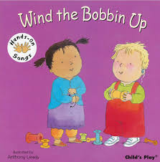  Miss Polly had a Dolly  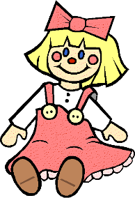 | Baa Baa Black Sheep  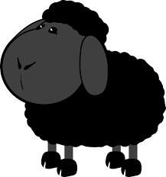  Moo Moo Jersey Cow  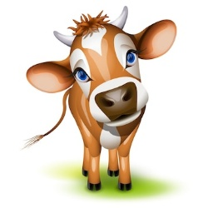 | Incy Wincy Spider    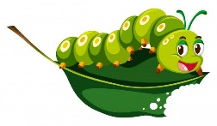  Tiny Caterpillar on a Leaf | 1,2,3,4,5 once I caught a fish  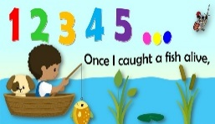  I had a little turtle  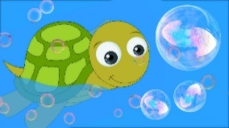
PSED
PSED is not specifically planned for in sequence across the year, however PSED Principles underpin daily classroom practice which ensures all aspects of developing PSED are covered.
Observations and next steps are central to supporting the children in making relationships, managing self and developing self-regulation.
C&L
C&L is not specifically planned for across the year. All aspects of developing CLL is considered throughout daily classroom practice, continuous provision, group time and key worker groups. Observations, next steps and target setting support the development of individuals. Our curriculum is designed and built upon stories which means children are immersed in high quality texts providing them with extensive opportunities to use and embed new words in a range of contexts. Children’s language is assessed through Welcomm on entry to Nursery. Small group interventions, high quality interactions with practitioners and a language rich environment supports all children with their communication and language development.
MD
Maths is specifically planned for in sequence across the year, building on concepts then moving on to in-depth teaching of number. Use real life examples of amounts ie a fork “3 prongs”

 | Number and Place Value:  Number songs Colours: Recognise and name colours in a variety of contexts. Say when object are/ are not the same colour.  Match: Explore and match objects that are the same.  Sort: Sort collections into sets based on attributes such as colour, size and shape. Vocabulary: size, same, different | Number and Place Value:  Number songs  Apply counting to 3 to Nursery routines.  Compare amounts:  Begin to understand collections can be more, the same or fewer than another set.  Measurement :  Understand objects can be compared and ordered according to size.  Encourage language of big and little, small and large. (More specific can be used – tall, long,  short)  Pattern: Copy, continue and create their own AB patterns. | Value:  Number songs  Apply counting to 5 to  Nursery routines. Explore in depth the value of 1, then 2. Identify representations of 1 and 2.  Subitise or count to find out how many and make their own collections. Begin to explore matching number names  to quantities and numerals.  Touch count different arrangements and understand cardinal principality.  Shape:  Explore, identify and talk about circles (link to number – 1 sided  shape)  Weight:  Understand heavy and light.  Explore comparisons of heavier and lighter objects.  Use language heavy, heavier than, heaviest and light, lighter than and lightest.  Position:  Understand the concept and use the language of ‘in, on, on top of, under, in front, behind, next to, in between.’ | Number and Place Value:  Number songs  Identify representations of 1,2, 3 and 4. Explore in depth the value of 3, then 4. Count on and back to 4. Subitise or count to find out how many and make their own collections. Begin to explore matching number names  to quantities and numerals.  Touch count different arrangements and understand cardinal principality.  Shape:  Explore, identify and talk about triangles, squares and rectangles. (link to numbers – 3 sided and 4 sided shapes)  Length and Height:  Begin using language to describe length and height: longer, shorter, taller, wider and narrower. Begin to compare objects by length and height. | Number and Place  Value  Number songs  Identify representations of 1,2, 3, 4 and 5. Explore in depth the value of 4, then 5.  Count on and back to 5. Represent 1-5 using marks, pictures and fingers.  Composition and subitising of numbers up to 5.  Addition and Subtraction:  Understand the concept of more and less  Understand that a group can be changed by adding 1 more and taking 1 less.  Begin to see the link between counting forwards and the 1 more patter and back and the 1 less pattern.  Shape:  Noticing shape in the environment.  Describe and talk about properties of 2D shapes (circles, triangles, squares and rectangles) Capacity:  Begin to explore empty and full. | Number:  Number songs  Explore in depth the value of 5 and 5 in the environment. Count, find and represent 5 on a 5 frame and a number line.  Time:  Order events in daily routines using first, next, then, last, day, night, morning, afternoon, before, after, today, tomorrow.  Direction:  ‘Up, down, across.’  Addition and  Subtraction:  Counting on and back  Finding a total  1 more/less  Composition of numbers to 5 –link to first, then, now, using mathematical stories.  Capacity:  Explore empty, full
Vocabulary
Number: addition and subtraction: number, numeral. 0, 1, 2, 3, 4, 5, none, how many, count, count up/down/from/to/back, more, less, same, different, equal, altogether, subitise, first, last, value, 5 frame, number line, sort
Shape and Pattern: shape, pattern, flat, curved, straight, round, corners, sides, rectangle, square, triangle, circle, pattern, match, repeating, same, different, sort
Measurement: measure, size, compare, sort, guess, enough, not enough, more, less, empty, full, half full, big (er, est), little, large(er, est) , small(er, est), light(er, est), heavy (er, est), tall(er, est), short (er, est), days of the week , morning, afternoon, evening, day, night, lunch, first, next, then, now, last, before, after.
Position and direction: in, on, on top of, under, over, behind, in front, through, outside, inside, up, down, across, forwards, backwards.
Phonics
During the summer term the children ready for phase 2 phonics will also begin the Super Sonic Phonics programme at set 1

Phase 1 phonics is taught throughout the year through planned activities and in continuous provision.  We continually revisit all aspects due to the 3 intakes of children. | Phase 1 aspect 1 – environmental sounds Tuning into sounds (auditory discrimination)  Intent -To develop children’s listening skills and awareness of sounds in the environment.  Intent – Further development of vocab and children’s identification and recollection of the difference between sounds.  Talking about sounds –  (developing vocab and language comprehension)  Intent – To make up simple sentences and talk in greater detail about sounds. | Phase 1 Aspect 2 – General sound discrimination – Instrumental sounds.  Tuning into sounds (auditory discrimination)  Intent – Become more familiar with the language and sequence of nursery rhymes.  Intent – To experience and develop awareness of sounds made with instruments and noise makers.  Phase 1 Aspect 2 – Instrumental sounds  Listening and remembering sounds (auditory memory and sequencing)  Intent – to listen to and appreciate the difference between sound made with instruments.  Phase 1 Aspect 2 – Instrumental sounds  Talking about sounds (developing vocab and language comprehension)  Intent – to use a wide vocab to talk about the sounds instruments make. | Phase 1 Aspect 3 General sound discrimination – Body Percussion (also recap of environmental sounds for class and new starters to term 2 throughout the week) tuning into sounds.  Intent – to develop awareness of sounds and rhythms.  Phase 1 aspect 3 – Body percussion  Listening and remembering sounds.  Intent – to distinguish between sounds and to remember patterns of sound and to distinguish musical instruments from voice sounds.  Phase 1 Aspect 4 – rhyme and rhythm  Tuning into sounds  Intent – to experience and appreciate rhythm and rhyme and to develop awareness of rhythm and rhyme in speech. | Phase 1 Aspect 4 Rhyme and Rhythm  Listening and remembering sounds  Intent – To increase awareness of words that rhyme and to develop knowledge of rhyme.  Rhyme and rhythm talking about sounds  Intent – to talk about words that rhyme and produce rhyming words.  Phase 1 aspect 6 voice sounds  Tuning into sounds  Intent- to distinguish between the differences in vocal sounds (including oral blending and segmenting)  Intent – listening and remembering sounds to explore speech sounds.  Intent – talking about sounds. To talk about the different sounds that we can make with our voices. | Phase 1 Aspect 5 Alliteration tuning into sounds.  Intent – to develop understanding of alliteration.  Phase 1 Aspect 5 alliteration listening and remembering sounds.  Intent – to listen to sounds at the beginning of words and hear the differences between them.  Phase 1 Aspect 5 Alliteration – talking about sounds  Intent – to explore how different sounds are articulated, and to extend understanding of alliteration and to generate words that begin with the same sound as the stimulus word. | Phase 1 Aspect 5 Alliteration – Talking about sounds.  Intent – to explore how different sounds are articulated and to extend understanding of alliteration. To generate words that begin with the same sound as the stimulus word.  Phase 1 Aspect 7 Oral blending and segmenting. Listening and remembering sounds.  Intent to listen to phonemes within words and to remember them in the order in which they occur.  Phase 1 aspect 7 Oral blending and segmentation. Talking about sounds  Intent – to talk about the different phonemes that make up words.
Physical Development
Physical activity is vital in children’s all-round development, enabling them to pursue happy, healthy and active lives. Gross and fine motor experiences develop incrementally throughout early childhood, starting with sensory explorations and the development of a child’s strength, co-ordination and positional awareness. By creating games and providing opportunities for play both indoors and outdoors, adults can support children to develop their core strength, stability, balance, spatial awareness, co-ordination and agility. Gross motor skills provide the foundation for developing healthy bodies and social and emotional well-being. Fine motor control and precision helps with hand-eye co-ordination, which is later linked to early literacy. Repeated and varied opportunities to explore and play with small world activities, puzzles, arts and crafts and the practice of using small tools, with feedback and support from adults, allow children to develop proficiency, control and confidence.
UW
Understanding the world involves guiding children to make sense of their physical world and their community. The frequency and range of children’s personal experiences increases their knowledge and sense of the world around them – from visiting parks, libraries and museums to meeting important members of society such as police officers, nurses and firefighters. In addition, listening to a broad selection of stories, non-fiction, rhymes and poems will foster their understanding of our culturally, socially, technologically and ecologically diverse world. As well as building important knowledge, this extends their familiarity with words that support understanding across domains. Enriching and widening children’s vocabulary.
UW  Our RE Curriculum enables children to develop a positive sense of themselves and  others and learn how to form positive and respectful relationships.  They will begin to understand and value the differences of  individuals and groups within their own community.  Children will have opportunity to develop their emerging  moral and cultural awareness.  Children will have the opportunity to work scientifically throughout the year. | Make connections between the features of their family and other families - celebrate differences.  Begin to make sense of their own life story and share photographs. Sequence family members by size – baby, child, adult  Learn basic body parts. Develop positive attitudes between the differences between each other. Introduce Nursery Values – Kindness and Friendship. Introduce Nursery routines - Being a good friend, helping hands. Explore our environment and talk about where they live.  Talk about their houses and the features. | Experience, observe and talk about changes in the environment (daily and through different seasons) including changes to trees and other plants, and changes in the weather our world.  Celebrate different celebrations - Diwali, Christmas and Bonfire Night.  Explore light and dark. Explore and identify differences in routine between day and night. To talk about special events that happens immediately to them Use simple words to talk about the passing of time – now, next, last night, today.  Understand the significance of  Remembrance day. Celebrate Nursery Rhyme week. | Experience, observe and talk about changes in the environment (daily and through different seasons) including changes to trees and other plants, and changes in the weather. Celebrate Shrove Tuesday.  Investigate freezing and melting and explain what is happening. Know which clothes are suitable to wear in winter. | Identify people who help us in our lives. Show an interest in different occupations. Imagine what we could be when we are grown up.  Talk about the Physical features of our school, West Street Community Primary and Nursery School.  Experience, observe and talk about animals and their babies and the importance of caring for animals.  Experience and find out where different fruit and vegetables come from | Experience, observe and talk about changes in the environment (daily and through different seasons) including changes to trees and other plants, and changes in the weather our world.  Explore change in living things – life cycle of caterpillars.  Experience, observe and talk about plants including growing and caring for plants. Explore and discuss healthy and unhealthy foods.  Talk about and share experiences of recent and upcoming events. Talk about and share family celebrations and events. | Experience, observe and talk about changes in the environment (daily and through different seasons) including changes to trees and other plants, and changes in the weather our world. Investigate mechanical toys. Investigate floating and sinking.  Discuss how they got to school and what mode of transport they used. Explore three modes of transport – sea, air and ground.  Explore simple map making.  Use BeeBots to explore directional language.  Experience and explore different small world models. Use simple words to describe the passing of time. Explore simple timelines.
EAD
EAD is not planned in sequence across the year, however there are opportunities within topics for skills to be developed, both independently and adult led. Children will have opportunities to deepen and transfer their skills throughout the year. Children will be encouraged to explore materials/ resources finding out what they are/what they can do, and decide how then they want to use them.
Drama will be covered through storytelling and imaginative play in continuous provision as well as performing for a large audience at Christmas time.
Music will be covered through planned music sessions, continuous provision as well as daily rhyme time.

 | Colour:  Experiencing using colours – to ensure they know their names. Adults to support and encourage children to represent their observations, ideas, thoughts and feelings through the resources available.  Explore painting as a sensory process using hands and fingers to create marks and mix colours.  Drawing:  Encourage accurate drawings of people that include all the visible parts of the body. (head, hands, fingers, where are they?) Independently access a range of media, materials and tools presented in different ways, in different contexts, with opportunities for open ended exploration. Texture and form:  Observe, explore and experiment how specific materials/tools can be used (safely), and opportunities to be taught specific skills and techniques for drawing, painting, collage, sculpture, etc  Experience and explore the world around them (including the natural world) using their senses, with opportunities to talk about what they see, hear, feel and smell. Handle, feel and manipulate materials. | Colour:  Uses a range of tools to make coloured marks on paper – glue sticks, sponges, brushes, fingers  Adults to support and encourage children to represent their observations, ideas, thoughts and feelings through the resources available.  Explore painting as a sensory process using hands and fingers to create marks and mix colours.  Drawing:  Independently access a range of media, materials and tools presented in different ways, in different contexts, with opportunities for open ended exploration. Texture and form: Observe explore and experiment, how specific materials/tools can be used (safely), and opportunities to be taught specific skills and techniques for drawing, painting, collage, sculpture, etc  Creates simple collages, using paper, pasta, beans and larger tactile things.  Handle, feel and manipulate materials. Impress and apply simple decoration to malleable materials. Pattern and Printing: Explore taking prints from objects: leaf, hand, feet, junk, bark, modelling clay etc. Imitate and create own simple repeating patterns using concrete objects, i.e. making an object train and photographing  (buttons/stones/blocks), bead threading patterns. Explore printing as an introduction to ‘pattern’ using a repetitive image and make their own patterns using different media and materials. Develop simple patterns by using objects | Colour:  Explore painting as a sensory process using hands and fingers to create marks and mix colours.  Drawing:  Adults to support and encourage children to represent their observations, ideas, thoughts and feelings through the resources available.  Explore a variety of different textures, using the correct language to describe them.  Independently access a range of media, materials and tools presented in different ways, in different contexts, with opportunities for open ended exploration.  Texture and form:  Observe, explore and experiment how specific materials/tools can be used (safely), and opportunities to be taught specific skills and techniques for drawing, painting, collage, sculpture, etc Explore a variety of different textures, using the correct language to describe them. Handle, feel and manipulate materials. | Colour:  Explore painting as a sensory process using hands and fingers to create marks and mix colours.  Drawing:  Explore and experiment freely with a range of tools, materials and techniques in 2D and 3D through drawing, painting, sculpture. Adults to support and encourage children to represent their observations, ideas, thoughts and feelings through the resources available.  Independently access a range of media, materials and tools presented in different ways, in different contexts, with opportunities for open ended exploration. Explore and experiment freely with a range of tools, materials and techniques in 2D and 3D through drawing, painting, sculpture. Encourage children to draw from their imagination and observation.  Texture and form:  Observe, explore and experiment how specific materials/tools can be used (safely), and opportunities to be taught specific skills and techniques for drawing, painting, collage, sculpture, etc Handle, feel and manipulate materials. Construct and build from simple objects  Investigate a wide range of found materials (‘junk’) as well as blocks, clay, soft wood, card, offcuts of fabrics and materials with different textures. | Colour:  Adults to support and encourage children to represent their observations, ideas, thoughts and feelings through the resources available.  Explore painting as a sensory process using hands and fingers to create marks and mix colours.  Drawing:  Independently access a range of media, materials and tools presented in different ways, in different contexts, with opportunities for open ended exploration. Offer opportunities to explore scale. Suggestions: - long strips of wallpaper - child size boxes - different surfaces to work on e.g. paving, floor, tab  Texture and form: Observe, explore and experiment how specific materials/tools can be used (safely), and opportunities to be taught specific skills and techniques for drawing, painting, collage, sculpture, etc Handle, feel and manipulate materials. Pattern and Printing: Explore simple symmetry – folding painted butterflies Artist Study: Introduce children to the work of artists from across times and cultures.  Creating art pieces with fruit in the style of Arcimboldo. | Colour:  Explore colour and colour mixing. Play instruments with increasing control.  Remember and rehearse songs, poems and nursery rhymes. Explore painting as a sensory process using hands and fingers to create marks and mix colours.  Discuss the differences between colours to explore and refine their colour mixing – for example: “How does blue become green?  Drawing:  Independently access a range of media, materials and tools presented in different ways, in different contexts, with opportunities for open ended exploration. Draw  with increasing complexity.  Texture and form: Observe explore and experiment, how specific materials/tools can be used (safely), and opportunities to be taught specific skills and techniques for drawing, painting, collage, sculpture, etc Handle, feel and manipulate materials.  Pattern and Printing: Explore the word through ‘real’ experiences, visits, objects, artefacts, photographs and video clips with opportunities to talk about features, including colours, textures, shapes, size, patterns.

