pe
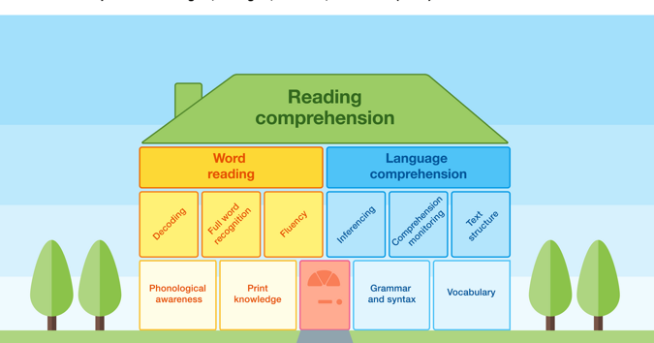
How much Reading does my child get?
Foundation and KS1
- 3 Little Wandle Letters and Sounds Revised Reading Practice sessions.
- Each session is 20 minutes.
- Year 2: In addition to Reading Practice sessions, Year 2 have a 30-minute whole-class reading session once a week.
KS2
- Reading is taught for 30 minutes daily. This involves:
- One 30-minute whole-class reading session.
- 4 further 30-minute sessions as part of a weekly ‘carousel’.

Other reading opportunities outside of the Reading lessons:
- Weekly visits to the library.
- 10 minutes every day for each class dedicated to a class text/story/novel.
- Independent reading and quizzing (AR) time.
- Using reading skills in other curriculum areas.
- Access to class reading corners.

How do we decide what to teach?

We follow the national curriculum which breaks down the expectations into year groups. In Foundation and KS1, we follow the Little Wandle Letters and Sounds Revised scheme.
In KS2, to help teachers plan, we use a combination of resources which provide children with opportunities to develop their reading fluency as well as their comprehension skills.

For KS2 reading planning, we use:
- Re-Think Reading resources.
- Literacy Shed.
- Project X books.
- Books from Accelerated Reader.
- Once Upon a Picture.
- Think Reading resources.
Class Novels
Every teacher reads to their class for at least 10 minutes a day. For this, we have developed a whole class reading spine. This ensures all classes and children are exposed to a variety of texts covering a range of topics including:
- Diversity
- Resilience/Growth Mindset
- Inspirational Females
- Mental Health and Wellbeing
- SEND/Inclusion

Reading at Hazeldown

At Hazeldown, we use Little Wandle Letters and Sounds Revised and the Accelerated Reader programme to support children to:

- Acquire proficiency in decoding.

- Develop fluency in reading.

- Enhance understanding and foster comprehension skills.

- Read for pleasure.

(Image: Education Endowment Foundation)

Reading Lessons

Foundation and KS1:
Little Wandle Letters and Sounds Revised lessons are broken down into three sessions across the week:
- Decoding
- Prosody
- Comprehension

KS2:
In KS2, during lessons, children are exposed to range of lesson formats and skills to support them in making progress in Reading. These include:
- 1 weekly, guided reading session with the teacher.
- 1 weekly, reading-based follow-up task.
- 1 session focused on ‘Book Buzz’ to encourage reading for pleasure.
- 1 session used for reading independently and quizzing on Accelerated Reader books.

Accelerated Reader
Accelerated Reader is a programme used once children are secure and fluent with phonically decodable books. As a guide, if children are fluently reading Phase 5 Set 5 books, they will take a STAR test. If they score at least a standardised score of 97, they will move onto the Accelerated Reader programme.

For the first half term of joining Accelerated Reader, children need to continue to read Phase 5 Set 5 books alongside their AR books to support with the transition.

Once on the Accelerated Programme, children should complete a STAR test at the beginning of every half term. This will provide them with a new reading range and teachers will set a points target.

Reading ranges provide children with a range in which they can choose books from in the library. The range is aimed to be challenging enough to make progress, but not too challenging to demotivate them from reading. This is an example of a reading range:

Points targets are set for each child on AR at the beginning of a half term. This is based on their range and how much of their target they achieved during the previous half term. Points are earned by quizzing on a book once a child has finished reading it. They will then move up the reading tree based on how their progress towards their point target.

Parents can view their child’s progress on Accelerated Reader by logging in through Home Connect. See the link on the Reading page of our school website.

Quizzes on Accelerated Reader can only be completed at school and between the times of 8.30 and 3.30pm.

Supporting your child at home
All children in Foundation and KS1 will bring their decodable book home once they have read it in school 3 times. Please read for at least 10 minutes at least 5 times a week.

Children from Foundation and KS1 will also have a ‘reading for pleasure’ book from the library. This is to be shared with children and they are not expected to be able to read this independently.

All children in KS2 should read at home for at least 15 minutes at least 5 times a week.

Please record what children have read at home in their reading records:

