Classroom Working Wall Diagram

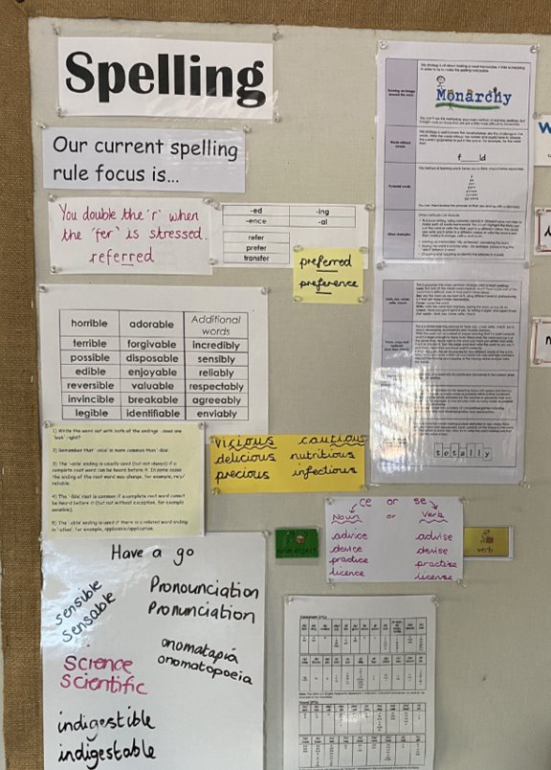

Curriculum Coverage

Using No Nonsense Spelling allows us to plan, deliver and assess pupils’ learning and progress within spelling sessions.
In KS1, there is a smooth transition from the learning of phonics to applying this knowledge to spelling.
Pupils with SEND who are working on an alternative spelling curriculum have full exposure to the age-related spelling curriculum and interventions are provided to continue to teach any gaps in knowledge.
Using their Spelling Journals, pupils develop their phonological awareness and spelling conventions to take ownership of their own progress. Pupils use the back of their Spelling Journals to record their own target words to practice.
‘Have A Go’ books enable children to increase their understanding of the different strategies they can use when a word is unfamiliar.

Assessment
To promote the effective use of Retrieval Practice, each term, year groups undertake an assessment based on the rules and spelling patterns they have been focusing on.

Spelling

Spelling at Hazeldown aims to help children to develop a strong connection between the letters and their sounds. In addition to this, learning high frequency ‘sight words’ (i.e. words that cannot easily be sounded out) will assist children in both their reading and writing.

No Nonsense Spelling
Here at Hazeldown, we use No Nonsense Spelling, which is a spelling programme designed to meet the needs of the 2014 National Curriculum in a manageable way.

The programme is easy to use, flexible and comprehensive, providing sufficient guidance to implement an effective spelling teaching programme from Year 2 to Year 6.

The programme consists of termly overviews, breaking down the requirements of the National Curriculum into strands with individual lesson plans and resources.

The focus of the programme is on the teaching of spelling, which embraces knowledge of spelling conventions – patterns and rules; integral to the teaching is the opportunity to promote the learning of spellings, including statutory words, common exceptions and personal spellings.

How often do we teach Spelling?
Every year group at Hazeldown receive four 20-minute sessions per week. A typical teaching sequence is as follows:

Lesson 1:
Revise – activate prior knowledge, revisit previous linked learning.

Lesson 2:
Teach – introduce the new concept, explain, investigate, model.

Lesson 3:
Practise – individual/group work, extend/explore the concept independently, investigate, generalize.

Lesson 4:
Apply/Assess – assess through independent application, explain and demonstrate understanding.

