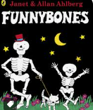
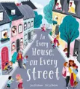
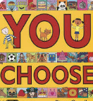
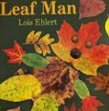

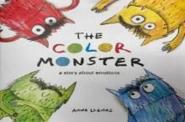
I wonder what makes me special…
marsh
orchards
prairie
meadow

midnight
cellar
connected
frighten
chat
slouch
mean
peep
landscape
portrait
vehicle
banquet
currant
gazing
looming
clamber
emotions
calm
fear
confused
Understanding the World
-Exploring digital devices
-Human body and senses
-Seasonal changes
-Celebrations
-Where we live
-Growing up and changing
Maths
-Colour matching
-Counting/Place value
-Prepositional language
-Days of the week/Months of the Year
-Measurement/Size
-Shape
-Patterns/Sequence

Communiction and Language
-Joining in with repeated refrains and anticipates key events and phrases in rhymes and stories
-Beginning to understand why and how questions
-Beginning to use more complex sentences to link thoughts e.g. using “and”, “because”
- Using talk to explain what is happening and anticipate what might happen next

-Developing fine and gross motor skills
-Strengthening pencil grips
-Developing different ways to move our body

PSED
-Building new relationships
-Developing confience and self-esteem
-Managing own feelings and behaviours
-Perservering a with chosen activity

Reading
-Knowing that print carries meaning and, in English, is read from left to right and top to bottom
-Talking about events and principal characters in stories and suggests how the story might end
-Clapping the syllables in words during sound play
-Recognising familiar words and signs such as own name and advertising logos
Writing
-Giving meaning to marks they make as they draw, write and paint
-Attempting to write their own name, or other names and words, using combinations of lines, circles and curves

Phonics

Physical Development
Expressive Arts and Design
-Mark maing with tools
-Drawing faces
-Hibernation boxes
-Scissor skills
-Welcome songs

