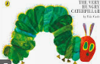
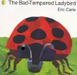
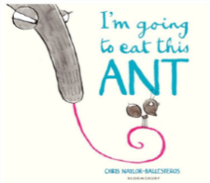
PSED
-Developing confience and self-esteem
-Managing own feelings and behaviours
-Perservering a with chosen activity
-Understanding and describing the celebrations of various faiths

Reading
-Recalling and discuss stories or information that has been read to them, or they have read themselves
-Hearing and says the initial sound in words
-Beginning to develop phonological and phonemic awareness, continues a rhyming string, and identifies alliteration
Writing
Identifying letters and writing recognisable letters in sequence, such as in their own name
Giving meaning to the marks they make as they draw, write, paint and type using a keyboard or touch-screen technology

I wonder what it feels like to be as small as a bug…

insist
eerily
raised
aphids
stomach
nibbled
cocoon
chrysalis
served
smothered
simmering
sauteed
Understanding the World
-Habitats
-Minibeasts
-Maps
-Taking photos/videos
-Explroring faiths
-Celebrations
Maths
-Place value/Numbers 0-4
-More/less/number matching
-Prepositional language
-Days of the week/Months of the Year
-Shape
-Patterns

Communiction and Language
-Indicating two-channelled attention, e.g. paying attention to something of interest for short or long periods; can both listen and do for short span
-Understanding questions such as who; why; when; where and how
-Using talk to organise thinking and activities, and to explain what is happening and anticipate what might happen next

9
-Ball skills
-Fine and gross motor skills
-Healthy eating
-Toothbrushing

Physical Development
Expressive Arts and Design
-Clay minibeasts
-Firework art
-Christmas crafts
-Nativity songs
-Nativity performance
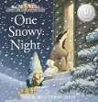
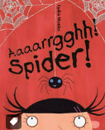
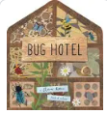
upside down
pet
clean
introduce
pollen
metamorphosis
species
predators
miserable
shivering
creak
stirred

