Good Morning Team 6,

Welcome to Conway@Home. As I am sure you are aware, we were due to go to Conway this week, from Monday to Wednesday. While we can’t pack our bags and go and enjoy the great outdoors together, we still want you to have a fantastic week, so we have arranged a virtual camp instead.
We are really looking forward to seeing all your fabulous photos/videos via school spider scrapbook or recorded in home learning books. Should you have any questions at all, please get in touch by email to- grace.young@oldfield.cheshire.sch.uk

We hope you have a wonderful week.

Best wishes,


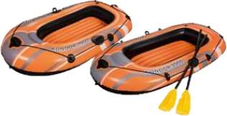

Miss Young and Mrs Rustom
Thanks for the lift Mrs Rustom; keep rowing.
Nearly there now Miss Young.
Conway@Home – Tasks, Challenges and Optional Additional Activities
Please be safe while doing these activities and check with an adult before starting any activity.

First things first
Pack your bag | You can never be too prepared for the great British weather. Write out you kit list for the trip. | Ideas:  - Draw out the items you’d have packed  - Pack a pretend bag for the next 3 days
Prepare a travel playlist | What’s a school trip without bus songs? Listen to 5 of your favourite songs whilst you travel along to Conway@Home | Ideas:  - Add a dance routine to the songs  - Sing along to the karaoke version  - Perform the songs to your household
Calculate the journey distance. | Seeing as we’re travelling to Conway from our homes, can you use Google Maps to help you plan a route? | Ideas:  - Calculate the distance in meters, kilometres and miles.  - How long would the journey take if you collected a friend on the way?
Build your campsite | You need somewhere to sleep! It could be a tent in your garden, or a den in your living room. | Ideas:  - Pitch tent in garden  - Pitch tent in house  - Build a den with bed sheets and sofa cushions  - Build a den outside
Build your campfire | What’s a camp without a campfire? Your task is to build a campfire using whatever you can find – it does not have to be real. | Ideas:  - Build a Lego fire  - Draw a fire  - Paint a fire on cardboard  - Use a google image

Key Challenges
Virtual Day trip | Take a virtual day out and visit one or more of these attractions.  For each of the attractions you visit sum up your experience by answering the following questions:  1. Where did you visit?  2. Describe your tour.  3. List 3 things you saw on your tour.  4. List 3 interesting facts about your tour.  5. List 3 things you learnt on your tour.  6. What was your favourite thing on your tour? | Virtual Trips:  - Use Google Map Street View to explore a different town  - Longleat Safari Park  - National Aquarium  - San Diego Zoo  - Houston Zoo  - Walt Disney World  - Frozen Ever after Ride  - It’s a Small World  - Monsters Inc. Mike and Sulley  - Pirates of the Caribbean  - SeaWorld Orlando  - National Marine Aquarium  - LegoLand Florida  - Atlanta Zoo Panada Cam  - Monterey Bay Aquarium  - The Louvre  - Smithsonian National Museum of Natural History  - British Museum, London  - NASA  - Langley Research Center  - Glenn Research Center  Or you can try some "augmented reality experiences" via The Space Center Houston's app.
Ten Minute Hike | How many steps can you take walking around your house (and garden if you have one) in ten minutes?  Record the number of steps that you take. | Ideas:  - Attempt to beat your steps each day.
Star Gazing | If we have a clear night, ask your adult if you can stay up a bit later and do some star gazing. Which different constellations can you see? | Useful apps for looking at the night sky:  NASA App: Track the movements of the International Space Station.  Star Walks Kids: An app that when you point it at the sky tells you the constellations you are looking at.  Alternatively, if the weather is bad then explore the constellations using https://in-the-sky.org/skymap.php.
Reflection | Write a diary entry each evening you go to bed reflecting on your Conway@Home adventure. | Ideas:  - Make a Conway@Home diary  - Draw cartoon strips of what you’ve completed each day  - Voice record the activities you enjoyed
Bedtime Story | In bed or your newly built den read a bedtime story. | Ideas:  - Film yourself reading  - Facetime a friend or relative and read to them  - Have you adult read with you  - Read to a sibling or your teddies
Rise and Shine | Conway@Home is about becoming independent- please make your bed each morning. | Ideas:  - Write instructions on how to make a bed  - Film yourself doing it

Fun Challenges
Scavenger Hunt | 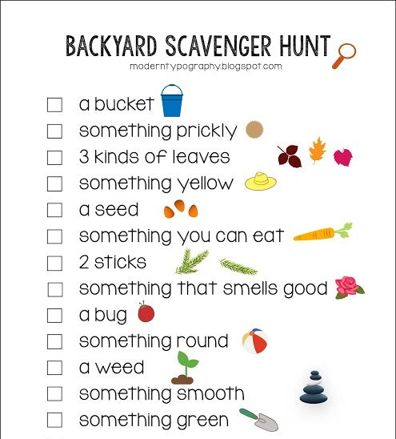  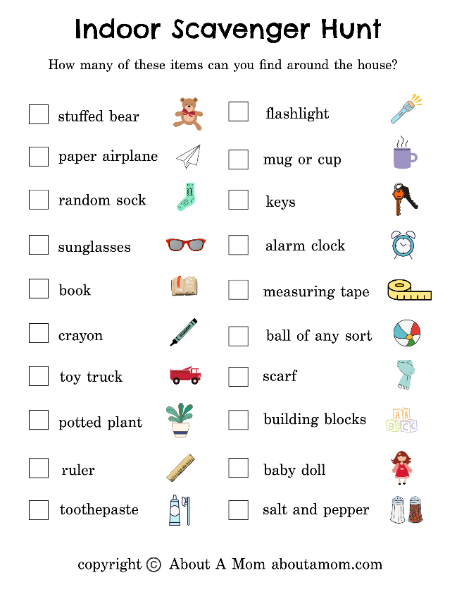  Can you find all of the items on the outdoor or indoor scavenger hunt?
Biscuit Challenge | Place a biscuit on your forehead, get it into your mouth without using your hands. Film and send it! | Example:  https://youtu.be/IZvQ25wLAFI  Is it easier with different biscuits?
Human Knot | With 3+ people (the more people, the more challenging it is). | Example:  https://youtu.be/lQ-a_6eA0EU  Have everyone stand in a circle facing the centre. Everyone raise their left hand and hold the left hand of someone across the circle. Then raise the right hand and hold the right hand of someone different across the circle.  You then need to get yourself unknotted, into a big circle without letting go of the other peoples’ hands.  How many people can you do it with?
Shoe tower | What’s the biggest tower you can build with shoes? | What’s the best way you have found to make a tower?
Tea Pot challenge | You will need a Tennis ball. Aiming to throw the ball up as it falls through you ‘teapot’ arm. | Example:  https://youtu.be/Hcl8iGkOX7I
Toilet People | Build your best Toilet person! | 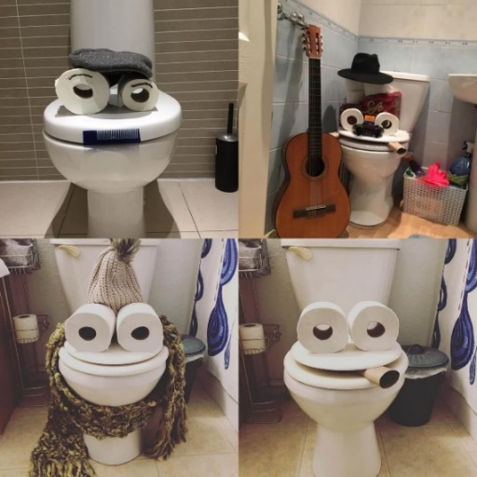

Additional Activities
Activity | Descript | Resources/Notes/Tips
Bottled up emotions | Our current situation can lead us to experience a range of emotions. Let’s get these out of our head. Using the templates, draw the emotion in the bottle and colour it in.  You can download the pdf version to print off and colour in, or, download load the image to your computer/tablet/phone and colour it in on there. | Templates:  - JPG Image  - PDF doc  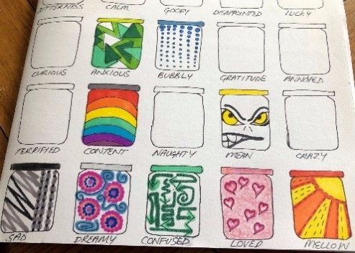  Example:
Send a hug | An easy way for us to brighten the day a friend or love one.  Draw around yourself, colour it in and write a message to someone you’re not able to see at the moment. | 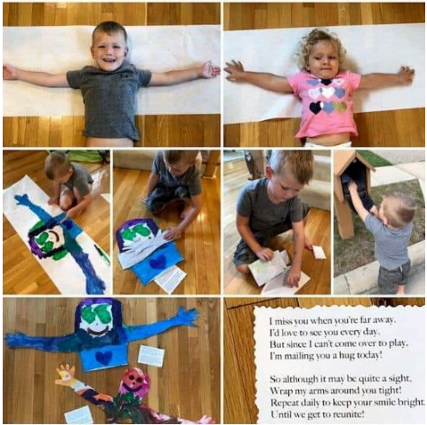
Mountain Climbing | If you have steps in or near your house, why not challenge yourself to climb a mountain.  For example, if you wanted to climb Snowdon, you would need to climb 7120 steps. | Different mountain heights as steps:  https://www.nhsggc.org.uk/media/213470/haw_challenge_stair_climb.pdf  https://www.muchbetteradventures.com/magazine/how-many-stairs-do-you-need-to-climb-to-reach-the-top-of-famous-mountains/
Learn a magic trick | Learn a simple magic trick(s) and perform it/them for your family | - Search “Simple Magic tricks” on google
Learn to juggle | Spend some time learning a new skill! | - Look up juggling tutorials on YouTube  - You don’t have to start will balls, try juggling with handkerchiefs
Recreate a famous picture or scene. | Use your imagination to recreate a famous picture or scene. | Examples:  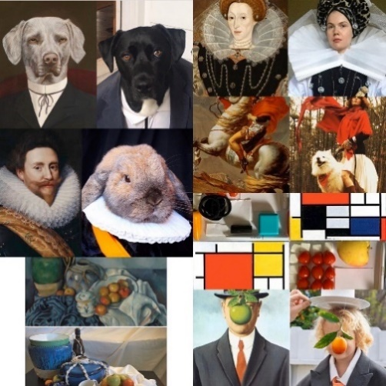
Origami Zoo | Create an origami zoo at home! | Suggested links:  - origamiway.com/origami-animals  - origami-instructions.com/origami-animals-instructions  - Search Google  - Find instruction videos on YouTube
Visit #TheGreatIndoors | Visit the national Scouting The Great Indoors website and see what activities they have posted on there you can have a go at | https://www.scouts.org.uk/the-great-indoors/

