My Year 5 Residential Trip

On Monday 15th June my class and I are going on a school residential trip to The Conway Centre in Anglesey. We will travel on a coach and the journey will take about an hour. Here are some pictures of the centre…
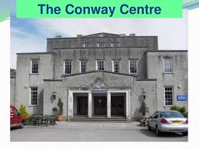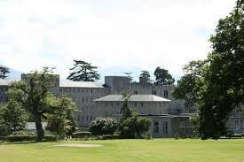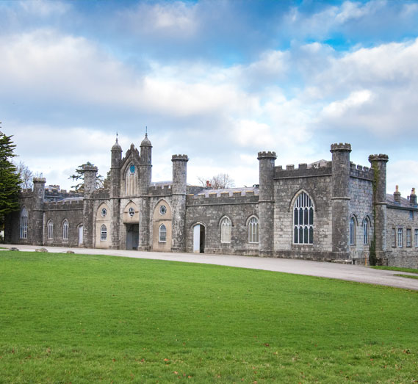

The Conway Centre is quite big and is surrounded by lots of grass and trees. We will stay there for two nights and lots of familiar adults from school will stay there too. This will be a really fun and exciting experience where I will be able to learn and try lots of new things.

We will be put into groups and the instructors at the centre will give us the right things to wear and explain everything we need to know.

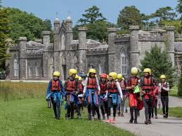

We will have a go at Indoor rock climbing, canoeing, via ferrata and zip wire.
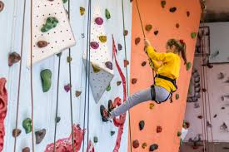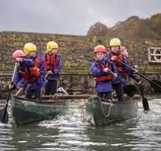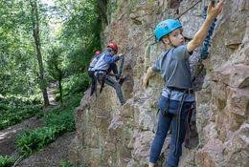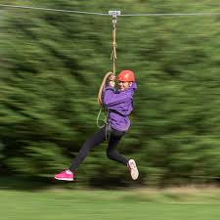

It’s going to be so exciting!

At tea time, we will collect our meals from the canteen and then all eat together. We will have lots of fun talking about our exciting days and what we have been up to.

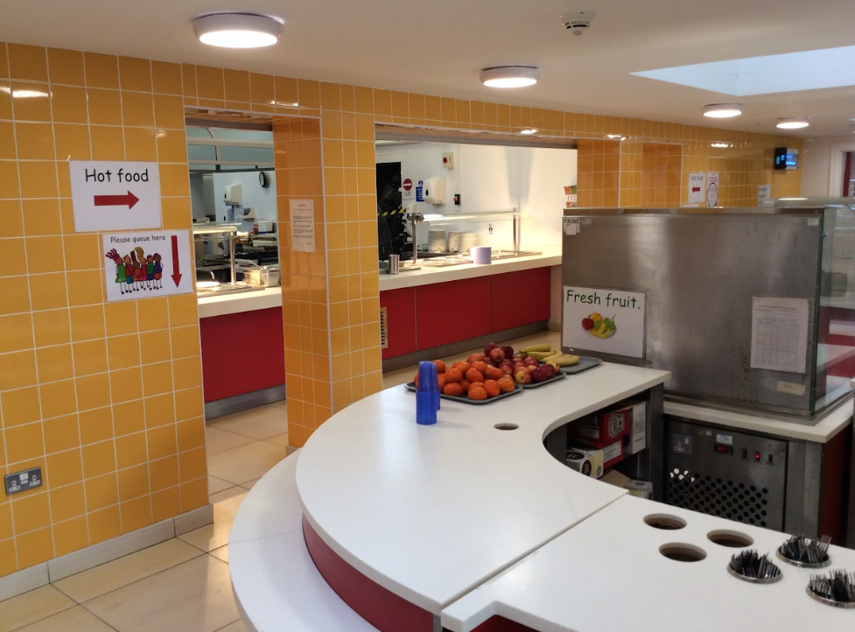
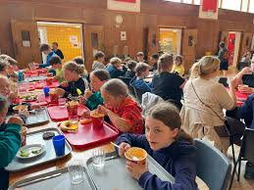

We will sleep in a house called Hafod.

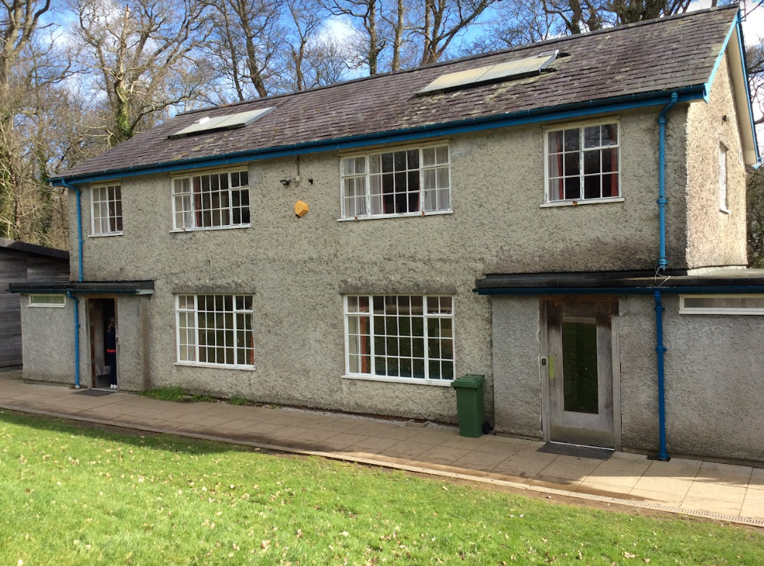
The boys will sleep on one side of the house and the girls on the other.

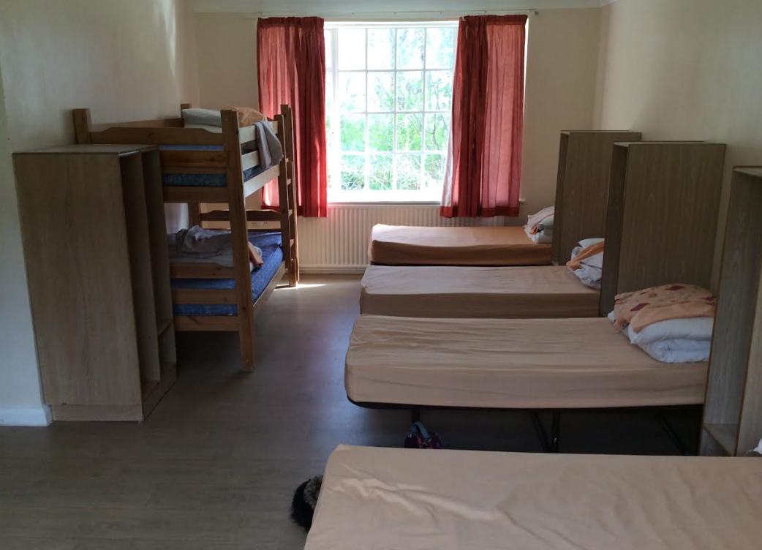
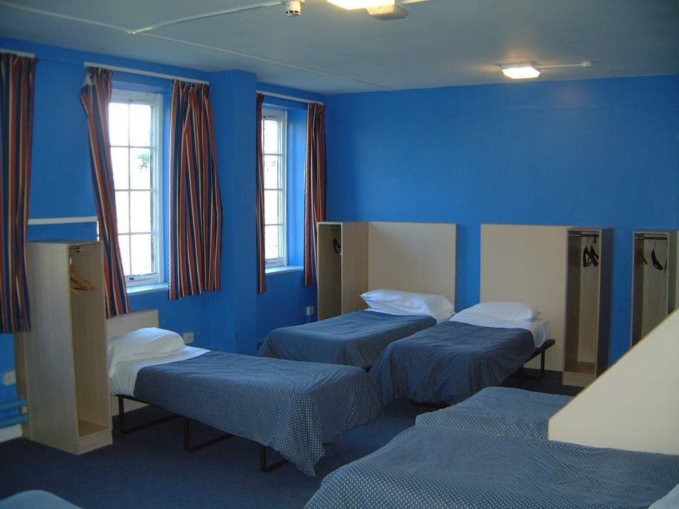
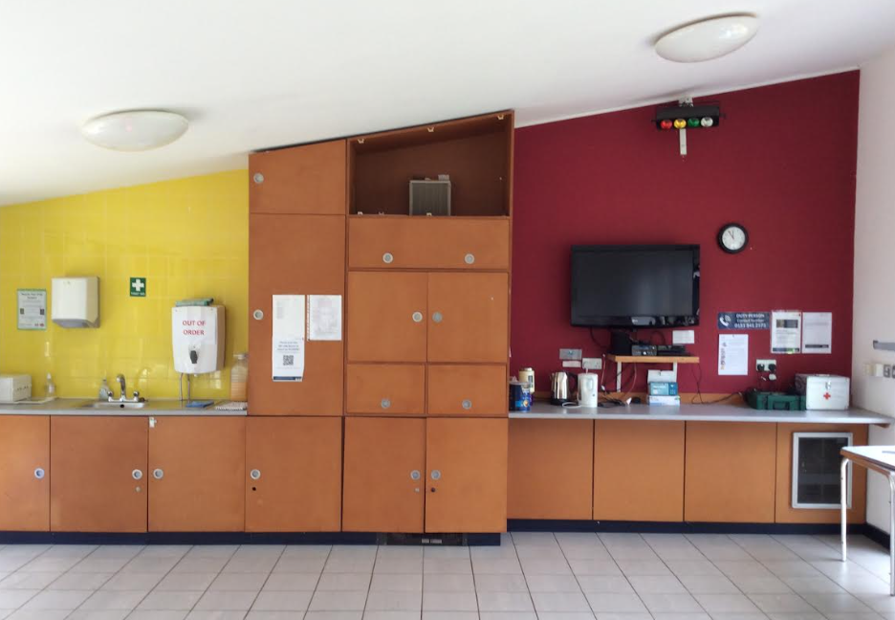
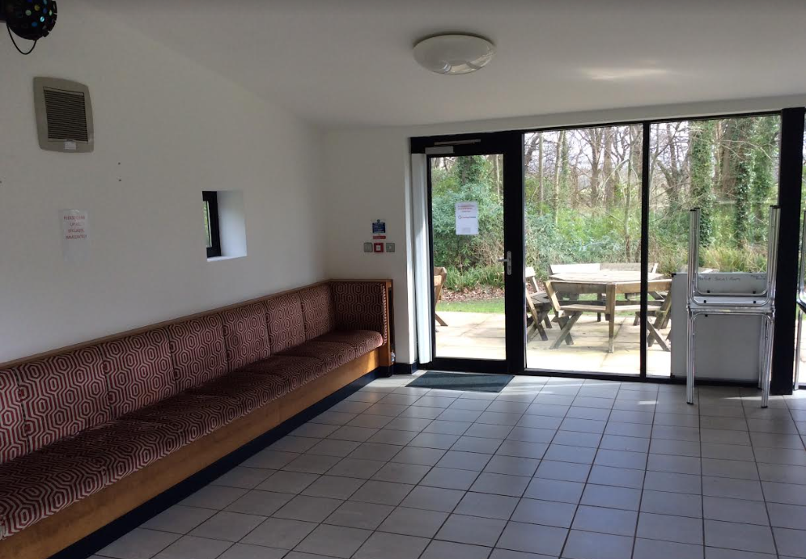
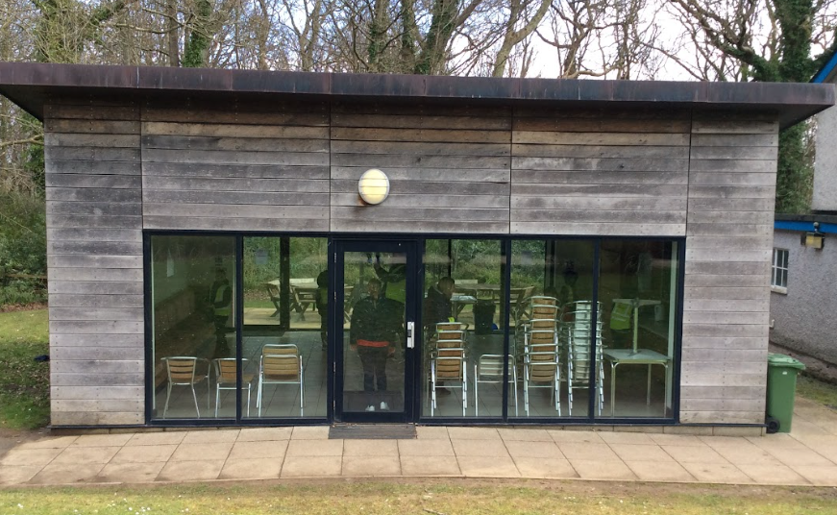
We also have a social room where we get to relax and watch TV.

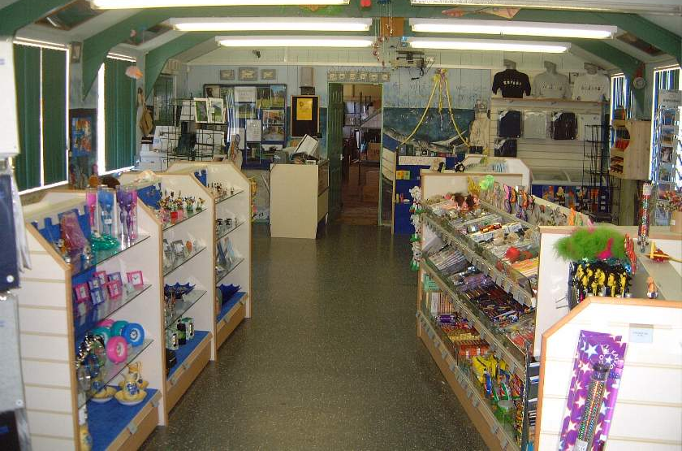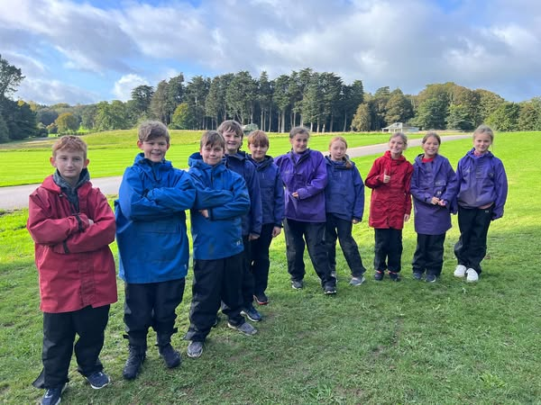

On our last night we will be able to go to the shop and buy some souvenirs. It is so much fun at the Conway Centre!

Even though I will try lots of exciting new activities I will also get to learn more about being away from home with my friends. It is a great opportunity for us all to spend time together.

Sometimes I get nervous and worried about trying new things. If I feel like that when I am away there will be lots of adults to help me and look after me. My friends will be there too and we will all help each other. I must remember that I am safe and everything is okay.

If I try my best and am able to have a go at these new things I will feel really happy and proud of myself. My teachers and my parents will be really happy and proud of me too. Everyone will feel happy!

We will then come home on the coach on Wednesday 17th and I will get to tell my parents and family about all the fun we have had!



