Carr Mill Primary School



Attendance
Policy

Approved by: | SLT/Governing body | September 2022
Last reviewed on: | September 2022
Next review due by: | September 2023 (Annually)



Contents
1.Introduction
2. What are the attendance expectations?
2.1 School Aims
2.2 Statutory Requirements
2.3 Responsibilities
3. . What are the school attendance routines?
3.1 The School Day
3.2 Registers
3.3 Lateness
3.4 Reporting Absence
3.5 Authorised / Unauthorised Absence
3.6 Leave of Absence During Term Time
3.7 Fixed Penalty Notices
3.8 Children Missing in Education
4. How do school monitor attendance?
4.1 Daily Register Checks
4.2 Weekly Attendance Review
4.3 Termly Monitoring
4.4 Reporting to Parents
4.5 Reporting Other Agencies and Services
5. How do school motivate children to have good attendance?
5.1 Rewards
5.2 Awareness
6. Who can support me to improve my child’s attendance?
6.1 Key members of staff who can provide support
7. What happens if my child has poor attendance?
7.1 Tier 1 ‘Green’
7.2 Tier 2 ‘Amber’
7.3 Tier 3 ‘Red’
7.4 Persistent Absentees
7.5 Severe Absentees
7.6 Part Time Timetables
8. Conclusion
8.1 Equality through Delivery of the Policy
8.2 Links to Government Legislation
8.3 Review of the Policy
9. Supporting Documents

(See Supporting Document contents page)

1. Introduction

At Carr Mill Primary School, we know that it is vital that our children attend school regularly and punctually to achieve best life outcomes. We want our children to become the best versions of themselves; academically, socially and morally as they grow into the next generation of our community. Good school attendance is the foundation to this.

‘Attendance is EVERYBODY’S responsibility’
#teamcarrmill are STRONGER when we work TOGETHER, therefore it is the responsibility of all members of our school community to maintain and monitor good school attendance.
Our attendance expectations are very simple:
We attend school REGULARLY
We attend school PUNCUALLY
We attend school READY to learn

We expect all our children to achieve at least a 96% attendance percentage each year. However, we know that there can sometimes be exceptional reasons why children cannot attend school, such as illness.
At Carr Mill Primary School, we will listen, understand, empathise and provide support when children are unable to attend school – however we will not tolerate poor attendance and will always be proactive in helping our families to improve this, enable children to return to the classroom as soon as possible.
This policy will set out, in detail, the many ways in which our #teamcarrmill community will work together to support good attendance
Key Attendance Contact at Carr Mill Primary School:
Mrs Katie Alexander – Deputy Head for Pastoral and Inclusion
Mrs Pauline Doyle – Family Support Worker

2. What are the attendance expectations?
2.1 School Aims
- We want all our children to attend school daily, arriving on time and to be ready for a day of learning.
- We want all our children to achieve at least a 96% attendance rate.
- We want to remove barriers that prevent children from having good school attendance
- We want to support families to achieve good school attendance for their children
- We want our children to be safe, healthy and successful.

2.2 Statutory Requirements
The 1996 Education Act states:
‘It is the duty of the parent of every child of compulsory school age to ensure they receive efficient full-time education suitable to their age, ability and aptitude, and any special educational needs they may have, either by regular attendance at school or otherwise’

A Supreme Court ruling on 6th April 2017 stated that ‘regularly’ means ‘in accordance with the rules prescribed by the school’ – which at Carr Mill is ensuring that your child maintains at least a 96% attendance rate.

Compulsory school age begins at the start of the term following the child’s 5th birthday and ends on the last Friday in June of the school year when they reach 16.

The school is obliged by law to differentiate between authorised and unauthorised absence. A letter or telephone message from a parent does not in itself authorise an absence. Only the school’s acceptance of the explanation offered by the letter/message authorises the absence.
The policy should be read in conjunction with other school policies relating to interaction between adults and pupils.
• Behaviour Policy
• SEND Policy
• Safeguarding and Child Protection Policy
• Complaints Procedure Policy
• Equality Policy
2.3 Responsibilities

 | School | Pupils
 | - Will provide a high quality and appealing curriculum which will appeal to all pupils and motivate them to attend school.  - Will monitor pupils attendance, taking action to ensure that this does not impact upon learning and achievement  - Will support children with any individual barriers that may impact on school attendance.  - Will provide support, where necessary to families, to help them to improve school attendance | - Will endeavour to follow our school attendance rules:  Attending school  REGULARLY  Attending school  PUNCTUALLY  Attending school  READY to learn.  - Will help us to spread the message of the importance of good attendance to their family and local community
Parents | Local Authority | Governors
- Will ensure that their child attend school daily, arriving on time.  - Will report absence on the first day and aim to have their child back to school as soon as possible.  - Will communicate any circumstances that may impact on their child’s attendance as soon as possible.  - Will arrange medical / dental appointments for their child outside of school hours, unless it is a specialist appointment that cannot be rescheduled.  - Will provide evidence for appointments during school time. | - Will monitor school attendance and support school to identify concerns.  - Will help the school to provide support to families, reducing and removing barriers which prevent their child from attending school.  - Will support families through attendance processes such as Attendance Support Plans, and Parenting Contracts  - Will be transparent and communicate clearly with families if their child’s attendance puts them at risk of a fixed penalty notice or criminal prosecution. | - Will appoint a named governor with responsibility for monitoring school attendance.  - Will keep up to date with local and national attendance initiatives and review the impact that these will have on the school.  - Will look at school attendance data termly, supporting and challenging the staff to improve attendance.  - Will review the attendance policy annually to ensure it remains in line with government legislation.
3. What are the school attendance routines?

3.1 The School Day
8:00 – Breakfast Bistro
Children can join our Breakfast Bistro daily. We use this club not only to provide wrap around childcare for families, but also to target children that may need a slower start to the day or would benefit from arriving at school a little earlier.
8:30am – Nursery Doors Open
8.40am – Main school gates open for Reception – Year 6
Our 'soft opening' allows children to get ready for their school day and begin their morning tasks. This could be anything from practicing writing their name to editing a piece of work from the previous day. Children can also grab a bagel on their way into school if they wish.
8.50m - The morning register is taken.
All children are expected to be in class ready for the register to be taken.
8:55am - The register ends and the school gates are closed.
Children who arrive to school after this time will receive a 'late mark', which stays on their attendance record. Children arriving after 8:55 should enter school through the main office.
9.20am - The morning register closes.
Children arriving to school after this time will be recorded with an unauthorised absence which will remain on their attendance record.
11:30am- End of the school day for our morning nursery children.
1pm – Afternoon registers are taken
15:00pm – End of the school day for Reception – Year 6
Children should be collected from their playground school exit.
17:00pm – After School club closes
All children must be collected by 5pm. Please note you may be subject to an additional charge by our after-school club provider if you arrive after this time.
3.2 Registers

The attendance register is a legal requirement and must be taken twice daily. The register is taken at the beginning of each morning and afternoon session at the times stated above. School must distinguish between authorised and unauthorised absences.
Registration is an important time when children are welcomed by the class teacher and news and information is shared. As a school, learning tasks begin as soon as the children enter the classroom. Children who arrive late miss out on this crucial time.
Registers are recorded electronically and coded in accordance with current government advice. Pupil absence will be recorded as ‘N’ (reason not known) until school receive a reason for the absence. This will then be changed to either an authorised or unauthorised code. School will make the decision whether an absence will be authorised.
The school’s register will inform the fire evacuation register. If the computer system fails, a paper register will be taken by the class teacher. This will be entered on to the system at the first opportunity.

3.3 Lateness

Poor punctuality is not acceptable. If your child misses the start of the school day, they can miss important learning and they do not spend time with their class teacher getting vital information and news for the day. Late arriving pupils can also potentially disrupt lessons.
Children can enter school from 8.40am, grab a bagel if they wish and go straight into class. The school day starts at 8.50am and we expect your child to be in class and ready to learn by that time.
School doors and the class register close at 8:55am. Pupils arriving after this time then need to access school from the main entrance via the school office. Parents will be asked to sign in their children with a reason for lateness on the electronic system. Those children arriving after 8:55am will receive a present mark coded as ‘L’ late on the register.
At 9.20am the registers will be closed. In accordance with regulations. If your child arrives after that time, they will receive a mark that shows them to be on site, but this will not count as a present mark, and it will mean they have an unauthorised absence (U).
If a child has 10 unauthorised marks during a 10-week period they may be issued with a Penalty Notice Fine (£60 per child, rising to £120 if not paid within 21 days).

Punctuality issues are taken very seriously by school and systems are in place to notify parents of the number of times a child is late half termly.
Parents of children who arrive late on a regular basis will be invited into school to discuss the issues and concerns around the punctuality of their child. If not addressed promptly by parents, it can lead to legal sanctions to address the issue.

3.4 Reporting Absence
REPORT IT FIRST DAY
If your child is going to be absent from school, please report this ASAP via the school office or through the School Spider App

If your child is absent, you must contact us on the first day of absence before 9.30am by phone, the school spider app or calling into the school office stating a reason why your child is absent.
Parents are requested to return their child to school as soon as possible after an absence. They can return to school if feeling better in the afternoon and should return to school once better even if there is only one day of the school week left.
School use a ‘first day response’ system for following up unexplained absence. This is a safeguarding strategy. School also has a ‘third and fifth day response system’ as a safeguarding strategy.
For this reason, it is important that you always keep school up to date with your current contact numbers. If we cannot reach parent/carers on the telephone numbers given, we will try and contact other emergency contact numbers you have provided.
If school cannot contact parents/carers or other emergency contacts for the absent child/ren, the Pastoral Team or Local Authority Education Welfare Officer will be requested to visit the home to confirm the reason why children are absent. School will then decide whether or not to authorise the absence.

3.5 Authorised/Unauthorised absences

Absence from school may be authorised if it is for the following reasons:

- Illness
- Unavoidable medical appointments (with evidence)
- Days of religious observance (with evidence)
- Exceptional family circumstances (with evidence)
If your child is ill and you are unsure if they should stay off school, please contact the school office for advice. Please note however we will not be able to give you any medical guidance – this should be sought from the appropriate service such as your GP, local walk-in centre or by calling 111.

Please refer to this helpful NHS guide to common illnesses and if they require absence from school:
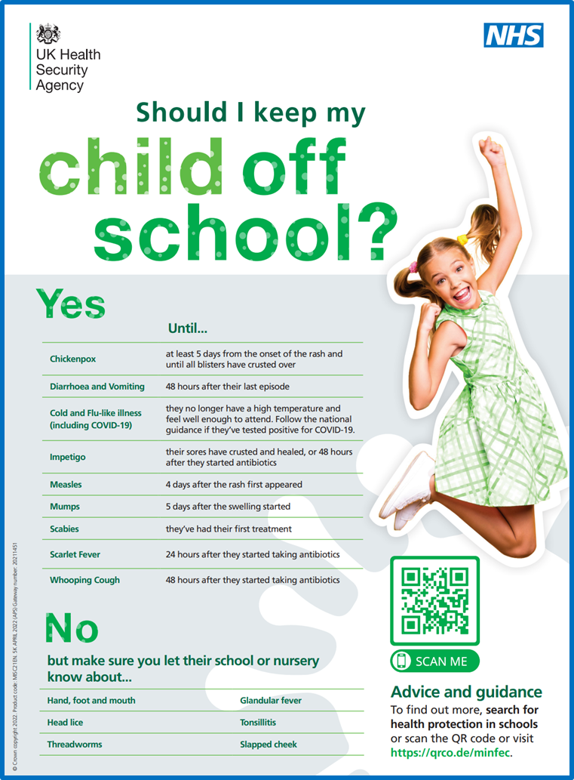

If a child’s absence is a cause for concern or your child is classed as a persistent absentee (attendance below 90%), school will ask the parent/carer for medical evidence such as prescriptive medicine, doctors stamped appointment cards, care at the chemist booklet etc. to authorise further absence. Parents will not be asked for doctor’s notes that incur a cost.

Absence from school will not be authorised for:

- Shopping
- Having to stay at home due to an unwell sibling or parent.
- Day trips
- Birthdays
- Holidays
- Rest days after a poor night sleep

Parents of children with a high incidence of unauthorised absence may be invited into school to attend a ‘School Attendance Meeting’ with a member of the Pastoral Team and/or the Local Authority Education Welfare Officer.
If not addressed promptly by parents, it can lead to legal sanctions such as Penalty Notice fines or prosecution in the Magistrates Court.

3.6 Leave of absence during term time

School cannot authorise time off for family holidays during term time and parents do not have the right to take their child out of school for such holidays.
Parents must apply for leave of absence during term time in all instances. A form (Appendix 1) is available, to request in writing a leave of absence from the school office or alternatively it can also be requested via our School Spider app.
Parents must apply to the Headteacher at least 2 weeks before the intended absence and provide necessary evidence of the exceptional circumstance. The Headteacher will decide if the leave will be granted and how many days will be authorised.
If the Headteacher does not grant an application for leave of absence and parents decide to take the holiday anyway, the absence will be unauthorised, and the parents may receive a Penalty Notice Fine. Penalty Notice Fines can be issued to each parent for every child concerned.

3.7 Fixed Penalty Notices

Carr Mill Primary School has adopted the use of Fixed Penalty Notices and complies with St Helens Local Authority code of conduct which governs the use of these.
The school may request a Fixed Penalty Notice to be issued if a pupil has 20 sessions (10 days) of unauthorised absence recorded within a 10-week period or if there are 10 sessions recorded as the pupil arriving late after the register has closed within a 10-week period.
Under the provisions of sections 444a and 444b of the Education Act 1996, the Local Authority may, in cases of unauthorised absence, issue a penalty notice to the parent(s) or carer(s) responsible. Under these provisions the penalty is £60 if paid within 21 days of the receipt of the notice, rising to £120 if paid after 21 days, but within 28 days of receipt. Penalty notices are issued to each parent/carer for each child.

3.8 Children Missing in Education

Carr Mill Primary School follow local authority children missing education policy and procedures. The school’s Designated Safeguarding Officer and Headteacher are responsible for the implementation and monitoring of all pupils who fall into the category of ‘Children Missing Education in partnership with the school’s Local Authority Education Welfare Officer.
During the first 10 days of absence, where a child has ceased to attend school without a valid reason, the school will take appropriate action to try to locate the child and establish whether they are on roll at another school.
Actions to trace should include:
- Initial action to contact parents/carers (phone call, ‘first day calling’, text, email)
- Checking possible whereabouts with staff and other pupils
- If any siblings at another school, check with that school
- Visit to last known address
- Writing to parents (at last known address or new address if known)
- Making contact with relevant agencies (social care etc)
If the child is not found, and/or not on roll at another school, within 10 days: Carr Mill Primary School will follow the Children Missing Education Procedure and inform the relevant services (social care) of our concerns.

4. How do school monitor attendance?

4.1 Daily Register Checks
At the beginning of each day once the registers have closed, we look at which children at absent from school. We check that we have explanations for absence, contacting families if we do not or need to ask more questions about the reason given. If we are unable to make contact, we will call the other numbers you have provided or complete a home visit.
If we have concerns about your child’s level of absence from school, we also may need to refer to other services or implement additional supportive measures (See Section 6).
If your child has not returned to school by day 3 of their absence, we will contact you for an update and to check everything is ok.
If your child continues to be absent after 5 days, we will contact you again to discuss their return to school.

4.2 Weekly Attendance Review
We monitor our registers on a weekly basis with the support of our Local Authority Educational Welfare Officer to check for patterns of absence, punctuality difficulties and children where attendance is becoming of concern.
If we are worried about any of the above, we will contact you and invite you into school to discuss our concerns and any support that may be required (See Section 6 for more detail).

4.3 Termly Monitoring
At the end of each term, we will send home a letter to inform you of your child’s current level of attendance. We will indicate where they fall on our school ‘Attendance Ladder’ (see page 13) and let you know if there are any further actions needed.
Remember you are aiming for your child to remain ‘green’ with attendance over 96%.
Attendance below 96% (amber) may result in you being required to attend school to discuss how we can support your child to increase their attendance rate.

Attendance below 92% (red) will result in a referral to the Local Authority Educational Welfare Officer to prevent your child from becoming a persistent absentee if attendance drops below 90%.

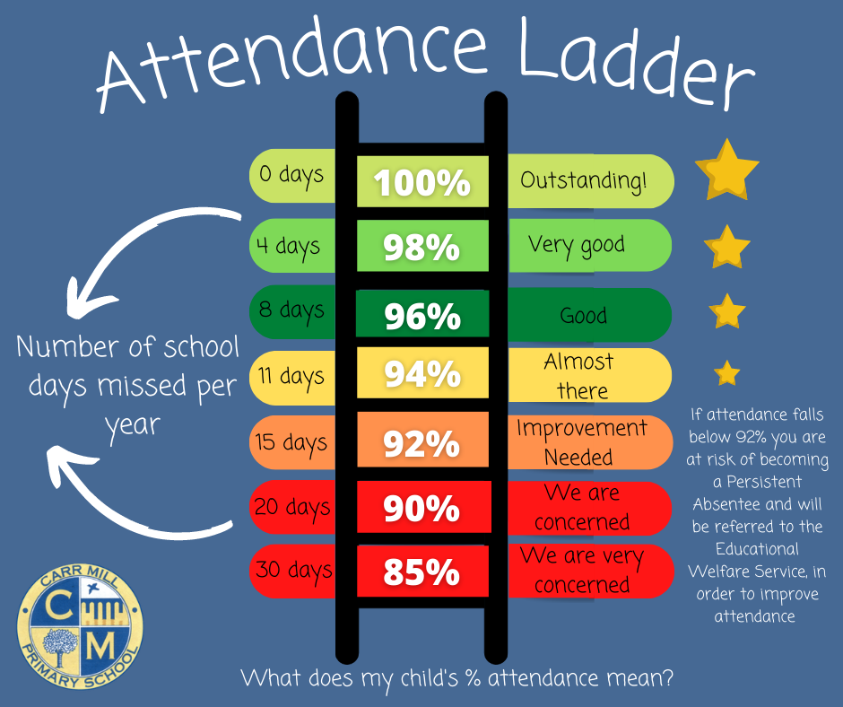

4.4 Reporting to Parents
In addition to receiving a termly letter to advise you of your child’s attendance. Parent/carers will also be informed of their attendance % rate at parents evenings and in the end of year report.
As we seek to raise the profile of attendance across school, please be advised that your child’s attendance will also be a topic of conversation during any other meetings that are held for them during the year. Staff may also choose to highlight attendance during any phone calls made to discuss other matters.
In addition, parents/carers can request their child’s attendance information at any point during the school year but contacting the school office.

4.5 Reporting to other agencies & services
Every term the school completes an attendance report to share with Governors. This information does not include individual pupil data but instead reports absence levels at a whole school / year group level.
The aim of reporting attendance data to our Governing body is to enable them to support and challenge school regarding pupil attendance, driving improvement and therefore increased outcomes for our children.
Whole school and individual pupil attendance data is also collected by the Local Authority, via the Educational Welfare Service, to ensure that no family miss out on support needed to improve attendance and therefore outcomes for their child.

5. How do school motivate children to have good attendance?

5.1 Rewards
At Carr Mill Primary School will strive to make pupils feel welcome and valued and will encourage good attendance with praise, incentives, and rewards through:
- A weekly class prize for the EYFS/KS1 & KS2 class with the greatest attendance (if their total if over our school 96% target)
- Individual house points awarded on a weekly basis for every child achieving 100% attendance.
- Weekly celebration text messages for children achieving 100% attendance
- Photos displayed on key stage attendance ladders to show those children who achieved ‘green’ for the week.
- End of term certificates for children who have maintained a 100% attendance score.
- End of year prizes for children who have maintained a 100% attendance score
- 15-day attendance challenges and rewards at times of the year with historically poor attendance.


5.2 Awareness
- Weekly attendance results and targets displayed in every classroom
- Regular class, phase group and whole school assemblies.
- Parents and pupils will be reminded regularly of the importance and value of good attendance and punctuality through children’s interim feedback sheets, classroom door posters, newsletters, letters home, social media posts and parents’ evenings.
15-day 100% attendance challenge winners

6. Who can support me to improve my child’s attendance?

We understand that sometimes children may have medical conditions, mental health needs or family circumstances that can be a barrier to good school attendance.
At Carr Mill Primary School, we are determined that we can, in most cases, provide solutions to ensure that children can be present at school and not miss out on the benefits that this brings.
We have a highly trained staff team who can support our families to develop individualised plans and where necessary additional supportive strategies to ensure that all children can be present at school.
All staff are happy to speak with you regarding concerns that may impact on attendance, and we encourage you to do so without delay. Staff members are present on the yard at the beginning and end of the school day or can be reached via the school office.

6.1 Key members of staff that can provide support
We always urge our families to contact class teachers in the first instance, who can provide support with friendship difficulties, worries about class work, homework etc
However, you may also want to speak to:
Key Stage Managers
Mr Daniel Hunter  EYFS | Miss Sally Hampton  KS1 | Miss Gill Mackenzie  KS2

Pastoral Team
Mrs Katie Griffin  Safeguarding Manager | Mrs Pauline Doyle  Family Support Worker | Mrs Ingrid Partington  Learning Mentor

SEND Team
Mrs Kate Barton  SENCo | Mrs Lauren Williams  Speech and Language Support

Mrs Katie Alexander – Deputy Head for Pastoral & Inclusion
Mrs Natalie Dawber – Local Authority Educational Welfare Officer
??????????? – Named School Governor for Attendance
7. What happens if my child has poor attendance?

We have a tiered approach to supporting our families with improving their child’s attendance

7.1 Tier 1 ‘Green’
If you child has attendance of 96% or above, they are classed as ‘green’. We will celebrate this will you at least termly using the measures described in Section 4. We ask that you continue to follow the school policy regarding reporting any absence from school and communicate any circumstances that may cause your child’s attendance to decline

7.2 Tier 2 ‘Amber’
If your child has attendance between 92% and 96%, they are classed as ‘amber’.
On a termly basis, parents of pupils whose attendance falls below 96% become closely monitored. Parents may be sent a letter or email alerting them to this fact. Parents may be invited to contact a named attendance support person if they require any support to improve their child’s overall attendance or if there are any specific issues that the school should be aware of.
If attendance falls below 92% you will be invited into school for a School Attendance Meeting, which may also be attended by the Local Authority Educational Welfare Officer. At this meeting we will look at things that are working well for your child, things that need to improve and put a plan in place to help your child’s attendance to improve, involving other supportive agencies if necessary e.g. School Health, Home Start, SEND services etc.

7.3 Tier 3 ‘Red’
If your child’s attendance falls below 91% we will complete a formal referral to the Educational Welfare Service. You will have already been into school to meet with us but the plans created have not been affective in improving your child’s attendance. With the Educational Welfare Officer’s support, we will create an Attendance Support Plan, if appropriate to do so. In some circumstances parents will be asked to provide medical evidence for any future absences for them to be authorised and the possibility of a fixed penalty notice being requested will be discussed if appropriate. The Attendance Support Plan will include attendance targets. The plan will be reviewed at the end of six weeks and next steps discussed depending on the outcomes of the plan.
7.4 Persistent Absentees
Your child becomes classed as a ‘Persistent Absentee’ if their attendance falls below 90%.
Every persistent absentee is assigned a key adult, who is usually their Key Stage Manager, and they will be discussed regularly in attendance/pastoral review meetings. Their academic progress will also be carefully monitored to ensure that absence from school is not having a detrimental impact upon their learning.
You will continue to be supported by both the school and the Educational Welfare Service to see an improvement to your child’s attendance. If no improvement is observed or your child continues to be absent from school on an unauthorised basis, despite a supportive package being put into place, formal support strategies may need to be considered, including:
- A Parenting Contract – setting out measures to improve attendance and timescales to do this.
- Fixed Penalty Notices
- Education Supervision Order
- Criminal prosecution
If your child has been classed as a ‘persistent absentee’ during the previous academic year, their attendance will be closely monitored, and you may be invited into school to attend a School Attendance Meeting as a preventative measure to prevent this from happening again.
Parents of children who are or have previously been ‘persistent absentees’ will always be contacted when their child is absent. The Pastoral Team and Educational Welfare Officer will make use of home visits to support with attendance.

7.5 Severe Absentees
If your child’s attendance falls below 50%, they are classed as a ‘severe absentee’. By this stage many services may be in place to provide support to your family, and you will be attending regular meetings at school – with a robust plan in place to try to improve attendance.
Individual child and family circumstances need to be extensively explored at this stage with appropriate referrals being made to other services e.g. Educational Welfare Service, SEND Support Service, Social Services, the School Health and other agencies to support and help pupils with attendance difficulties, if all professionals involved agree this is needed.
The school will support pupils who are absent as a result of long term chronic or life-threatening illness by adhering to current government guidance for children with medical needs. This may involve a plan of support and a re-integration plan back into school.
7.6 Part Time Timetables
All pupils of compulsory school age are entitled to a full-time education. In very exceptional circumstances, where it is in a pupil’s best interests, there may be a need for a temporary part-time timetable to meet their individual needs. For example, where a medical condition prevents a pupil from attending full-time education and a part-time timetable is considered as part of a re-integration package.
A part-time timetable should not be used to manage a pupil’s behaviour and must only be in place for the shortest time necessary and not be treated as a long-term solution.
Any pastoral support programme or other agreement should have a time limit by which point the pupil is expected to attend full-time, either at school or alternative provision.
There should also be formal arrangements in place for regularly reviewing it with the pupil and their parents. In agreeing to a parttime timetable, a school has agreed to a pupil being absent from school for part of the week or day and therefore must treat absence as authorised.

8. Conclusion

8.1 Equality through delivery of this policy
Carr Mill Primary School is committed to the principle of equality for all pupils irrespective of race, religion, gender, language, disability or family background, and to the active support of initiatives designed to further this principle.
All members of #teamcarrmill are valued, important and deserve equal access to a high-quality education through good attendance at school.

8.2 Links to Government Legislation
This attendance policy adheres to current government legislation and guidance.
For further information please refer to:
- Section 7 & 436A of the Education Act 1996
- Under the provisions of sections 444a and 444b of the Education Act 1996
- Section 175 of the Education Act 2002
- The Education (Pupil Registration) Regulations 2006
- The Education (Pupil Registration) (Amendment) Regulations 2010
- The Education (Pupil Registration) (Amendment) Regulations 2011
- The Education (Pupil Registration) (Amendment) Regulations 2013
- The Education (Pupil Registration) (Amendment) Regulations 2016
- Education and Inspections Act, 2006 - Part 1 Section 4
- Supporting Pupils at School with Medical Conditions. Statutory guidance for governing bodies of maintained schools and proprietors of academies in England. 2014.
- Working together to improve school attendance. Guidance for maintained schools, academies, independent schools, and local authorities. May 2022

8.3 Review of the policy
This policy has been reviewed in light of DFE guidance, latest initiatives and any Local Authority policy and procedures. The policy cross references all statutory policies.
This policy will act as a working document for how we promote good attendance at Carr Mill Primary School and may be subject therefore to amendment throughout the academic year in between annual review.

Supporting Documents
Contents
1.Impact of Poor Attendance
2. Attendance Policy of a Page
3. Termly attendance letters to share level of attendance
3.1 Tier 1 (96% or higher)
3.2 Tier 2A (92 – 96%)
3.3 Tier 2B (90-92%)
3.4 Tier 3 (90% or below)
4. School Attendance Meeting Letters for children whose attendance has fallen below 92%
4.1 Invite to School Attendance Meeting
4.2 Family did not attend School Attendance Meeting
4.3 Document to be completed at School Attendance Meeting
5. Letter to notify family that a child has become a Persistent Absentee.
6. Letters sent prior to an absence related Fixed Penalty Notice
6.1 Letter sent once a child has reached the threshold of 10
unauthorised sessions absent within a 20- week period
6.2 Letter sent once a child has reached the threshold of 20
unauthorised sessions absent within a 20- week period
6.3 Letter to inform the monitoring period has failed and a Fixed
Penalty Notice will be issued
7. Letters sent prior to punctuality related Fixed Penalty Notice
7.1 Letter sent to inform that a child is at risk of reaching the
threshold of 10 unauthorised absences due to ‘U marks’
within a 10-week period
7.2 Letter sent to inform that a child has reached the threshold
of 10 unauthorised absences due to ‘U marks’ within a 10
week period – fixed penalty to be issued
8. Letter sent to inform that a Fixed Penalty Notice will be issued following a term time holiday

- Impact of poor attendance

Extract taken from:
‘Working together to improve school attendance. Guidance for maintained schools, academies, independent schools, and local authorities’
Published May 2022

The pupils with the highest attainment at the end of key stage 2 and key stage 4 have higher rates of attendance over the key stage compared to those with the lowest attainment.
At KS2, pupils not meeting the expected standard in reading, writing and maths had an overall absence rate of 4.7%, compared to 3.5% among those meeting the expected standard. Moreover, the overall absence rate of pupils not meeting the expected standard was higher than among those meeting the higher standard (4.7% compared to 2.7%).
At KS4, pupils not achieving grade 9 to 4 in English and maths had an overall absence rate of 8.8%, compared to 5.2% among those achieving grade 4. The overall absence rate of pupils not achieving grade 9 to 4 was over twice as high as those achieving grade 9 to 5 (8.8% compared to 3.7%)
For the most vulnerable pupils, regular attendance is also an important protective factor and the best opportunity for needs to be identified and support provided. Research has shown associations between regular absence from school and a number of extra-familial harms. This includes crime (90% of young offenders had been persistently absent) and serious violence (83% of knife possession offenders had been persistently absent in at least 1 of the 5 years of study)

https://explore-education-statistics.service.gov.uk/find-statistics/the-link-between-absence-and-attainment-at-ks2-and-ks4/2018-19
https://explore-education-statistics.service.gov.uk/find-statistics/the-link-between-absence-and-attainment-at-ks2-and-ks4/2018-19
https://www.gov.uk/government/statistics/understanding-the-educational-background-of-young-offenders-summary-report
https://www.gov.uk/government/statistics/knife-and-offensive-weapon-sentencing-january-to-march-2018
- Policy on a Page
Paper copy to be shared annually with parents and carers with direction to read the full attendance policy published on the school website

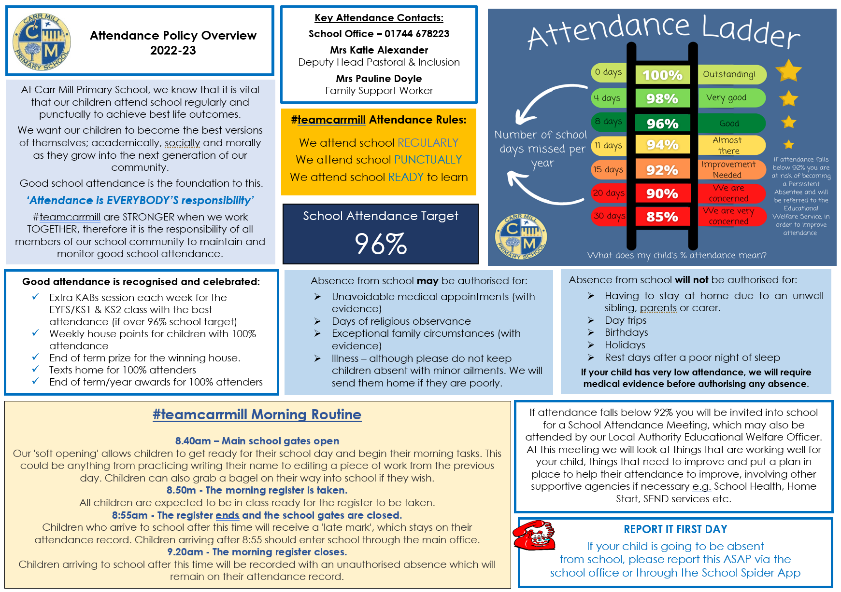

3. Termly attendance letters to share level of attendance
3.1 Tier 1 (96% or higher)
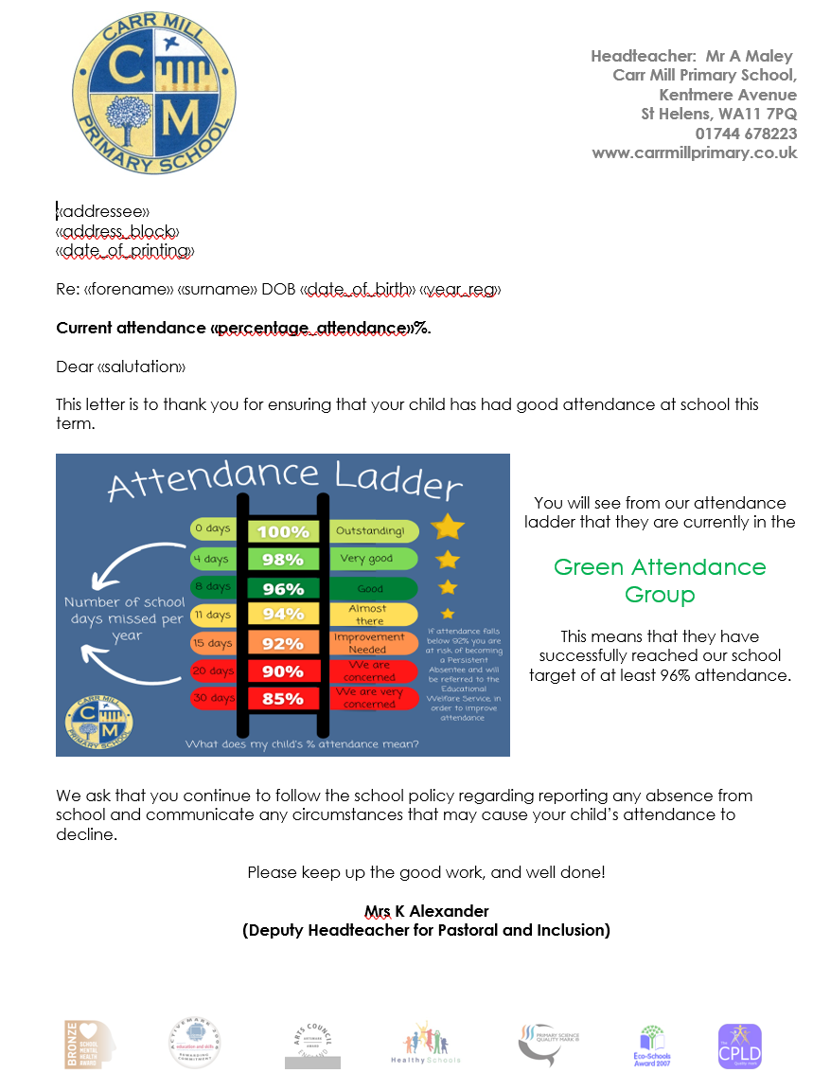

3.2 Tier 2A (93-96%)


3.2 Tier 2A (90-92%)
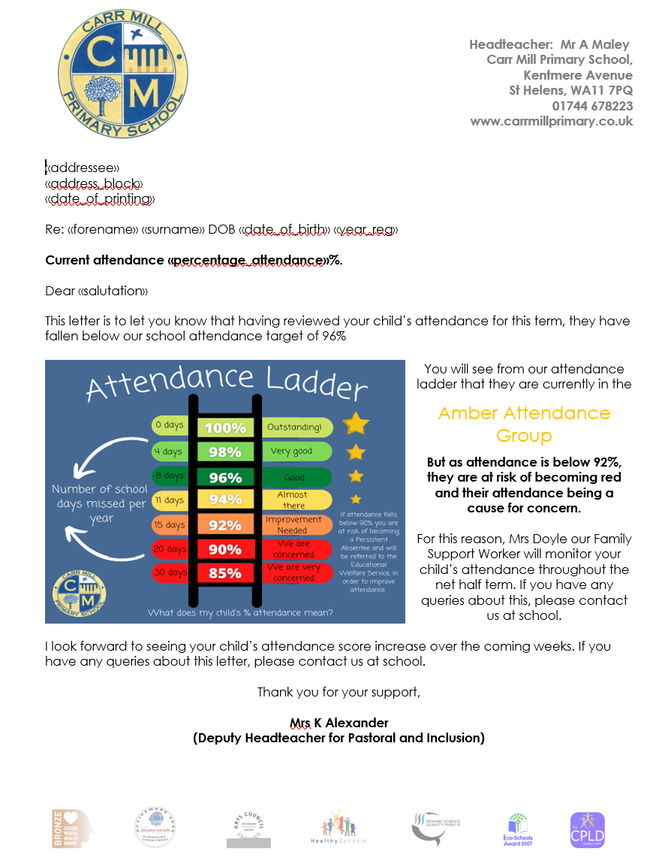

3.2 Tier 3 (90% or below)
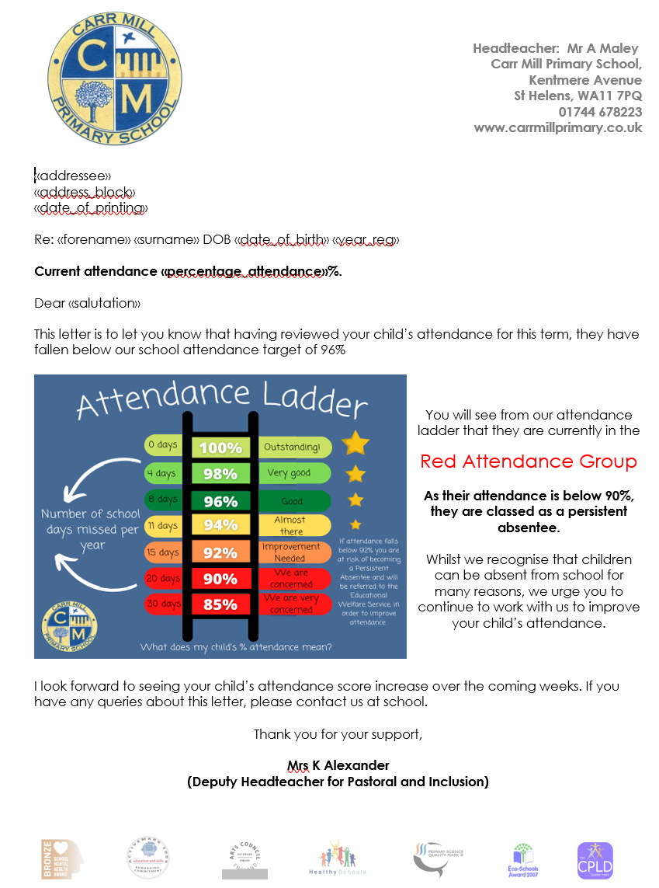

4. School Attendance Meeting Letters for children whose attendance has fallen below 92%
4.1 Invite to School Attendance Meeting
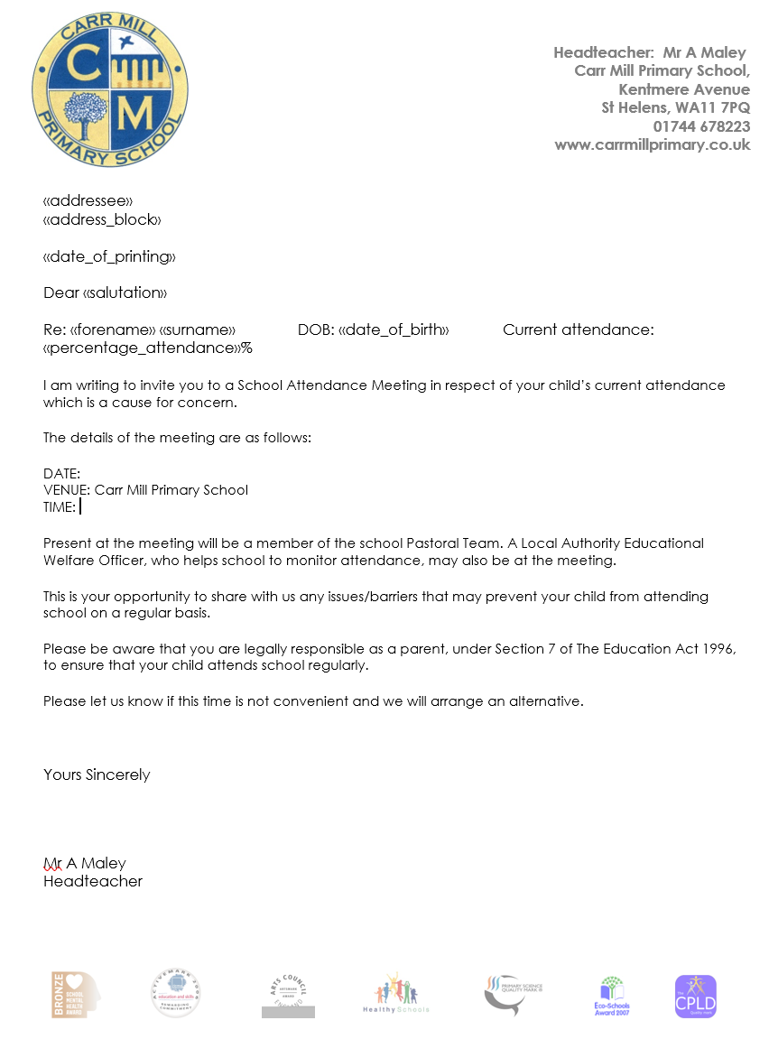
4.2 Letter as parent/carer did not attend a School Attendance Meeting
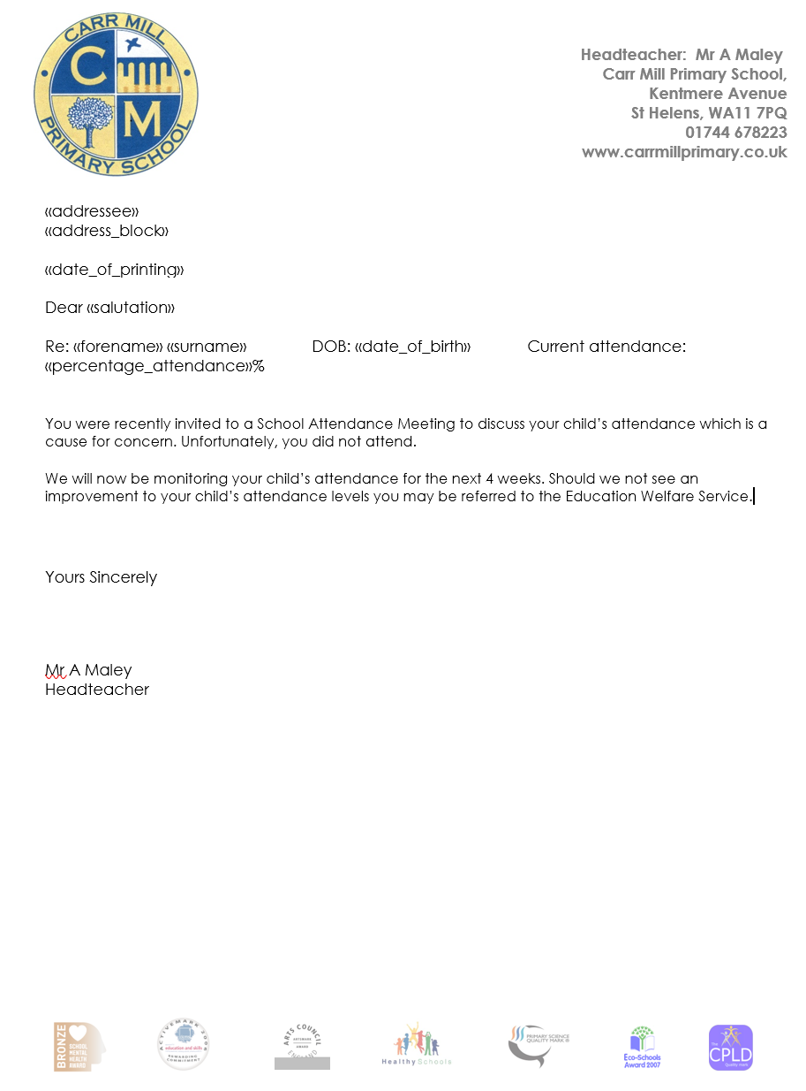

4.3 Document to be completed by school and family at a School Attendance Meeting

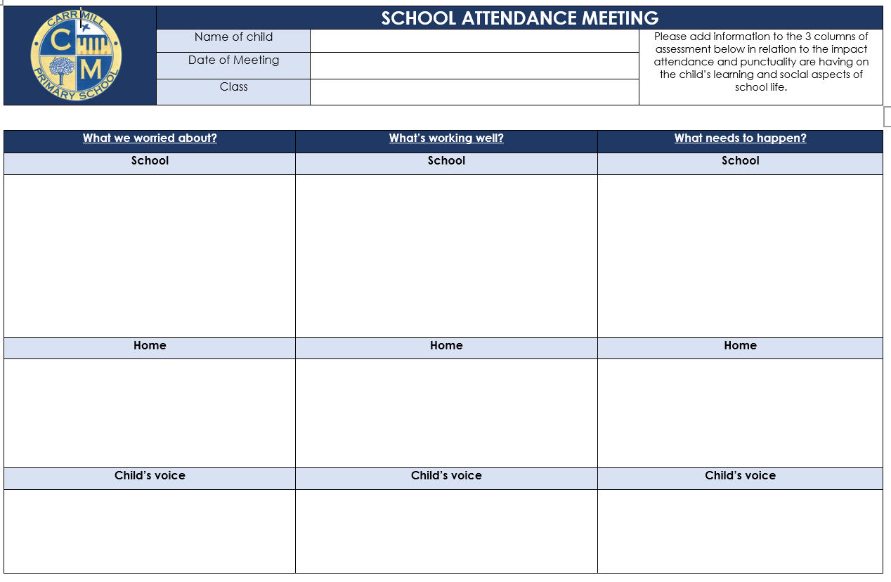
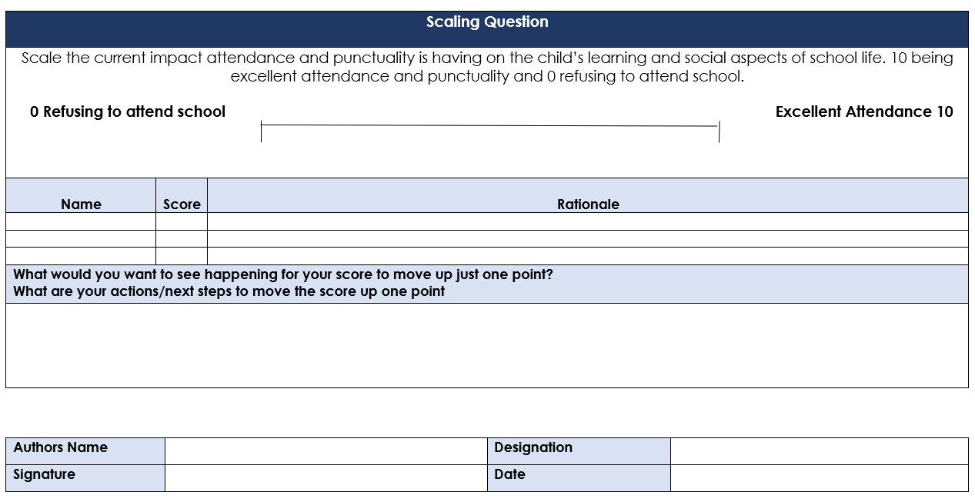

5. Notice of child becoming a Persistent Absentee.
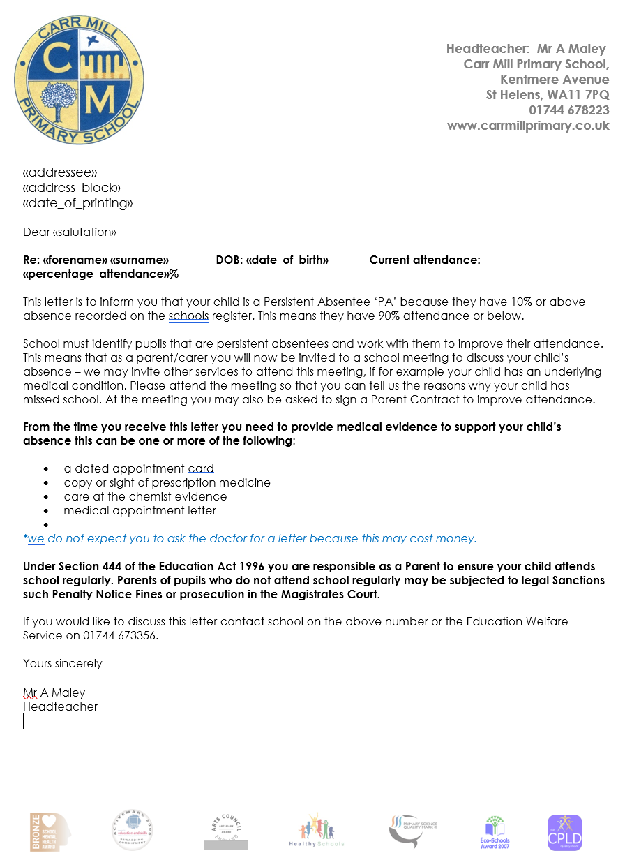

6. Letters sent prior to absence related Fixed Penalty Notice
6.1 Letter sent once a child has reached the threshold of 10 unauthorised sessions absent within a 20- week period
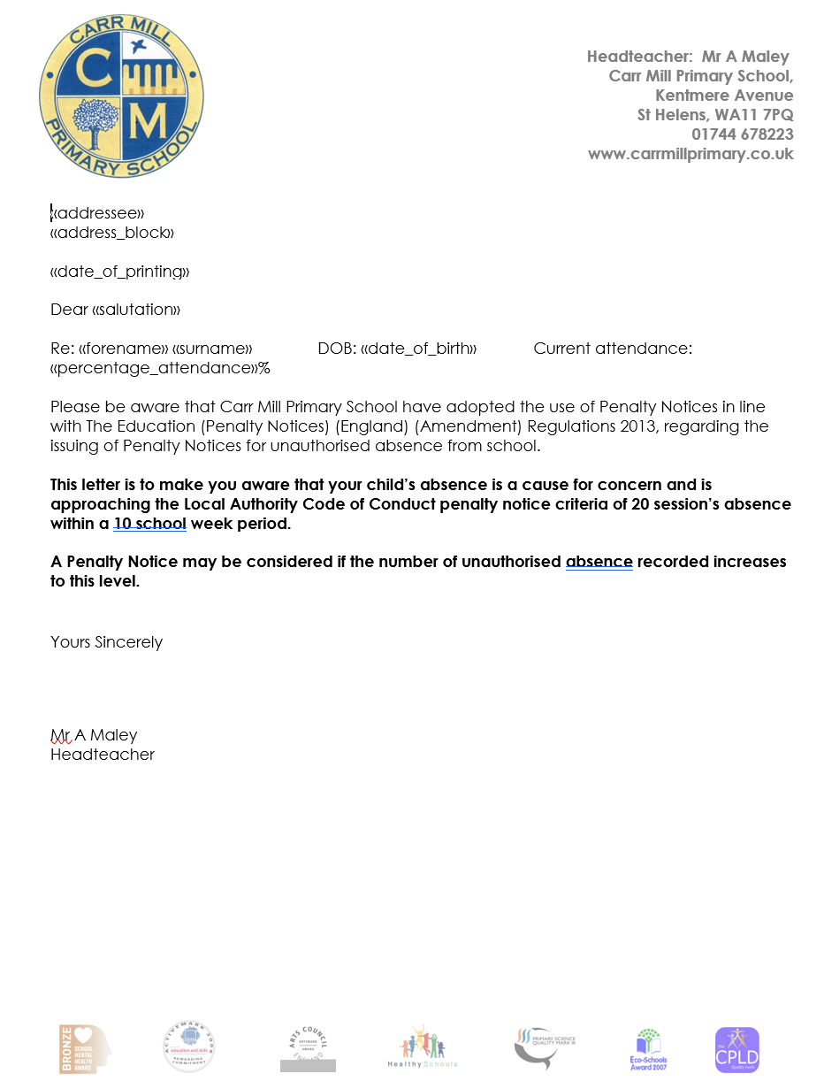

6.2 Letter sent once a child has reached the threshold of 20 unauthorised sessions absent within a 20- week period
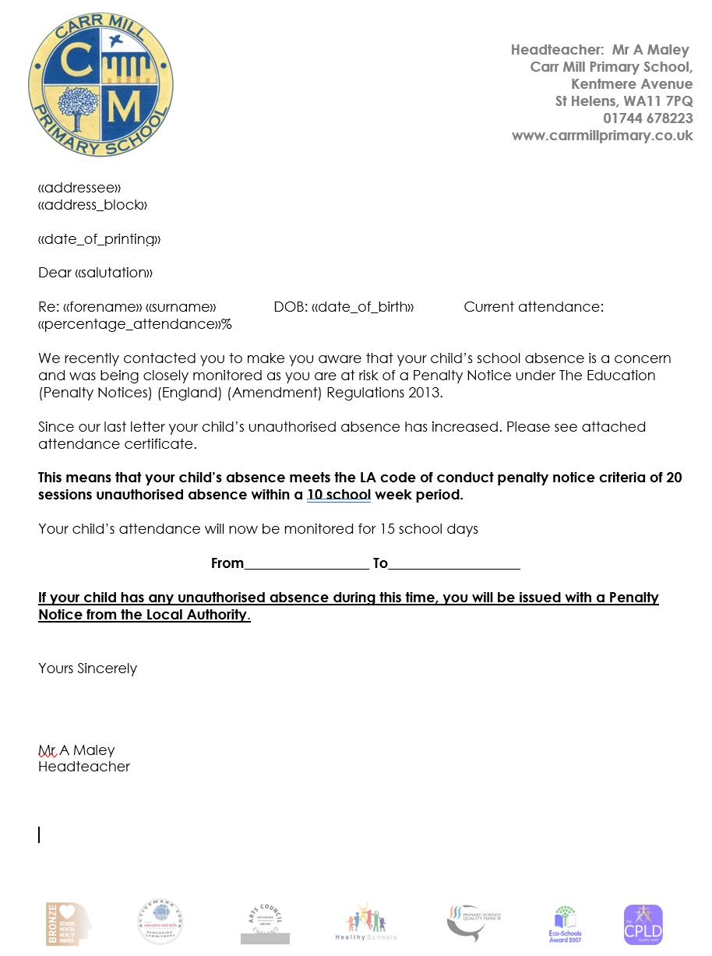

6.3 Monitoring period failed – fixed penalty to be issued
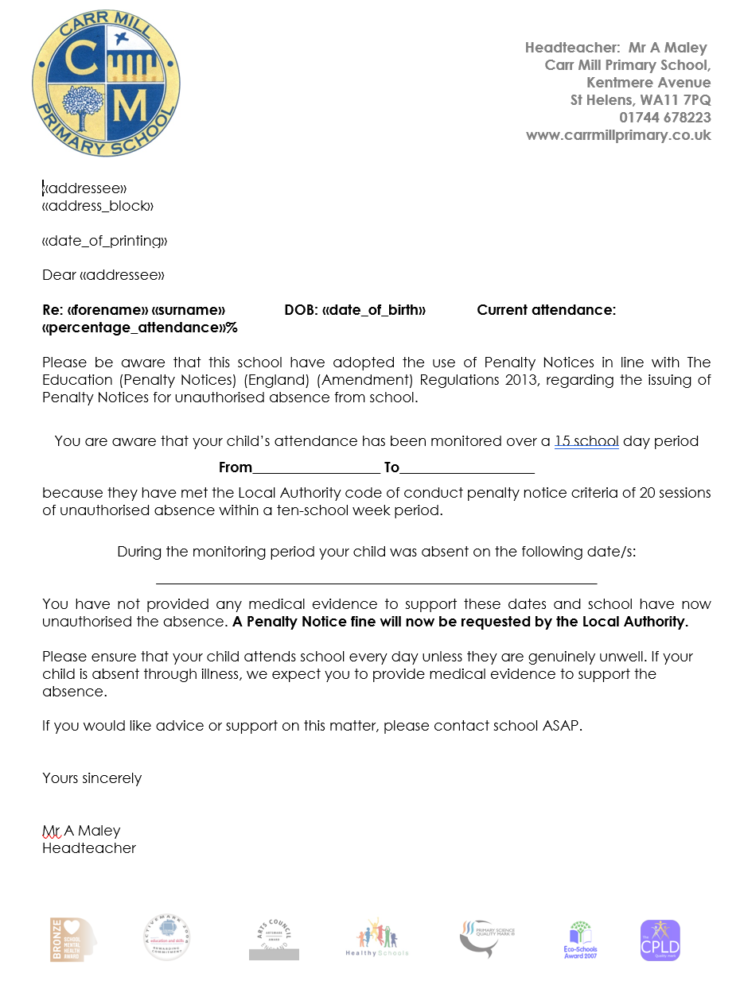

7. Letters sent prior to punctuality related Fixed Penalty Notice
7.1 Letter sent to inform that a child is at risk of reaching the threshold of 10 unauthorised absences due to ‘U marks’ within a 10 week period
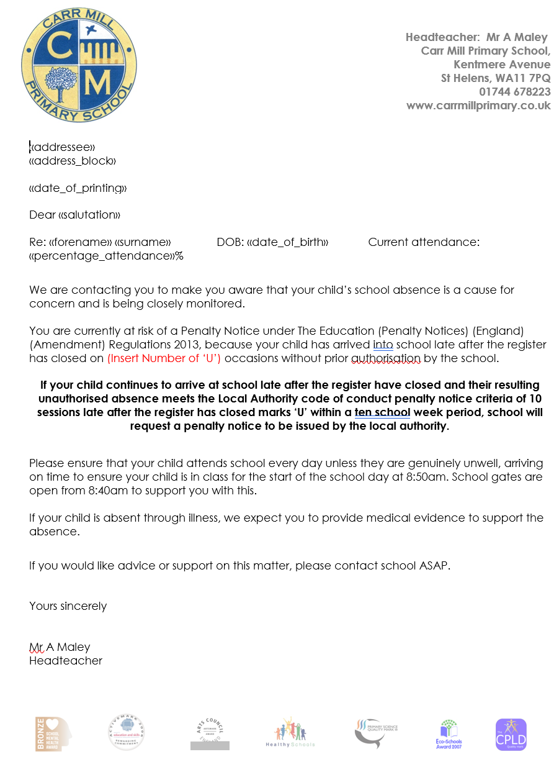
7.2 Letter sent to inform that a child has reached the threshold of 10 unauthorised absences due to ‘U marks’ within a 10 week period – fixed penalty to be issued
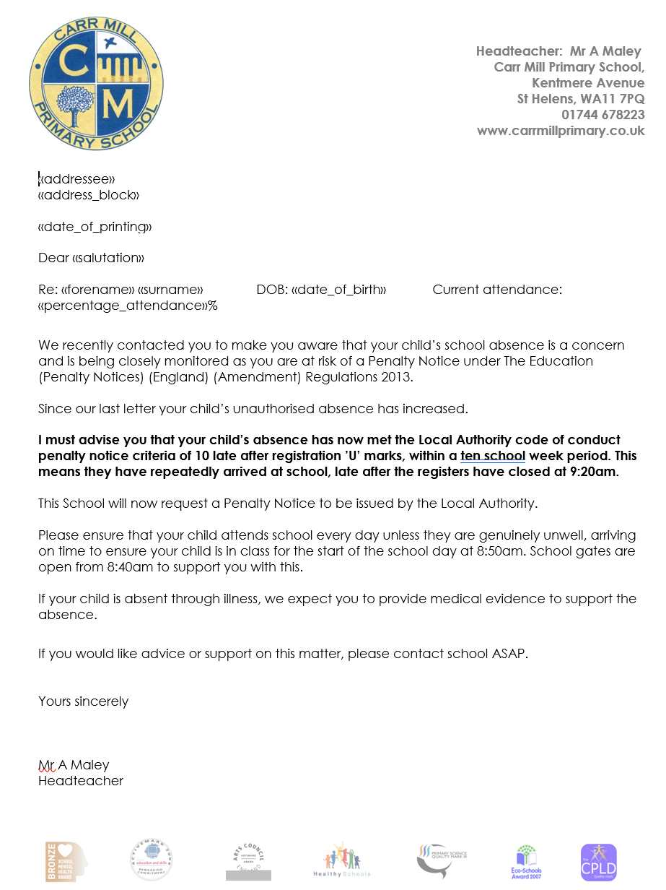

8. Fixed Penalty Notice to be issued as 20 session absence in a 10 week period have been recorded following a holiday taken in term time
