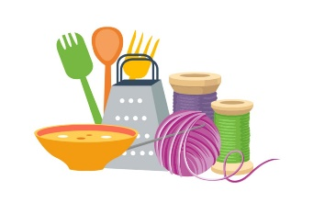
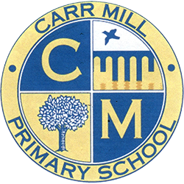
Design and Technology
Statement of Intent
"The best way to predict the future is to design it."
— Buckminster Fuller
At Carr Mill, we understand that Design and Technology plays an essential role in providing a broad and balanced curriculum. DT is an inspiring and practical subject that encourages children to become creative thinkers and effective problem-solvers through the design and manufacture of purposeful products.
Our curriculum is designed using the National Curriculum as its foundation and has been carefully mapped to ensure clear progression of substantive and disciplinary knowledge, vocabulary and skills throughout the school. Through the study of structures, mechanisms, textiles, electrical systems and cooking and nutrition, children develop the technical knowledge and practical expertise needed to participate confidently in an increasingly technological world.
We aim to inspire pupils to take risks, become resourceful, innovative and enterprising, whilst developing an appreciation of how design and technology have shaped the world around them. Children are encouraged to design purposeful products that solve real and relevant problems, considering the needs of users and specific design criteria.
By the end of Key Stage 2, we want our pupils to be confident designers, makers and evaluators who can apply their creativity, technical knowledge and practical skills to a range of contexts and challenges.
Our curriculum aims for children to:
- Develop the creative, technical and practical expertise needed to perform everyday tasks confidently.
- Design purposeful, functional and appealing products for themselves and other users.
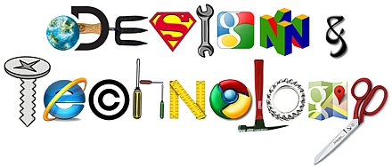
- Generate, develop, model and communicate their ideas through discussion, annotated sketches, prototypes and digital technologies.
- Select and use appropriate tools, materials and components safely and effectively.
- Evaluate their ideas and products against design criteria and identify ways to improve them.
- Build and apply a repertoire of knowledge, understanding and skills to design and make high-quality products.
- Understand and apply the principles of nutrition and learn how to cook a range of dishes.
- Understand how key events, inventors, engineers and designers have contributed to the development of the modern world.
Implementation
The Design and Technology curriculum has been carefully mapped using a two-year cycle to ensure breadth, balance and progression through our mixed-age class structure.
DT is taught through a block-timetabled approach, with each year group studying Design and Technology. The DT Coordinator has developed a bespoke curriculum map and progression framework that clearly identifies the substantive knowledge, disciplinary knowledge, vocabulary and skills to be taught in each year group. Units are planned to ensure progression across the key areas of structures, mechanisms, textiles, electrical systems and cooking and nutrition.
Teaching follows the design process of:
Research → Design → Make → Evaluate
Children investigate existing products, explore the work of influential designers, engineers and inventors, and develop their own ideas through discussion, sketches and prototypes. They are taught to select and use appropriate tools, materials and equipment safely and accurately whilst developing increasing levels of independence and technical competence.
Teachers revisit prior knowledge at the start of each unit and explicitly teach subject-specific vocabulary to support understanding and communication. Opportunities are provided for children to evaluate existing products and critically reflect upon their own designs, enabling them to understand how products can be improved and refined.
Learning is recorded through design work, written evaluations, annotated sketches and photographic evidence of practical outcomes. Assessment is carried out at the end of each unit using age-related expectations identified within the progression framework. This information is used to inform future planning and identify areas requiring further development.
The DT Coordinator monitors the quality of teaching and learning through lesson visits, work scrutiny, pupil voice, staff discussions and assessment analysis to ensure consistency and progression across the school.
Impact
The impact of our Design and Technology curriculum is demonstrated through the quality of pupils' discussions, designs, practical outcomes and evaluations.
Children develop a secure understanding of the design process and can confidently explain how they have researched, designed, made and evaluated products. They demonstrate increasing resilience, creativity and independence when faced with design challenges and are able to apply previously learned knowledge and skills to new contexts.
Through pupil voice, children demonstrate enthusiasm for DT and can discuss their learning using subject-specific vocabulary. They understand how designers, engineers, inventors and technological developments have influenced everyday life and the wider world.
Assessment evidence shows clear progression in knowledge, skills and vocabulary across all year groups. By the end of Key Stage 2, pupils leave Carr Mill as confident, reflective and capable designers who are equipped with the practical, creative and technical knowledge required for the next stage of their education and future lives.

