Carr Mill Primary School



Behaviour
Policy

Approved by: | SLT/Governing body | January 2026
Last reviewed on: | January 2025
Next review due by: | January 2027

1. Introduction
At Carr Mill Primary School, we aim to create a safe and happy environment where exemplary behaviour enables all to feel secure and respected within an atmosphere of learning without limits. Everyone in #teamcarrmill is expected to maintain the highest standards of personal conduct, to accept responsibility for their behaviour and to encourage others to do the same.
We recognise that each individual child is at a different stage of social learning. Only through a consistent approach to supporting their behaviour will we be able to achieve an environment in which children can learn and develop as caring and responsible people.
This policy outlines the underlying philosophy, nature, organisation and management of pupil behaviour at Carr Mill. It is a working document designed to enhance the development of positive relationships between children, adults working in the school, parents and other members of the wider school community. It reflects current and developing practice within our school.
The fair and consistent implementation of our Behaviour Policy is everyone’s responsibility. This document sits alongside our Behaviour Policy Overview (Appendix A), that allows visitors to our school to understand the key aspects of our policy during their visit.

2. Our Core Beliefs

‘Adult behaviours create children’s responses and behaviour.’

- Behaviour can change and every child can be successful.
- Positive, targeted praise is more likely to change behaviour than blaming and punishing.
- Reinforcing good behaviour helps children feel good about themselves.
- An effective reward system and celebrating success helps to further increase children’s self-esteem enabling them to achieve even more.
- Understanding each child’s needs and their individual circumstances helps us to act in the fairest way possible for that child, at that moment.
- When the adults change, everything changes.
3. Aims
Through this policy we aim to:

- Ensure a consistent and calm approach to and use of language for managing behaviour;
- Ensure that agreed boundaries of acceptable behaviour are clearly understood by all pupils, staff and parents;
- Ensure that all adults take responsibility for behaviour and follow-up any issues personally;
- Promote the use of restorative approaches in place of punishments;
- Promote pupils’ self-esteem by providing an effective system of rewards and praising effort in both work and behaviour;
- Ensure our pupils are polite, happy and considerate of others’ feelings;
- Encourage our pupils to respect their own and others’ property;
- Foster good citizenship and self-discipline;
- Encourage a positive, calm and purposeful atmosphere where pupils can learn without limits.

As a school community, through the taught curriculum as well as during all other opportunities e.g. lunchtimes and extended provision such as Breakfast Bistro and After School clubs, we aim to:

- Teach specific social skills e.g. sharing, turn taking, listening to each other, how to address people politely, etc.;
- Teach strategies for children to solve conflicts peacefully;
- Teach specific co-operative and collaborative skills to enable children to work effectively as a member of a group;
- Agree boundaries of acceptable behaviour with all pupils and regularly remind children of these;
- Enable children to recognise, understand and respond to a range of feelings;
- Develop vocabulary to enable children to express feelings verbally rather than physically;
- Promote equal opportunities and instil a positive attitude towards differences;
- Promote an ethos of peer support;
- Ensure the atmosphere in the classroom environment is conducive to learning;
- Ensure children are aware of the consequences of their words and actions towards themselves and others.

‘It is the everyday habits of adults that provoke a change in pupil’s behaviour.’

4. The Basics
4.1 This is how we do it here
#teamcarrmill School Rules:
We are READY
We show RESPECT
We are SAFE

We recognise that clear structures of predictable outcomes have the best impact on behaviour. Our school’s principles for behaviour sets out the rules, relentless routines and visible consistencies that all children and staff follow. It is based on the work of Paul Dix and his book ‘When the adults change, everything changes’. Good behaviour is recognised sincerely rather than just rewarded. Children are praised publicly and reminded in private.

‘’When people talk about behaviour, they obsessively search for the instant solution. Some peddle magic dust or ‘behaviour systems’ that glisten yet quickly fade. Others relentlessly scream for a bigger stick to beat students down with. Both extremes harbour an irresistible idea that there is a short cut to changing behaviour. They sell the lie that you can provoke sustained behavioural change in others without doing much hard work yourself. The truth is that there is no alternative to the hard work: building relationships with those who would rather not, resetting expectations with those who trample them, being relentlessly positive and sustaining a poker face when confronted with challenging behaviour.’’
Paul Dix, Pivotal Education

Our school has three simple rules: ‘We are Ready, We show Respect and We are Safe’, generated through discussions with staff, pupils and parents and which are applicable to a wide variety of situations. These rules are explicitly taught and modelled by all members of our school community.

However, we also understand that for some children, following our behaviour expectations are beyond their current developmental level. In this case, these children will have access to bespoke positive behaviour plans, which may include carefully targeted sanctions and rewards to reinforce positive behaviour.

4.2 Core Principles

- Our behaviour policy is applied with absolute consistency by all.

- Our children need the behaviours that we expect, to be a successful learner at our school.

- We praise our children in public and discuss poor behaviour in private. We do not shout.

- We know that all behaviour is communication.

4.3 Adult Strategies to Develop Excellent Behaviour
At Carr Mill Primary School, adults apply the following principles in all interactions with pupils:

- IDENTIFY the behaviour we expect

- Explicitly TEACH behaviour

- MODEL the behaviour we are expecting

- PRACTISE behaviour

- NOTICE excellent behaviour

- CREATE conditions for excellent behaviour

4.3. Language Around Behaviour

We understand that a common and consistent use of language around behaviour is essential in creating clear boundaries for learning how to behave. Phrases such as ‘kicked off’ or ‘screaming fit’ are unhelpful in these instances and adults should remain professional and calm at all times.

Conversations should follow a script and behaviours should be discussed as the behaviours they are, and not be personal to the child. Most conversations around behaviour would normally be conducted, in the first instance, by the class teacher. However, we strongly encourage all adults to ‘pick up their own tab’ and apply our 5 steps ‘in the moment’ rather than waiting to refer children on to their teacher.

Incidents are then logged on CPOMS (our school’s internal logging system), at the staff member’s discretion.
5. Shared Scrips and Expectations

Good behaviour is recognised sincerely in the moment and we aim to make positive behaviour about relationships rather than a transactional act such as a reward or prize The power of the group is at the core of this plan where adults notice and reward excellent behaviour that goes ‘above and beyond’.

‘Children are praised publicly and reminded in private.’

Our three simple school rules are further explored and explicitly taught in class, assemblies and other school experiences. For example, they might be expanded as follows:

WE ARE READY

I will help myself and others to learn by being in the right place, with the right equipment and ready to listen and complete my work.

WE SHOW RESPECT

I will listen and talk politely to adults and other pupils; and look after equipment and other people’s possessions.

WE ARE SAFE

I will be kind and look after myself and others, following appropriate instructions from adults.

5.1 Visible Adult Consistencies

These are the visible behaviours exhibited by staff and which are consistent and can be expected by children. Through these consistencies, adults will build respectful relationships with pupils.

- Children are greeted at the classroom door and/or in the classroom, daily by their teacher and/or teaching assistant. This enables everyone to start the day positively and with a smile. Members of the Leadership Team and/or support staff will also meet and greet children and parents at the gate or in other areas of the school.

- Staff will be calm, consistent and fair in their treatment of children, parents and colleagues. Adults in school will avoid shouting at children or becoming emotionally charged. They will model self-control through their calm approach and will deal with individuals fairly.

- Staff will ‘pay first attention to the best conduct’ and will endeavour to catch children ‘doing the right thing’ in order to praise and recognise desired behaviours. This encourages children to be role models and makes expectations on behaviour clear for all.

- Staff accompany children to the playground at playtimes and the end of the day. At playtimes, there must be an adult on duty before children are left.

- Staff intervene whenever incidents occur, following Restorative Approaches where possible.

- All staff challenge children who are not keeping school rules in a non-confrontational way

5.2 Above and Beyond Recognition

Children will be recognised for their good behaviour in a number of ways, including:

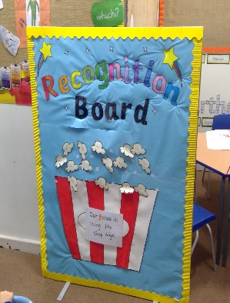
Recognition Board

Children’s names will be moved onto recognition boards when they have exhibited the target behaviour for that day or week. The aim should always be for the whole class to get on the board in order to create the feeling of a team effort with the target chosen to reflect a behaviour which the class need to practise. A child’s name will not be removed from the board once it is on.

Good News Notes

Certificates, good news postcards and other positive messages will be sent home regularly by class teachers and members of SLT to inform parents of good behaviour.

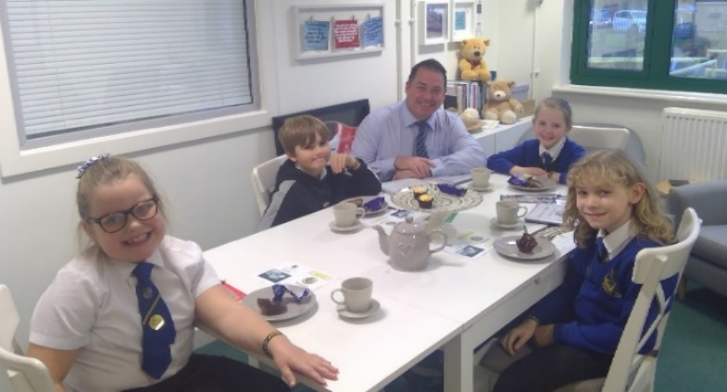
Social Media
At Carr Mill we use Facebook and Twitter extensively to share good news about our pupils.
Tea@2 with Mr Maley
Children who consistently display our behaviour values can be invited to a special Tea@2 celebration with the Headteacher.

5.3 Relentless Routines

These routines, consistently seen and heard around school, will ensure all pupils are clear about the behaviour expectations of all adults.

- Pupils will be expected to demonstrate pride in their school uniform by being perfectly presented.
- When adults in school require the full attention of a class or group of children, they will use the stop sign. Pupils are taught to stop what they are doing, turn to face the adult and Be Ready to listen. This ensures a quiet and calm classroom where the teacher can address pupils at the same time.
- Similarly, adults may use a silent countdown indicating that children should return to their seats etc.
- Children demonstrate wonderful walking when moving around our school building, ensuring they are doing so in a safe way.

5.4 Stepped Sanctions

Section 5 outlines the steps an adult should take to deal with poor behaviour in the classroom. It includes micro-scripts for each step to ensure consistency in language and predictability for pupils which, in turn, results in all children being treated fairly.

Staff should always use a measured, gentle approach; referring to the child by name; lowering themselves to the child’s physical level; making eye contact; delivering the required message; and then leaving the conversation to allow the child ‘take up time.’

Adults should not be drawn into and/or respond to any secondary behaviour, which children sometimes use as a distraction from the initial behaviour or to escalate the situation further.

Sanctions will be applied fairly and proportionately, with reasonable adjustments made in accordance with the Equality Act 2010.

5.5 Restorative Conversations

Following incidents of poor behaviour, it is imperative that the teacher who initially dealt with the behaviour (supported by a colleague or a member of SLT if appropriate) should conduct a restorative conversation with the pupil. This will help to ensure that the relationship between adult and pupil remains positive but also teaches the child to evaluate and reflect on their behaviour.

The questions used will depend on the age and individual needs of the pupil. For the youngest children, the two questions in bold should be used initially, with other questions being used if appropriate, so the children learn early on in their school life that their actions have an impact on others and also consequences for them
6. Our Behaviour Blueprint
Our Rules | Visible Adult Consistencies | Above and Beyond Recognition | Relentless Routines
We are READY  We show RESPECT  We are SAFE | Daily meet and greet  Staff notice and respond to good behaviour  Staff intervene whenever incidents occur.  All staff challenge children who are not keeping school rules. | - Recognition Boards  - Meet and greet  - Positive notes in class  - Positive Post Cards  - Social Media positive  messages  - Tea@2 with Mr Maley | Perfectly Presented  Stop sign  Silent countdown  Wonderful Walking

Stepped Sanctions
Gentle approach > use child’s name > down to child’s level > make eye contact > deliver message > walk away!
1. REMINDER (reinforce 3 rules, privately if possible):
I noticed you chose to … (state the noticed behaviour).
This is a REMINDER that we need to Be … (state relevant rule: Ready, Respectful, Safe).
You now have the chance to make a better choice.
Thank you for listening. (Give the child ‘take up time’ and DO NOT respond.)

Example - ‘I notice that you’re running. You are breaking our school rule of being safe. Please walk. Thank you for listening.’
2. FINAL WARNING:
I noticed you chose to … (state the noticed behaviour).
This is the second time I have spoken to you. You need to speak to me for two minutes after the lesson.
(Insert child’s name) … if you choose to break our school rules again, you leave me no choice but to ask you to move to … / go to the quiet area / thinking mat, etc.
Do you remember when … (model of previous good behaviour)? That is the behaviour I expect from you. Think carefully. I know that you can make good choices.
Thank you for listening. (Give child ‘take up time’ and DO NOT respond.)
Example - ‘I have noticed you are not ready to do your work. You are breaking the school rule of being ready. You have now chosen to catch up with your work at playtime. Do you remember that yesterday you started your work straight away and got it finished? That is what I need to see today. Thank you for listening.’
SPACE TO COOL OFF:
3. IN CLASSROOM > 4. IN ANOTHER CLASS > 5. SOMEWHERE ELSE

I noticed you chose to…(state noticed behaviour). You need to…(describe appropriate place in classroom e.g. reading corner, quiet desk etc) I will come back to speak to you in two minutes.
Child sent to designated area of classroom
5-10 minutes sitting alone in order to reflect, calm down etc without causing further disturbance
Child to complete an appropriate task e.g. reflection sheet, continue with work, watching sand timer
If behaviour improves, return to class. If not or child refuses, move to step 4

Example - ‘I noticed you choosing to use rude words. You are breaking the school rule of showing respect. You have chosen to go and sit in the quiet area. I will come back and speak to you in 2 minutes. Thank you for listening.’
4. IN ANOTHER CLASS  I noticed you chose to … (state the noticed behaviour).  You need to go to … (state the classroom or other space you need them to go to). I will come and speak to you at the end of the lesson.  *DO NOT describe the child’s behaviour to other adults in front of the child*  Example - ‘I have noticed you chose to continue to use rude words. You are breaking the school rule of showing respect. You have now chosen to go and sit in Ms Hampton’s classroom. I will come and speak to you at the end of this lesson. Thank you for listening.’ | - Child escorted to designated colleague / follow up to check child has arrived.  - Remainder of lesson working alone without causing further disturbance.  - Possible removal of privilege / playtime.  - Teacher must provide work / activity for the child to complete and communicate this to colleague.  - If behaviour improves, return to class. If not or if child refuses, move to Step 5.  - Record on CPOMS  For regular occurrences:  - Discussion with SLT and/or SENCO: consider Behaviour Intervention and/or additional support.  - Begin monitoring to identify areas of concern / possible causes/ appropriate targets.  - Parents contacted by teacher to inform them that behaviour is a cause for concern.
 | - Child escorted to / collected by appropriate adult.  - From remainder of lesson through to a half day working alone without causing further disturbance.  - Possible removal of a privilege / playtime.  - Teacher must provide work / activity for child to complete as soon as possible after removal.  - Record on CPOMS.  For regular occurrences:  - Discussion with SLT / SENCO as soom  as appropriate.  - Parents informed of withdrawal by teacher or Key Stage Manager / SLT depending on nature of incident.  - Meeting with parents to investigate possible causes / alternative strategies.  - Referral to multi agencies i.e. Behaviour Support / Mental Health Practitioner, etc.
  5. SOMEWHERE ELSE
  I noticed you chose to … (state the noticed behaviour).
  I will now contact … and you will need to go to … / with them (tell the child who you will contact and where they will go (if previously arranged). I will come and speak to you at the end of the lesson / next break / end of the day.
  *DO NOT describe the child’s behaviour to other adults in front of the child*
  Example - ‘I have noticed you have chosen to continue to use rude words. I will now contact Mr Maley and you will need to complete your learning outside his office. I will come and speak to you at the end of the day. Thank you.’
FOLLOW UP, REPAIR AND RESTORE

Use the restorative questions to follow up the incident, repair relationships and enable the child to learn what to do next time.

1. What happened? (Neutral, dispassionate language.)
2. What were you feeling at the time?
3. What have you felt since?
4. How did this make people feel?
5. Who has been affected? (use age/stage appropriate language e.g. ‘hurt / upset’ for KS1 children)
6. How have they been affected?
6. What should we do to put things right?
7. How can we do things differently in the future?

The number of questions to be used MUST depend on the age of the child. Those in BOLD should be used with the youngest children.

*Remember that it is not the severity of the sanction that is important; it’s the certainty that this follow up will take place.

7. Extreme Behaviours
Some children may display extreme behaviours due to early childhood experiences, family circumstances, or specific additional needs. At Carr Mill Primary School, we recognise that behaviour is often a form of communication, expressing emotions or needs. Many children require a sense of safety before they can regulate their behaviour effectively.

Where possible, our most experienced and skilled staff build strong relationships with individual children. Children exhibiting extreme behaviours may have Individual Management Plans (IMPs), which detail bespoke support, strategies, and expectations. Additional support may also be provided through a Pastoral Support Plan (PSP), where appropriate.

Responding to Extreme Behaviour

In rare instances where a child’s behaviour places themselves or others at immediate risk, physical intervention may be necessary. This will:

- Only be used as a last resort, in line with the Restrictive Interventions and Use of Force Policy.
- Be applied only by experienced, trained staff, unless there is an immediate risk to safety.
- Be fully recorded on CPOMS, in line with statutory guidance (DfE, 2026).
- Trigger review and update of the child’s IMP, including consideration of multi-agency support where appropriate.

Post-Incident Response

Following an incident of extreme behaviour, the school may consider a fixed-term exclusion, at the discretion of Senior Leadership Team (SLT), in situations where:

- Staff require time to recover following an extreme incident.
- The child requires time to reflect on their behaviour.
- Additional planning is needed to provide targeted support for the child.
- Being at home is likely to have a positive impact on the child’s future behaviour.

Where these conditions are not met, alternative measures may include a day withdrawal, supervised by the Headteacher or a member of SLT in another part of the school.

Throughout this process, it is essential that staff:

- Communicate clearly with parents and carers, explaining what is happening and why.
- Arrange meetings to review the incident, share the child’s IMP, and discuss next steps to support positive behaviour.

Sanctions will be applied fairly and proportionately, with reasonable adjustments made in accordance with the Equality Act 2010.
8. Unacceptable Behaviours

Occasionally, some children may behave in an extreme way which is out of character for them. At Carr Mill, behaviour is monitored through a safeguarding lens. Where necessary, concerns are logged and escalated in line with the Child Protection Policy and the statutory requirements within the Keeping Children Safer in Education DfE guidance.

Unacceptable behaviours may be expedited through our system of Stepped Sanctions in order to be dealt with more quickly by a member of SLT. If this occurs a focussed meeting involving SLT and the staff members will be arranged to discuss what happened.

However, it is important to maintain that all adults can deal with these types of behaviour.

Unacceptable behaviours may include:

- Violence (i.e. physical contact made with the intention to harm)
- Defiance / rudeness towards any adult
- Persistent taunting, teasing and bullying behaviour
- Stealing
- Spitting
- Swearing

Following any unacceptable behaviour, sanctions will be applied fairly and proportionately, with reasonable adjustments made in accordance with the Equality Act 2010.
Unacceptable behaviours may also result in the application of our Suspension and Permanent Exclusion Policy.
Repeated unacceptable behaviours may result in individualised arrangements and plans being put in place around the child, for example and Individual Management Plan, a report card or reward chart.
Repeated unacceptable behaviours may also result in referral to external services via our multi-agency hub TESSA. Parental consent will always be gained prior to this.

9. Bullying

9.1 Definition:
Bullying is any deliberate behaviour, repeated over time, that intentionally hurts or intimidates another individual, either physically, verbally, socially, or online (cyberbullying). Examples include:
- Name-calling, taunting, or threatening
- Physical aggression or damaging belongings
- Exclusion, spreading rumours, or intimidation
- Harassment via digital platforms, including social media, messaging apps, or gaming platforms

9.2 Prevention:
Our school promotes a culture of respect and inclusion through:
- Regular teaching on respect, diversity, and digital safety
- Staff training to recognise and respond to bullying
- Clear classroom rules and supervision at breaktimes
- Encouraging positive peer relationships and student-led initiatives

9.3 Reporting Bullying:
Pupils, staff, and parents can report bullying by:
- Speaking to any member of staff
- Using confidential reporting boxes/email where available
- Contacting the designated safeguarding lead (DSL) or anti-bullying coordinator

9.4 Response and Investigation:
All reports of bullying are taken seriously and will be addressed promptly:
- Staff record incidents and report to senior leaders
- An investigation will be conducted, gathering statements from all parties
- Appropriate sanctions or restorative actions will be applied based on the severity of the incident

9.5 Support for Pupils:
Pupils affected by bullying will receive:
- Emotional support from staff, counsellors, or mentors
- Guidance on coping strategies and digital safety
- Opportunities to participate in restorative processes, if appropriate

9.6 Related Policies:
For more detailed procedures, please refer to the school’s Anti-Bullying Policy and also Child and Child Abuse Policy.

10. Physical Attacks on Adults

At Carr Mill, we take incidents of violence toward staff very seriously. We also understand that staff are the adults in the situation and can use a ‘common sense’ approach to keep themselves and the child safe to manage the situation effectively. Staff can use ‘reasonable measures’ to protect themselves in accordance with our Positive Handling Policy (Appendix B) and call for additional support if needed. Staff who defend themselves will have the full support of the Leadership Team and the Local Governing Body, as long as their actions are in line with our policy and do not use excessive force. Only staff who have been trained in physical restraint should
restrain a child unless there is an immediate risk to that child or another person as outlined in Appendix F.

All staff should report incidents directly to the Headteacher and/or Designated Safeguarding Lead and should be recorded on CPOMS and in the log of incidents which is maintained by the School Business Manager – Mrs Colette Rimmer. We appreciate these incidents can also cause distress for the adults involved, therefore all staff are entitled to take some time away from the classroom to recover their composure.

Whilst incidences of violence towards staff are wholly unacceptable, we must remember that we are a nurturing school that values each child under our care. It is important for us as adults to reflect on the situation and learn from our actions. Children who attack adults may do this for several reasons but as adults, we still need to show compassion and care for the child. Exclusion will only happen once we have explored several options and have created a plan around a child.

Together: everyone matters Together: everyone succeeds.

#teamcarrmill
#strongertogether

11. Suspension and Permanent Exclusion

For more information, please see the Suspension and Permanent Exclusion Policy

Exclusion is an extreme step and will only be taken in cases where:

- Long-term or repeated misbehaviour that is not responding to strategies in place and the safety and learning of others is being seriously hindered.

- The risk to staff and other children is too high.

- The impact on staff, children and learning is too high.

Permanent exclusion will always be a last resort and the school will endeavour to work with the family to complete a managed move to a more suitable setting where possible. There will in most cases also have been a bespoke package of support designed around the child in the format of a Pastoral Support Plan – which will have involved the advice and input from our multi-agency professional partners.

In all instances, what is best for the child will be at the heart of all decisions making processes.

12. The Role of the Parent

At Carr Mill, active parental involvement is welcomed, appreciated and deliberately encouraged in order to:

- Ensure that children attend school regularly, arriving on time, alert and ready for the tasks
ahead and are collected, promptly, at the end of the day;

- Understand and reinforce the school language as much as possible;

- Share in the concern about standards of behaviour generally;

- Support the work of the school as staff seek to support the whole family.

We will always aim to contact parents quickly when there are concerns about deteriorating levels of acceptable behaviour. However, staff will not routinely contact or inform parents of minor digressions.

13. Application and scope of this policy

This Behaviour Policy is applicable to our entire school community and will only be effective if everyone is empowered to use it with confidence and consistency.
There may be occasions when special rules need to be applied, e.g. in the dining room, at play and lunch times or when off site, etc. but the same principles of promoting good behaviour will always apply.
This policy also applies to online behaviour that impacts the school community. (See Online Safety Policy)
This policy is published on the school website and available to parents on request

14. Monitoring and Evaluation

The school’s Leadership Team will monitor the effectiveness of the policy at least once a year and report back to the Governing Body. The Leadership Team will also monitor the visible consistencies around the school and the use of language and personal follow-up. Records will be kept by the Leadership Team in order to monitor and evaluate any changes brought about by the policy.

All concerned parties will be kept informed of any review and action that will need to be take

Appendices

Appendix A – Behaviour Policy on a page
Appendix B– Screening and searching pupils, confiscation of items
Appendix C – The power to discipline beyond the school gate

Appendix A – Behaviour Policy on a Page

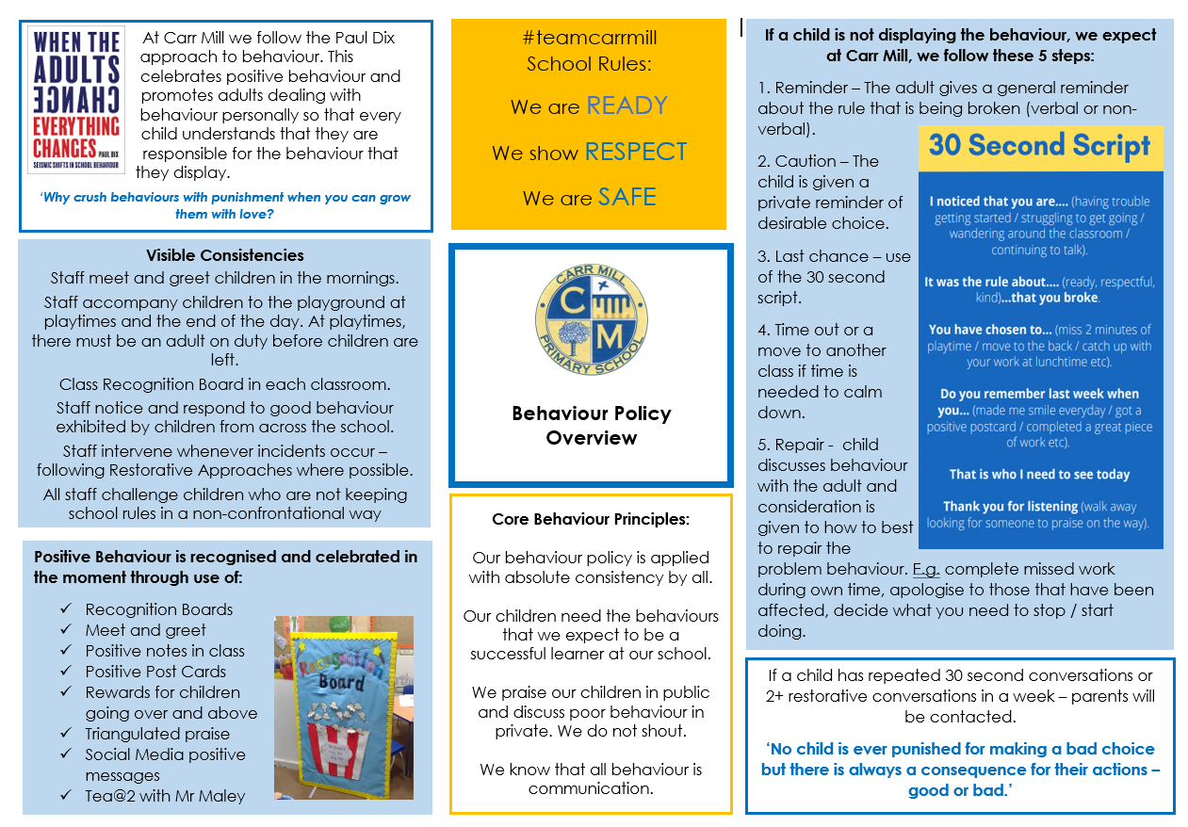

Appendix B –
Screening and Searching Pupils & Confiscation of Items
Key Points Searching:

- School staff can search a pupil for any item if the pupil agrees.

- Head teachers and staff authorised by them have a statutory power to search pupils or their possessions, without consent, where they have reasonable grounds for suspecting that the pupil may have a prohibited item.

Prohibited items are:
- Knives or weapons
- Alcohol
- Illegal drugs
- Stolen items
- Tobacco and cigarette papers
- Fireworks
- Pornographic images
- Any article that the member of staff reasonably suspects has been or is going to be used: to commit an offence, or to cause personal injury to, or damage to the property of, any person (including the pupil).

- Head teachers and authorised staff can also search for any item banned by the school rules which has been identified in the rules as an item which may be searched for.

Schools’ obligations under the European Convention on Human Rights (ECHR)

Under article 8 of the European Convention on Human Rights pupils have a right to respect for their private life. In the context of these particular powers, this means that pupils have the right to expect a reasonable level of personal privacy.
The right under Article 8 is not absolute, it can be interfered with but any interference with this right by a school (or any public body) must be justified and proportionate.
The powers to search in the Education Act 1996 are compatible with Article 8. A school exercising those powers lawfully should have no difficulty in demonstrating that it has also acted in accordance with Article 8. This advice will assist staff in deciding how to exercise the searching powers in a lawful way.

Who can search?
Any teacher who works at the school, and any other person who has the authority of the Headteacher.

Under what circumstances?
You must be the same sex as the pupil being searched; and there must be a witness (also a staff member) and, if at all possible, they should be the same sex as the pupil being searched. There is a limited exception to this rule. You can carry out a search of a pupil of the opposite sex to you and without a witness present, but only where you reasonably believe that there is a risk that serious harm will be caused to a person if you do not conduct the search immediately and where it is not reasonably practicable to summon another member of staff.

When can I search?
If you have reasonable grounds for suspecting that a pupil is in possession of a prohibited item.

Confiscation
School staff can seize any prohibited item found as a result of a search. They can also seize any item, however found, which they consider harmful or detrimental to school discipline. Such items should be handed in to a senior member of staff.

Screening
It is not the policy of the school to routinely screen pupils without identified cause.
Further advice for staff can be found at this link:

http://www.education.gov.uk/schools/pupilsupport/behaviour/behaviourpolicies/f0076897/screening-searching-and-confiscation

Appendix C
The power to discipline beyond the school gate
Teachers have a statutory power to discipline pupils for misbehaving outside of the school premises. Section 89(5) of the Education and Inspections Act 2006 gives Headteachers a specific statutory power to regulate pupils’ behaviour in these circumstances "to such extent as is reasonable."

The school will respond to any inappropriate behaviour which occurs anywhere off the school premises and which is witnessed by a staff member or reported to the school; such reports should be made to the Headteacher or other senior member of staff, who will apply appropriate sanctions in relation to the general principles laid down in this Behaviour Policy.

In all of circumstances, the Headteacher will consider whether it is appropriate to notify the police or anti-social behaviour coordinator in the Local Authority of the actions taken against a pupil. If the behaviour is criminal or poses a serious threat to a member of the public, the police should always be informed. In addition, school staff should consider whether the misbehaviour may be linked to the child suffering, or being likely to suffer, significant harm. In this case the school staff will follow the school’s Safeguarding Policy.

