History in action- A year in the making at Carr Mill 2022/23
October 2022  Black history month whole school assembly. | 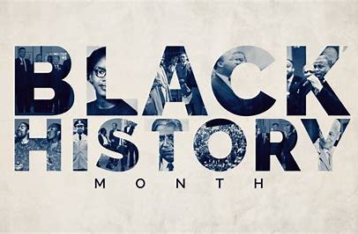
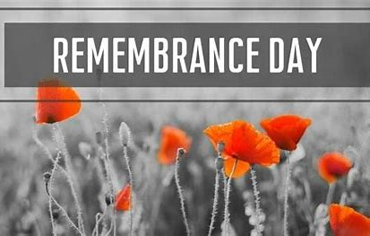 | November 2022  Remembrance Day whole school assembly
Autumn 2 2022
KS1Unit of Work: How has Carr Mill changed overtime?
Comparing old and new maps of our local area.  What was there that isn’t there now?  What is new?  Why are there not as many roads/houses? | 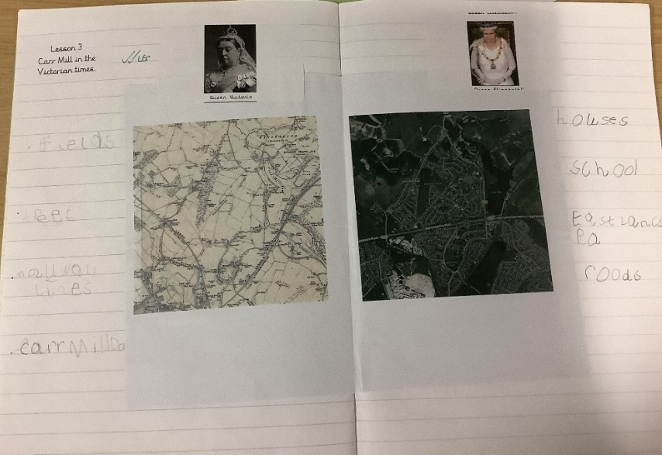
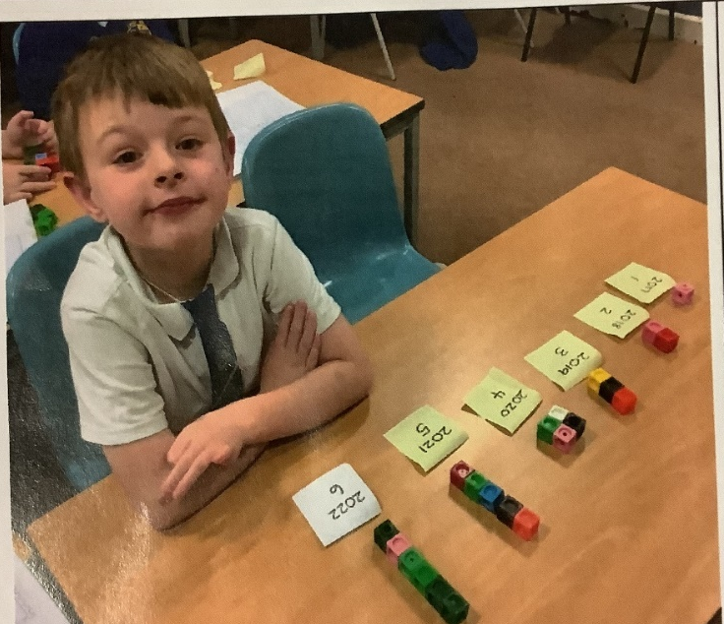 | Chronology: Using multi-link cubes to create a timeline.  How old is old?
Our Monarchy over time | 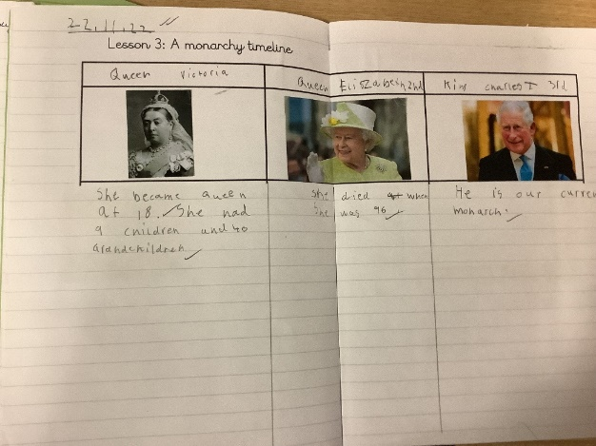
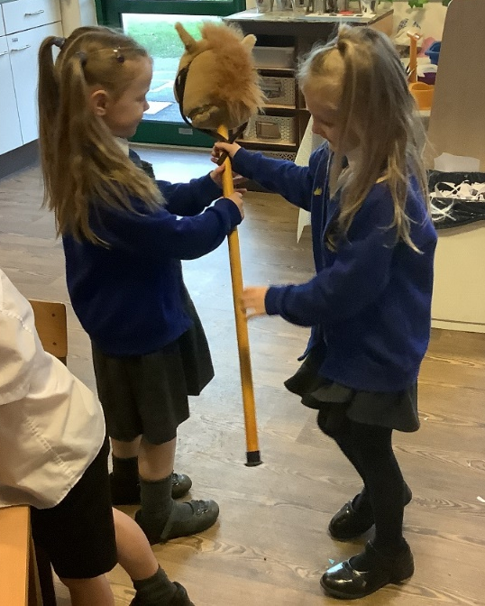
Victorian era experience day
Investigating Victorian style games…
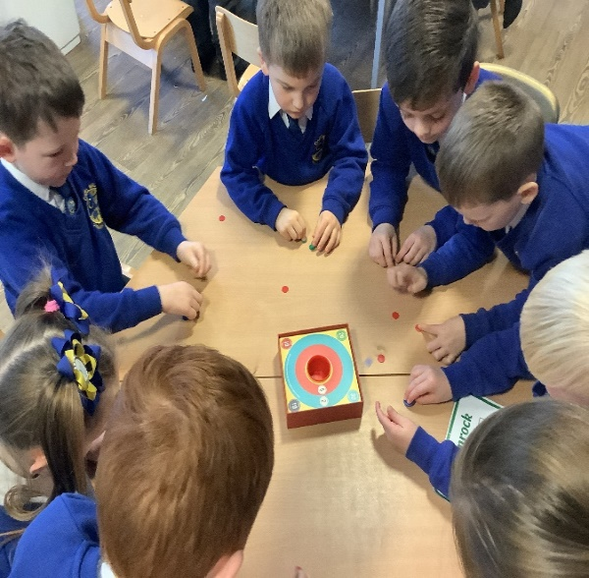

Our learning inspired Lucy to go and find evidence of history in our local area. | 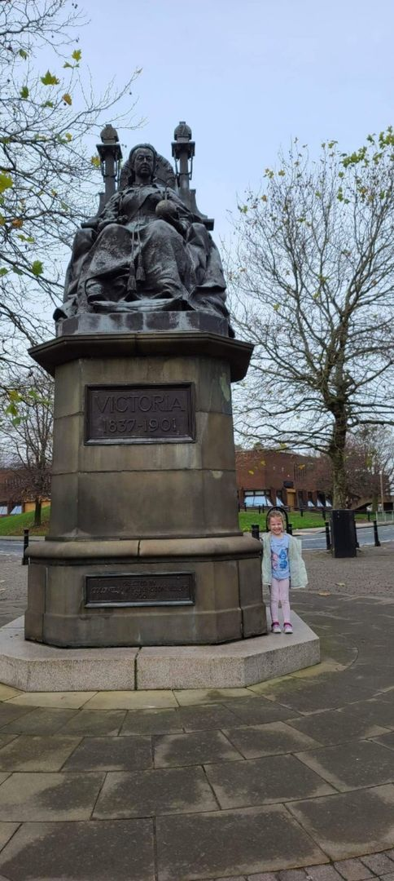
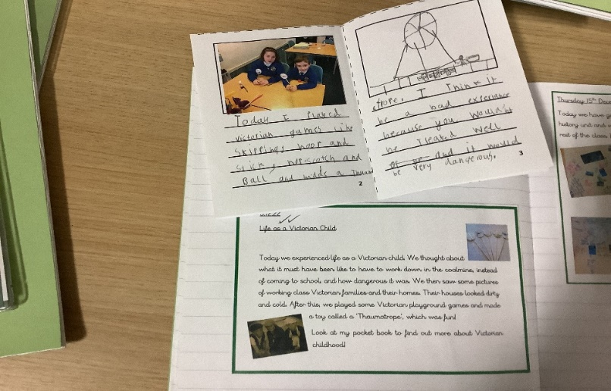 | Victorian era experience day- Y2 reflection task
LKS2: Coaly and Paney: The impact of the industrial revolution on St Helens
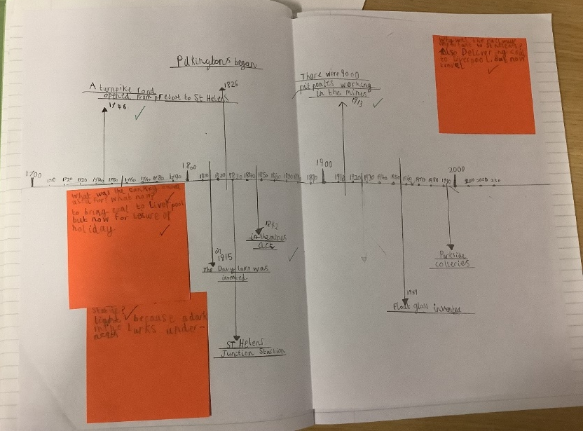 | Creating timelines to display our understanding of the glass industry in St Helens.
Using research to find out about the positive and negative effects of the industrial revolution on St Helens. | 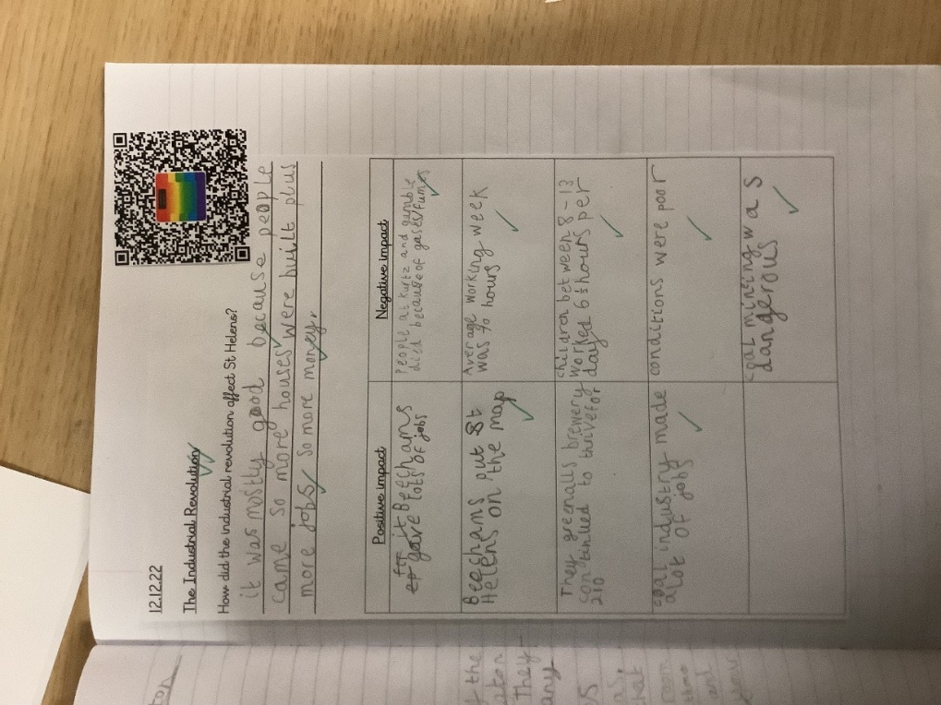
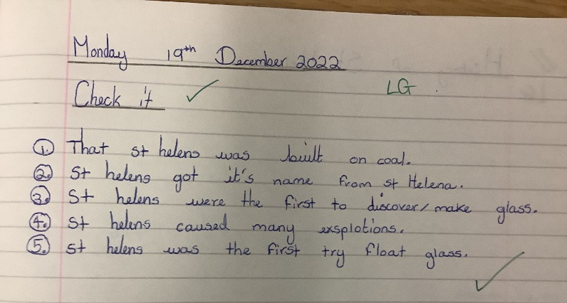 | Check it tasks are completed throughout topics to check children’s understanding so far.  This check it tasks shows what the child can remember about the history of St Helens.
UKS2 Unit of work Roman Britain and Invasion
Using timelines and maps to understand the Roman invasion of Britain. | 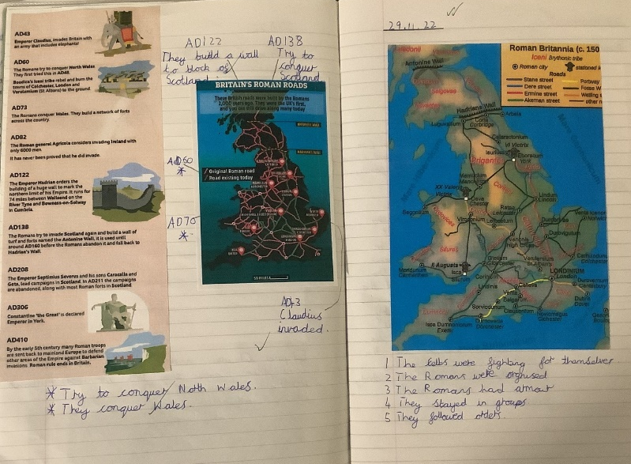
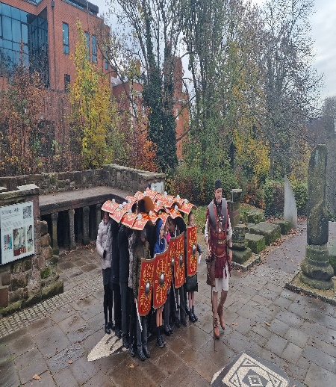 | A trip to Chester to look at evidence of the Roman invasion and a bit of fun in the Dewa experience learning how the Roman army was so successful due to their techniques.
Using primary sources to gain an understand of what Boudicca might have looked like. Thinking about why there are different interpretations of what she looks like and how historians came to those conclusions. No actual photographs. | 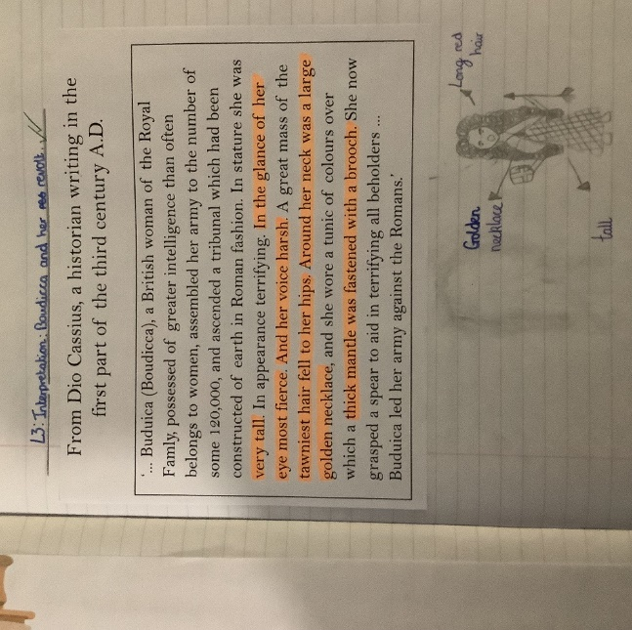
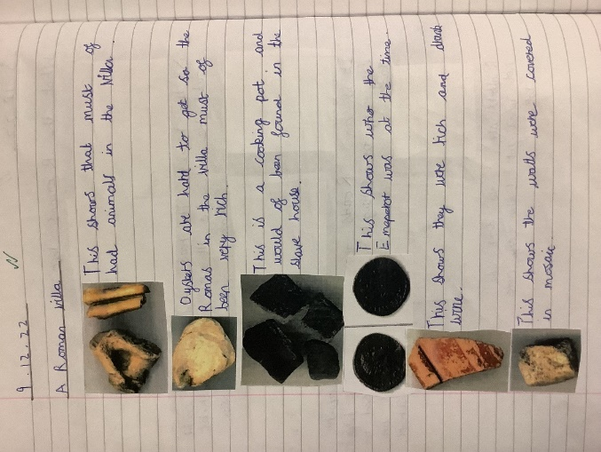 | Looking at artefacts to draw conclusions and gain a better understanding of Roman life.  Did all Romans live in Villas with underfloor heating and running water?
Annotating our whole school timeline to support research and ensure we have a wider understanding of periods of British History. | 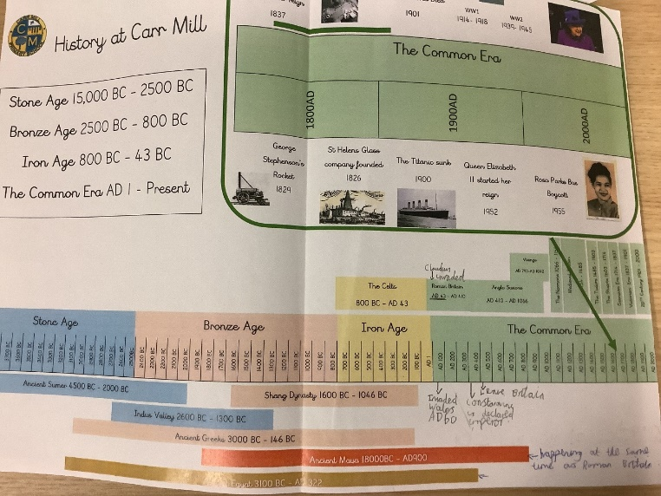
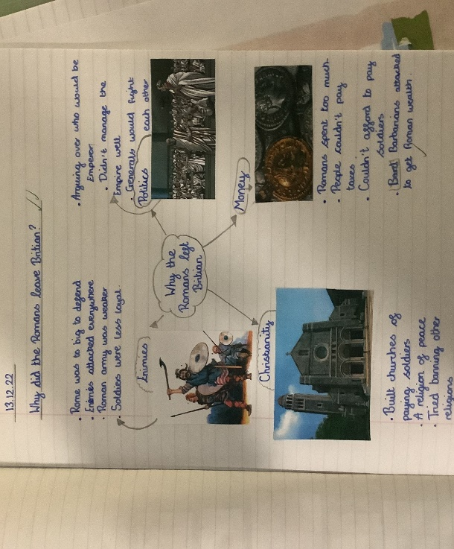 | Reflecting on why the Romans might have left Britain in 410AD
January 2023  Holocaust Memorial Day whole school assembly | 
January 2023
Pupil Voice- Today I got to sit with some children from each key stage in our school to find out what they enjoy about history lessons and what they can remember from their previous history topic.

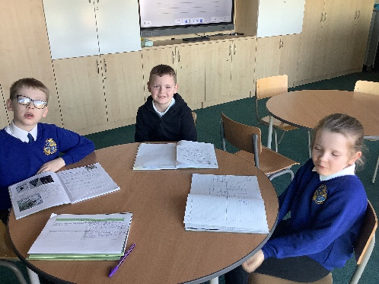
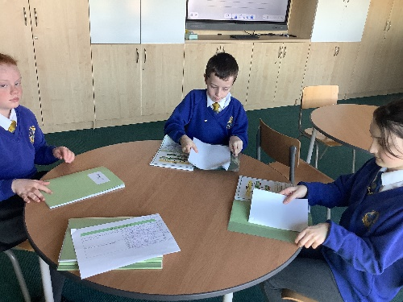
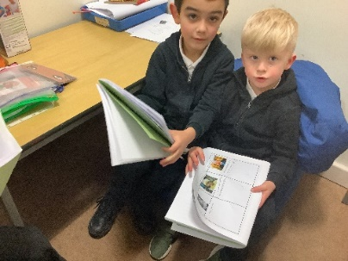

TBC….. Coming up…. Rosa Parks/ The Stone Age/ Anglos Saxons- Invaders or Settlers? The King’s Coronation!

January 2023

January 2023

