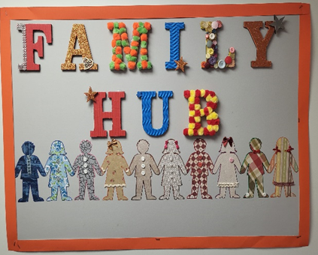

FAMILY HUB
- Promote family activities happening in the local community.
- Arrange workshops from speakers or professionals from outside agencies.
- Organise regular, flexible, informal discussion groups.
- Invite parents with specific knowledge, experiences or unique skills to run parent learning sessions.
- Arrange befriending sessions between families who have experienced similar circumstances.
- Signpost to correct agencies.
- Use Class Dojo to share information & maintain good communication.
- Ask for your views and ideas with regular questionnaire’s.
- Support families during TAC meetings and other appointments.
- Moving forward begin our Heaton’s Super Siblings support group!
- Use Heaton’s School’s on-site facilities to arrange fun Parent Wellbeing Sessions.
- Support maybe available in the following areas:
  - Benefits.
  - Form Filling.
  - Charity Applications.
  - Support Letters.
  - Housing.
  - Self-Care.
  - Behaviours.
  - Mental Health.
  - Friendships.
  - Family difficulties.
  - Transport.
  - Parenting Strategies.
  - Healthy Eating.
  - Training, courses or further education.
  - Volunteering.
  - Employment, CV writing.
  - Grief.
  - Attendance.
  - Food vouchers.

