Summer Activities to Enhance Skills for School-Based Occupational Therapy

Summer is a fantastic time for students to engage in fun activities that also support their occupational therapy goals. Here are some creative ideas to keep children active and learning during the break:

- Craft Projects: Engage kids in arts and crafts that require cutting, coloring, and assembling. This helps improve fine motor skills, hand-eye coordination, and creativity. Simple projects like making friendship bracelets, paper mâché, or painting can be both enjoyable and beneficial.

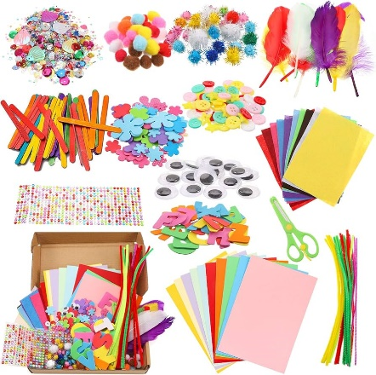

- Outdoor Play: Encourage activities like running, jumping, and climbing at local parks or playgrounds. These activities enhance gross motor skills, balance, and coordination. Incorporating obstacle courses can add an element of fun while challenging their physical abilities.

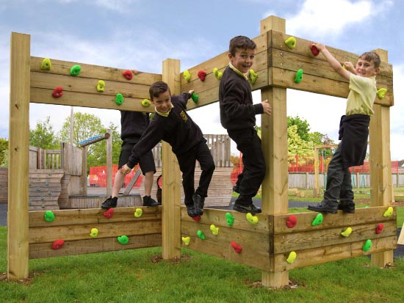

- Cooking and Baking: Involve children in the kitchen with age-appropriate tasks. Measuring ingredients, stirring, and following recipes can boost fine motor skills, sequencing, and planning abilities. Plus, it's a great way to teach healthy eating habits.



- Sensory Bins: Create sensory bins filled with rice, beans, or sand. Hide small objects for children to find. This can help with tactile discrimination and provide sensory input that is calming and organizing.

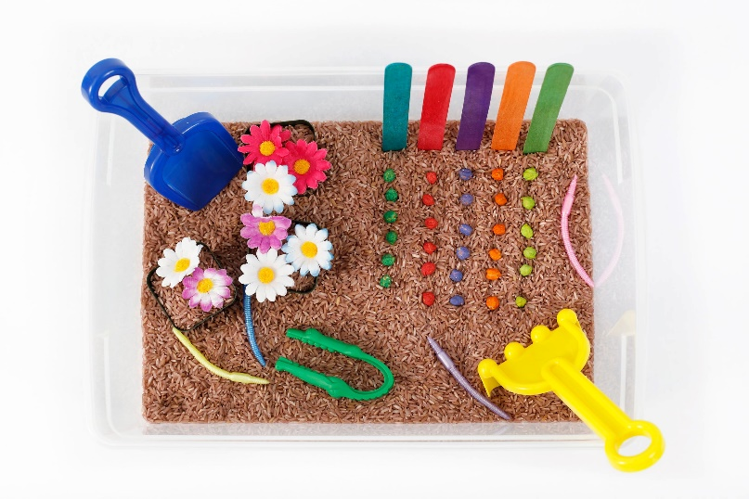

- Gardening: Gardening tasks like digging, planting, and watering can improve motor planning, strength, and coordination. It also teaches responsibility and provides sensory experiences through different textures and smells.

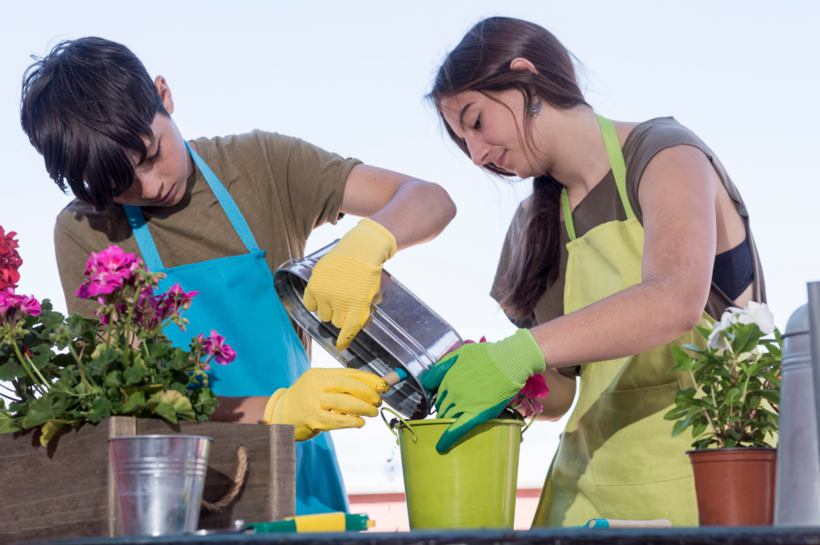

These summer activities are not only enjoyable but also help children maintain and develop skills that will support their occupational therapy goals throughout the school year.

The OT team hopes that everyone has a great summer, and look forward to seeing everyone back in September!

