Pupil premium strategy statement – Heaton School
This statement details our school’s use of pupil premium (and recovery premium) funding to help improve the attainment of our disadvantaged pupils.
It outlines our pupil premium strategy, how we intend to spend the funding in this academic year and the outcomes for disadvantaged pupils last academic year.

School overview
Detail | Data
Number of pupils in school | 93
Proportion (%) of pupil premium eligible pupils | 27%
Academic year/years that our current pupil premium strategy plan covers (3 year plans are recommended) | 2021/2022  2022/2023  2023/2024
Date this statement was published | December 2023
Date on which it will be reviewed | June 2024
Statement authorised by | Jonathan Curtis  Headteacher
Pupil premium lead | Andrew Ruddick  Deputy Headteacher
Governor / Trustee lead | Terry Conlon  Chair of Governing Body

Funding overview
Detail | Amount
Pupil premium funding allocation this academic year | £22,920
Recovery premium funding allocation this academic year | £11,400
Pupil premium (and recovery premium) funding carried forward from previous years | £0
Total budget for this academic year | £34,320

Part A: Pupil premium strategy plan

Statement of intent
Our focus at Heaton School is to ensure that all our students are given every opportunity to ‘Prepare for Adulthood’. Our aim is to use pupil premium funding to help us achieve and sustain positive outcomes for our disadvantaged pupils, whilst ensuring that such students are given every likelihood to achieve and progress at a level similar to those students who are not disadvantaged.
Our strategy will be driven by the needs and strengths of each young person, based on formal and informal assessments, not assumptions or labels. In September 2018 a new Leadership team commenced their roles. The Headteacher decided to implement a three year strategy for Pupil Premium expenditure (2018 – 2021) based on previous successes to allow for continuity during a possible period of change in school but with potential for flexibility and change.
With the interruption of the Covid pandemic and another period of change in the SLT, stability is key to ensure outcomes are met. Therefore, the strategy has therefore remained in place moving forward for the 2021-22 period. Going forward into 2022-2023 and 2023-2024 the need of our students has not waivered or changed significantly. However, performance data does reflect where our strategy needs be focussed.
Our strategy continues to focus on three specific areas which are outlined in more detail in the Outcomes section below and reviewed at the end of each year:
• Communication
• Independent Living Skills
• Friendship and Community / Health and Wellbeing

At the heart of our approach is high-quality teaching focussed on areas where disadvantaged pupils require it most, targeted support based on robust diagnostic assessment of need, and helping pupils to access wide opportunity within a broad and balanced curriculum, individualised to need where appropriate.
Although our strategy is focused on the needs of disadvantaged pupils, it will benefit all pupils in our school where funding is spent on whole-school approaches.

Challenges
This details the key challenges to achievement that we have identified among our disadvantaged pupils.
Challenge number | Detail of challenge
1  Internal  Challenges | - Limitations the school environment brings around mixing students with different needs due to safety i.e. PMLD with significant challenging behaviour  - Emotional, physical, social and communication difficulties caused by the children’s various needs present the greatest barriers to learning at Heaton and impact on all areas of school life  - Children require additional support from a range of therapy, medical and other professional services to meet their complex needs.  - Medical conditions, time in hospital and possible deterioration in health for some students  - Independence, confidence, self-esteem, resilience, problem solving and life/communication skills need high levels of support to enable our children to access their environment and community; raising aspirations about what they can achieve in life.  - Many of our children have obstacles to their individual learning based on their ability to communicate, social and emotional development; several cohorts have a limited ability to play and/ or interact with others.  - All of our PP children enter our specialist provision or alternatively in to various year groups through school with significant developmental and learning delay. In addition, our children have a wide range of difficulties with other restricted abilities and communication issues which mean that their baseline scores are considerably lower than their peers nationally.  - Our pupils access the curriculum at a developmentally appropriate level and school provides additional support in order to move towards independently achieving progress on their SEND learning journey.  - Heaton School numbers – high school population, increase of complexity of need and managing the environment to meet this mix safely leads to constant curriculum/organisational reforms.
2  External challenges | - All our children have a full EHC plan with a clear statement of SEN need; all are allocated a school place via the LEA SEN department.  - Attendance - families are encouraged to develop a better understanding of the importance of good attendance and the impact this has on academic and social achievement.  - Difficulties integrating within the community and limited access to facilities and services - Parents can require support from school to ensure they access a range of services and receive their adequate entitlement.

Intended outcomes
This explains the outcomes we are aiming for by the end of our current strategy plan, and how we will measure whether they have been achieved.
Intended outcome | Success criteria
Pupil Premium students to match achievement/ progress of Non Pupil Premium Pupils  Working using a curriculum targeted towards preparation for adulthood we hold high aspirations for all students at whatever level is appropriate to the individual. Students work towards Heaton levels (H – levels) which fall in line with National Curriculum pre-key stage and engagement levels and offers scope to capture small (yet significant) steps of progress. Students are expected to achieve the equivalent of a sublevel increase (approximately 25 H level sub standards) within a year. Our aim is that all our Pupil Premium students achieve expected (and exceed) levels of achievement in line with their peers. | Evaluation of progress of PP students around IEP targets specifically in Preparation for adulthood targets.  Termly reviews made by curriculum leads on the success of the pathways to enable students to access all experiences at school  Termly/ end of year H level progression data – Pupil Premium vs non Pupil Premium.
Communication  Students to progress in their communication skills  Communication is embedded throughout the school curriculum. A total communication approach throughout school promotes a culture of communication development throughout the school. The Therapies team support processes. | We expect Students to make progress in their communication skills and to demonstrate progress towards communication focussed IEP targets (ie – Clear progressive attainment of termly targets)
Independent Living Skills  Students to increase levels of independence  At Heaton School we endeavour for all our students to grow in confidence and increased ability to work independently. What constitutes progress will be different depending on the students needs and abilities – independence for some students may be focussed on less reliance from an allocated support member of staff, where as for others it may be participating in a specific activity independently.  Going forward an emphasis is going to be on improving reading skills to promote increased independence | IEP targets to outline ‘steps of progression’.  We expect students to demonstrate an improvement in their reading through evidence gleaned from progression H level / comparative data.
Friendship and Community / Health and Wellbeing  All students are encouraged to engage and build positive social interactions/ friendships within school.  Regular social activities such as Music Therapy and input from Manchester City (City in the Community) PE lessons enable such interactions to develop.  We will also promote ‘community’ through activity and support to enjoy unstructured times such as break / lunch time. | H level progression highlighted on assessment data  Evidence/ case studies of interventions through music therapy and PE lessons to improve ‘sense of community’

Activity in this academic year
This details how we intend to spend our pupil premium (and recovery premium) funding this academic year to address the challenges listed above.

Teaching (for example, CPD, recruitment and retention)
Budgeted cost: £2,000.00
Activity | Evidence that supports this approach | Challenge number(s) addressed
Consultant to advise on synthetic phonics strategy throughout school – CPD provided for Literacy lead. This will be disseminated across the team to enhance the overall teaching of phonics  All teachers to receive twilight training to improve phonics T and L throughout school (Feb 24) | Phonics improves the accuracy of the child’s reading but not necessarily their comprehension. It is important that children are successful in making progress in all aspects of reading including comprehension, the development of vocabulary and spelling, which should also be taught explicitly.  EEF research - Synthetic phonics  https://www.drsarahmoseley.com/ | 1  vi , vii and viii

Targeted academic support (for example, tutoring, one-to-one support structured interventions)
Budgeted cost: £13,000
Activity | Evidence that supports this approach | Challenge number(s) addressed
We will employ a music therapist from Nordoff Robbins to deliver 1.5 days of individual and group based therapy sessions.  This academic year students will also receive 0.5 day a week of Omni music sessions | Music is a proven tool to promote and develop positive social and communication interaction/ development  Music Therapy research  soundbeam impact on SEND research | 1 i - ix  2

Wider strategies (for example, related to attendance, behaviour, wellbeing)
Budgeted cost: £6,500
Activity | Evidence that supports this approach | Challenge number(s) addressed
Student support lead to attend restorative and lego therapy intervention training to widen offer within student support  Communication intervention given to students on a needs by need basis and appropriate resources purchased to enable communication skills to develop.  Family Worker to provide training for parents to improve understanding of childs needs and strategies to support within the home setting. | Students (especially those with ASD) find it hard to regulate – targeted support with a member of staff who can guide/ support regulation strategies can benefit such students.  Research on behavioural intervention  Communication intervention provides focussed work that ensures students develop to communicate and interact with the wider world.  AAC devices  Family worker impact research/ case study | 1  1  2

Total budgeted cost: £21,500

Part B: Review of the previous academic year

Outcomes for disadvantaged pupils
Overall:

2021/2022

Those students who receive Pupil Premium progress and achieve within school more than the Non Pupil Premium students – (Pupil Premium 66% achieved at expected/ exceeding levels in camparison with 46% for Non Pupil Premium)

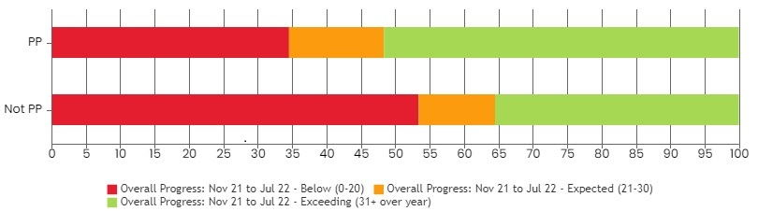

2022/2023

Those students who receive Pupil Premium progress and achieve within school more than the Non Pupil Premium students – (Pupil Premium 64% achieved at expected/ exceeding levels in camparison with 59% for Non Pupil Premium)
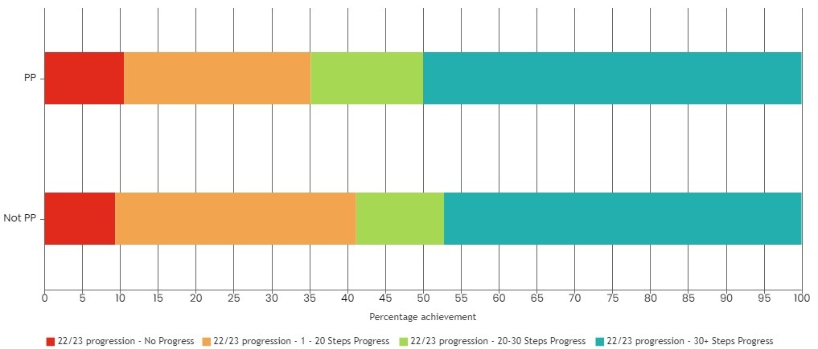

Communication:

2021/2022

The chart below highlights that in the 2021/2022 academic year Pupil Premium students who received Pupil premium attained expected H levels (or exceeded) at 56% - slightly lower than Non Pupil premium students at 72%.

This highlights the need for targeted communication support and for students to have increased access to communication resources and targeted intervention on a needs by need basis.
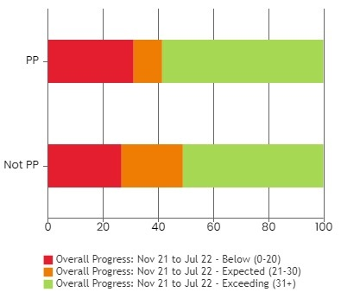

2022/2023
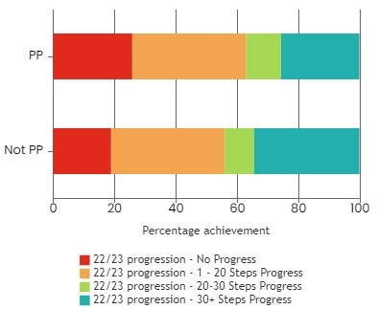

Non Pupil Premium students achieved 82% of expected or above progress in their communication development this academic year. Compared to 77.5% Pupil Premium. This highlights a need for communication resources to be sought for relevant students in order to bridge the gap in attainment.

In Reading Pupil Premium students made comparably similar progress in comparison with Non Pupil Premium students – 78.5% made expected or greater progress.

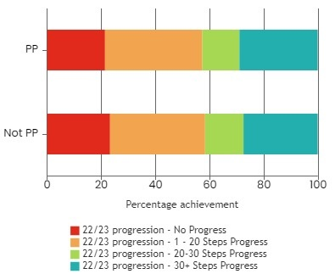

Externally provided programmes
Programme | Provider
Music Therapy/ Assistive Music Technology | Nordoff Robins  https://www.nordoff-robbins.org.uk/  Omni Music  https://omnimusic.org.uk/

