Long Term Plan Cycle A (2026/27)
Term | Autumn 1 | Autumn 2 |  | Spring 1 |  | Spring 2 | Summer 1 | Summer 2
Golden Threads | Diversity GT1 |  |  | Citizenship GT2 |  |  | Environment GT3
Reading fluency and comprehension | 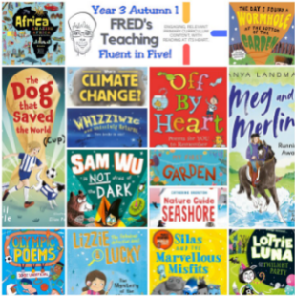 | 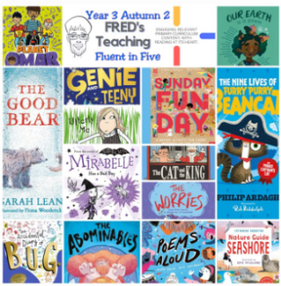 |  | 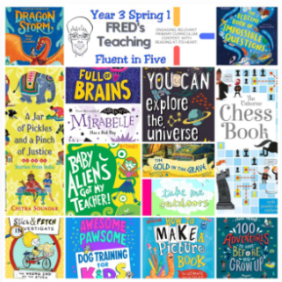 |  | 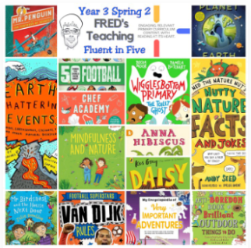 | 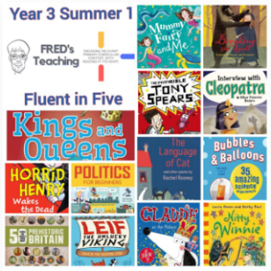 | 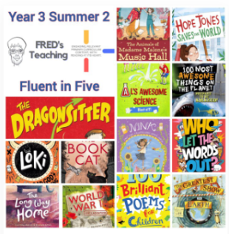
Reading – for Pleasure | The Hodgeheg  Dick King Smith | The Christmasurus  Tom Fletcher  Fantasy Adventure  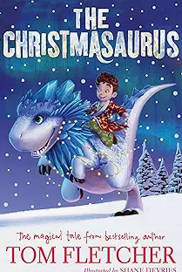 |  | The Hundred Mile an Hour Dog  Jeremy Strong  Humour GT2  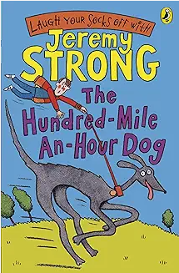 |  | Various Poetry | Beowulf  Michael Morpurgo | The Lion, The Witch and the Wardrobe  CS Lewis
Talk for Writing | Rapunzel (Twisted Tale)  Embedded instructional writing (e.g., How to Escape a Tower)  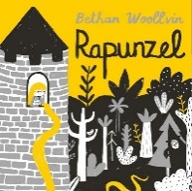 | The Wild Robot (Survival)  Research and retrieve information from non-fiction texts  GT2  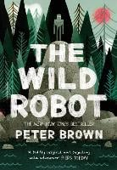 |  | 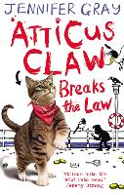  Atticus Claw (Mystery)  Narrative |  | Detective Handbook (Report/Instructions)  Full Non-Fiction Unit: Information layout, subheadings, formal tone  GT2 GT3 | 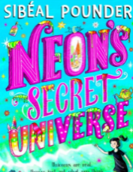  Recount  GT1, GT3  ull Non-Fiction/Hybrid Unit: Adverts, persuasive features, travel guide | 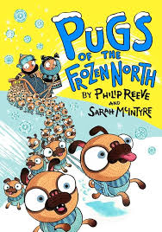  Diary Entry  GT1, GT2, GT3
Grammar focus | Coordinating Conjunctions: and, but, so  Subordinating Conjunctions: while, because, as, when |  |  |  |  |  |  | Expansive noun phrases
Spelling | • Week 1–2: Revision of Year 2 suffix rules (-ed, -ing, -er, -est, -y).  • Week 3–4: Prefixes un-, dis-, mis- (disappear, disappoint).  • Week 5–6: Prefix in- and its variants (il-, im-, ir-) (inactive, impossible).  • Statutory Words Focus: accident(ally), actual(ly), address, answer, appear. | • Week 1–2: Prefixes re-, sub-, inter- (return, subheading, international).  • Week 3–4: Prefixes super-, anti-, auto- (supermarket, antisocial, autograph).  • Week 5–6: Short vowel $/ι/$ spelt y (myth, gym, pyramid).  • Statutory Words Focus: arrive, believe, bicycle, breath, breathe, build, busy/business. |  | • Week 1–2: The suffix -ation added to verbs (information, preparation).  • Week 3–4: The suffix -ly (standard additions and root words ending in -y) (sadly, happily).  • Week 5–6: Homophones & Near-Homophones Set 1 (accept/except, affect/effect, ball/bawl).  • Statutory Words Focus: calendar, caught, centre, century, certain, circle, complete. |  | • Week 1–2: Short vowel $/Λ/$ spelt ou (young, touch, double, trouble).  • Week 3–4: Endings sounding like $/\int{∂}/$ (-sure) and $/t\int{∂}/$ (-ture) (measure, creature).  • Week 5–6: Possessive apostrophe with regular plural nouns (girls', boys').  • Statutory Words Focus: consider, continue, decide, describe, different, difficult, disappear. | • Week 1–2: Endings sounding like $/z∂n/$ (-sion) (division, decision).  • Week 3–4: Words with $/k/$ sound spelt ch (Greek origin) (scheme, chorus, echo).  • Week 5–6: Homophones Set 2 (brake/break, fair/fare, grate/great, groan/grown).  • Statutory Words Focus: early, earth, eight/eighth, enough, exercise, experience, experiment. | • Week 1–2: Words with $/\int{/}$ sound spelt ch (French origin) (chef, machine).  • Week 3–4: Words ending in $/g/$ spelt -gue and $/k/$ spelt -que (league, antique).  • Week 5–6: Consolidated Review & Dictée Application.  • Statutory Words Focus: extreme, famous, favourite, February, forward(s), fruit, grammar.
Maths | Place Value  Addition and Subtraction  Multiplication and Division  Measurement and Area |  |  | Multiplication and Division  Length and perimeter  Fractions  Mass and capacity  Fractions |  |  | Time  Decimals  Money  Shape  Position and direction  Statistics
Science | Sounds Spectacular  Sound | What’s the Matter?  Liquids, solids and gasses. |  | Fit for Success  Nutrition, skeletons and muscles  GT2  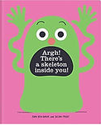 |  | Shining the Light  Light and dark | A Feast of Flowers, Fruit and Seeds  The lifecycle of flowering plants  GT3  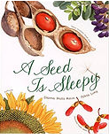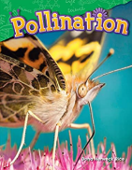 | A World of Living Things  Grouping and classifying living things  GT3  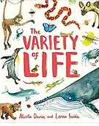
History | British History  Would you prefer to have lived in the Stone, Bronze or Iron Age? |  |  |  |  | How did the achievements of the ancient Maya impact their society and beyond? | British History  What changed in Britain after the Anglo-Saxon invasion?  GT1  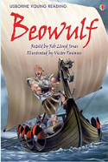  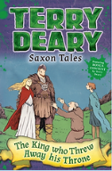
Geography |  | Why do people live near volcanoes?  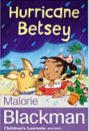  The destructive powers of nature.  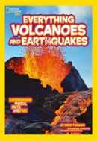 |  | Where does our food come from? |  |  |  | Rainforests  Why are rainforests important to us?  GT1 GT3  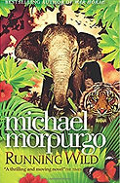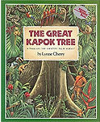
DT |  | Cooking and nutrition:  Adapting a recipe |  |  |  | Textiles:  Fastenings | Let’s Go Fly a Kite!  Design, make and evaluate kites.
Art | Prehistoric Painting |  |  | Explore tone, texture and proportion |  |  |  | Rainforest Art  Study the art of Michael Rousseau and create art in a similar style.  GT3
ICT | Computing systems and networks – connecting  Word processing | Creating media – stop-frame animation  Touch typing |  | Programming – sequencing sounds  Word Processing | Data and information – Branching databases  Touch typing |  | Creating media – Desktop publishing |  | Programming – events and actions
Music | South Africa (instrumental) |  |  | Developing singing technique |  |  | Body and tuned percussion (Rainforests)
MFL | French greetings with puppets |  | French adjectives of colour, size and shape | Playground games – numbers and age |  | In a French classroom | Bon appetit | Shopping for French food
RE | How do people welcome new life into the world? How do people show their commitment to a religion?  GT2 GT1 |  |  | How do people celebrate marriage?  GT2 GT1 |  |  | What do people believe about the afterlife? How is this expressed in funeral practices?  GT2 GT1
PSHE/SRE | Me and My Relationships GT2 |  | Valuing Difference  GT2 GT1 | Keeping Myself Safe  GT2 |  | Rights and Responsibilities GT2 | Being My Best  GT2 | Growing and Changing  GT2
PE | Rugby and Netball |  | Football and Hockey/Swimming | Rugby and Netball/Swimming |  | Football and Hockey/Swimming | Rounders and Cricket | Athletics and Gymnastics
Enrichment opportunities | WildPines Visit  Harvest Festival GT2 GT3 |  | Lincoln Castle/Magna Carta GT2 GT3 |  |  | Visit to Gainsborough and Old Hall GT1  World Book Day GT2 GT3 | The Collection  King Arthur Visit | Woodside Falconry GT3  Beach GT2 GT3  Transition Sleepover GT2
Long Term Plan Cycle B (2025/26)
Term | Autumn 1 | Autumn 2 |  | Spring 1 |  | Spring 2 |  | Summer 1 |  | Summer 2
Golden Threads | Diversity GT1 |  |  | Citizenship GT2 |  |  |  | Environment GT3
Topic | Wonderful World | Rampaging Romans |  | Regal Railways |  | Dinosaurs |  | Enchanting Egyptians
Reading Fluency
Reading – for Pleasure | 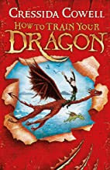  How to Train your Dragon?  Historical, medieval fantasy | 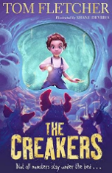  The Creakers  Fiction  Humour and Horror |  | 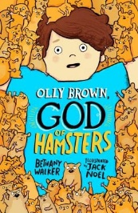  Ollie Brown: The God of Hamsters  Humour |  | Fantastic Mr Fox  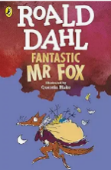  Roald Dahl  Humour |  | 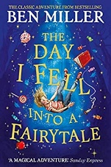  The Day I Fell into a Fairytale:  Fairy tale and Folklore  Action and Adventure |  | 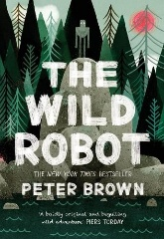  The Wild Robot  Nature vs technology  Social  Science and Nature
Talk for Writing | 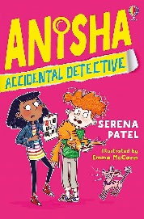  Anisha: Accidental Detective  Narrative  GT1 | 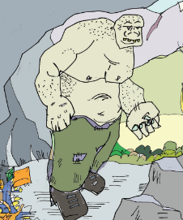  The Truth about Mountain Ogres  Non-fiction  Information report  GT1 |  | How to capture a Frost Giant?  Instructions  GT1 |  | Topic Related writing :  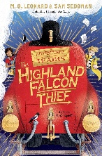  Warning Tale based on the text The Railway Children.  GT3 |  | Topic related writing:  Detective story  Identify language and structure choices that create suspense.  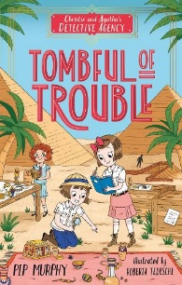 |  | 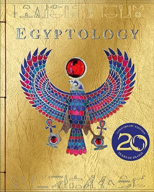  Egyptology  an information text based around Tutankhamun.  Information text  GT1
Spelling | • Week 1–2: Revision of prefix rules & adding vowel suffixes to multisyllabic words with stressed/unstressed final syllables (forgetting, preferred vs gardener, limited).  • Week 3–4: The suffix -ly with root words ending in -le and -ic (gently, basically).  • Week 5–6: The suffix -ous (standard root words and dropping final -e) (poisonous, famous).  • Statutory Words Focus: group, guard, guide, heard, heart, height, history. | • Week 1–2: The suffix -ous (words ending in -our changing to -or, and keeping -e for soft $/d3/$) (humorous, courageous).  • Week 3–4: Endings sounding like $/\int{∂}n/$ spelt -tion (root ending t/te).  • Week 5–6: Endings sounding like $/\int{∂}n/$ spelt -ssion (root ending ss/mit).  • Statutory Words Focus: imagine, increase, important, interest, island, knowledge, learn. |  | • Week 1–2: Endings sounding like $/\int{∂}n/$ spelt -sion (root ending d/se).  • Week 3–4: Endings sounding like $/\int{∂}n/$ spelt -cian (occupations; root ending c/cs) (musician, electrician).  • Week 5–6: Homophones Set 3 (here/hear, heel/heal/he'll, knot/not, mail/male).  • Statutory Words Focus: length, library, material, medicine, mention, minute, natural. |  | • Week 1–2: Words with $/s/$ sound spelt sc (Latin origin) (science, scene, fascinate).  • Week 3–4: Words with $/eι/$ sound spelt ei, eigh, or ey (vein, weigh, neighbour, obey).  • Week 5–6: Possessive apostrophe with irregular plural nouns (children's, men's, mice's).  • Statutory Words Focus: naughty, notice, occasion(ally), often, opposite, ordinary, particular. |  | • Week 1–2: Homophones Set 4 (main/mane, meat/meet, medal/meddle, missed/mist).  • Week 3–4: Homophones Set 5 (peace/piece, plain/plane, rain/rein/reign, scene/seen, weather/whether, whose/who's).  • Week 5–6: Dictionary skills (using first 2–3 letters) & Etymology investigations (e.g., bi- + cycle, med- in medical/medicine).  • Statutory Words Focus: peculiar, perhaps, popular, position, possess(ion), possible, potatoes, pressure. |  | • Week 1–2: Consolidation of Year 3/4 Prefixes & Suffixes in extended writing.  • Week 3–4: Final Review of Year 3/4 Statutory Word List.  • Week 5–6: Dictée Challenge & Proofreading Showcase.  • Statutory Words Focus: probably, promise, purpose, quarter, question, recent, regular, remember, sentence, separate, special, straight, strange, strength, suppose, surprise, therefore, though/although, thought, through, various, weight, woman/women.
Maths | Place Value  Addition and Subtraction  Multiplication and Division  Measurement and Area |  |  | Multiplication and Division  Length and perimeter  Fractions  Mass and capacity  Fractions |  |  |  | Time  Decimals  Money  Shape  Position and direction  Statistics
Science | Habitat Helpers  Changing environments  GT2 GT3  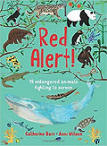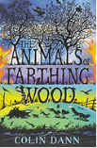 | Electric Personalities  Electricity, circuits and safety |  | Magnetic Fun and Games  Forces and magnets. |  | This Planet Rocks  Rocks, soil and fossils.  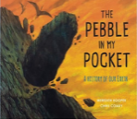  GT3  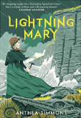 |  | Plants – Greatly Green Growers  Plants – lifecycles  GT3  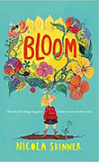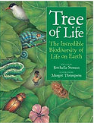 |  | The Circle of Life  Human digestive system, teeth and food chains  GT2 GT3
History |  | The Romans in Britain  Why did the Romans invade and settle in Britain?  GT1 GT2 GT3  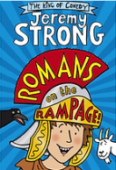  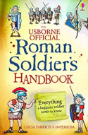 |  | Railways  How have childrens’ lives changed?  How the creation and development of the railways happened and how it changed the way people live.  GT2 GT3 |  |  |  | Ancient Egypt  Study of an ancient culture.  GT1 GT2  What was important to ancient Egyptians?  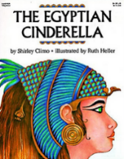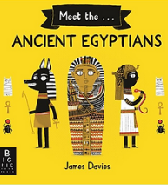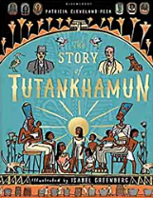
Geography | Who lives in Antarctica?  Maps, atlases and globes. Compass directions and mapping.  GT3 |  |  |  |  | Land Use  Are all settlements the same?  GT2 GT3 |  | The River Nile  What are rivewrs and how are they used?  How the Nile was used historically and how it is still used today.  GT1 GT3
DT |  | Roman Entertainment  Study Roman Entertainment. Build and Design a fit-for-purpose Roman Chariot |  |  |  | Marble Run  Design, create and evaluate a marble run. Use scientific knowledge of forces to slow down marble.  GT2 |  | Textiles:  Egyptian collars |  | Egyptian Tomb  Antichamber + entrance + tomb  GT3
Art | Art from around the world  Learn about artists from around the world. Study and replicate their style.  GT1 | Drawing:  Developing drawing skills |  | Autumn  Draw, paint, collage and model using a variety of different materials.  GT3 |  |  |  | Egyptian Masks  Papyrus – Ancient Egyptian scrolls  GT1
ICT | Computing systems and networks – the internet  Word processing | Creating media – Audio production  Touch typing |  | Programming  Word Processing |  |  | Data logging  Touch typing | Creating media – photo editing | Programming – Repetition in games
Music | Creating composition |  |  | Rock and Roll |  |  |  | Space: contrasting dynamics
MFL | This is me |  | School days | Birthday celebrations |  | Colourful creatures |  | Fabulous French food |  | Gourmet tour of France
RE | Big Questions (including Christianity)  What does pilgrimage mean to individuals and communities?  GT2 GT1 GT3 |  |  | Creation (including Christianity)  Which RWs communities can we find in our neighbourhood? (yr 3 topic)  GT1 GT3 |  |  |  | Philosophy for Children: enquiry-based topic, e.g. moral and ethical dilemmas.  Story based unit, The Lion, The Witch and The Wardrobe, Pilgrim’s Progress.
PSHE/SRE | Me and My Relationships  GT2 |  | Valuing Difference  GT1 GT2 | Keeping Myself Safe  GT2 |  | Rights and Responsibilities  GT2 |  | Being My Best  GT2 |  | Growing and Changing  GT2
PE | Rugby and Netball/Swimming |  | Football and Hockey/Swimming | Rugby and Netball/Swimming | Football and Hockey/Swimming |  |  | Rounders and Cricket |  | Athletics and Gymnastics
Enrichment opportunities | Author visit  Harvest festival |  | Roman Visit | York Railway Museum |  | Dinosaur and Fossil day |  | The Collection |  | Class assembly  Beach trip  Transition sleepover

