PSHE and HRE– Curriculum Map Cycle A
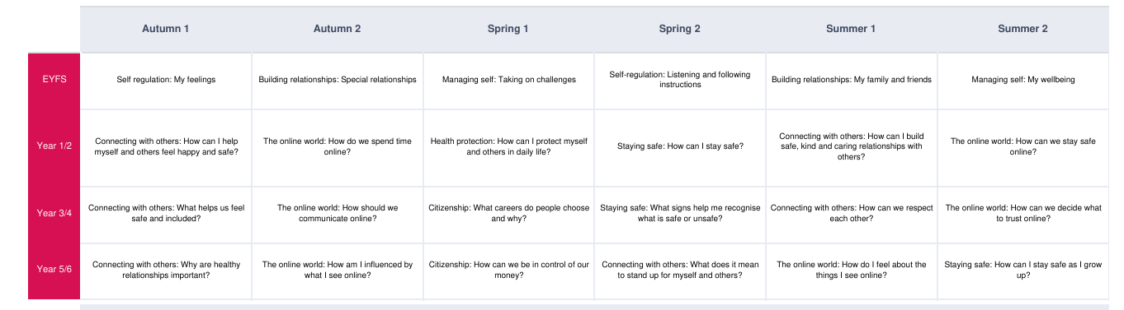
PSHE and HRE– Curriculum Map Cycle B