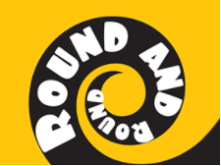
Key Questions –
What instruments can you hear?
Do you like this song? Why?
How is the song put together?
What is the style of Music?
Can you find the pulse?
What is rhythm and pitch?
Can you play simple notes?

Key skills –
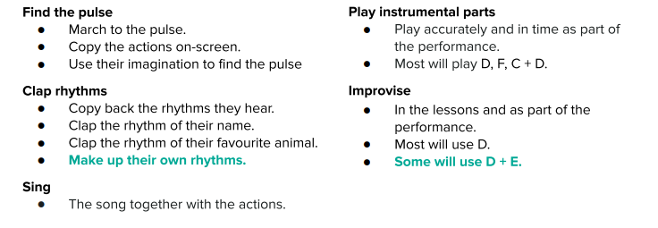
What I will be taught –
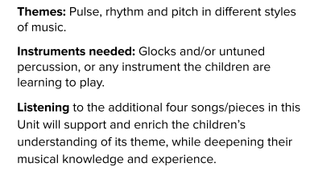
What I should already know –
• Invent, adapt and recount narratives and stories with peers and their teacher.
• Sing a range of well-known nursery rhymes and songs.
• Perform songs, rhymes, poems and stories with others, and (when appropriate) try to move in time with music.

Key vocabulary –
