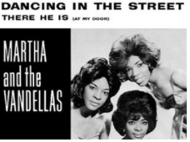
Key Questions –
- How has music changed over time?
- Can you move in time to the music?
- Do you like this song? Why?
- How does the music make you feel?
- What instruments can you hear in the music?
- Can you identify the artist?
- Can you invent rhythmic and melodic patterns?
Key skills –
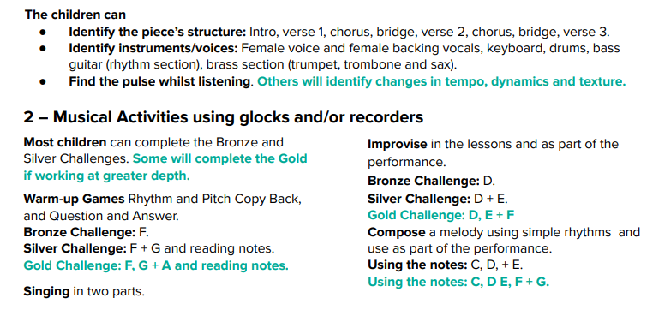

What I will be taught –
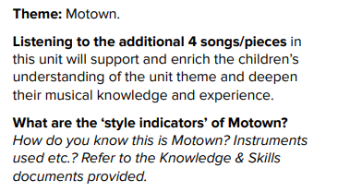
What I should already know –
- How to find the pulse of a song and move to it
- Simple chords on instruments
- Listening to different songs and giving opinions on them
- Simple improvisation with instruments
- Singing in groups
- Different genres of music and how they sound

Key vocabulary –
