What should I know …  • How to group familiar food products e.g. fruit and vegetables  • How to explain where food comes from  • How to cut, peel, grate and chop a range of ingredients  • How to work safely and hygienically  • Why we need a variety of foods in our diet to keep us healthy  • How to measure and weigh food items  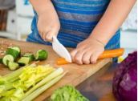 | I will be taught facts on…  • That fruits and vegetables grow in different countries based on their climates.  • That ‘seasonal’ fruits and vegetables are those that grow in a given season and taste best then.  • Know that eating seasonal fruit and vegetables has a positive effect on the environment.  • The hygiene and safety rules to follow when preparing food  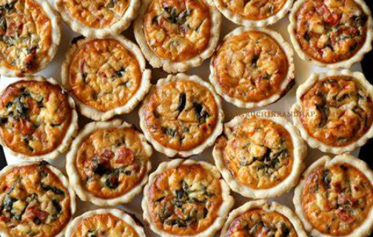 | Key Questions …  • Product - what different ingredients can be used in a healthy tart using seasonal ingredients?  • Purpose – when might you need to eat a healthy tart?  • User - who is going to eat your healthy tart?  • What ingredients will you need?  • What tools and techniques will you use to prepare the meal?  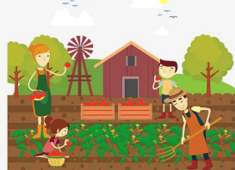
Key Vocabulary and Definition… | Key skills…  • To analyse the taste, texture, smell and appearance of a range of foods  • Follow the instructions within a recipe.  • To design their own tart recipe using seasonal ingredients.  • Understand the basic rules of food hygiene and safety.  • To select a range of tools with accuracy  • To select the techniques used i.e. grating, chopping and peeling  • To evaluate a product against the design criteria | Web links …  https://www.bbcgoodfood.com/recipes/collection/kids-cooking  https://www.kidspot.com.au/kitchen/recipes/collections/cooking-with-kids  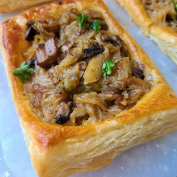
  Recipe | A list of instructions for making a food dish.
  Ingredient | One of the parts of a mixture
  Sensory | Involving or using one of the senses.
  Savoury | Not sweet or salty
  Technique | The particular method or way of  doing or performing something
  Evaluate | Assess or judge something

