
Key Questions –
- Can you find the pulse of the music?
- Can you move in time to the music?
- Do you like this song? Why?
- Which notes have you used?
- Can you improvise?
- How does the music make you feel?
Key skills –
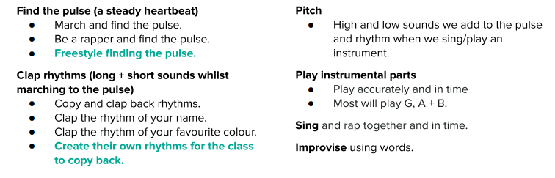
What I will be taught –
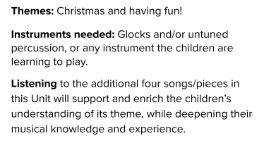
What I should already know –
- How to find the pulse of a song and move to it (basic)
- Simple chords on instruments
- Listening to different songs and giving basic opinions on them

Key vocabulary –
