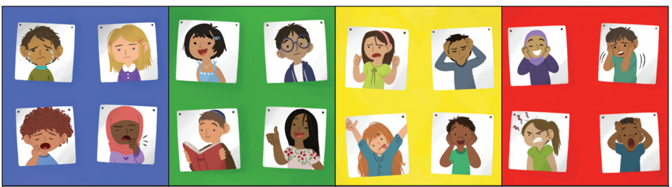


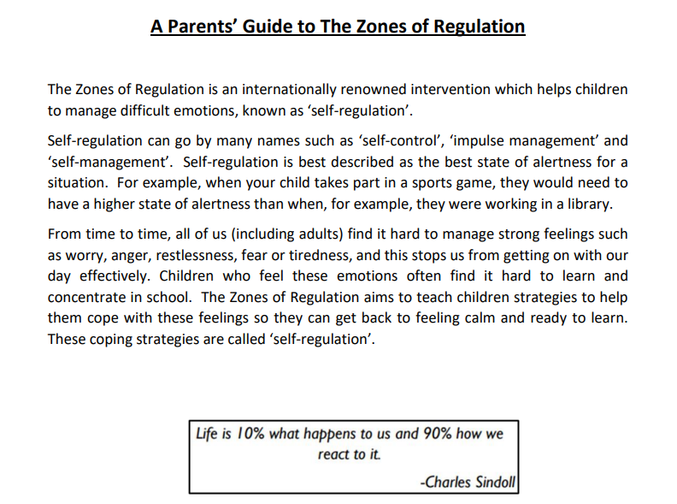

At Stephen’s Primary School, we are launching the Zones of Regulation throughout the whole school. We want to teach all of our children good coping and regulation strategies so they can help themselves when they experience anxiety and stress. In the classroom, sometimes children panic when faced with a tricky learning problem or challenge. By teaching them how to cope with these feelings might make them better at tackling learning challenges and build better resilience so they don’t give up so easily when faced with difficulty.

We want children at Stephen’s to grow into successful teenagers then adults. Teaching the children at a young age about managing their feelings will support them in later life so that they don’t turn to negative coping strategies which affect their mental and physical wellbeing.
