Google Classroom Guide
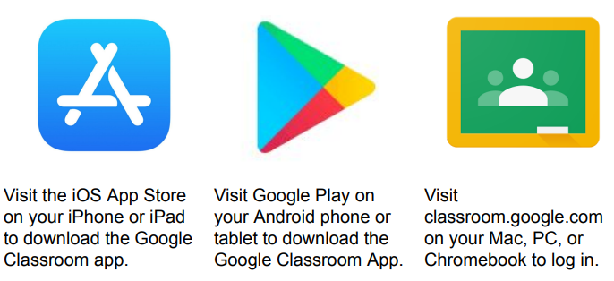

You will then need to log in using the email address and password you have been given by your teacher. Example
eXXXXXXXf@ainsdalestjohns.org
E//////*

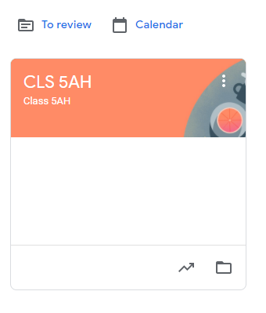
You should see your class displayed on the screen – click on your class to open it.
Important note for parents –if you are struggling to access your child’s class and have your own Google account on a shared device, please make sure you are logged into the correct account.
If a child tries to access at home and it is not working, it may be that they need to ‘log out’ of a parent account first.

Class Page - Stream
The class page has 3 tabs across the top. The ‘stream’ tab is the default and will always be the first to appear.
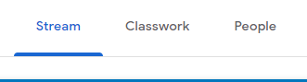
The stream is a bit like a news feed and will display any recent posts that the teacher has made to the children and any information about assignments that have been recently set. The most recent post will appear at the top.
Classwork
Click on the ‘Classwork’ tab. This is where class assignments/tasks are posted. Pupils will spend most of their time on this page, reviewing, and completing course work assigned by the teacher.
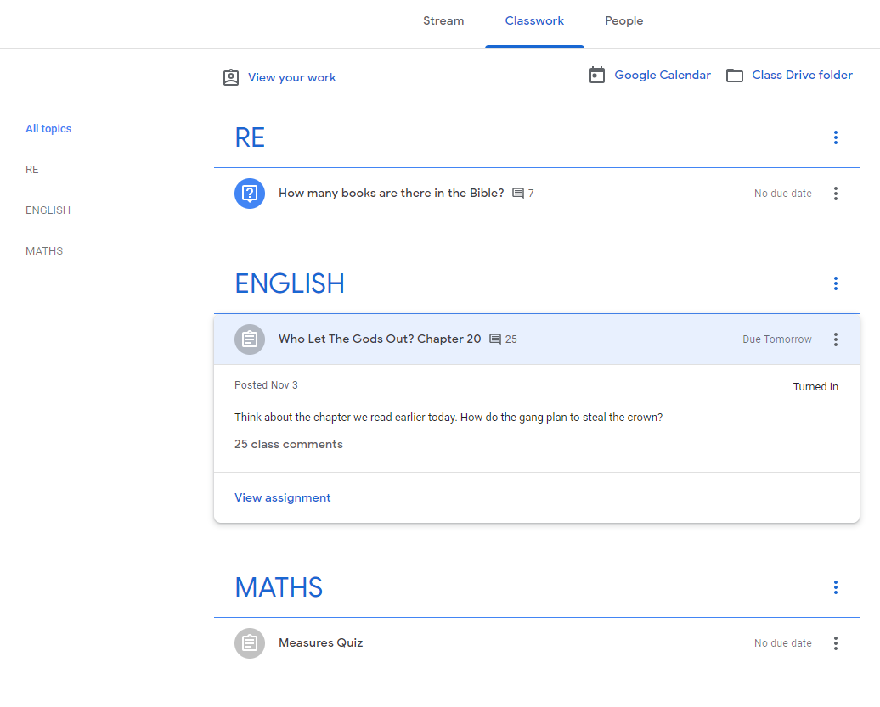
1. The classwork page is organised into topics – this may be sorted by different subjects or different weeks depending on the class.
2. Pupils can view a summary of all their upcoming tasks by clicking on ‘View your work’.
3. Pupils can click on an assignment to preview it. To view all the details, then click ‘View assignment’.
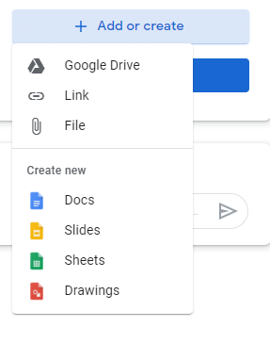
When you open an assignment, you can see all the materials/resources/instructions given to you by your teacher. Click on ‘+Add or create’. If you want to send a photograph or word document etc. to your teacher, click ‘File’ and attach your work. Alternatively, you can create a document/slideshow/drawing directly into Google Classroom by clicking on the relevant app: Docs, Slides, Sheets, Drawings. This is probably the quickest way of completing your work.

Once you have chosen to create a new document, click on the document to edit it. Google classroom is constantly saving your work as you type, so if you don’t finish, or your computer switches off, you will not lose your work. Once completed, click ‘Turn in’. Your teacher will now be able to provide feedback on your work. They may return it to you to make changes if they think you need to.
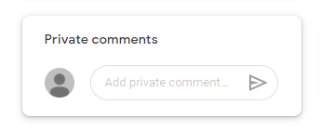
You can also share private comments with your teacher here.

