
Pre-School
Read Write Inc (Phonics)

Adswood Primary - Enjoy, Believe, Achieve

In Nursery (ages 3–4), Read Write Inc. focuses on pre-reading skills and introducing the very first single letter sounds. At this stage, the goal is building listening skills, oral blending, and letter recognition through multi-sensory play rather than formal reading.

Here is a guide to Read Write Inc. Phonics for Nursery children:

1. What Nursery Phonics Focuses On

Environmental & Musical Sounds: Learning to listen carefully to spoken words, environmental noises, and musical rhythms.

Fred Talk (Oral Blending): Hearing sounds spoken out loud and blending them into words without seeing text yet (e.g., adult says "Pass me the c-u-p", child points to the cup).

Set 1 Single Sounds: Introducing the first group of single letters (m, a, s, d, t, i, n, p, g, o) with visual picture cards and hand rhymes.

Gross & Fine Motor Development: Preparing hand and core muscles for writing through mark-making, air-writing, and sensory play.

2. Nursery Speed Sound Sequence

In Nursery, sounds are introduced slowly—usually 1 or 2 per week. Children learn the sound alongside a picture mnemonic and a handwriting phrase. Here is an example of the first 3 sounds…
Sound | Picture Mnemonic | Handwriting / Formation Phrase
m | Maisie, mountain, mountain | Down Maisie, over the mountain, over the mountain
a | Apple | Around the apple and down the leaf
s | Snake | Slither down the snake

3. Key Nursery Activities & Techniques

Fred Talk Games

Nursery children play oral blending games with "Fred the Frog":

Fred Says: "Fred says touch your h-ea-d" or "Fred says sit on the f-l-oo-r."

What’s in the Bag?: Pulled items out of a bag using Fred Talk ("Look, it's a d-o-g!").

Fred’s Lunch: Asking for food items using sounds ("Would you like an a-p-l?").

Pure Sounds

Teaching clean sounds is essential from day one. Avoid adding "uh" at the end:

m = mmmm (continuous sound, not muh)

s = ssss (hissing sound, not suh)

t = short, crisp t (not tuh)

Air Writing & Sensory Mark-Making

Before picking up a pencil, Nursery children practice letter shapes through movement:

Writing letters in the air with giant arm movements.

Tracing letters in sand trays, shaving foam, or glitter boxes.

Forming letters using playdough or ribbons.

4. How to Support a Nursery Child at Home

Keep it short and playful: 3–5 minutes of sound practice a day is plenty for a 3-year-old.

Play oral Fred Talk games: Talk in Fred Talk during routines ("Put on your s-o-c-k-s").

Emphasize listening skills: Go on "sound walks" outside to name noises (traffic, birds, wind) to build auditory discrimination.


Read aloud every day: Storytime builds vocabulary and comprehension long before a child can decode text themselves.
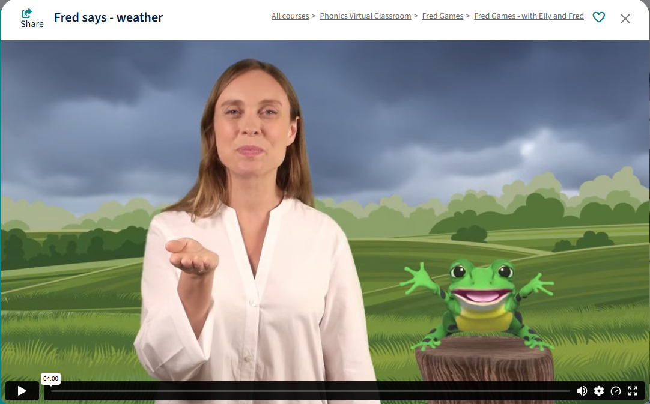

We will send our Virtual Classroom Video’s throughout the year - Here is a Fred Game about the Weather.

