Pre-School Newsletter

Adswood Primary - Enjoy, Believe, Achieve
Autumn 1 Term
Thursday 3rd September – Friday 23rd October 2026
Our topic theme for this half term is called :
Super Duper You

What will we read this half term ?
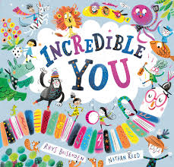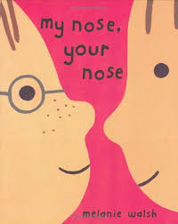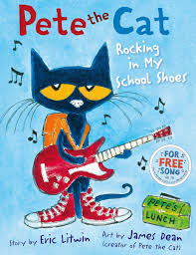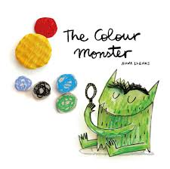
What will we learn this half term?
English
During Autumn 1, the children will be exploring the theme ‘All About Me’ through a range of engaging stories and activities. We will be reading the books above to encourage children to celebrate their individuality, understand their emotions, recognise similarities and differences and learn about different family structures.
Throughout the term, children will develop a sense of ‘self’ by talking about their own interests, features, feelings and abilities. They will also learn about the people who are important to them, who lives in their home and how every family is unique. Through play, discussions, creative activities and circle times, children will build confidence, develop positive relationships and begin to understand and respect the diversity of others.
Maths
In Nursery and Pre-School, we follow the Master the Curriculum Maths Scheme to provide children with a strong foundation in early Mathematical understanding. Through practical, play-based activities and everyday experiences, children will develop their confidence in counting, recognising and comparing quantities, exploring patterns, sorting and matching objects, and using mathematical language. Learning will be carefully sequenced to build on prior knowledge, encouraging children to investigate, problem-solve and develop a positive attitude towards Maths in an engaging and meaningful way in our classroom.
In Autumn we will begin to learn about:
- Colour
- Matching
- Sorting
- Number 1
- Number 2

Phonics
This term, we will begin introducing children to early phonics through the Read Write Inc. programme. These lessons will be building listening and attention skills, learning to hear and identify different sounds, develop oral blending and begin to recognise and pronounce initial letter sounds. We use Fred Talk to support children to blend and segment. We have lots of Read Write Inc. videos that we can also send you over our SeeSaw app too!
Willow Garden
Our Willow Garden is our outdoor learning space where children have the opportunity to explore, discover and learn through nature. Regular sessions in the Willow Garden encourage children to develop confidence, independence, curiosity and resilience whilst in a natural environment. They can build, create, investigate wildlife, work together and take part in practical activities that support their physical, social, emotional and cognitive development.

We will be going to the Willow Garden Tuesday Afternoons and Thursday Mornings. We provide ‘splash suit’ waterproofs and spare socks, if you could please provide your child with their own wellies to put on their peg. (Our first sessions will be Tuesday 22nd September and Thursday 24th September).
Homework
We would love to work together to support your child’s independence and development, so here are some ideas to challenge your child at home in the Autumn 1 Term:
- Toilet Training (Bedtime Routine)
- Put on and take off coat independently
- Zip up own coat
- Put on shoes and fasten the velcro
- Wash and dry hands independently
- Use a knife and fork at mealtimes
- Drink from an open cup
- Read together - three times a week
- Talk about who lives in your home
We are pleased to share that we will be welcoming an Urdu-speaking EAL Teaching Assistant from Stockport Council into our Pre-School on a Monday, she’s called Abida. Abida will be working alongside our team to support our Urdu-speaking children with their communication, language and learning.
We look forward to a lovely first Autumn 1 half term with you Pre-School!
Best Wishes,
Miss Syddall {Nursery Teacher}, Mrs Santana-Reedy {Nursery Nurse},
Miss Crummett and Miss Racz {Nursery Nurse}, Tonie Potter{Play Worker}

