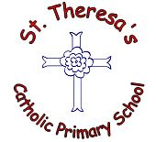

Collect FREE donations for St Theresa’s Catholic Primary School every time you shop online.
Join here:
easyfundraising.org.uk/ causes/sttheresascp
Collect FREE donations for St Theresa’s Catholic Primary School every time you shop online.
Join here:
easyfundraising.org.uk/causes/sttheresascp

