ADVENT  Advent is a season observed in many Christian Churches and families as a time of waiting and preparation for the celebration of the Nativity or birth of Jesus at Christmas. The term is a version of the Latin word meaning "coming".  For Christians, the season of Advent anticipates the coming of Christ from three different perspectives: "in the flesh in Bethlehem, in our hearts daily, and in glory at the end of time." | 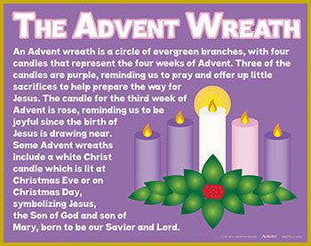
The season of Advent helps us to share in the ancient longing for the coming of the Messiah, and to be ready for his Second Coming.
​Advent is the beginning of the Liturgical Year and starts on the fourth Sunday before Christmas (sometimes known as Advent Sunday).
During Advent many churches, homes and schools have an Advent Calendar, light an Advent Wreath, pray extra an Advent prayers, or light a Christingle There are also other familiar ways of preparing for Christmas, such as setting up Christmas decorations, sending cards and visiting friends and family.

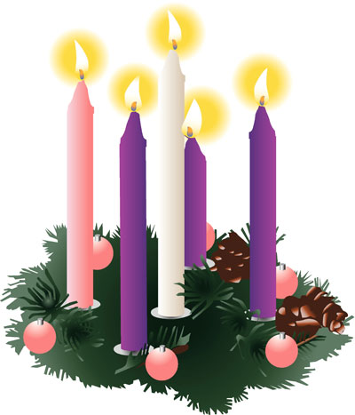

Here is an Advent & Christmas Calendar – please take time with your child each day throughout Advent to talk and think about each special thought or message.



