Palm Sunday
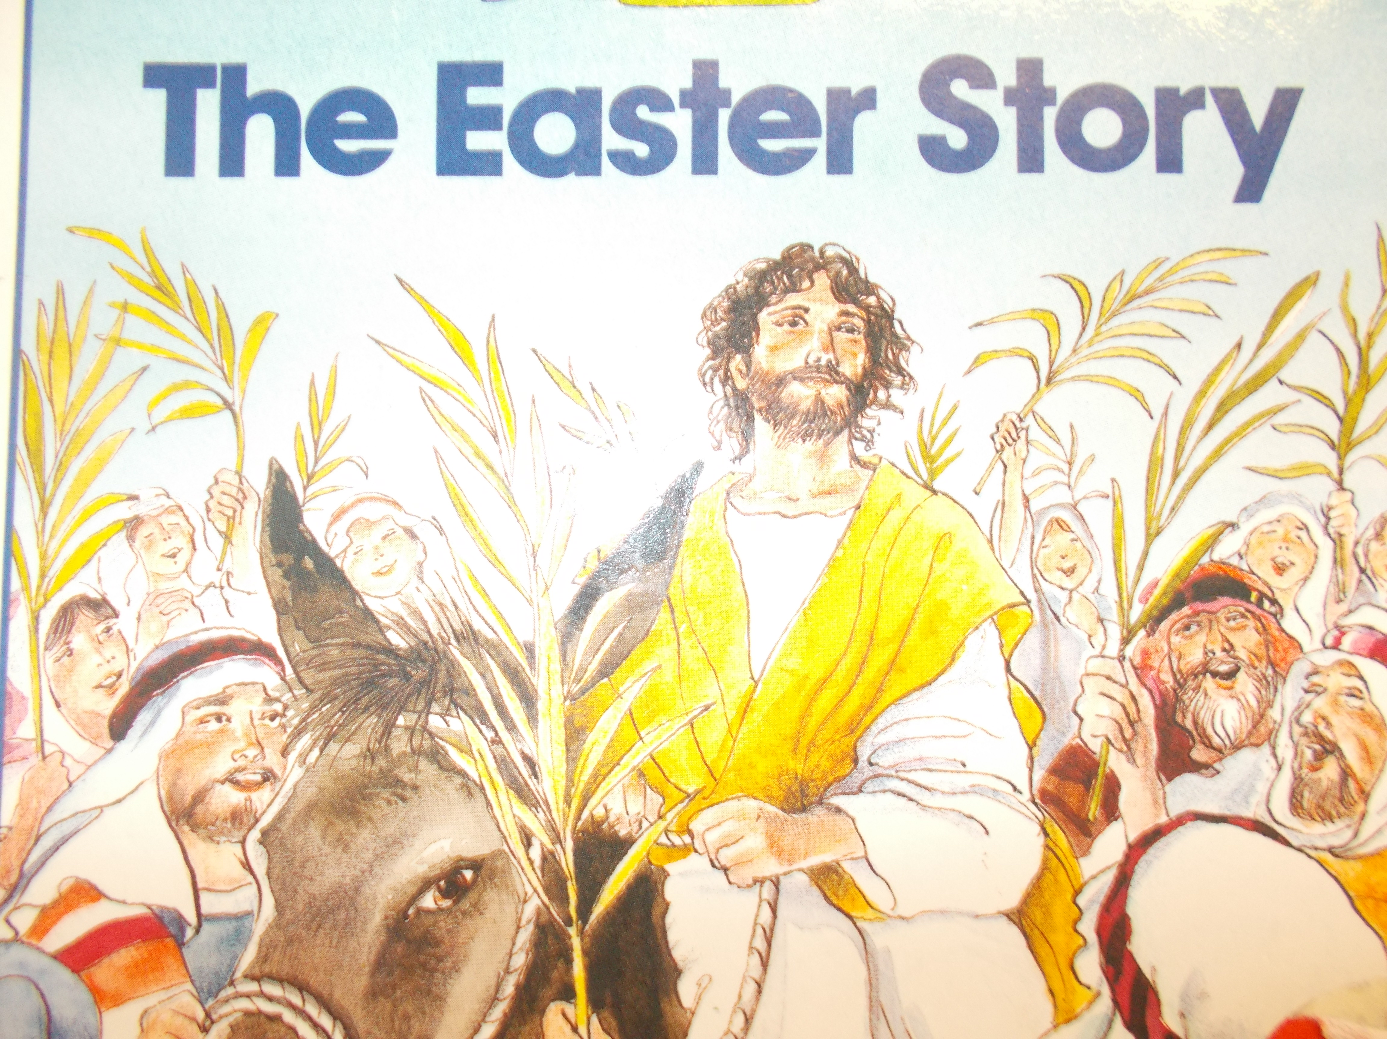

We learned about Palm Sunday, we made palms, re-enacted the story and learned 2 new songs.

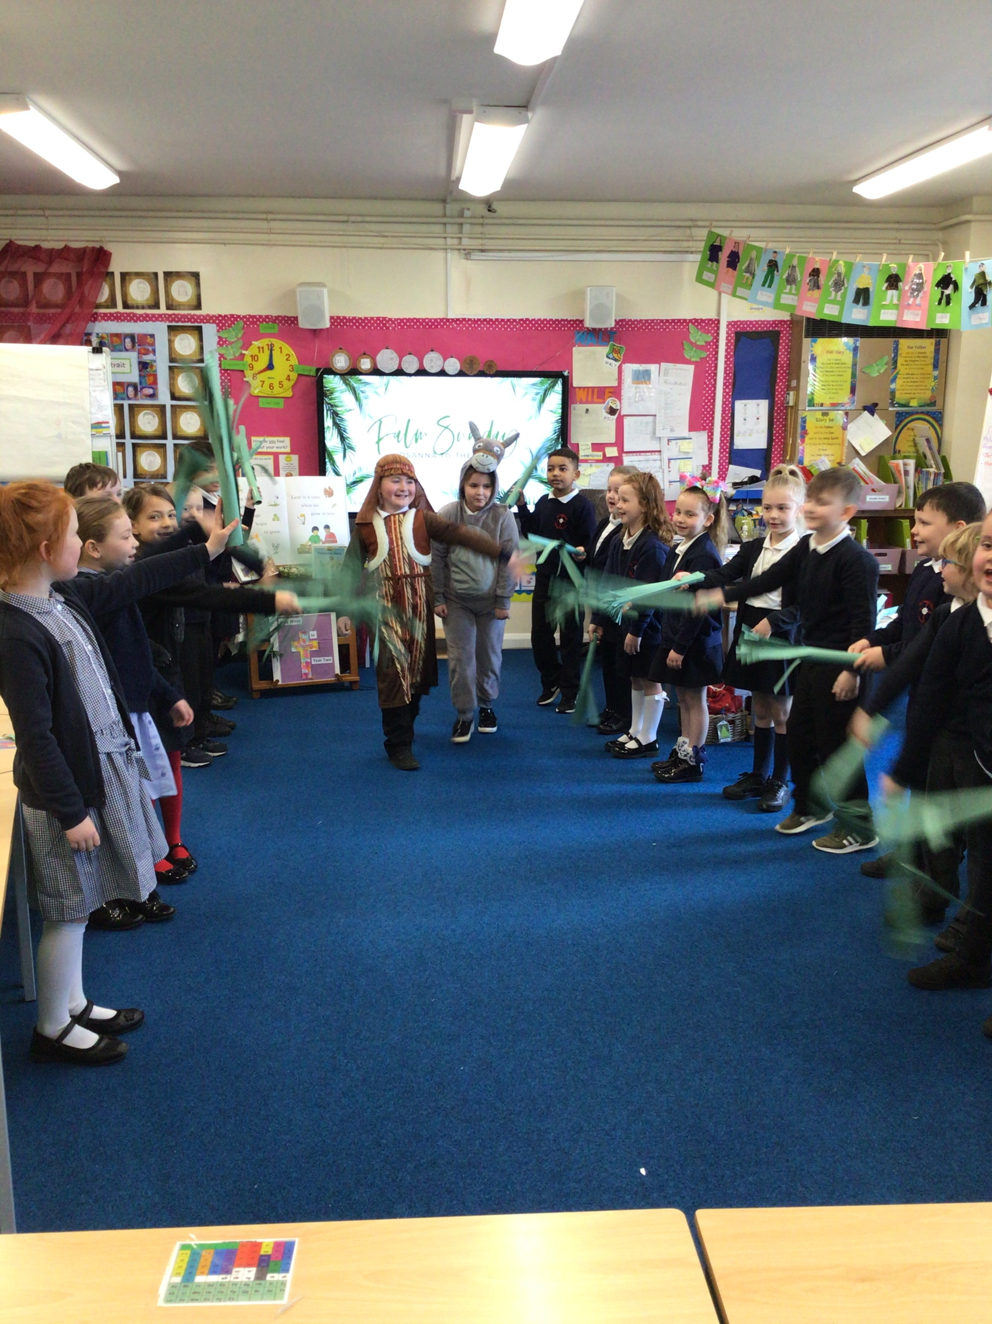
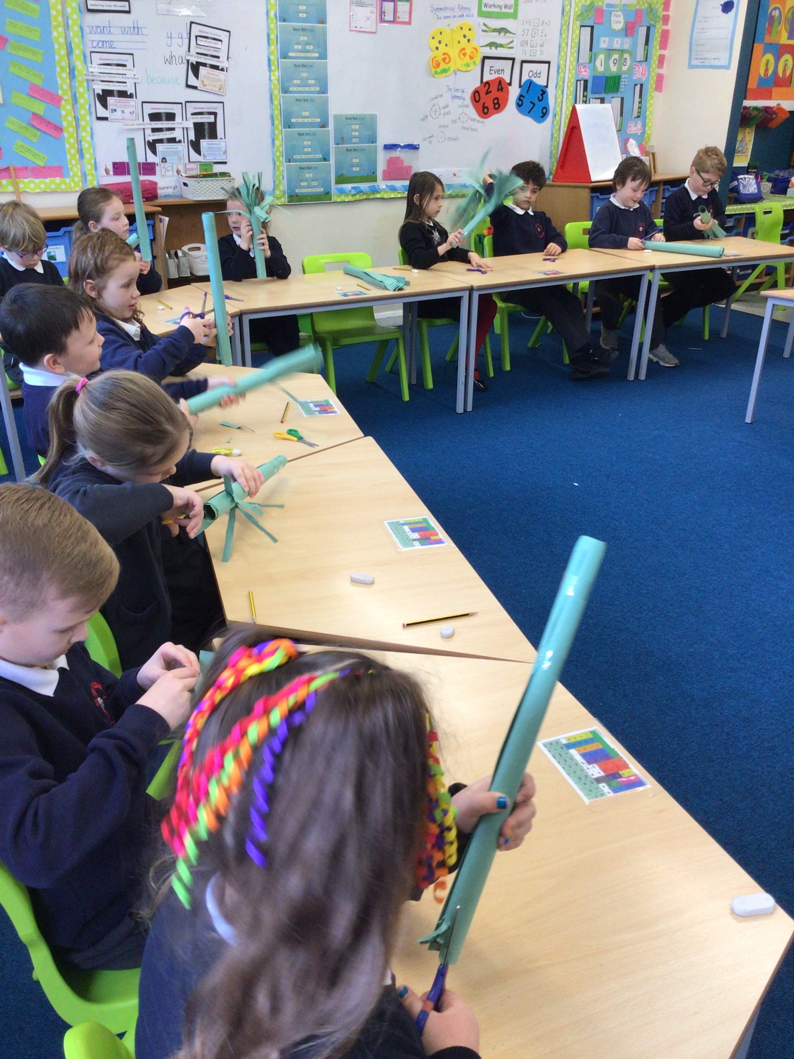



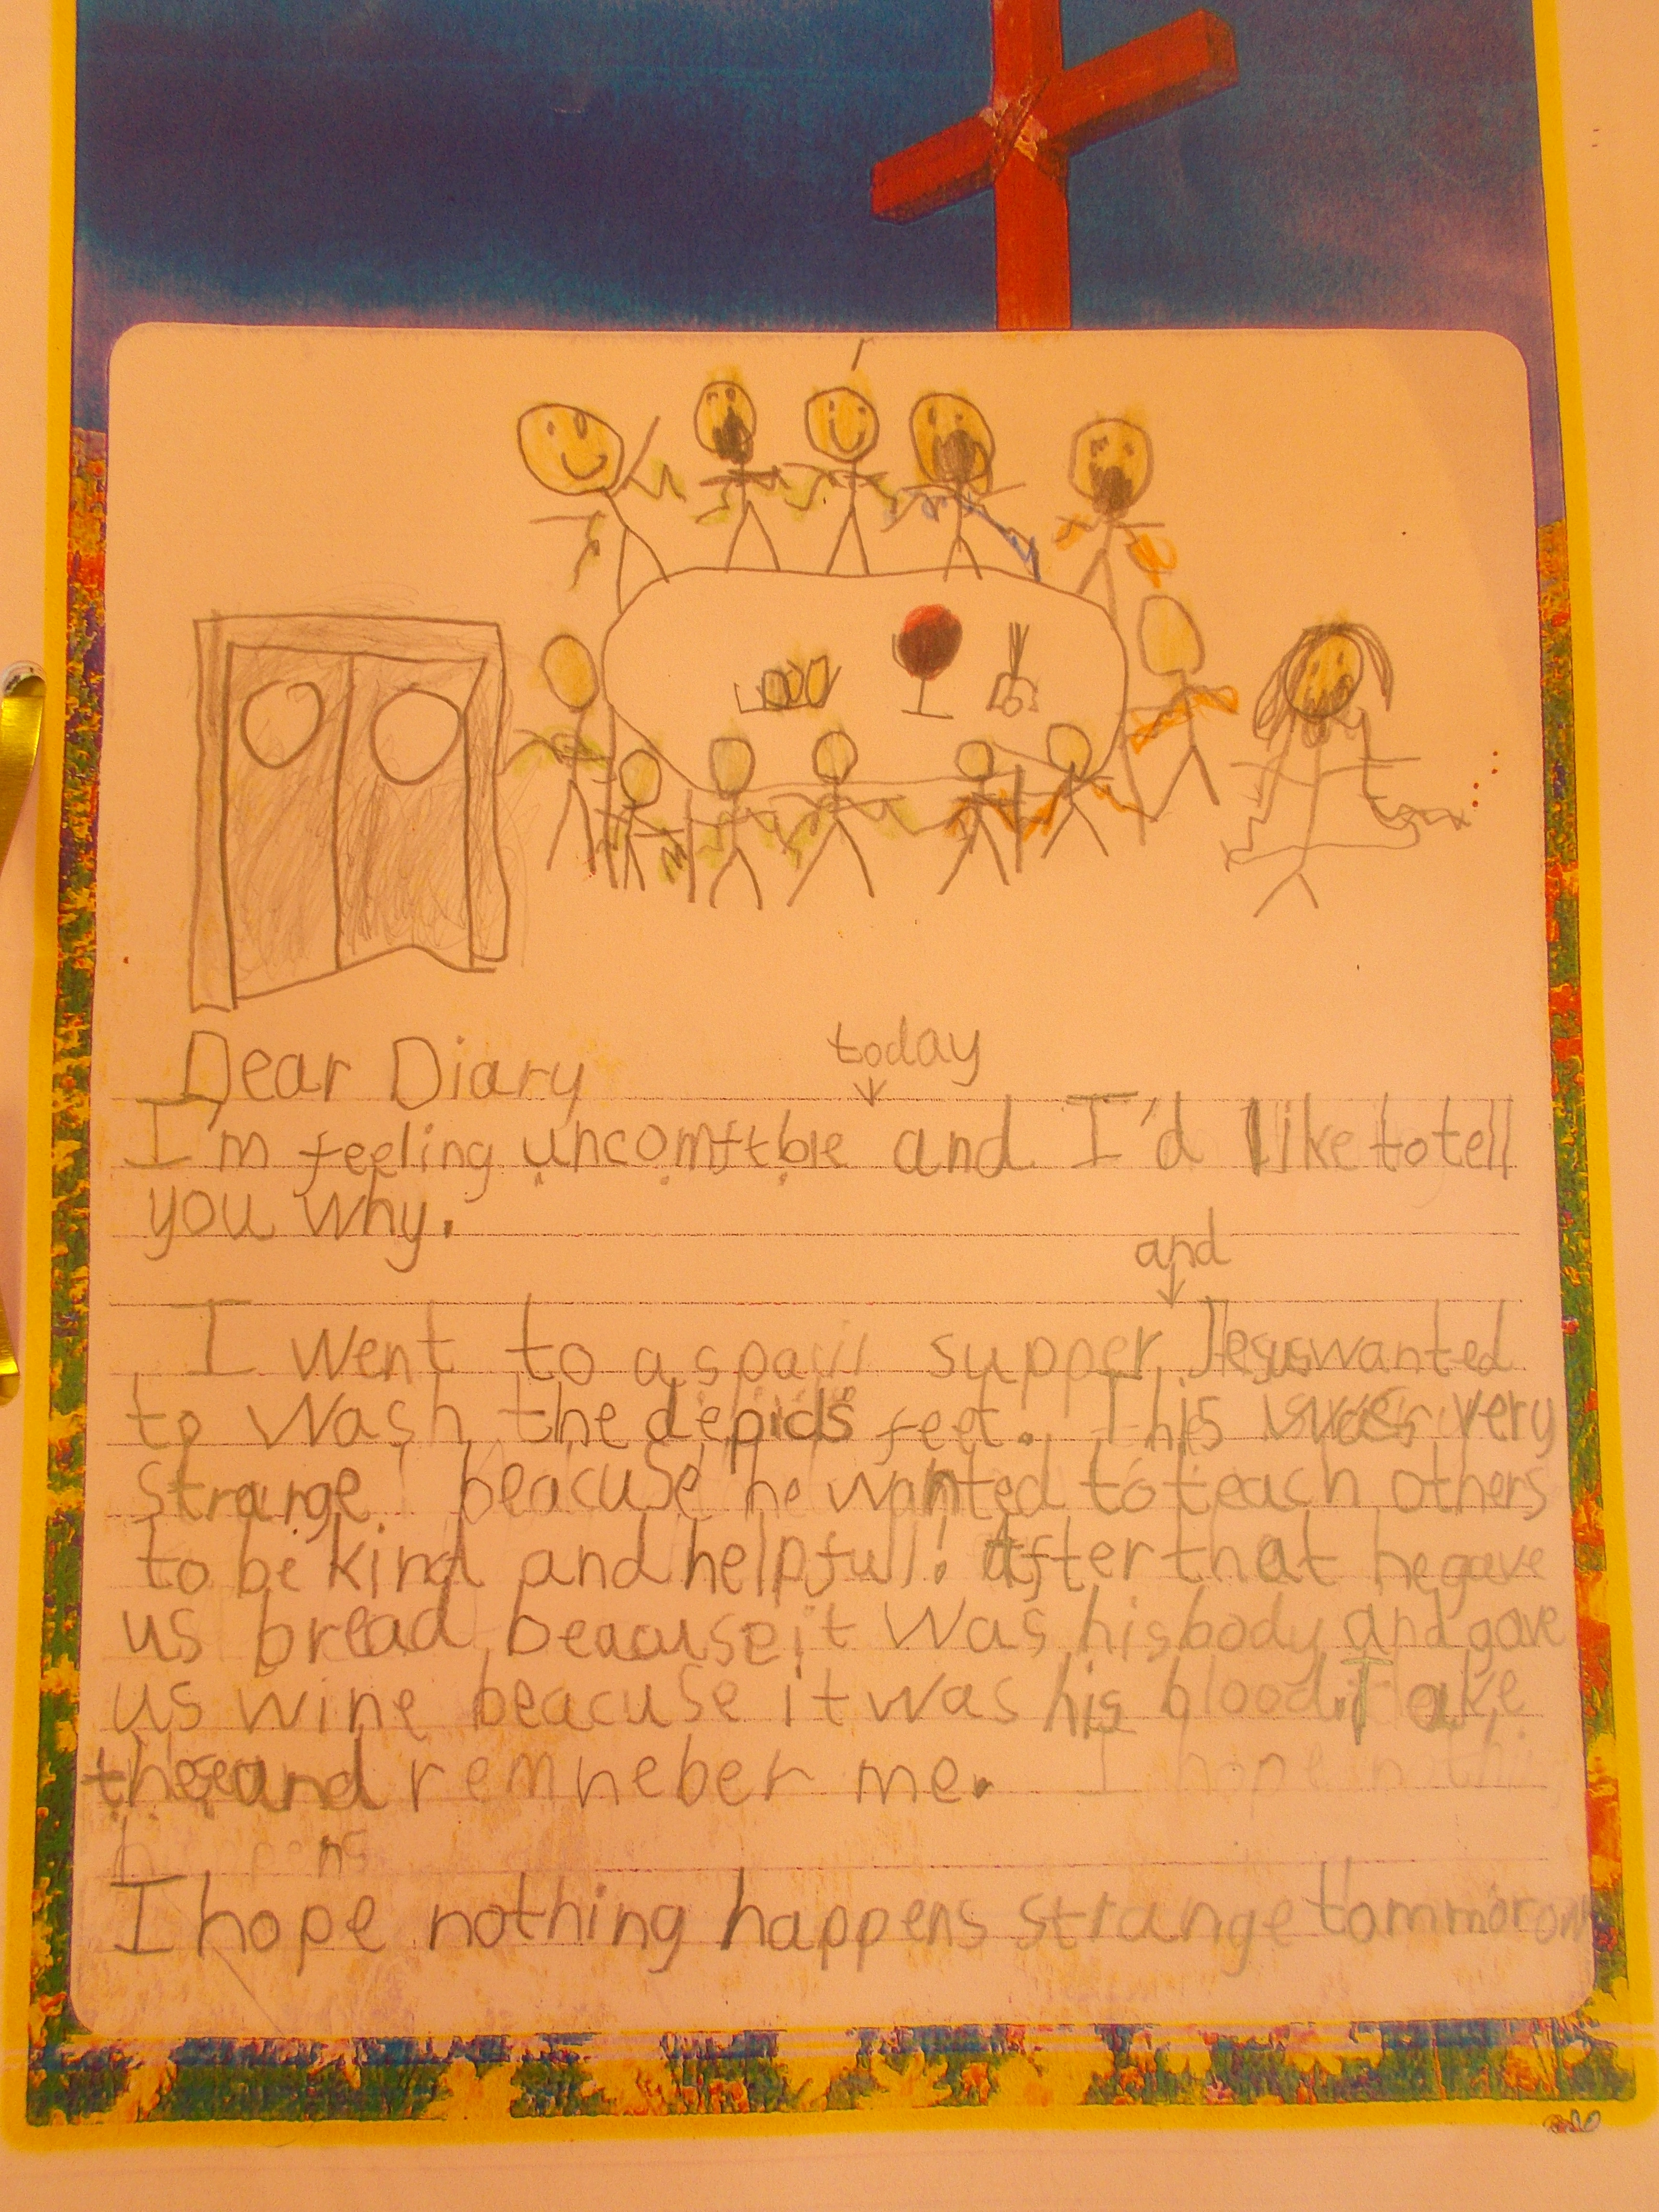
Maundy Thursday
We wrote a diary from the disciple’s perspective

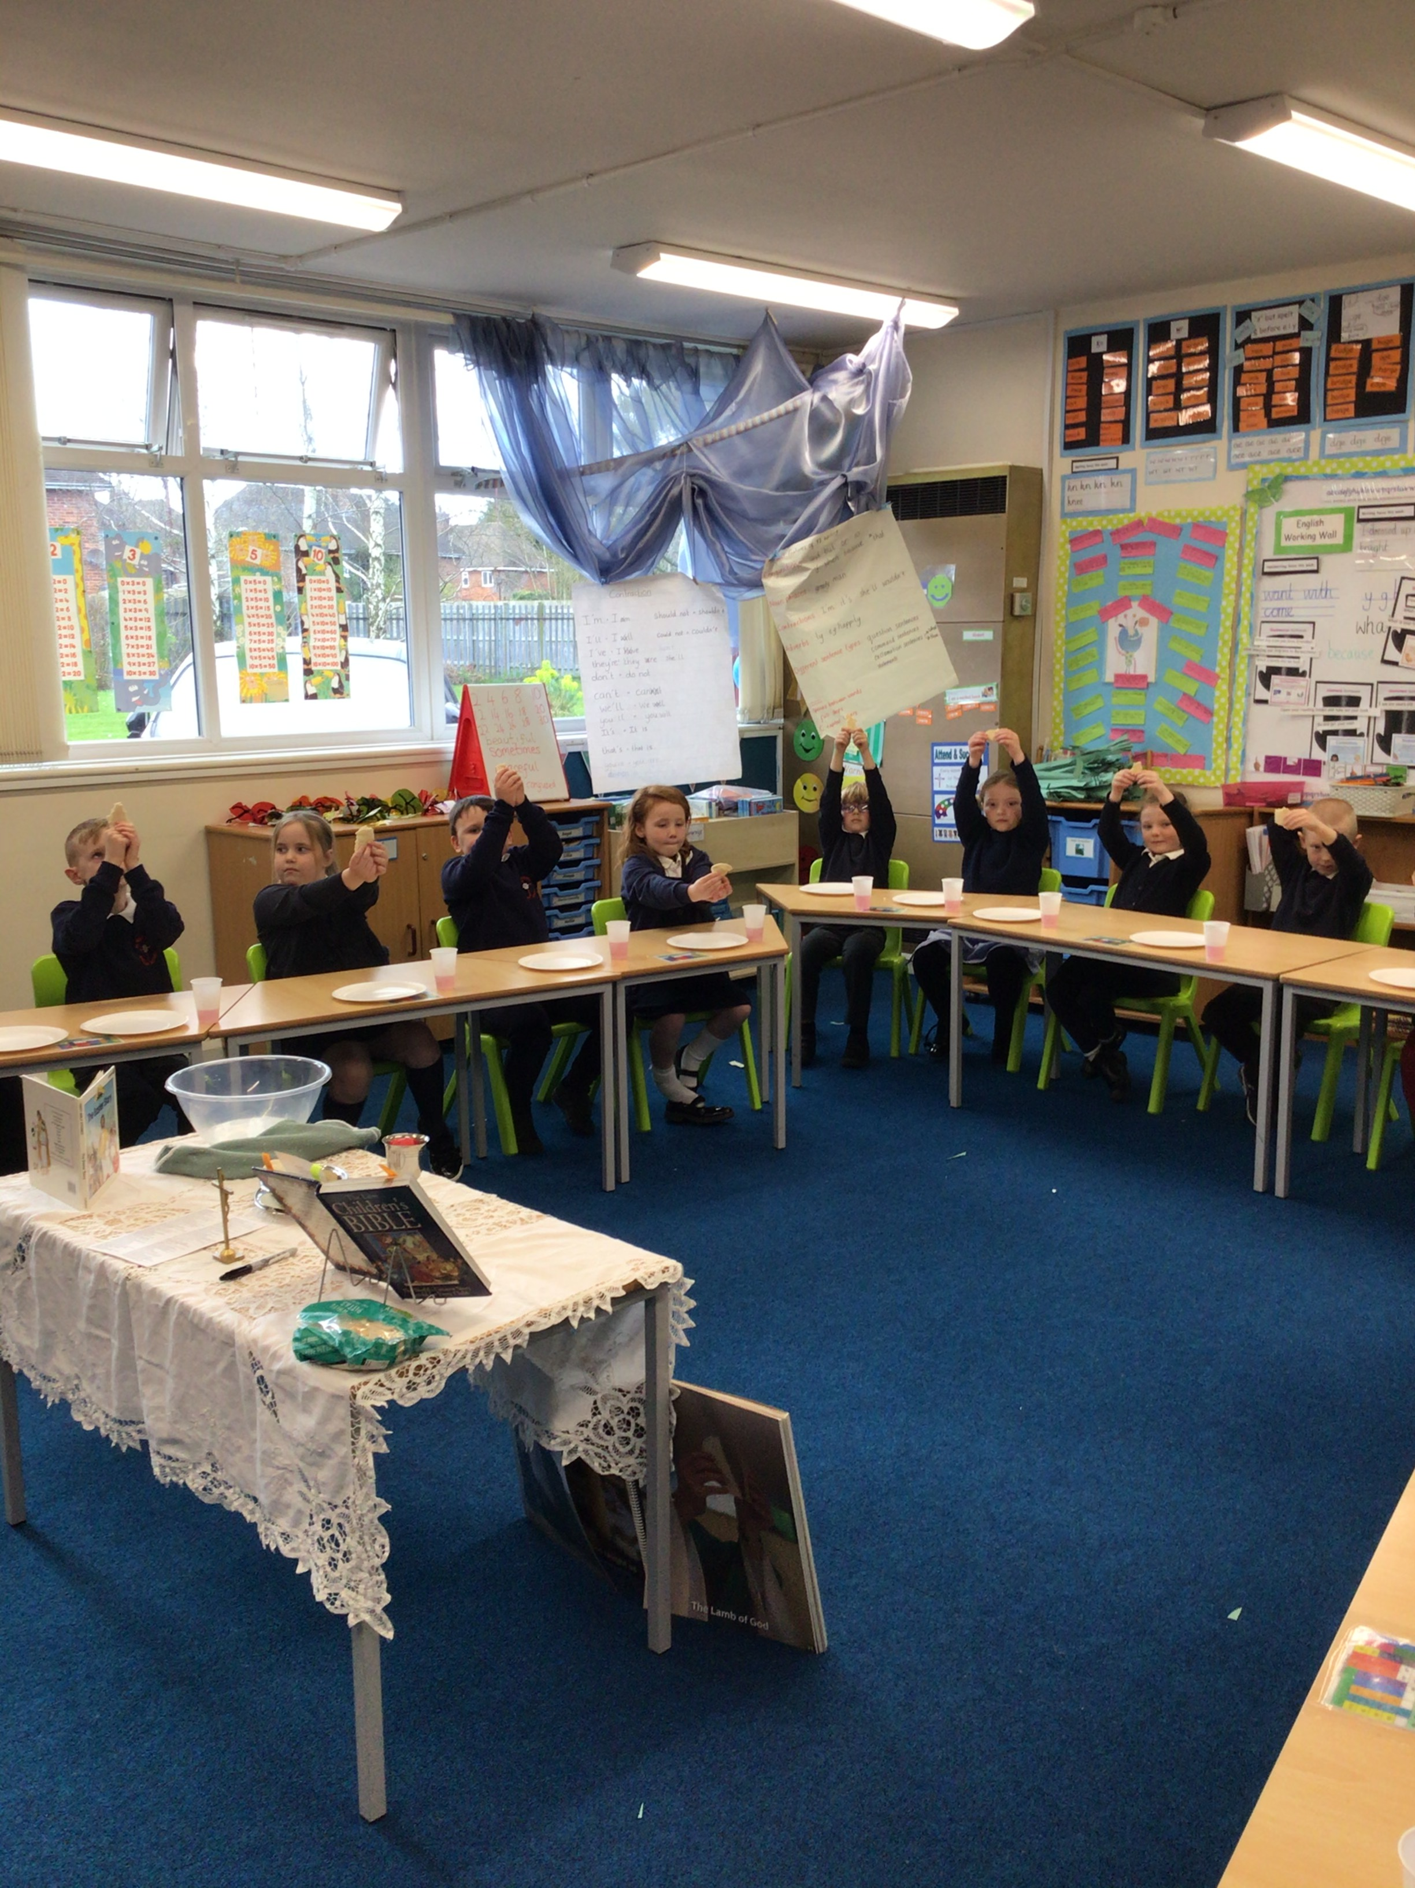

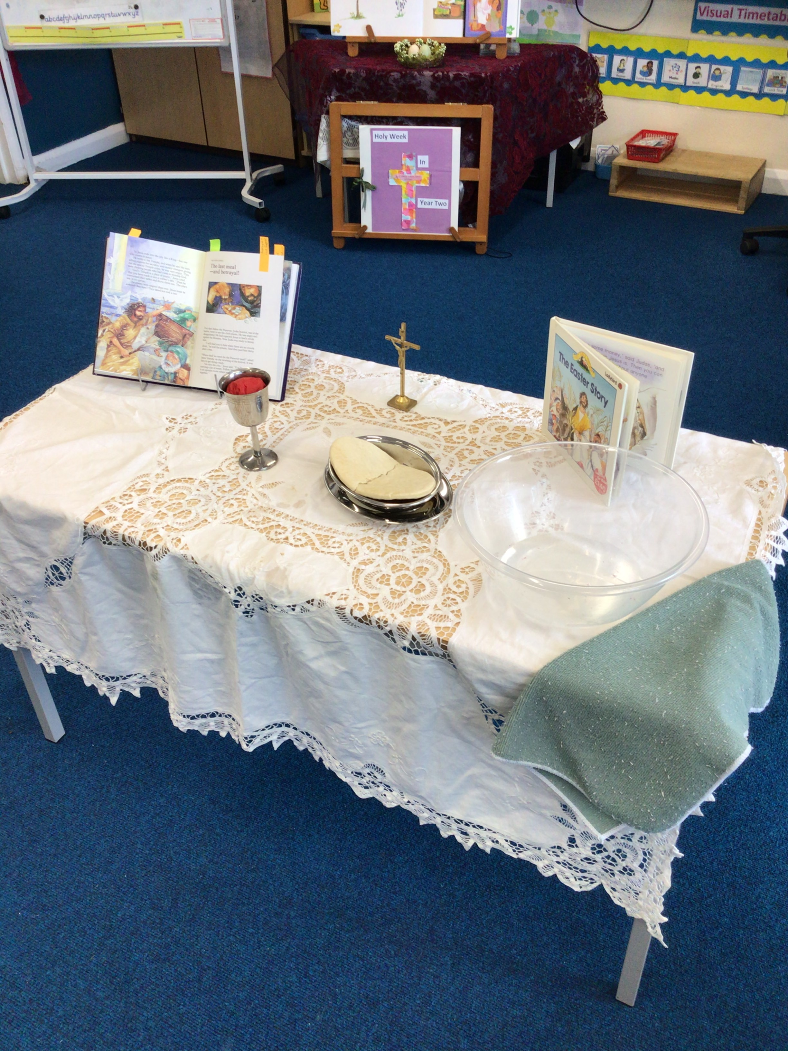

Good
Friday

At the last supper Jesus told us to remember him and spread the Good News.

At the last supper Jesus told us to remember him and spread the Good News.

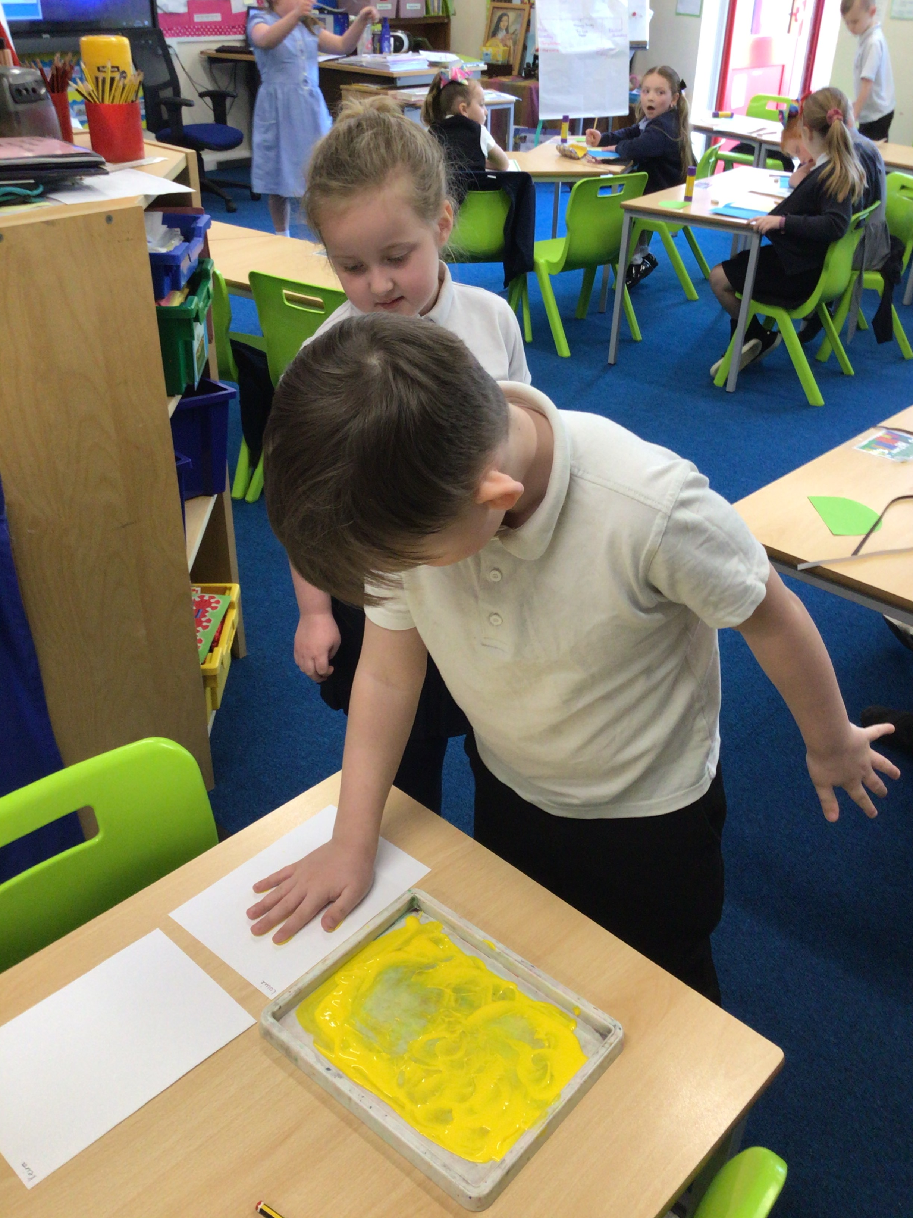
At the last supper Jesus told us to remember him and spread the Good News.

We wrote a diary from the disciple’s perspective
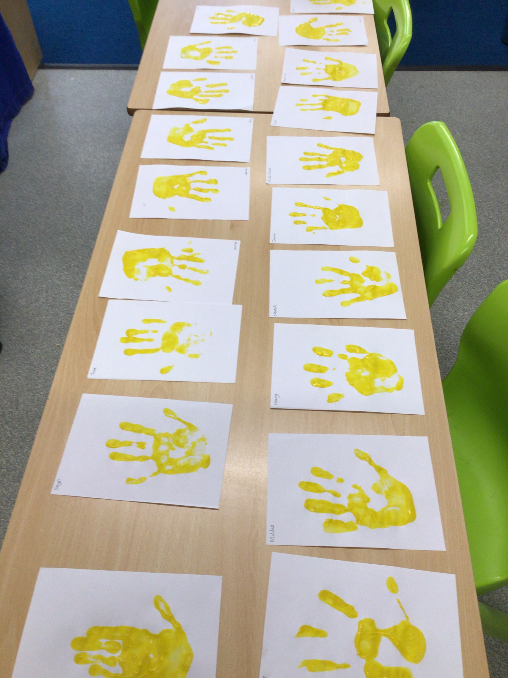
We wrote a diary from the disciple’s perspective
We wrote a diary from the disciple’s perspective
Easter Sunday
Good Friday
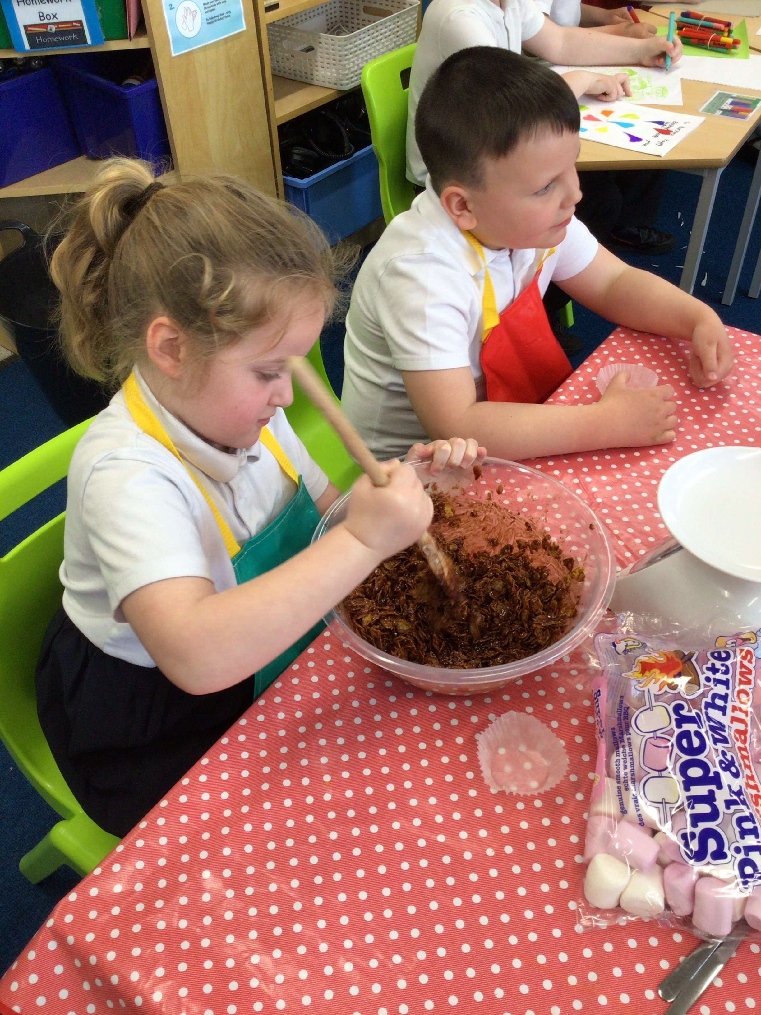
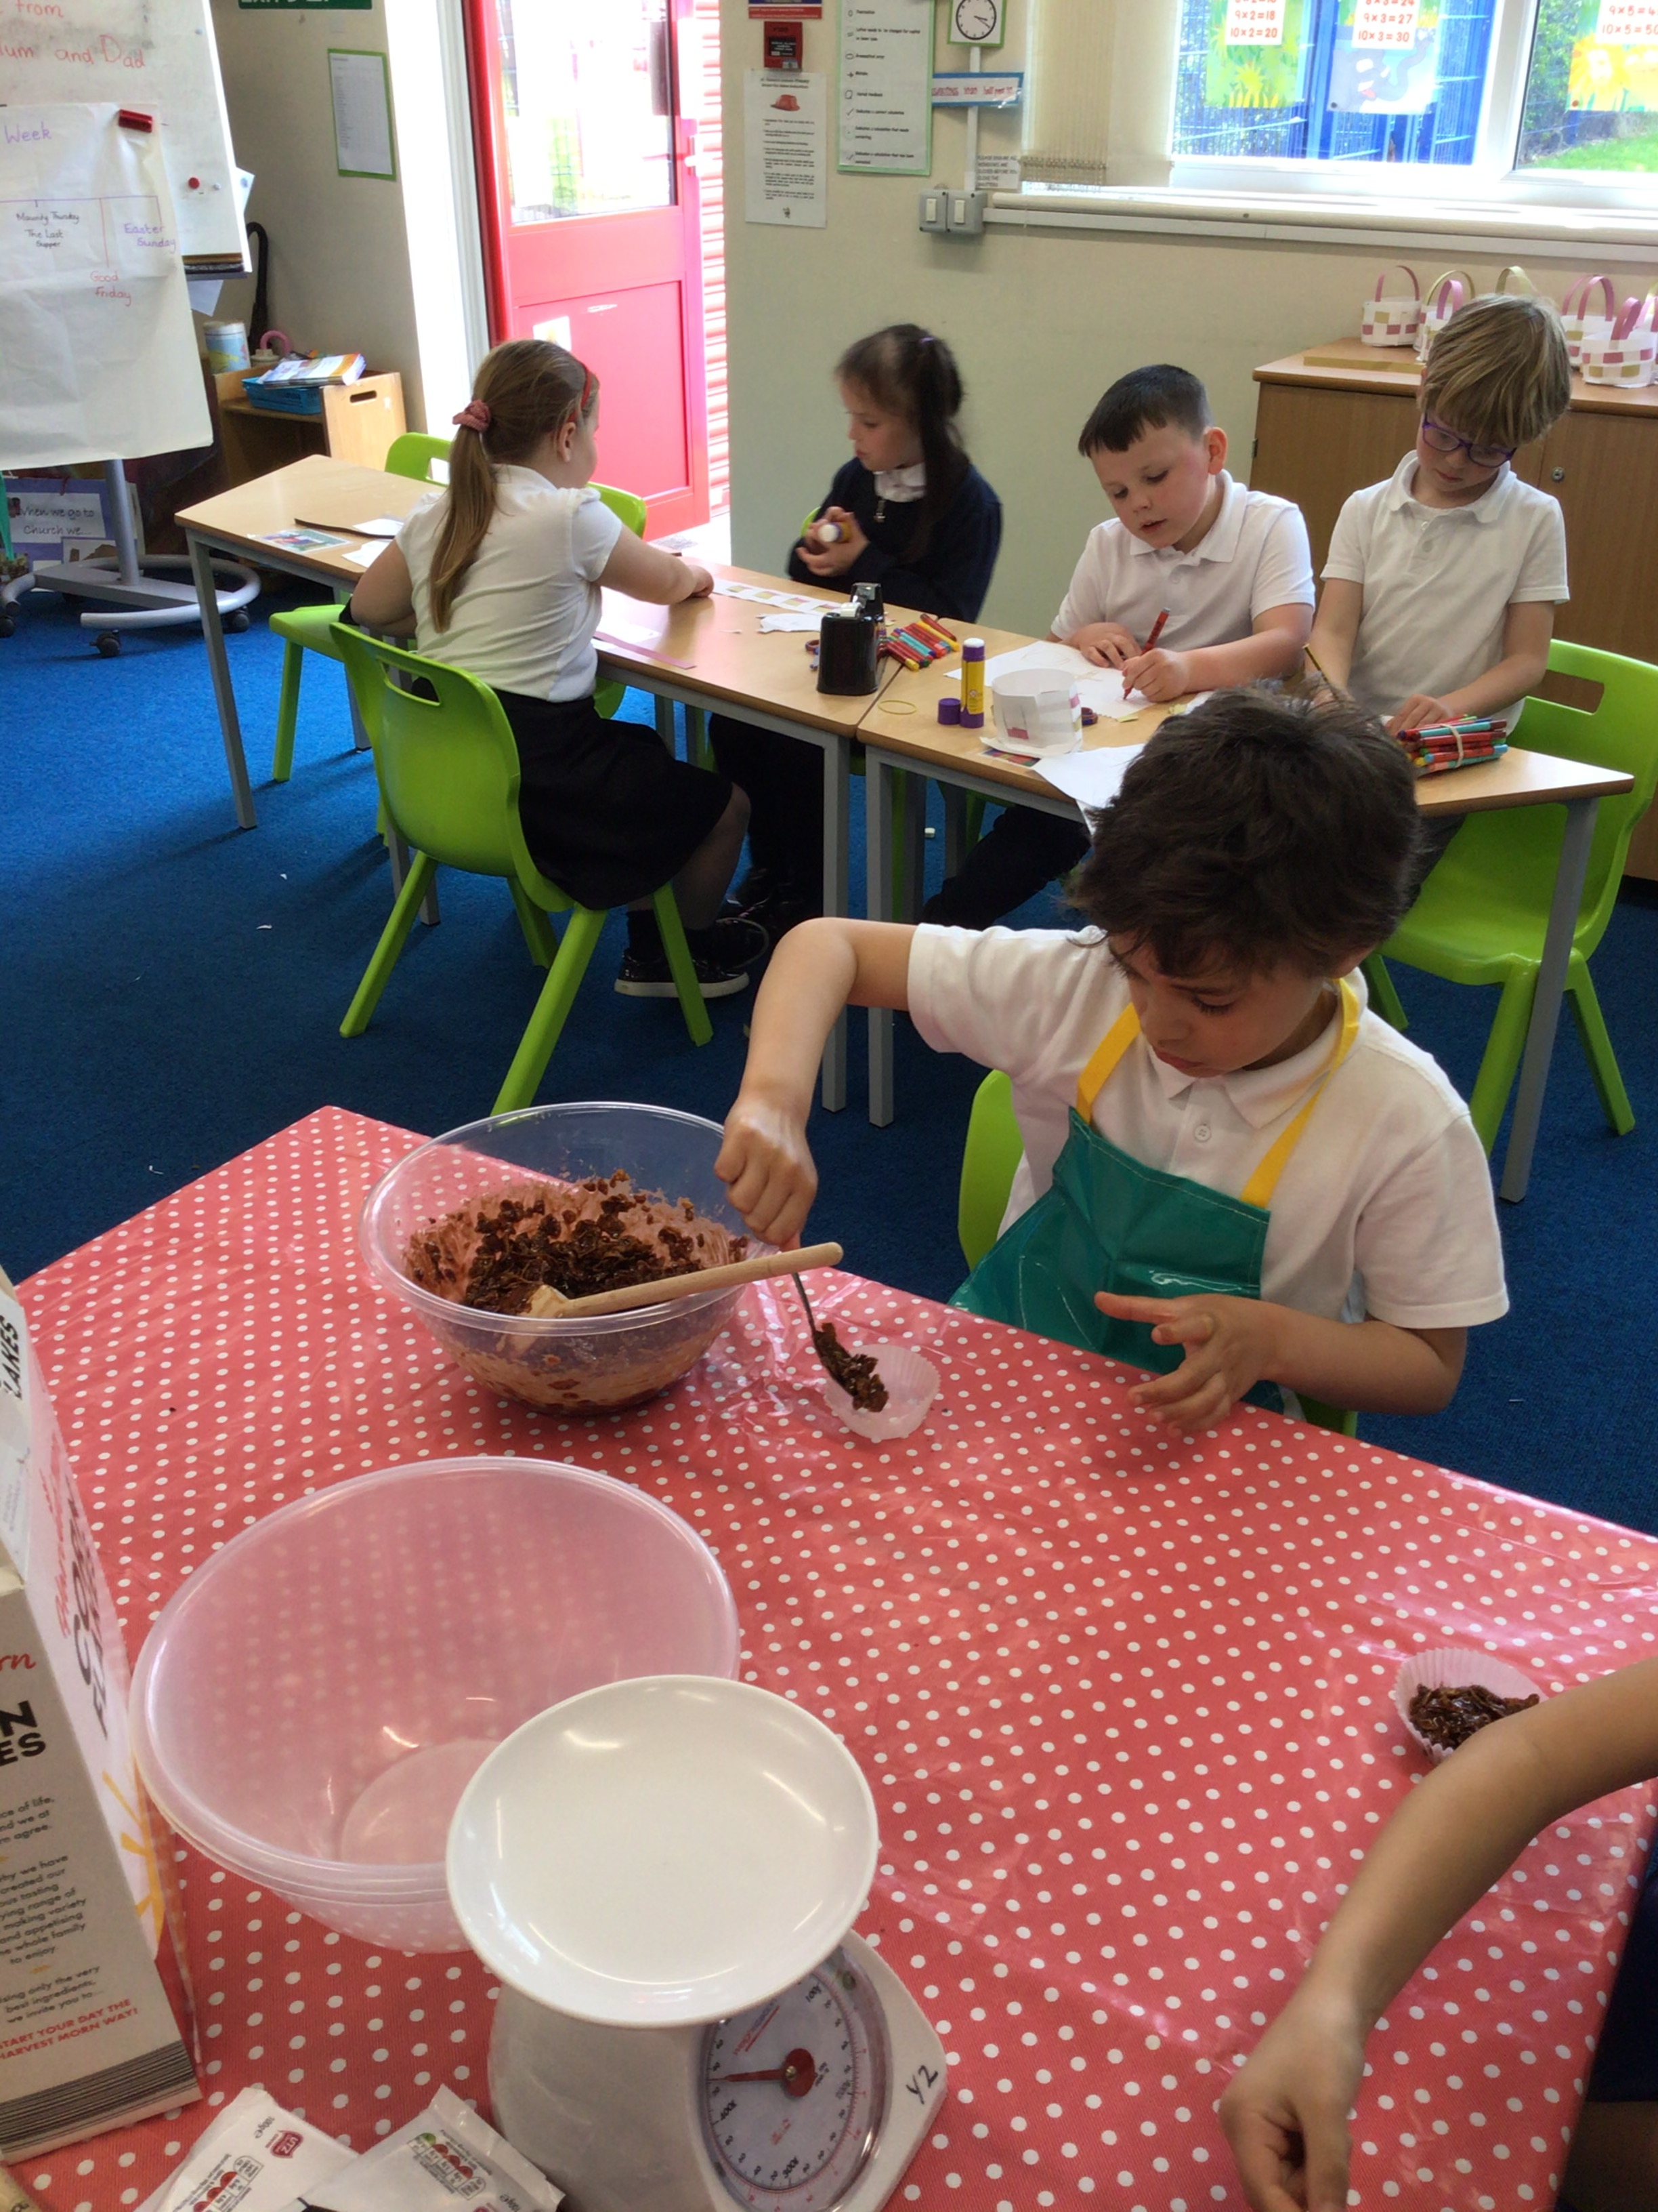
Picture of Easter card

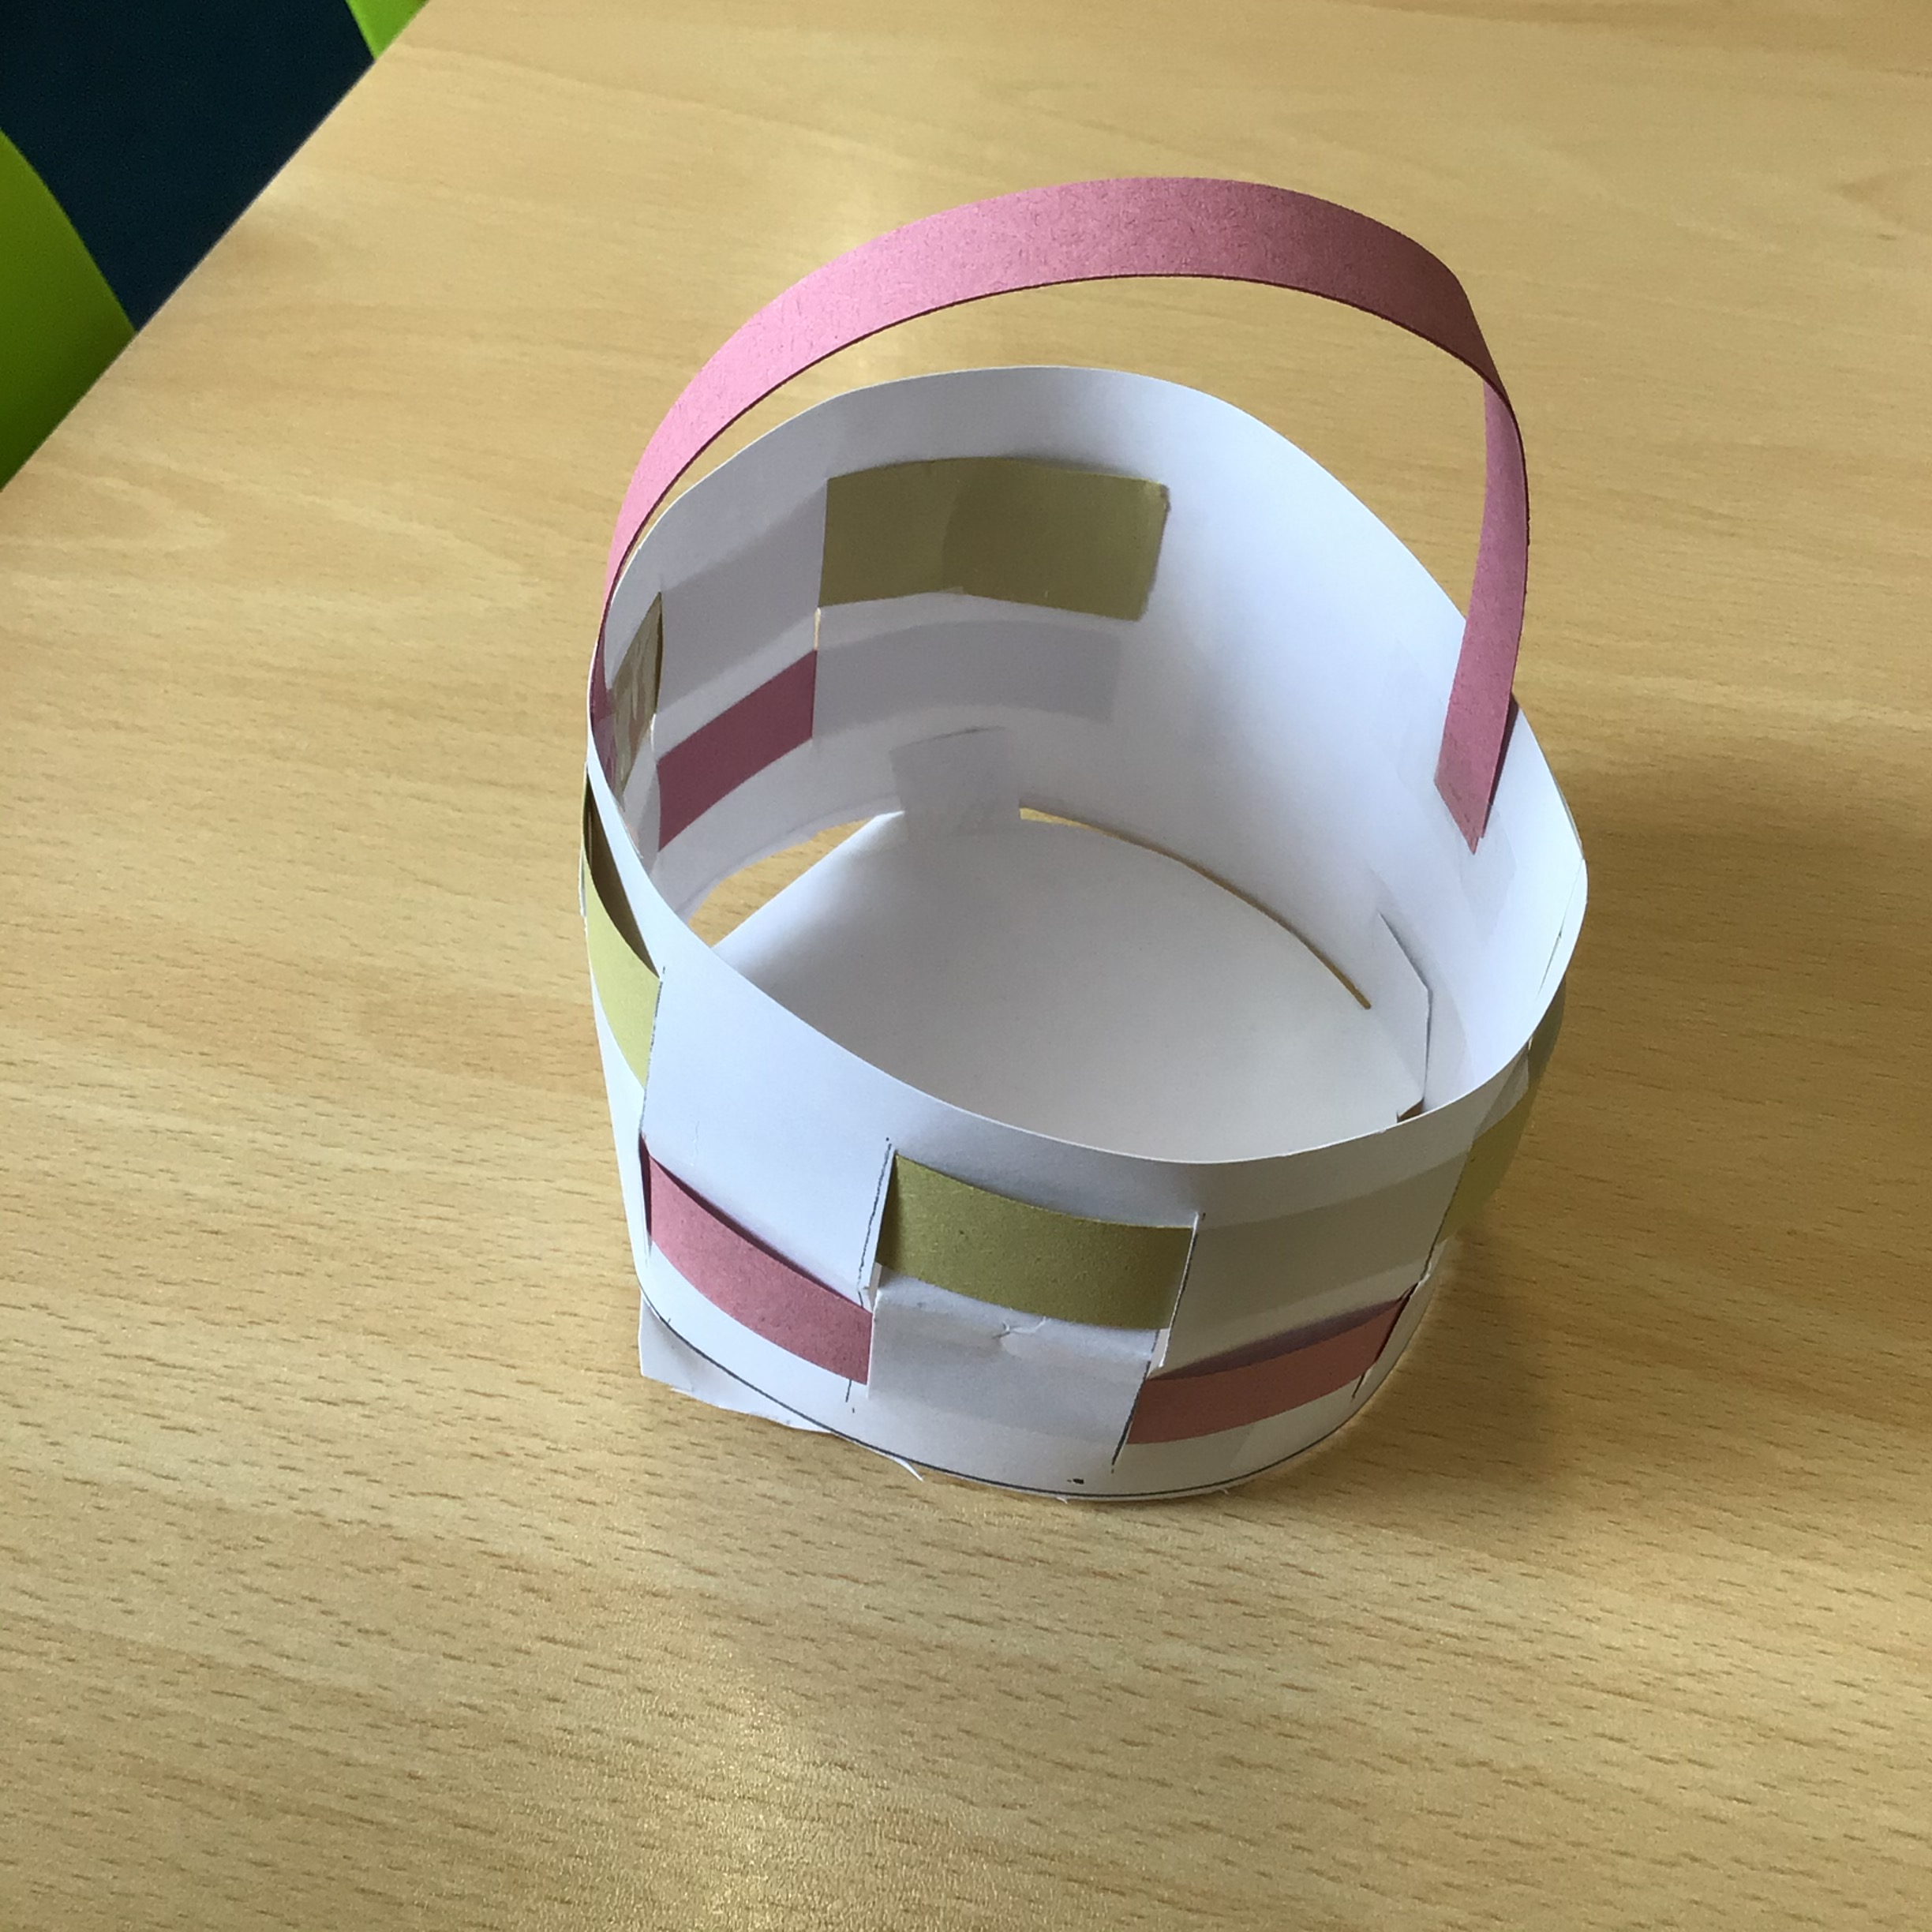
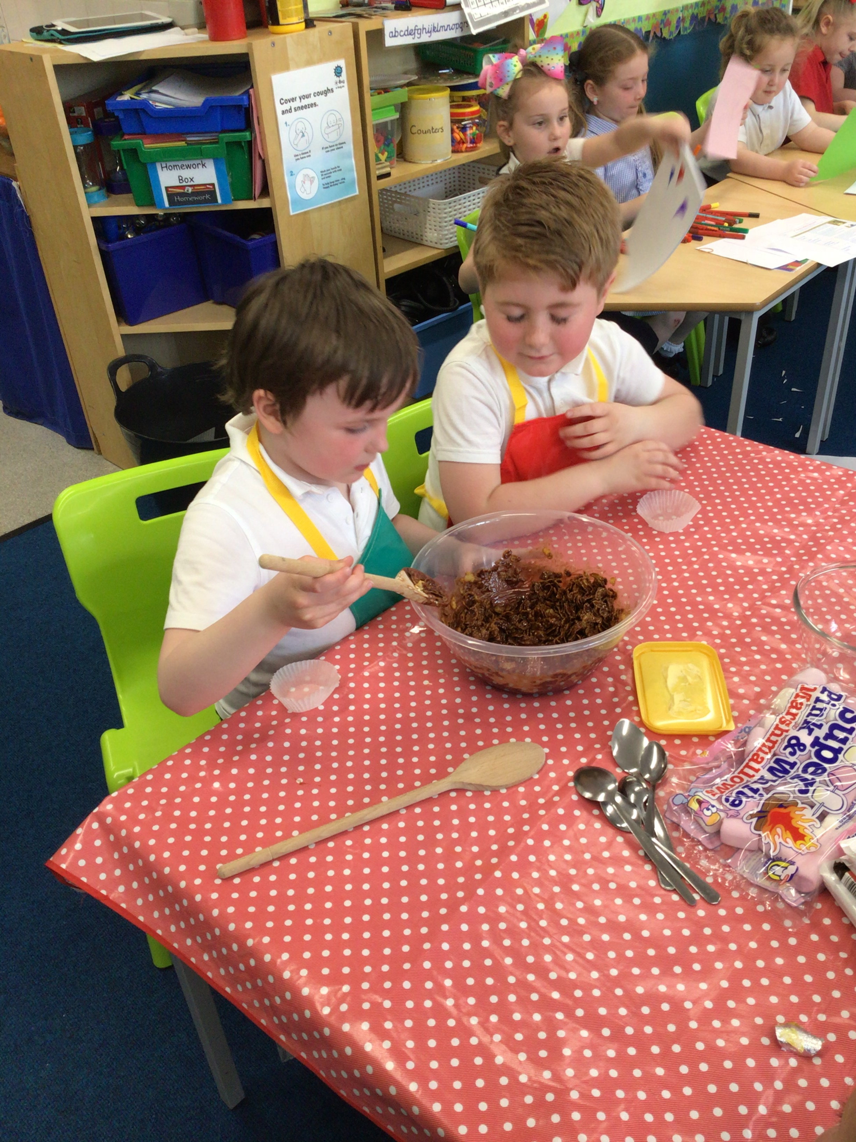
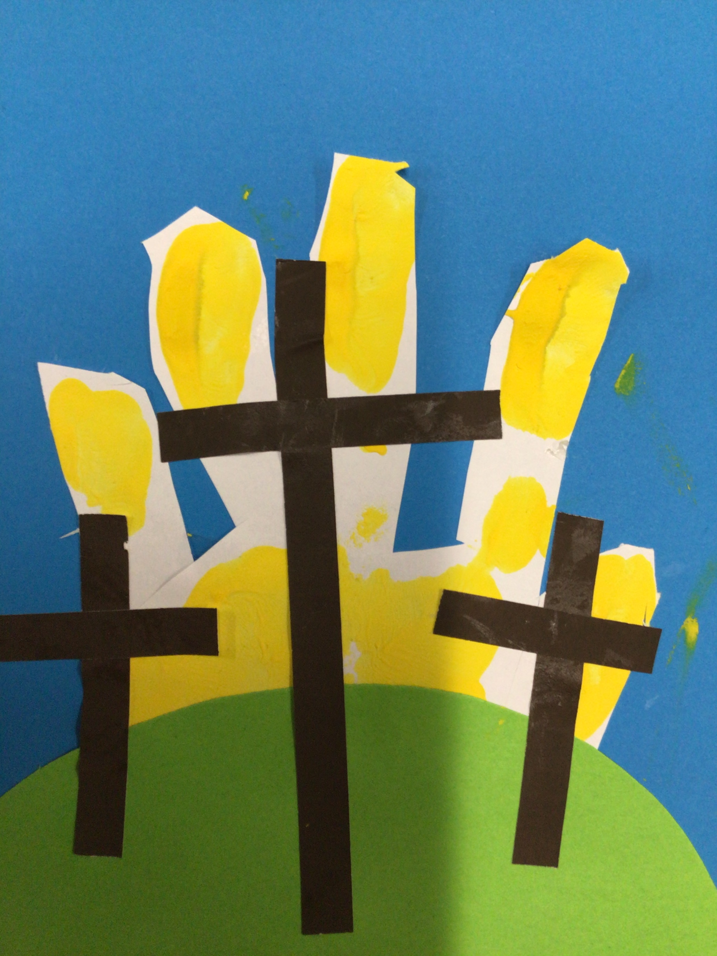
Jesus was nailed to the cross. We call this ‘The crucifixion’ Jesus died on the cross. It was a very sad Friday. Jesus died on the cross to show that we too can live forever.

