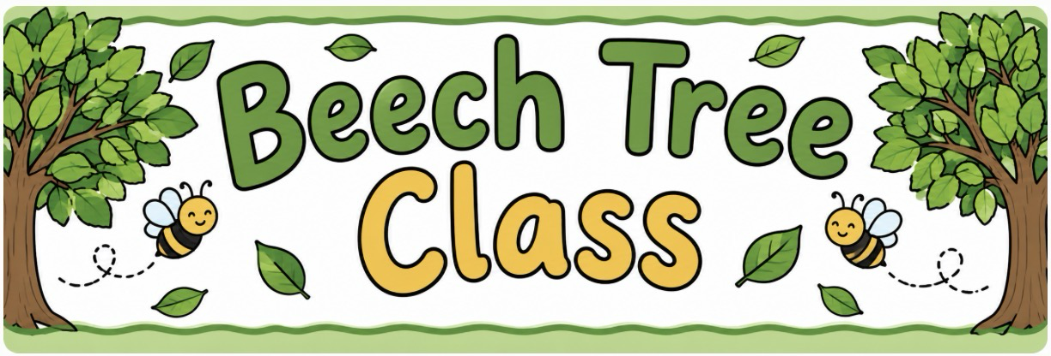

Dear Parents / Carers,
I hope you all had a lovely Summer break and are feeling rested and recharged! I hope you enjoyed spending quality time with your family and loved ones. I am so excited to be starting this new school year and I hope the children are looking forward to being in Beech Tree class! We have lots of fun and exciting things planned for this term.
Below are some reminders and information for our class. We try to keep to routines every week but will occasionally change items to suit the needs of the children and any other additional events happening in school. Have a read through our curriculum overview on the class page on the website to see all the exciting things we have planned for the Autumn term.

Reading
Children are encouraged to read at home at least three times each week. Please note in the school planner when your child has read, the page number reached and any comment you may wish to make. School planners will be checked on a weekly basis, but planners should be in school each day so reading and any other notes can be recorded.
All children will complete a whole class guided read, focusing on different reading skills and activities each day. Whenever possible, children are also heard to read individually, so assessment continually takes place. It is therefore important that the children are encouraged to read their reading books (as well as any other reading materials) at home on a regular basis.
Please try to read with your child on a frequent basis; ten minutes a day makes such a difference. We always encourage children to read other material/books, not just their school reading books. The local libraries are also an excellent way to encourage and support reading for pleasure. These can also be noted in the reading section of the school planners.

Spellings
Spellings will be posted on our Google Classroom page each Friday and the children will be tested the following Friday.
These will focus on either a particular spelling rule/pattern and will also include some words taken from the statutory word list. They will be taught and practised throughout the week in school also. The spelling rules and statutory words are for Years 3 and 4 so please don’t be alarmed if your child receives some of the same spelling words or the same rule that they previously had. This is intentional to ensure that they can apply them in their writing.
Weekly spellings will be available on Spellingframe.co.uk so the children can practice them online and play games.
Please try to help your child to look at these words, pointing out any particular patterns that will help them to remember them. Many children find learning spellings very challenging so this should be low key and a fun few minutes.

PE
Children will have Outdoor PE on a Monday and swimming on a Friday and should come to school in their PE kits on these days. PE kits should be their house colour t-shirt, black shorts/leggings/joggers and a black jacket/hoodie.
If any grown ups can offer their support with walking to and from swimming, please let me know. Your help is appreciated!
Please remember to tie back long hair and wear no jewellery for safety reasons.

Homework
Homework will be set on a Friday and this should be completed by the following Wednesday by 6pm. LbQ will be used to support the children with their homework. Homework will consist of an activity linked to the unit of work they are covering in class, so they should be able to complete the activity independently. However, if your child feels they need some extra support to complete the activity they should ask in school asap.
Google Classroom will also be used to provide homework support and activities so please make sure you access our Google page regularly. Beech Tree class code is 3si6mltu. Any questions around homework, please let me know.

Times Tables
I would like to remind you that we will be having a big focus on times tables this year as the Year 4 children will be completing their Multiplication Times tables Check in June 2027. TTRS will continue again this year, to support the children’s learning and the children will all have their own individual login, which will be written in their school planners. Children should be practising their times tables frequently to ensure they are ready for the MTC using UR Brainy (accessed via Google, no login necessary).
Please don’t hesitate to ask if you have any questions.

Kind regards,
Miss Fazakerley

