Welcome Back – Elder Tree Class

Dear Parents/Carers,
I hope you have all had a lovely summer break and are ready for an exciting year ahead. To begin our school year, the whole school transition topic will be ‘Together we Learn and Grow’ which will culminate in a whole school picnic in our school grounds.

Maths and English
Our Maths topics for this autumn term will focus heavily on number, place value and the four written calculations and it is imperative that children are supplementing this work with basic skills practise at home. Please encourage the children to use their log in for Times Table Rockstars regularly at home to ensure they know all the multiplication and division facts accurately and rapidly as this knowledge and recall will be hugely beneficial this year.
In our English lessons this term, we are continuing to work on our knowledge of punctuation and grammar from across KS2, with a particular focus on being able to extend our sentences through the use of different clauses. All of our writing across the year will be inspired by high-quality texts and children's literature and we will be starting the term off with some writing linked to the non-fiction text Can We Save the Tiger? by Martin Jenkins. Where possible, we will try to link our spellings in class to our writing also. We will be completing daily whole class reading sessions to develop the children’s reading stamina, pace, understanding of vocabulary and comprehension skills alongside individual reading sessions where each child will be heard to read by an adult bi-weekly. Alongside everything we do in school, it is incredibly important that children are reading a variety of texts both fiction and non-fiction regularly at home and recording their comments in the planners. The planners need to be in school daily and to be signed at by an adult regularly. Finally, the children will need to focus on using spelling strategies and rules consistently to ensure they spell a variety of common and uncommon words accurately. They need to be practising their spellings regularly at home. Please see the spelling strategies document to support your child learning their weekly word lists at home.



The Wider Curriculum In our History lessons, we will be studying the enquiry question 'How did the steam engine change the world?' with a focus upon the Industrial Revolution and its impact upon our town and the wire industry. We will continue to use a range of historical skills, including looking at different historical sources including using our knowledge of our local area.

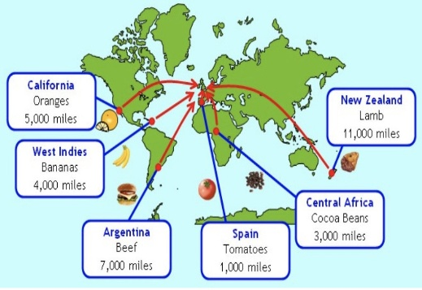
Our Geography topic for this term is ‘Where on Earth does it come from?' This topic looks at the use of land around the world (including farming), trade links and the distribution of natural resources including food. Children will look at where commonly used resources come from, how they travel and how land is used differently. As part of the topic, children will plot on a world map where foods they eat have travelled from and they are always quite astonished at just how far many of our foods travel to reach our dinner plates!
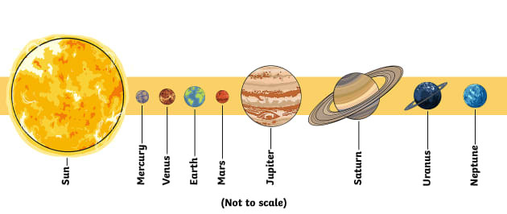
In our Science lessons this term, we look at the two topics of 'Forces in Action' and 'Earth and Space'. Throughout their lessons, children will explore the forces of gravity, air resistance, water resistance, and friction as well as looking at levers and pulleys before moving on to learning about our solar system, orbits of the moon and the Earth's rotations.
Homework
Like last year, we will be setting a weekly English and maths task for the children to complete
on Learning by Questions. These tasks will be set on a Friday and should be completed by the
following Wednesday. All the tasks will be linked to learning that has taken place in school so
the children should be able to complete the tasks mostly independently. If you find your child
struggling on a particular question, please make a note of the question number in their reading
diary and we can go through this in class together.
PE
Sessions are scheduled for Thursday (indoor) and Friday (outdoor). Children should
come to school dressed in their PE kits on these days. Long hair should be tied back and any
jewellery removed.
Y6 SATs
As I am sure you are already aware, this year all Year 6 children will complete their End of Key Stage 2 National Assessments – more often known as SATs. These will take place in the month of May and we ask that you ensure any absences are prevented as best they can be during this time. Your child will be prepared for these throughout the year as part of normal classroom practise and if you have any questions at all regarding these, please contact a member of the Y6 team in school.
I hope that you have found the information in this letter useful, but for any other updates or
information please remember to visit our Google Classroom page regularly. If you wish to
contact me at any time, I am available through the school office or at the end of the day most
afternoons. I am very much looking forward to the year ahead, and know that with your
continued support, it will be a great one!
Kind Regards,
Mr Hennessey

