Welcome to Summer Term in Reception
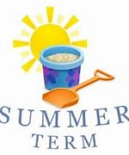

We hope you all had a wonderful Easter break and are ready for lots of fun and games in the Summer Term.
We are excited to explore our themes of ‘Growing’ and ‘Traditional Tales’ with your children. This term, we will delve into the wonders of nature and the magic of storytelling, fostering creativity and curiosity.
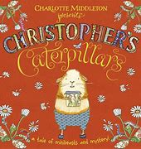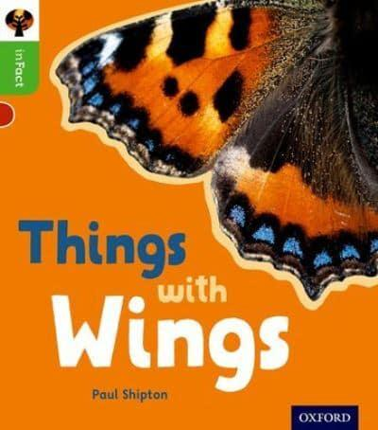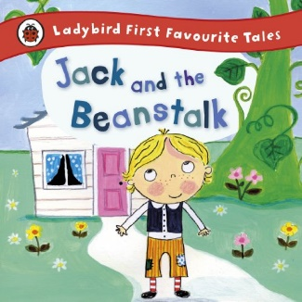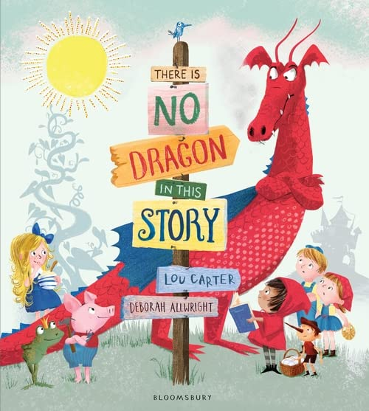

We have a fantastic trip planned to Windmill Farm on Thursday, 21st May, where the children will experience the joys of farm life firsthand.

Transition is an extremely important part of the Summer Term. We will be preparing the children for their move to Year 1, further developing independent skills and building confidence. Look out for more information coming soon on Arbor.

Thank you for your continued support!

The Reception Team

