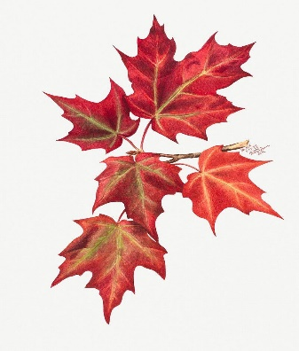
Maple Tree Summer Welcome Letter 2026

Welcome back Maple Tree Class!
We hope you all had a wonderful Easter break and are looking forward to our final term together!
On this page you will find out lots of information about what we have planned across our core curriculum and some useful information about life in Maple Tree. Please note our PE days have no remained as Thursdays (outdoor) and Fridays (indoor). Please ensure your child is dressed appropriately and has a water bottle in school.
We know sometimes it is hard to find out from the children what they have been up to in school, so if you scroll to the bottom of the page, you will find our class Twitter feed. With this, we endeavour to keep you updated with all of the exciting things that we get up to as we try to take lots of photos!
If you do have any questions or would like to speak to us about anything, please do not hesitate to contact us.
We look forward to another great term!
Kind Regards,
Mrs Williams, Mrs Franklin & Mrs Pearson
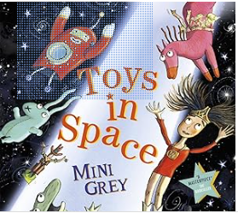
English
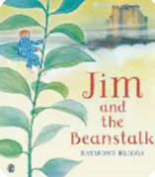
In English, the children will use a variety of different stimulus throughout the term to engage and inspire their writing. English this term begins with a focus on poetry linked to British wildlife, where children will explore language, rhythm and imagery. We will then move on to writing a non-chronological report based on the text Toys in Space, developing skills in organising information clearly. Just before half term, we will read Jim and the Beanstalk and use it as inspiration to write a detailed setting description, focusing on descriptive language and creative writing techniques.
Maths
Maths this term begins with finishing our measurement topic, where children will look at measuring in grams, millilitres and litres alongside comparing volume and capacity. As always, they will be solving various problems using their knowledge of the four operations. We will then be developing our understanding of fractions, focusing on finding halves, quarters, thirds and three quarters of shapes and numbers. In our final topics, children will develop their skills in telling the time, statistics and exploring position and shape.

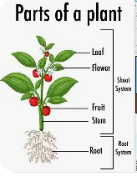
Science
Our science topic this term is all about plants. Children will learn to identify and name common plants and their key parts, including roots, stems, leaves, and flowers. They will explore what plants need to survive, focusing on water and light through simple testing and observations. Pupils will also learn about the plant life cycle, understanding how plants germinate, grow, and reproduce.
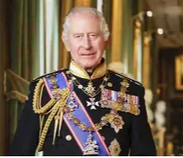
History
This term, History focuses on the question “What does the Royal Family mean to us?” Children will explore the monarchy from Elizabeth I through to the current monarch, Charles III. They will learn about the Royal Family tree and examine the roles and responsibilities of its members, both past and present, gaining an understanding of how the monarchy has changed over time and its significance today.

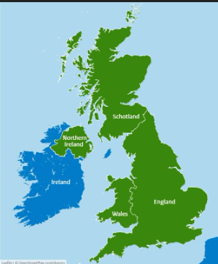
Geography
Geography this term explores the question “Where can I find the King of England?” Children will learn that we live in England, which is one of the four countries that make up the United Kingdom. They will be introduced to the idea that each country has its own capital city, with a focus on our capital, London. Through simple map work, pupils will develop their understanding of location and build knowledge of key places within the UK.

