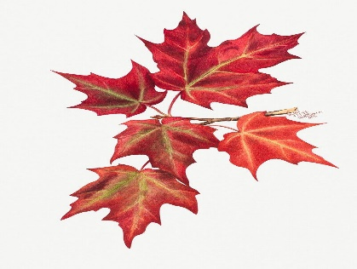
Maple Tree Spring Welcome Letter 2026

Welcome back Maple Tree Class,
We hope you have had a fantastic Christmas and lots of quality family time. We can’t wait to start all our fun learning activities that we have planned for spring term. We also have our school trip and our residential to Tattenhall, so it is going to be a very exciting start to 2026!
On this page you will find out lots of information about what we have planned across our core curriculum and some useful information about life in Maple Tree. Please note our PE days are the same - Thursdays (outdoor) and Fridays (indoor). Please ensure your child is wearing their school PE kit with a dark hoodie, has their hair tied back and if possible remove any earrings on these days.
We know sometimes it is hard to find out from the children what they have been up to in school, so if you scroll to the bottom of the page, you will find our class Twitter feed. With this, we endeavour to keep you updated with all of the exciting things that we get up to as we try to take lots of photos!
If you do have any questions or would like to speak to us about anything, please do not hesitate to contact us. We look forward to another great term!
Kind Regards,
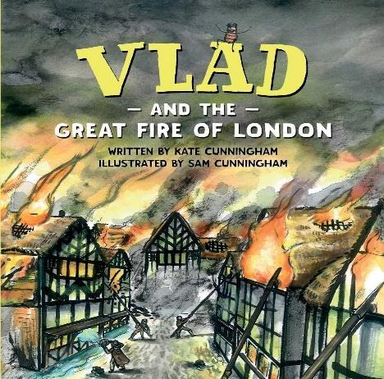
Mrs Williams, Mrs Franklin and Mrs Pearson
English
In English this term, we have planned lots of reading and writing activities. We like to link our learning in English to a book and this term we are going to use texts that link to our exciting history and geography topics. This half term we are linking our writing to our learning about the Great Fire of London using a book called ‘Vlad and the Great Fire of London’ by Kate Cunningham, where Vlad the flea and his friend Boxton the rat, who love eating and biting their way around London, suddenly find themselves caught up in a great fire. We will also be doing some fire poetry to link in with this topic.
Maths
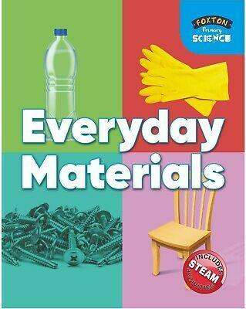
In maths this term we will start off by learning about money, followed by multiplication and division. We will then move on to investigate length, height, mass, capacity and temperature. As always, we try to make our learning as practical as possible. We encourage the children to carry on with their learning outside of school by using the Numbots and TTRockStars Apps to help them embed their knowledge of number bonds and the 2, 5 and 10 times tables. We will continue with our daily Fast Five sessions to retrieve all our previous learning on number, place value and addition and subtraction from last term and we will also be focusing on improving our mental maths skills this term too.
Science
We will be starting our new topic of ‘Materials’ where we look at the properties of everyday materials and some of their uses. We will be investigating how materials can change shape and also linking our science to our history and will be investigating how materials to build houses have changed since the Great Fire of London.
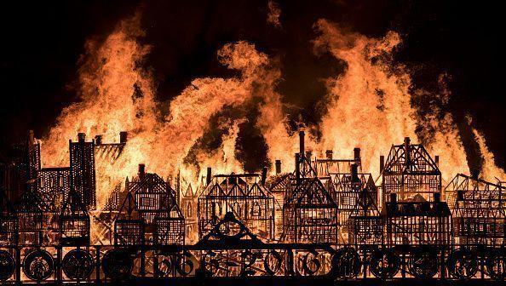
History
This term we study one of our favourite history topics, ‘The Great Fire of London!’ We learn all about how it started and the impact it had on the city of London. We will be looking at lots of non-fiction texts as well as all the wonderful fictional texts that we will be reading in English about this historical event. We also use this opportunity to get the fire brigade to come into school and talk about fire safety, as well as be on standby when we create our own’ great fire’ and burn down some houses! Fingers crossed we can do this later in the term. We are also very excited to do our very first trip to Weaver Vale museum to learn about a similar ‘great fire’ that occurred in the area in 1583.

Geography
G’day! We are also very excited about our geography topic this term which is where we compare British coastlines to the east coast of Australia. The children love learning about the famous Australian landmarks as well as the varying physical differences, aspects and climate compared to the UK. There is so much to learn about Australia so we will also be linking our art and DT units to this unit too.

