Great Sankey Primary School and Nursery

Prospectus and Application Procedures 2025-2027



|  |
| --- |
| Ratified by Governors – March 2023 and annual amendments made to dates |
|  |

**Headteacher: Mrs Lisa Wilding**

# Welcome to Great Sankey Nursery

This prospectus is designed to give you an insight into the time that your child will spend in our Nursery at Great Sankey Primary School. We pride ourselves on being able to offer high-quality education for children aged 3 and 4 and aim to give your child the best start possible.

We look forward to our time together working alongside you and your child.

# Meet The Nursery Team

|  |  |  |
| --- | --- | --- |
|  |  | |
| Mrs Sharon Johnson  Nursery Teacher  *(Monday Tuesday and Wednesday)* | Mrs Liz Mayers  Nursery Teacher  (*Wednesday Thursday and Friday)* | |
|  |  |
| Mrs Angela McVey  Nursery Teaching Assistant  First Aider | Mrs Abbi Williams  Nursery Teaching Assistant  First Aider |

**Learning Through Play**

At Great Sankey we strongly believe that children in the Nursery learn best through first-hand experience and purposeful play activities. To your child, play is their 'work' and we value it as such.

The nursery environment supports children to be fully engaged in purposeful play of their own choice and interest. Through careful observations of children’s learning and interests, we are able to select resources and materials, to ensure that during their play, children encounter the learning experiences that suit their needs. Play that is well planned and skilfully supported and challenged by teachers helps build important life skills such as curiosity, creativity, problem solving, use of their imagination, concentration, persistence, develop language to express themselves and resilience.

We follow the child’s lead and recognise each child’s different starting points, planning carefully to help each child meet their next steps in learning to ensure that they reach their full potential. Each child’s individual needs are catered for in an atmosphere that celebrates individuality and diversity, where everyone is included and everyone matters.

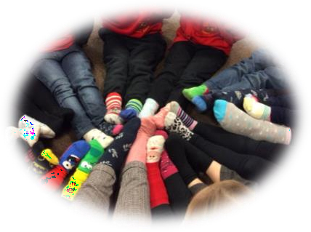

We aim:

# Our Aims

* To provide a welcoming atmosphere for all children, parents and carers.
* To provide a happy, caring, safe, stimulating environment where children can develop lively, enquiring minds.
* To enable your child to develop as an individual and as a member of the wider community.
* To help your child develop a good self-image, self-motivation, independence, tolerance and resilience.
* To value and develop children’s curiosity and creative thinking, giving them time to develop ideas and celebrating their efforts and their learning.
* To work in partnership with all our parents and families in the education of their child.
* To offer children and their parents a service that promotes equality and values diversity.
* To add to the life and well-being of the local community.

With these principles in mind your child can develop in confidence, make personal, social and academic progress and work towards becoming an independent, resilient learner.

We aim to deliver an education of high quality and create an environment which will enable your child:

* To acquire the skills knowledge and understanding that will form the firm foundation for future learning.
* To develop the ability to communicate clearly and confidently with a wide range of vocabulary and listen with understanding, interest and enjoyment.
* To support and manage their emotions, develop a positive sense of self and have confidence in their own abilities, showing resilience when needed.
* To help make friendships with others, co-operate and resolve conflicts amicably.
* To move towards acquiring a reasoned set of attitudes, behaviour and values including a respect for each other’s race, culture and creed.
* To develop their physical skills, understanding how to look after their bodies and what they need to do to keep themselves healthy.
* To manage their personal needs independently.
* To develop a life-long love of reading.
* To develop a strong understanding of number and provide frequent and varied opportunities to build and apply this understanding as well as developing spatial reasoning skills in all areas including shape, space and measures.
* To explore and enjoy art, music, singing, imaginative role play and dance.
* To explore and find out about their environment and people and places that have significance in their lives and society.
* To become active, motivated and ‘thinking’ learners.

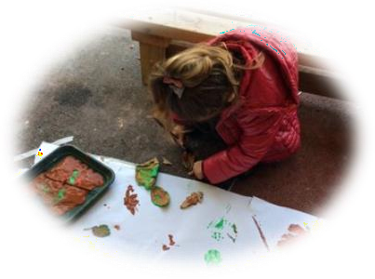Great Sankey Nursery School offers: excellent provision; fun outdoor play; highly qualified caring staff; a flexible curriculum of rich play and learning opportunities and; most importantly, a safe, nurturing environment where your child will feel happy, secure and cherished.

# Parents as partners

We are keen from the onset to build up a strong partnership with all our parents and carers and we value your input and support. Parents are members of our setting who have full participatory rights. These include a right to be:

* recognised
* valued and respected
* kept informed
* consulted
* involved
* included at all levels.

As a parent/carer you can play a vitally important role when your child starts in Nursery. We believe it is very important to share information with one another about your child's achievements, targets and emotional well-being. When your child starts in Nursery they will begin their ‘Learning Journey’. This is a record of significant things that they do both at home and in Nursery, so we ask that you provide evidence of anything significant that your child has done at home e.g. learnt to ride their bike, begun to use a knife and fork at tea time, achieved a swimming badge, begun a football or dance club. This evidence could be a photograph, a written explanation, a picture or comments which we can then add to their Learning Journey and our All About Me tree in Nursery, which celebrates children’s personal achievements. This is also a great way to encourage the children to talk as they proudly explain what they have been doing to their friends and teachers.

## Focus Children

Each week 3 children are selected who will be the ‘focus children’ for the following week. These children are given a form to take home for their parents to complete – asking about current interests of the child, any special events in the family and any questions that the parents may have. We also ask that parents send in some photographs of the child/family enjoying activities outside of Nursery. We value the knowledge and understanding you have of your child and would really appreciate it if you would share this with us so that together we can plan activities to meet your child’s needs. This will help us plan for their future learning and development.

When the photographs and form are returned your child will be able to share and talk about them with their friends and teachers. During this week any productive interactions with the focus child are recorded and added to their learning journeys. At the end of the week parents will receive information answering any of their questions and updating them of their child’s progress.

Each term your child will be chosen to be a focus child.

## Nursery X (Twitter) Page

You can follow us on our dedicated X (Twitter) page where you will see posts about what we’ve been getting up to during the week and reminders of upcoming events. @gsp_nursery

## Newsletters

Our weekly newsletters are sent out to parents via email on Friday afternoons. Newsletters give important information about upcoming events, celebrate learning across school and achievements outside of school, as well as informing you of any important notices. You can also find weekly newsletters on our website under the parent information section.

## Stay and Play

We hold Stay & Play sessions during the year. We invite parents and grandparents to stay and play for a while and to see your child in action in our provision.

## Parent Meetings/Evenings

We hold three parents’ evenings throughout the year. These are an opportunity for you to discuss and celebrate your child’s learning as well as look at next steps in their learning journey. At the end of the year, you will receive a written report of all that your child has learnt during their time in Nursery.

## Ofsted

Our last inspection result was “continues to be GOOD”. The inspectors said:

*“Inside and outside the classroom, pupils across the school take part in a rich variety of activities. These activities enable pupils to develop a deep knowledge of local and world cultures. Teachers care about pupils’ well-being. Every day, teachers practise techniques that will help pupils to remain calm and reflective should life become difficult. Pupils value this.”*

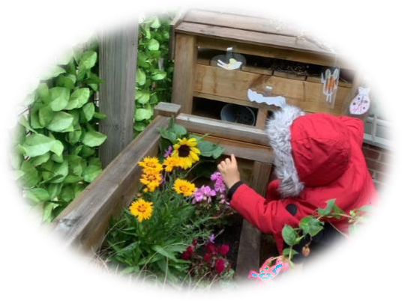Great Sankey Primary School was last inspected in September 2021 and we are delighted with the very good report we received. If you would like a copy it is available to view on our school website: <https://www.greatsankeyprimaryschool.co.uk/page/ofsted-reports/116124>

# Applying for a Nursery Place

## When can my child start nursery?

## Subject to availability, children are eligible for a place from the term following their 3rd birthday. For the academic year 2026-27, places will be prioritised for children born between 1st September 2022 and 31 August 2023 first. Once all these applications have been accommodated, children may be offered a place at the beginning of each term following their 3rd birthday. If places allow, there will be a further intake after both the Christmas and Easter Holidays.

## When should I apply?

## Applications for places starting in September 2026 should be made by 6th March of the same year. Applications received after this date will be considered on a first come first served basis. Session planning will commence after the cutoff date has passed.

## If places allow, further intakes may be considered in January and April. Applications should be made by the 2nd Friday in the preceding October and January respectively. Session planning will commence after the cut off dates have passed, and applications received after this date will be considered on a first come first served basis. See the example below:

|  |  |  |
| --- | --- | --- |
| Term/Start Date | Application Deadline | Places confirmed by |
| Autumn – September 26 | 6th March 2026 | 17th April 2026 |
| Spring – January 2027 | 9th October 2026 | 14th November2026 |
| Summer – April 2027 | 8th January 2027 | 30th January 2027 |

## What is the criteria for allocation of places if over-subscribed?

## Where there are more applications than places available, the following criteria will be applied:

## Children in care and children formerly in care*

## Children with special educational needs as defined by the Children’s Act 1989 or the Education Act 1996.

## Children with exceptional personal or domestic circumstances presented by the parents which justify, in the Governor’s view, priority for nursery education.

## Children with a sibling already in school, where the sibling is expected to continue at school the following year. This includes full, half or step siblings, and foster siblings living at the same address as part of the same family unit.

## Children resident in the Borough of Warrington.

## Children resident outside the Borough of Warrington.

## * formerly in care is defined as children who were looked after but ceased to be so because they were adopted or became subject to a child arrangement order or special guardianship order.

## If there are insufficient places to accommodate all the children in one of the categories detailed above priority is given to children living nearest the school. This is defined as children living nearest to the school measured as a direct distance from the child’s permanent place of residence to the school measured using a Geographical Information Address Point System based on the local land and property gazetteer. This measures straight line distances from the address point of the permanent place of residence to the address point of the school.

## Prior to the session planning process commencing, children who are already enrolled in our nursery and continuing into the next academic year will be invited to reserve additional sessions or make amendments to future sessions. Such amendments must be submitted to the school office no later than 7th March. There is no guarantee amendments can be accommodated after this date and any such applications received will be considered on a first come first served basis.

## Session planning will take place between the school prior to places being offered. We will try to be as flexible as possible in meeting parents’ needs, however as places are subject to availability, it may not be possible to accommodate all of a child’s preferred sessions, therefore parents will be offered a place on a waiting list to see if a place becomes available.

## Applications received before the cut off dates will be considered in line with the afore mentioned criteria. Applications received after cut off dates will be considered on a first come first served basis.

## There is no right of appeal against the allocation of places to nursery.

## Fees and Charges

## Sessions at Great Sankey Primary School are available in 3 hour blocks and can be taken from the universal offer of up to 15 hours funding for 3 and 4 year olds. We also offer extended funding up to 30 hours for families in receipt of a valid code from HMRC.

## Once any funded entitlement is utilised, additional sessions can be purchased at a cost of £16.50* per 3-hour session. If there is insufficient funding to cover the lunch time period, there is a charge of £4.00* to cover the cost of supervision.

## Parents and carers can choose to order a school meal for their child at a cost of £2.60* or alternatively, a packed lunch can be supplied from home. Children are provided with the option of a portion of fruit each day at a cost of £0.30*.

**How do I apply for a place at Great Sankey Primary School nursery?**Please return a completed application form to the school office. Forms can also be emailed to [admin@greatsankeyprimary.tcat.uk.com](mailto:admin@greatsankeyprimary.tcat.uk.com)

Forms can be downloaded from our website:

<https://www.greatsankeyprimaryschool.co.uk/page/nursery/116304> or obtained from the school office.

**Starting Nursery**

## What times can my child come to Nursery?

We run morning sessions from 8.30 – 11.30am and afternoon sessions from 12.15 – 3.15pm. Families may choose from a blend of morning or afternoon sessions. Children may also attend a full day from 8.30am – 3.15pm.

Lunch times are £4* per session or if preferred, 45 minutes can be allocated from funded hours. A school meal may be ordered from the kitchen for £2.60* or alternatively, a packed lunch can be provided from home. It is important that all children arrive on time as arriving late can affect the learning taking place in the setting.

## How do you get to know my child?

We have a special induction session before your child starts, where you can explore our Nursery environment with your child. You will meet the nursery staff who will get to know your child really well and are available to discuss anything relating to your child.

The induction period into Nursery is really important. We want your child to feel happy and safe with us. To make sure that this is the case we use a staggered start for the beginning of their first half term. Experience has shown us that this works best for the children as they become familiar with their new surroundings, routines and getting to know the staff. If after the settling in period has passed and your child is still unsettled, please do not be concerned we will tailor the session according to your child's needs.

## What is the environment like?

Our Nursery is set up with areas indoors and outdoors, which appeal to children and their interests. They support learning in all areas of development, but the two areas do not mirror each other. We have thought carefully about the lay out and resources available for the children so that there are opportunities to develop skills across all areas of learning wherever your child prefers to play.

Indoor the children have the choice of a very wide range of toys, resources, craft materials and activities. Through play, each child is encouraged to try new activities, build friendships, be creative, play co-operatively, develop independence and express themselves with confidence. Our sessions are organised so that the children can choose from, and work at, a range of activities and, in doing so, build up their ability to select and work through a task to its completion. The children are also helped and encouraged to take part in adult-led small and large group activities which introduce them to new experiences and help them to gain new skills, as well as helping them to learn to work with others.

Our outdoor space is truly unique and offers our children the freedom to play together and to explore and develop in an exciting, fun and safe environment. Outdoor activities contribute to children's health, their physical development and their knowledge of the   
world around them. The children have the opportunity, and are encouraged, to take part in outdoor child-chosen and adult-led activities, as well as those provided in the indoors.

Below are photographs showing some of the areas available to your child:

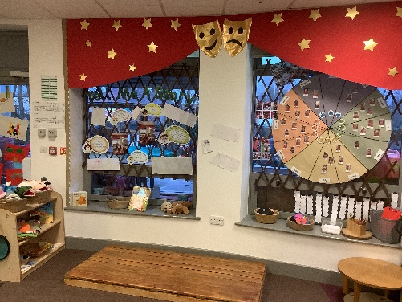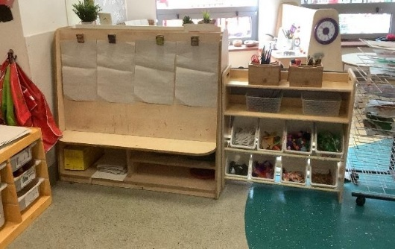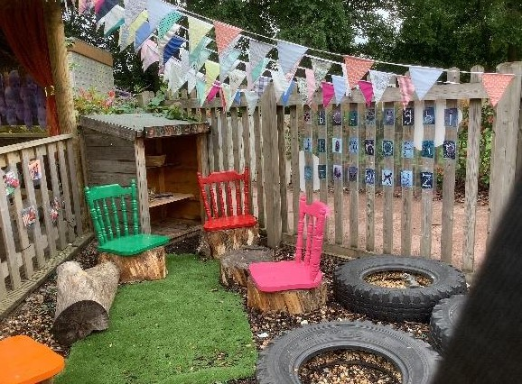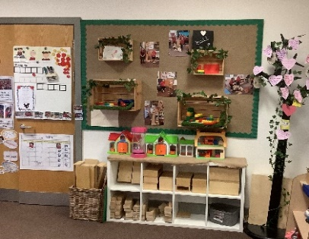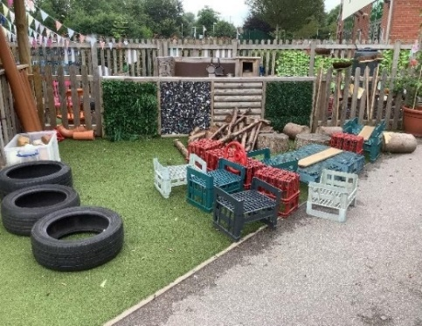

**How will you support my child’s learning?**

At Great Sankey we recognise that children learn and develop in different ways and at different rates. Children start to learn about the world around them from the moment they are born. The care and education offered by our setting helps children to continue to do this by planning learning experiences that meet the individual needs and interests of the children through a balanced provision of adult led and child initiated opportunities.

We deliver a curriculum based on The Early Years Foundation Stage Framework. We follow the 4 guiding principles that shape practice in the early years. They are:

**Learning and Development**

Children develop and learn at different rates. The framework covers the education and care of all children in early years provision, including children with special educational needs and disabilities (SEND).

**Enabling Environments**

children learn and develop well in enabling environments with teaching and support from adults, who respond to their individual interests and needs and help them to build their learning over time. Children benefit from a strong partnership between practitioners and parents and/or carers.

**Positive Relationships**

help children learn to be strong and independent.

Every child is a **Unique Child**

who is constantly learning and can be resilient, capable, confident and self-assured.

The framework also describes the seven areas of learning and development which must be implemented through planned, purposeful play. These are all important and inter- connected. Three areas are particularly important for building a foundation for igniting children’s curiosity and enthusiasm for learning, forming relationships and thriving.

They are called the prime areas. We also support children in four specific areas, through which the three prime areas are strengthened and applied.

The Areas of Learning and Development comprise: Prime Areas:

* Communication and Language
* Personal, Social and Emotional Development
* Physical Development

Specific Areas:

* Literacy
* Mathematics
* Understanding the World
* Expressive Arts and Design

For each area, the framework sets out the Early Learning Goals. These goals state what it is expected that children will know and be able to do by the end of the reception year of their education.

In addition, the framework describes three characteristics of effective teaching and learning that detail the ways in which children learn from their environment, experiences and activities.

The three characteristics of effective teaching and learning are:

* playing and exploring - children investigate and experience things, and ‘have a go’
* active learning - children concentrate and keep on trying if they encounter difficulties, and enjoy achievements
* creating and thinking critically - children have and develop their own ideas, make links between ideas, and develop strategies for doing things

Throughout the year our children play, make friends, develop and learn. They have great fun, exploring and creating, indoors and outside. They gain independence, confidence and resilience.

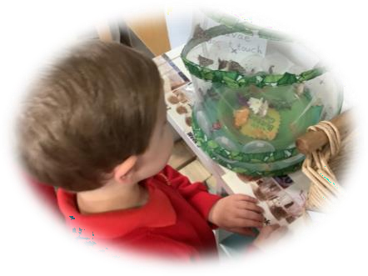

## How will you know my child is progressing?

We assess how young children are learning and developing by observing them frequently. We use information that we gain from observations, as well as from photographs, to document their progress and where this may be leading them. This is known as your child's Learning Journey. We believe that parents know their children best and we ask them to contribute to assessment by sharing information about what their children like to do at home and how they as parents are supporting development. We make periodic assessment summaries of children’s achievement based on our ongoing Learning Journeys. These form part of children’s records of achievement. We undertake these assessment summaries at regular intervals as well as times of transition, such as when a child moves on to school.

Your child's Learning Journey helps us to celebrate her/his achievements with you and to work together to provide what your child needs for her/his well-being and to make progress. In addition to informal sharing of achievements and working together parent consultations are held three times a year. Your child will receive an end of year report before they start reception school.

## What happens when I bring my child to Nursery?

Each Nursery session begins with your child being greeted at the door by one of their teachers. In the first couple of weeks you may want to come in with your child to help them to settle. This is absolutely fine and you should be prepared to stay in Nursery whilst your child settles into their new environment and daily routine.

It can be a great comfort to them if you help them to find their name card and put it on the sign in board. You can then help them to find their peg in the cloakroom and encourage them to take off their bag and coat by themselves and hang them on their peg. Your child will then be ready to explore the Nursery classroom and you can play together whilst they settle in for their session. When you have said goodbye and are ready to leave just let one of the teachers know so we can ensure the doors are locked behind you.

## 

## What does my child need to bring to Nursery?

Your child will need to bring a bag daily. This needs to be big enough to put in any pictures or models they make as well as letters from Nursery. They should be able to open and close it easily by themselves. We have found a medium sized rucksack to be best as their hands can be kept free to carry anything else they need.

Your child will also need a water bottle each day. This is in addition to the drink you provide in their lunchbox if they stay for lunch.

We also ask that you provide a drawstring bag with a change of clothing, including underwear and shoes. If your child is not yet fully toilet trained, please can you include two sets of clothing. This bag will remain in Nursery.

It is important that all clothing and belongings are clearly labelled with your child’s name.

## What should my child wear to Nursery?

School uniform is optional in Nursery but please dress your child in suitable clothing. They need to be able to run and climb and they will get their clothes dirty with paint, glue, mud, food etc. Please be assured that we do have aprons for the children to wear, but it is inevitable that paint, pen, mud and food may come into contact with their clothes.

We encourage children to gain the skills that help them to be independent and look after themselves. These include taking themselves to the toilet and taking off, and putting on, outdoor clothes and wellingtons.

We would suggest:

* Jogging bottoms or leggings with a t-shirt and sweatshirt or cardigan.
* A weather appropriate coat that is warm and waterproof as we spend a large majority of our time outdoors in ALL weathers.
* Shoes/trainers with Velcro straps.
* Wellington boots to be kept in Nursery.
* Hat, scarf, gloves, sunhat when needed.

It is important that all clothing and belongings are clearly labelled with your child’s name. Please note: nursery will not be held responsible for clothing that is not labelled.

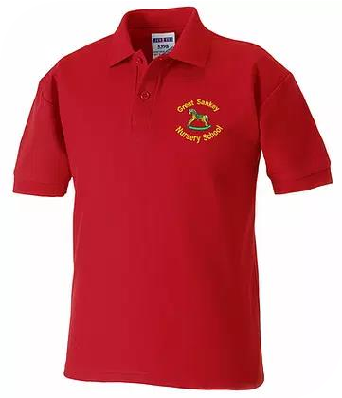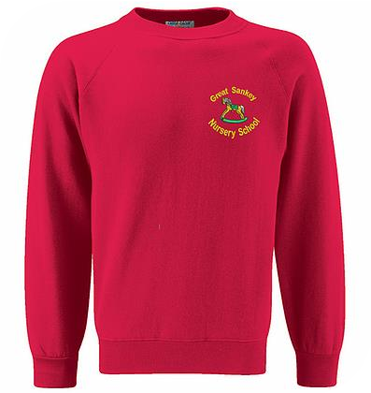

Nursery uniform can be purchased online from <http://www.sg-embroidery.co.uk/>[www.sg-embroidery.co.uk](http://www.sg-embroidery.co.uk) or from <https://www.touchline-embroidery.com/>

## What will my child eat at Nursery?

Each morning and afternoon we provide the children with a healthy snack. The children are offered a piece of fresh fruit alongside the drink they bring in their water bottle from home. We aim to make snack time as independent as possible and encourage children to help themselves to snack and get their own water bottle. We provide the option for children to have a fruit snack at a cost of £0.30* pence per day. Snack money is collected on a monthly basis via our school parent portal, Arbor.

If your child is staying for lunch they can either bring in a packed lunch from home or have a hot meal provided by the school kitchen at the prevailing rate (currently £2.60). If you choose to provide a packed lunch, it should be brought in a lunchbox, which is clearly labelled with your child’s name. Packed lunches should be healthy and we ask for no chocolate bars, sweets, fizzy drinks or glass bottles. We also request that due to allergies, parents do not include nuts or foods containing nuts.

## What can I do with my child before they start Nursery?

A few simple suggestions to do at home:

* Have conversations with your child. This may sound so obvious, but it is probably the most valuable thing that you can do, as it supports your child’s language development.
* Read stories together every day. Look at the pictures and talk about the story.
* Sing songs and nursery rhymes, including number rhymes.
* Get out and about and have fun!

# Policies and Procedures

## Accidents

Cuts, bumps and bruises are treated with a cold compress, ice pack or plaster if necessary as well as plenty of TLC. In the case of a serious accident you will be contacted immediately. A member of staff with first aid qualifications will take responsibility until you arrive at Nursery. If your child has received a heavy head bump you will be informed of the circumstances by a telephone call so you can decide whether to collect your child or have them remain at Nursery. Any other incidents and you will be notified by an accident slip or your child’s teacher at the end of their session.

## Toileting

It is preferred that all children are toilet trained prior to starting Nursery however we do appreciate that some children may need support with this area, particularly if there is a medical need. Children will always be encouraged to be as independent as possible. We recommend that children wear manageable clothes in order to achieve this. Please see our 'Going to the toilet' guide (in activity pack).

## Special Educational Needs

As part of the setting's policy to make sure that its provision meets the needs of each individual child, we take account of any additional needs a child may have.

The setting works to the requirements of the 2014 Special Educational Needs and Disability Code of Practice.

Our school’s Special Educational Needs and Disability Coordinator (SENDCo) is Mrs Williams.

## Illness and medicines

If a child appears unwell during the day – has a temperature, sickness, diarrhoea or pains, particularly in the head or stomach, the parents will be called and asked to collect the child, or send a known carer to collect on their behalf.

After sickness or diarrhoea, parents are asked to keep children home for 48 hours after the last episode. Where children have been prescribed antibiotics, parents are asked to keep them at home for 48 hours before returning to the setting. Only prescribed medication can be administered by Nursery staff. Before medication can be accepted in Nursery, a request for Nursery to administer the medicine must be completed. This is available from the school office.

Please contact us on 01925 728176 to report a pupil absence or email us on [attendance@greatsankeyprimary.tcat.uk.com](mailto:attendance@greatsankeyprimary.tcat.uk.com) if your child is unwell and will be absent.

If your child has asthma we ask for an inhaler to be kept in Nursery with a spacer, labelled with their name and dosage required. Again, an administering medicine form must be completed before we can do this.

## Toys from home

We ask that no toys or precious items come to Nursery. Please note: we will not be held responsible for toys that have been brought into Nursery.

Sometimes a change in routine at home e.g. new baby or emotional upset- may mean a sudden return to a comforter. Please inform us of any known change in home life which may cause upset in the knowledge that this will be treated confidentially.

## And finally...

We hope that you have found this prospectus informative and that it has answered many of the questions that you may have had. However, if you need clarification or anything at all please do not hesitate to contact a member of the Nursery team.

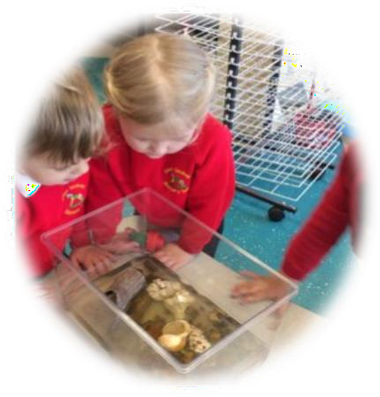

Version No 3

Issued February 2024

Reviewed Spring 2025, next review due Spring 2026

* All prices shown are current prices and may be subject to change.