Welcome to GSP Nursery – Seedlings Class

Am session: 8.30am – 11.30am (group session begins 8.45am)

Pm session: 12.15am – 3.15pm (group session begin 12.45pm)

Mrs Johnson Class Teacher (Mon, Tue, Wed)

Mrs Mayers Class Teacher (Wed, Thu, Fri)

Mrs McVey Teaching Assistant (Mon – Fri)

Miss Williams Teaching Assistant (Mon – Fri)

Last year was the first year Nursery were offered hot dinners and it was a huge success. The children really enjoyed them and we will be offering hot dinners again this year. Please can we remind you to order your child’s hot dinner before they come into nursery that day and talk to them about what you have ordered so that they know what they will be having to eat for their lunch.

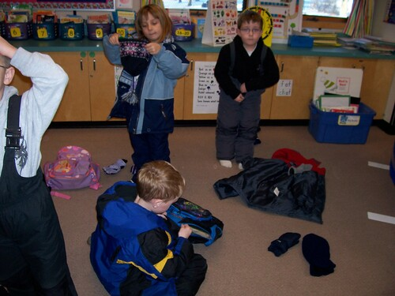As the weather is very changeable at this time of year, please send your child in with a warm, waterproof coat (with their name clearly written inside and on all their uniform) and suitable footwear that they can put on themselves such as Velcro fastenings.

Please can we remind you to send in at least (2 or 3 full changes of clothing especially lots of extra socks and underwear in a small back pack with some nappy bags or small bin liners to put wet clothes in). It is a vital part of children’s development to play outdoors and experience what nature has to offer, so there will be times when your child gets very wet or muddy from the outside classroom as our waterproofs and wellies are not always 100% waterproof!

This term we will also be continuing to develop their independence in getting themselves dressed and undressed, so we would really like your support in encouraging your child at home to put on their own socks and shoes, coat and back pack. Please can you ensure that your child comes into nursery wearing their coat and with their back pack on their back and water bottle in their other hand (this really helps to prevent a build up inside the door and they can put their bottles straight onto the shelf).

Thank you for your continued support.

Mrs Mayers & Mrs Johnson (Class Teachers)

This is what your child will need to bring each day:

1. Wearing clothes or nursery uniform that is clearly labelled with their name on everything, especially jumpers and cardigans!
2. A drink bottle – with their name clearly labelled on it.
3. A back pack – with their name clearly labelled on it (for pictures and letters to go home and any changes of clothes). A separate small draw string pump type bag can remain in nursery with the following (at least 2 or 3 spare sets of socks, underwear, bottoms and tops, nappy bags or small bin liners for wet clothes, wet wipes, spare pair of shoes/trainers ALL NAMED PLEASE).
4. Either a packed lunch with their name clearly labelled on it and a separate drink OR parents order a hot dinner via Arbor and let the child know in the morning before nursery what they have ordered.