PRAYERS TO SAY AT HOME


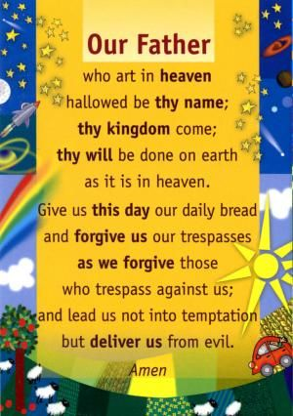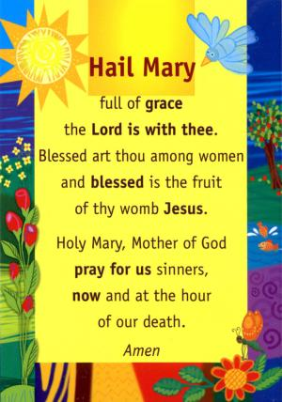
October is traditionally the month of the Rosary
The Rosary is a prayer to remind us that Jesus loved us so much that he died on the cross for us. The rosary tells the story of Jesus’ life in four parts:
The Joyful Mysteries, The Sorrowful Mysteries, The Glorious Mysteries, The Luminous Mysteries. Catholics have been given a very special gift in the rosary. Each time we pray the rosary we should focus on Jesus’ life as well as a special person or intention that we want to pray for.
