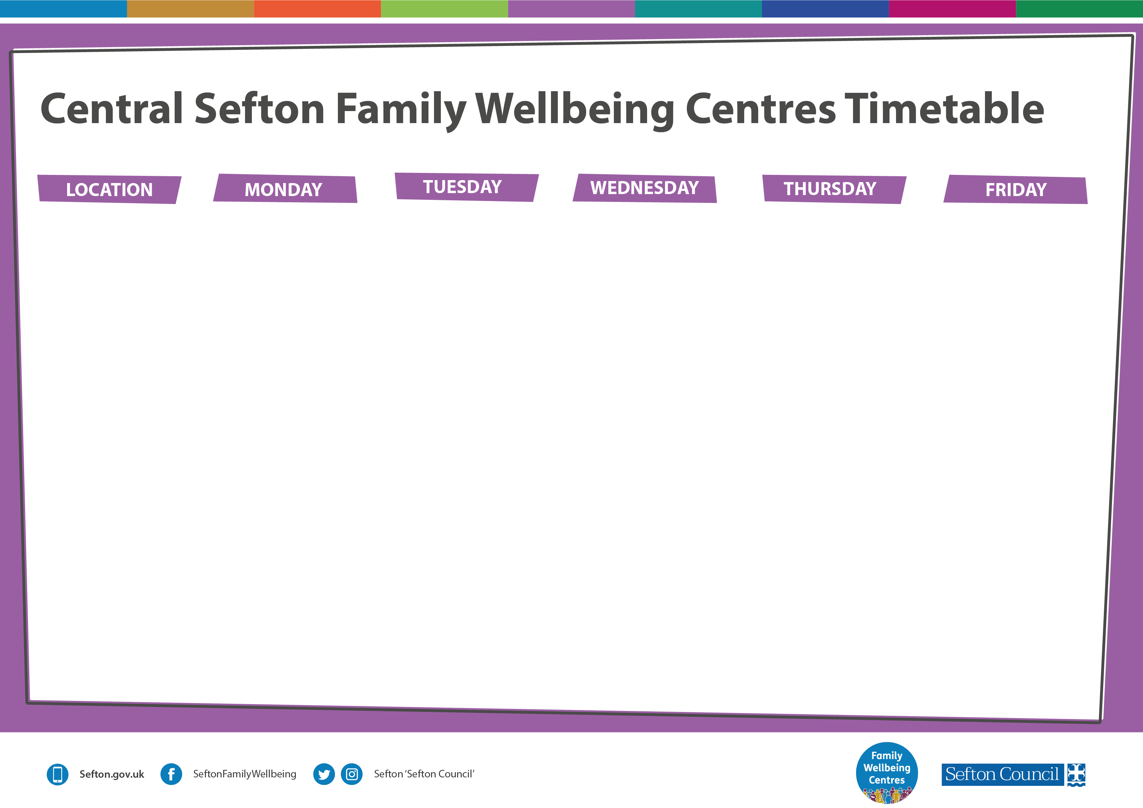
Sept – Dec 2023 – drop in available every day for Vitamins, Advice & Guidance

ALL DAY
MHST 1-1 Therapy Sessions
APPOINTMENT ONLY

ALL DAY
Venus 1-1 Therapy Sessions
CLOSED GROUP

Morning/Afternoons
Some bookable room spaces – please email Thornton.FWC@sefton.
Gov.uk to enquire

All Day
MHST 1-1 Therapy Sessions
CLOSED GROUP

3.00pm-5.15pm
DBT Group Sefton Camhs
CLOSED GROUP

Morning/Afternoons
Some bookable room spaces – please email Thornton.FWC@sefton.
Gov.uk to enquire

11:00am-1:00pm
Riding the Rapids
10 -week parenting course for parents of children/ young people with an Autism Spectrum diagnosis or other complex needs.
REFERRAL ONLY

Afternoon
Talking Therapies
CLOSED GROUP

Thornton Family Wellbeing Centre
Stannyfield Drive
Thornton
L23 1TY

Tel : 0151 934 4991
Email: Thornton.FWC@
sefton.gov.uk

FOR MORE INFORMATION ABOUT OUR PROGRAMMES – PLEASE SEE REVERSE

10:00am-12:30pm
Venus Centre sessions
CLOSED GROUP

Morning
Talking Therapies
CLOSED GROUP

12:00pm-3:00pm
Advanced Solutions
DROP IN

Morning/Afternoons
Some bookable room spaces – please email Thornton.FWC@sefton.
Gov.uk to enquire

Smoke Free Pregnancy
Appointment Only
12.00pm - 4.00pm

Morning/Afternoons
Some bookable room spaces – please email Thornton.FWC@sefton.
Gov.uk to enquire

9:00am-10:00am
Advice & Guidance drop-in sessions.
Twice weekly confidential and face to face advice with our family workers.
DROP IN
START DATE TO FOLLOW

Children’s Incontinence Nurse
APPOINTMENT ONLY

Relax Kidz
Start date to be confirmed – call the centre for more information

Morning/Afternoons
Some bookable room spaces – please email enquiries@hudsonprimary.co.uk for availability

9:00am-10:00am
Advice & Guidance drop-in sessions.
Twice weekly confidential and face to face advice with our family workers.
DROP IN
START DATE TO FOLLOW

Various Times
Midwife Appointments
BOOK ON through your midwife or GP

Morning/Afternoons
Some bookable room spaces – please email enquiries@hudsonprimary.co.uk for availability

Smoke Free Pregnancy
Appointment Only
12.00pm - 4.00pm

9:30am-12:00pm
Riding the Rapids
10 week parenting course for parents of children/ young people with an Autism Spectrum diagnosis or other complex needs.
REFERRAL ONLY
START DATE TO FOLLOW

Morning/Afternoons
Some bookable room spaces – please email enquiries@hudsonprimary.co.uk for availability

10:00am-11:00pm
Baby Massage
From birth to crawling (after hip check)
Led by our trained family worker, baby massage can help relax and soothe your baby.
BOOK ON
START DATE TO FOLLOW

1:00pm-2:00pm
Nutrition & Wellness Workshop
Join our Nutrition and Wellness Workshop to discover the keys to a balanced lifestyle. Learn about eating habits, meal planning etc.
BOOK ON
START DATE TO FOLLOW

10:00am-12:00pm
Debutots
Learning through story, drama and play.
MORE INFORMATION TO FOLLOW

1:30pm-2:45pm
Nurture Parent Group
4 week interactive course to support parents to understand and promote the positive mental health of their children.
MORE INFORMATION TO FOLLOW

Morning/Afternoons
Some bookable room spaces – please email enquiries@hudsonprimary.co.uk for availability

Hudson Family Wellbeing Centre
Moorhey Road
Maghull
L31 5LE

Tel: 0151 526 1568
Email: Hudson.FWC
@sefton.gov.uk

FOR MORE INFORMATION ABOUT OUR PROGRAMMES – PLEASE SEE REVERSE

Sept – Dec 2023 – drop in available every day for Vitamins, Advice & Guidance
September 2023 - drop in available every day for Vitamins, Advice & Guidance

