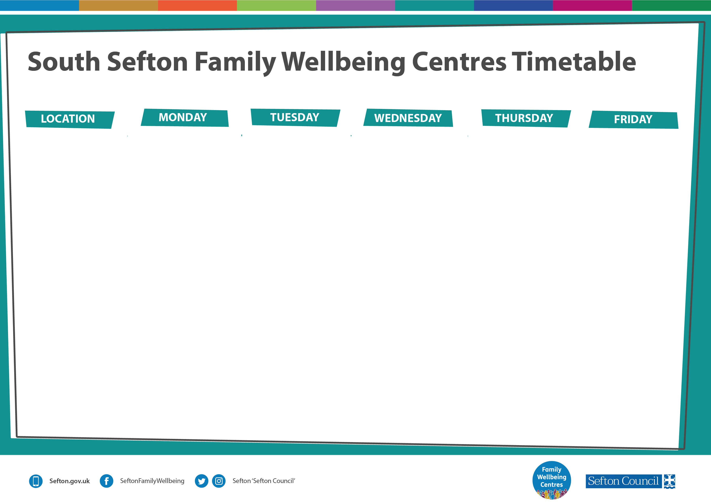
Sept – Dec 2023 – drop in available every day for Vitamins, Advice & Guidance
September 2023

10:00am-12:00pm
VIG (Video Interactive Guidance)
REFERRAL ONLY

1:00pm–2:30pm
Flow Fitness
For 0-5 year olds
Starting 30/10/23 for 6 weeks
BOOKING ONLY

1:00pm–2:30pm
Change, Grow, Live
Coffee afternoons for adults & young people with substance misuse concerns. Starts 25th September
DROP IN

10:30am – 1:30pm
Riding the Rapids Teen
10 -week parenting course for parents of young people with an Autism Spectrum diagnosis or other complex needs. Starts 29th September
REFERRAL ONLY

1:00pm–2:15pm
Stay & Play
suitable from birth to 4 years. Starts 11th Sept. Creative play, messy play, crafts and lots of fun!
Starting 15/09/23
DROP IN

Smoke Free Pregnancy
Appointment Only
12.00pm - 4.00pm

12:30pm–3:00pm
Portage Stay & Play
From birth to 5 years
Monthly – dates ?????
Closed group.

12:00pm–2:30pm
Cancer support group
Referral Only

3:00pm–5:00pm
IPT-A 121 sessions
Mental Health Support
Appointment only.

Morning/Afternoons
Some bookable room spaces – please email MarieClarke.FWC@sefton.gov.uk to enquire.

9:30am–11:30am
Active Sefton Henry Healthy Family Programme
For parents and children aged 0-5
Date TBC
BOOKING ONLY

10:30am–12:30pm
Ace Recovery Programme Adults
Starting 12/10/23
REFERRAL ONLY

Morning/Afternoons
Some bookable room spaces – please email MarieClarke.FWC@sefton.gov.uk to enquire.

9:30am–11:30am
Chattertime
a playgroup to help develop speech and language skills. Ages 18 months to 4 years.
Starts 26th September
REFERRAL ONLY

9:30am–11:30am
Triple P Primary,
a 6 -week parenting course for primary ages, starts 26th September
BOOKING ONLY

Morning/Afternoons
Some bookable room spaces – please email MarieClarke.FWC@sefton.gov.uk to enquire.

Seaforth Family Wellbeing Centre
Caradoc Road, Seaforth, L21 4NB

Tel: 0151 286 7807
Email: MarieClarke.FWC@sefton.gov.uk

FOR MORE INFORMATION ABOUT OUR PROGRAMMES – PLEASE SEE REVERSE

Sept – Dec 2023 – drop in available every day for Vitamins, Advice & Guidance
September 2023

9:30am-11:30am
Sefton Parent Carer Forum
Drop-in sessions for parents/carers providing advice, guidance & support. Come and have a chat with us and with other families.
Starting 22nd September

12:30pm-2.30pm
Sefton Parent Carer Forum
Drop-in sessions for parents/carers providing advice, guidance & support. Come and have
a chat with us and with other families.
Starting 22nd
September

Smoke Free Pregnancy
Appointment Only
12.00pm - 4.00pm

Morning
ACE recovery PCN female
Creche available Referral Only.

Afternoon
ACE recovery PCN Male
Creche available.
Referral Only.

Morning/Afternoons
Some bookable room spaces – please email MarieClarke.FWC@sefton.gov.uk to enquire.

Morning
ACE recovery PCN female
Creche available Referral Only.

Afternoon
ACE recovery PCN Male
Creche available.
Referral Only.

9:30am-11:30am
Sefton Parent Carer Forum
Drop-in sessions for parents/carers providing advice, guidance & support. Come and have a chat with us and with other families.
Starting 20th September

12:30pm-2.30pm
Sefton Parent Carer Forum
Drop-in sessions for parents/carers providing advice, guidance & support. Come and have a chat with us and with other families.
Starting 20th September

9:30am-11:30am
Sefton Parent Carer Forum
Drop-in sessions for parents/carers providing advice, guidance & support. Come and have a chat with us and with other families.
Starting 18th September

12:30pm-2.30pm
Sefton Parent Carer Forum
Drop-in sessions for parents/carers providing advice, guidance & support. Come and have a chat with us and with other families.
Starting 18th September

Morning/Afternoons
Some bookable room spaces – please email MarieClarke.FWC@sefton.gov.uk to enquire.

Morning
ACE recovery PCN Male
Creche available.
Referral Only.

Afternoon
ACE recovery PCN female
Creche available Referral Only.

Morning/Afternoons
Some bookable room spaces – please email MarieClarke.FWC@sefton.gov.uk to enquire.

Cambridge Family Wellbeing Centre
Cambridge road
Bootle
L20 9LQ

Tel: 0151 282 5436

Email: MarieClarke.FWC@sefton.gov.uk

FOR MORE INFORMATION ABOUT OUR PROGRAMMES – PLEASE SEE REVERSE

