Alderley Edge Community Primary School
TOPIC: Water Cycle | Strand: Geographical processes | Year 4
What should I already know?
- Evaporation happens when water (a liquid) turns into water vapour (a gas) when it is heated.
- Condensation happens when water vapour (a gas) turns into small water droplets (liquid) when it is cooled.
- Plants absorb water through the soil to help them grow
- Climate regions of mountains
- Features of mountains and rivers
Geographical Skills and Fieldwork
- Present what you know about the water cycle using a variety of skills using appropriate vocabulary.
- Observe evaporation and condensation in action by using bowls of water and mirrors /glass.

  The Water Cycle
  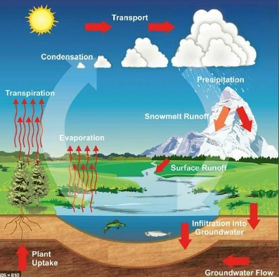
   | Vocabulary
  absorb | soak up or take in
  atmosphere | the layer of air or other gases around a planet
  condensation | small drops of water which form when water vapour or steam touches a cold surface, such as a window
  evaporation | to turn from liquid into gas; pass away in the form of vapour.
  gas | a form of matter that is neither liquid nor solid. A gas rapidly spreads out when it is warmed and contracts when it is cooled.
  groundwater | water that is found under the ground. Groundwater has usually passed down through the soil and become trapped by rocks.
  liquid | in a form that flows easily and is neither a solid nor a gas.
  precipitation | rain, snow, sleet, dew, etc, formed by condensation of water vapour in the atmosphere
  runoff | rain in excess of the amount absorbed by the ground
  surface | the flat top part of something or the outside of it
  transpiration | evaporation of water from a plant's leaves, stem, or flowers
  water vapour | water in the gaseous state, esp when due to evaporation at a temperature below the boiling point

How Does the Water Cycle Work?
- Evaporation:
- The Sun causes the water from the Earth to evaporate.
- This water evaporates from seas, lakes, streams and even puddles.
- When it evaporates, water turns into water vapour.
- Condensation:
- As the water vapour rises, it cools down.
- As it cools down, condensation happens and water vapour condenses to small droplets of water.
- Clouds are made from a mix of dry air and small droplets of water.
- Precipitation:
- As condensation continues to happen, more droplets of water vapour are formed.
- When the droplets become heavy and large enough, they fall back to the Earth’s surface in the form of rain or snow.
- Runoff and Transpiration:
- As precipitation happens in the form of rain or snow falling back to Earth, water is absorbed into the soil.
- This water is used by plants to grow - when water from plant leaves evaporates back into the atmosphere, this is called transpiration.
- Water may also run off and enter oceans, seas and rivers.
- Water then evaporates again and the water cycle begins again!

