Alderley Edge Community Primary School
TOPIC: County of Cheshire | Strand: Location Knowledge | Year 3

   | What should I already know?
  • | The country I live in is called England.
  • | I live in Alderley Edge, which is a in England. It is near Manchester , which is a city.
  • | The similarities and differences between Alderley Edge and Manchester.
  • | England is a country in the United Kingdom (England, Scotland, Wales and Northern Ireland).
  • | London is the capital city of England. There are similarities and differences Alderley Edge and London.
  Vocabulary
  city | a large town. Manchester is a city.
  climate | the general weather conditions that are typical of a place
  coastal | an area of land close to the sea
  compass point | any of the main points of a compass: north, south, east and west
  country | an area of land that is controlled by its own government.
  county | a region of Britain or Ireland which has its own local government
  England | a country in the United Kingdom. Alderley Edge is a village in England.
  farm | an area of land used to produce crops or to breed animals and livestock.
  harbour | a sheltered port so that boats can be left there safely
  human features | features of land that have been impacted by human activity
  landscape | everything you can see when you look across an area of land, including hills, rivers, buildings, trees, and plants.
  physical features | natural features of land
  port | a harbour area where ships load and unload goods or passengers
  river | a large, natural stream of fresh water that flows into the sea or a lake.
  sea | a large area of salty water that is part of an ocean
  town | a large group of houses, shops and buildings where people live and work. Towns are larger than villages but smaller than cities. Macclesfield and Alderley Edge are towns.
  United Kingdom | The UK, is officially known as the United Kingdom of Great Britain and Northern Ireland. It includes England, Scotland, Wales and Northern Ireland.
  village | a small group of houses, perhaps with a few shops, that are often in the countryside. Alderley Edge is a village.
  Geographical Skills and Fieldwork
  - Use Google Earth to find Alderley Edge. Zoom out until you see Cheshire. Which other towns do you see? What do you notice about Cheshire?
  - Describe the human and physical features of Cheshire.
  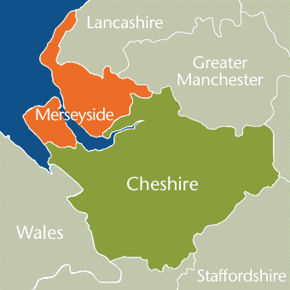
  - Create a leaflet showing places of interest in Cheshire
Where is Alderley Edge?
- Alderley Edge is in the county of Cheshire.
- Cheshire is in the country of England, which is in the United Kingdom.
- Cheshire is made up of Cheshire East, Cheshire West, Warrington and Halton
- Other places in Cheshire include the towns of Macclesfield, Wilmslow and Crewe
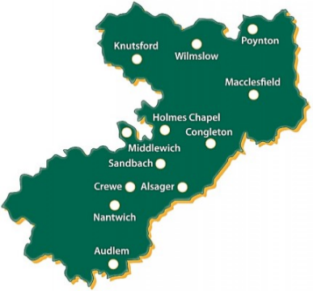
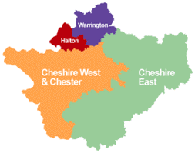
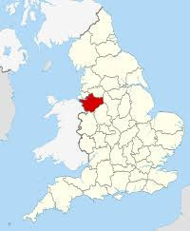
Alderley Edge

 | Features of Cheshire
 | Human features | Physical features
Cheshire | Cheshire has many villages (such as Alderley Edge) and towns (such as Macclesfield). The main city is Chester  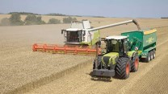  Cheshire has many farms and is famous for the farming trade – Cheshire potatoes  Cheshire has salt mines  Cheshire is famous for Cheshire Cheese  Historically Macclesfield was famous for silk  Other industries include cars (e.g. Bentley in Crewe) and tourism | River - Main rivers include the Mersey and Dee. River Bollin, in Wilmslow, is a tributary to the River Mersey into the Irish Sea  Cheshire has a lot of sandstone which is mined  Highest point – Shining Tor on the border with Derbyshire  The landscape is green as there are many fields.  The climate is mild. The summers are warm and the winters are cool.  Cheshire's natural hazards include floods

