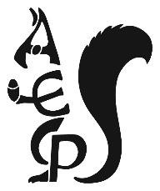

Alderley Edge Community Primary School
Behaviour Policy
This policy was written by the children with support from the school council and staff.
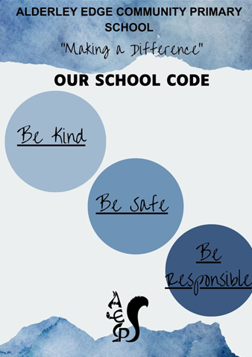

Expectations of Behaviour at AECPS
At AECPS, we expect children to behave well at all times. When members of staff see children behaving well in school and on the playground behaviour is rewarded with :
- A ‘well done’
- House points for our houses (Tatton, Chorley, Capesthorne and Warford)
- Class awards – given to whole classes that are well behaved
- Attendance certificate


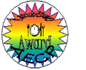
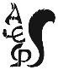
- School visits
- Kindness fairy certificates
- Child of the Week
- Star of the Day
- Midday awards
- Headteacher awards
- Letters home from the Headteacher
- Learning to Learn awards

Adults and staff look for:
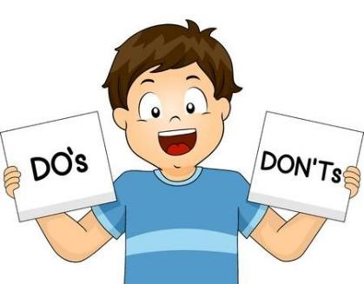
- Enthusiasm for learning
- Trying our best
- Good manners
- Respect towards children, teachers and school property
- Listening to others
- Children being polite and helpful
- Children following the school rules

What happens if you don’t follow the rules

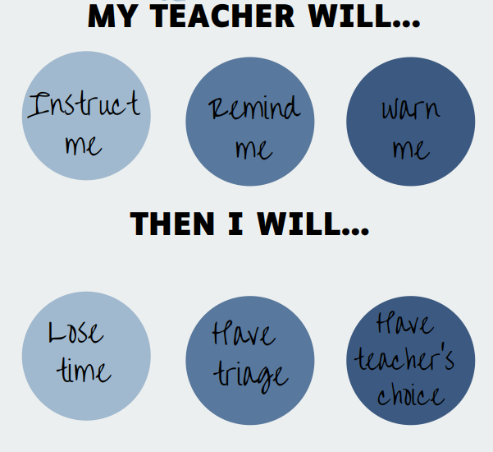


Unacceptable behaviour
- Not following the school rules
- Stopping children learning in lessons
- Rudeness or being disrespectful
- Physically hurting someone
- Not following instructions
- All forms of bullying
- Vandalising school property

Luckily, children in our school behave well. We can all make mistakes as long as we can learn from them and make the right choices.
For more information talk to you class teacher

